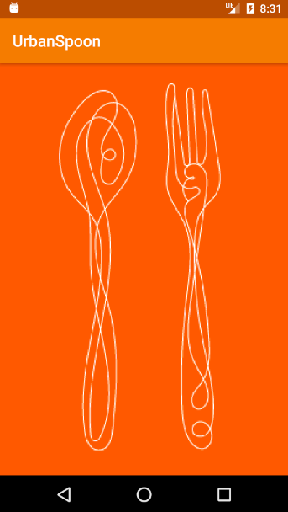

**Splash Screen**

**(Initial screen that is shown to the user i.e., welcome** screen)

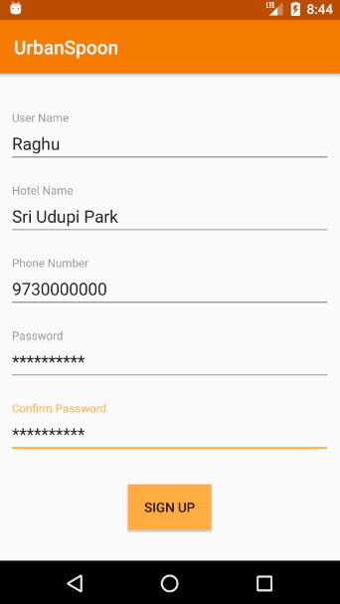 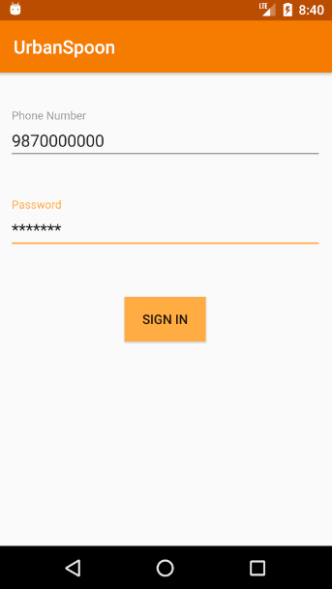

**Login Page**

**Registration Page**

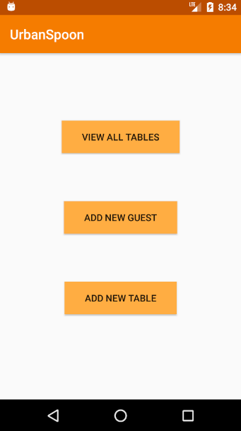

**Options Page**

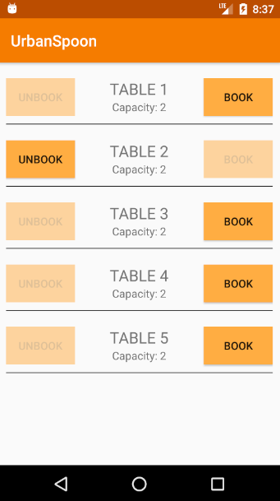 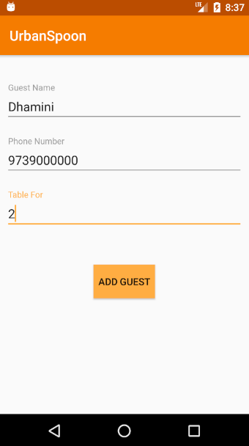 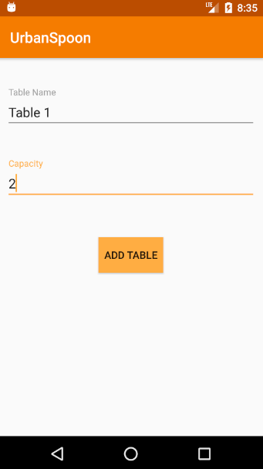

**Booking and Unbooking Page**

**(Where manager can book and unbook table as and when guests arrive/leave)**

**Add Table Page**

**(This page is used to add new table)**

**Add Guest Page**

**(This page is used to add new guest to the queue as and when they arrive)**