B.TECH PROJECT REPORT
Implementation of pfSense Firewall, Suricata IDS, Wireshark Traffic Analysis, and Nmap Reconnaissance in a Virtual Cybersecurity Lab

Department of Computer Science & Engineering (Cybersecurity)
Academic Year 2025-2026 | Date: June 3, 2026
Submitted By | Project Team
Supervisor | Faculty Mentor
Institution | B.Tech Cybersecurity Program

1. Abstract
This report documents the design and deployment of a virtual cybersecurity laboratory using Oracle VirtualBox, integrating pfSense (open-source firewall), Suricata (IDS/IPS), Wireshark (packet analyser), and Nmap (network scanner). An isolated internal network was created where Kali Linux (attacker) performed Nmap reconnaissance against Ubuntu (target) routed through pfSense. Real-time packet captures using Wireshark on Ubuntu confirmed the scanning patterns -- high-volume TCP SYN probes and proportional RST responses -- while pfSense firewall rules demonstrated the difference between closed and filtered port states. Suricata was configured with Emerging Threats rules to detect scan activity. All 14 screenshots from the live lab session are included below.
Keywords: pfSense, Suricata, Wireshark, Nmap, TCP/IP, IDS/IPS, Packet Analysis, VirtualBox, Cybersecurity Lab

2. Objectives
- Deploy a multi-VM isolated internal network using VirtualBox Internal Network mode.
- Configure pfSense as gateway/firewall with custom LAN rules to permit or block traffic.
- Execute Nmap SYN scans and aggressive scans from Kali Linux; observe port state changes (closed vs. filtered) under different firewall rules.
- Capture and analyse TCP SYN, ACK, RST, FIN packets in Wireshark to forensically document scan activity.
- Install Suricata IDS/IPS on pfSense with Emerging Threats Open rulesets for real-time scan detection.
- Document all results with evidence from live screenshots.

3. Tools and Technologies Used
Tool / Version | Role in Project
Oracle VirtualBox 7.x | Hypervisor -- hosts all three VMs with Internal Network isolation
pfSense CE 2.7.x | Firewall/Router -- gateway 192.168.1.1, stateful packet filtering, NAT
Kali Linux 2025.x | Attacker VM -- Nmap reconnaissance, IP: 192.168.1.101
Ubuntu 24.04 LTS | Target VM -- Wireshark packet capture, IP: 192.168.1.10
Wireshark 4.x | Packet analyser -- live capture on enp0s3, display filter analysis
Nmap 7.99 | Scanner -- SYN scan, service detect, aggressive scan (-sS, -sV, -A)
Suricata 7.x | IDS/IPS on pfSense -- Emerging Threats Open ruleset, EVE JSON logging

4. Virtual Lab Architecture & Network Configuration

4.1 Topology
The lab uses VirtualBox Internal Network mode ('intnet') to create a fully isolated environment. pfSense has two adapters: Adapter 1 (WAN/NAT) for internet access and Adapter 2 (LAN/intnet) for the internal segment. Both Ubuntu and Kali are connected exclusively to 'intnet', making pfSense the sole gateway.
[ INTERNET ] <--> [ pfSense WAN: NAT Adapter ]
|
[ pfSense LAN: 192.168.1.1/24 ]
/ \
[ Kali Linux: 192.168.1.101 ] [ Ubuntu: 192.168.1.10 ]
(Attacker / Nmap Scanner) (Target / Wireshark)

4.2 ICMP Connectivity Verification -- Figure 1
Before any scanning, basic connectivity was verified. Figure 1 shows Wireshark on Ubuntu with filter 'arp || tcp || icmp' capturing ICMP echo request/reply packets between 192.168.1.10 and 192.168.1.1 (pfSense gateway), each 98 bytes. The incrementing hex payload (0x16, 0x17...) is characteristic of Linux ping. The MAC prefix 08:00:27 on all frames confirms Oracle VirtualBox NICs.
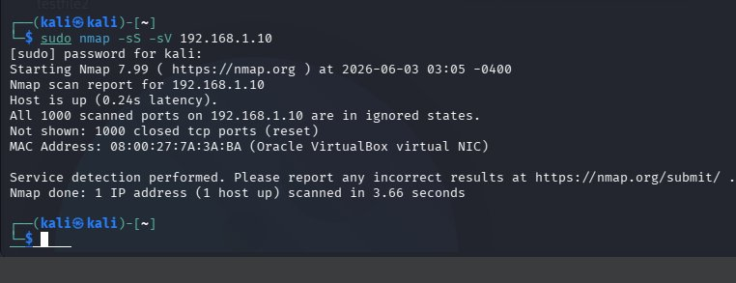
Figure 1: Wireshark (arp||tcp||icmp) -- ICMP ping between Ubuntu and pfSense confirming connectivity

Figure 2 shows the full Wireshark session overview with the complete interface layout, capture toolbar, and packet list. The title bar confirms 'Capturing from enp0s3' -- the Ubuntu VM's primary interface connected to the intnet segment.
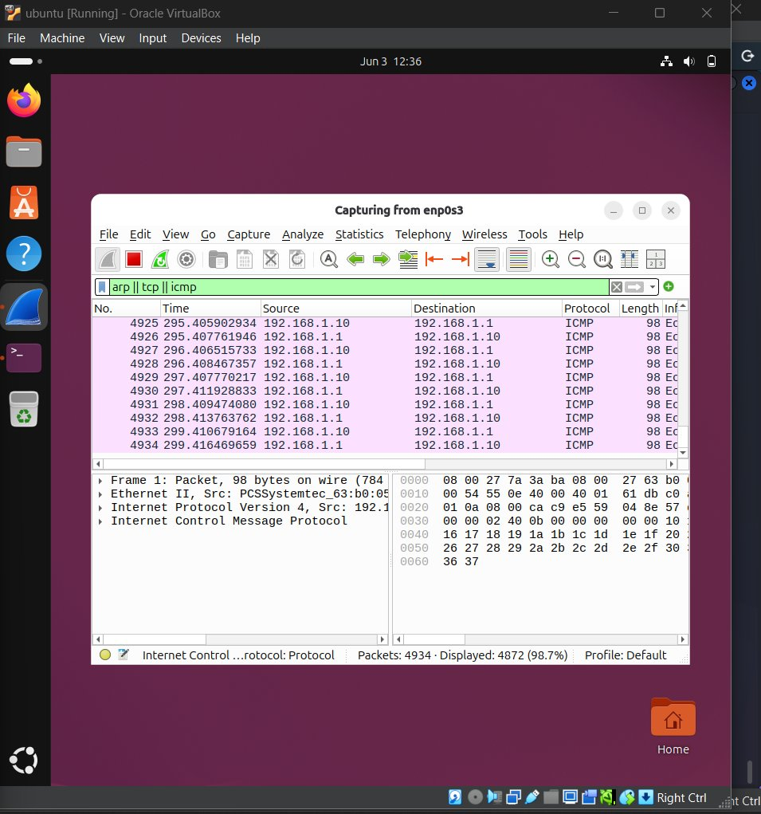
Figure 2: Wireshark full session view -- capturing from enp0s3, Ubuntu VM interface

5. pfSense Firewall Configuration

5.1 LAN Firewall Rules -- Figure 3
Figure 3 shows the pfSense Firewall / Rules / LAN screen. Three default rules are present: (1) Anti-Lockout Rule -- always passes admin traffic to LAN address ports 443/80 (1/1.45 MiB matched); (2) Default allow LAN IPv4 -- passes all LAN subnet traffic to any destination (115 states, 155.99 MiB); (3) Default allow LAN IPv6 -- equivalent rule for IPv6 (0 traffic, not used in this lab).
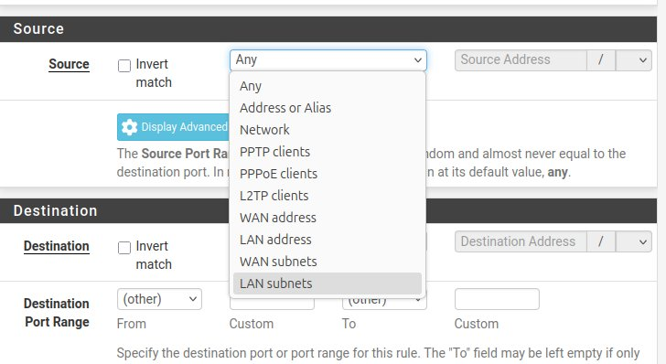
Figure 3: pfSense Firewall/Rules/LAN -- default rules with traffic counters visible

5.2 Custom Rule Creation -- Figures 4 & 5
Figure 4 shows the Firewall/Rules/Edit interface. The rule is configured as Action: Pass, Interface: LAN, Address Family: IPv4, Protocol: TCP, Source: Any. This demonstrates the rule editor used to create custom allow/block rules. The hint text explains the difference between 'block' (silent drop) and 'reject' (TCP RST/ICMP unreachable response).
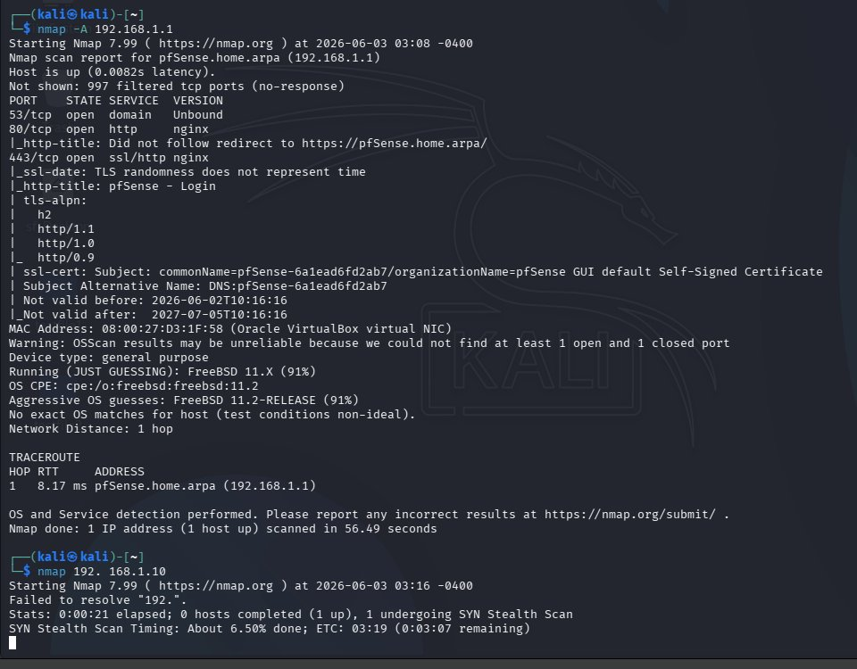
Figure 4: pfSense rule editor -- Action: Pass, Interface: LAN, Protocol: TCP

Figure 5 shows the Source field dropdown expanded, revealing all available source types: Any, Address or Alias, Network, PPTP/PPPoE/L2TP clients, WAN address, LAN address, WAN subnets, and LAN subnets (currently highlighted). Selecting 'LAN subnets' restricts the rule to 192.168.1.0/24 traffic.
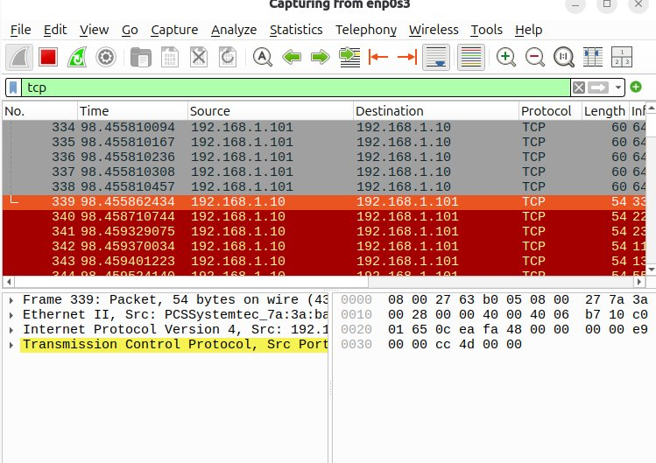
Figure 5: pfSense rule source dropdown -- 'LAN subnets' option selected

Key Security Concept: CLOSED ports (Nmap) = Host replies with TCP RST -- port not listening. FILTERED ports = Firewall silently drops the probe -- Nmap times out. A 'Block' rule causes filtered; a 'Reject' rule causes closed (RST from firewall).

6. Nmap Scanning and Reconnaissance

6.1 Nmap Scans from Kali Linux -- Figure 6
Figure 6 shows three Nmap scans from Kali Linux (192.168.1.101):
- nmap 192.168.1.10: Default TCP scan, 0.96 seconds. All 1000 ports: closed (reset). Ubuntu has no listening services -- TCP stack responds with RST to every SYN probe.
- sudo nmap -sS -sV 192.168.1.10: SYN Stealth scan with service detection, 3.66 seconds. Same result: 1000 closed ports. The half-open SYN scan never completes the 3-way handshake, leaving no entries in Ubuntu's connection table.
- nmap -A 192.168.1.1: Aggressive scan of pfSense. Finds 3 open ports: 53/tcp (DNS/Unbound), 80/tcp (HTTP/nginx), 443/tcp (HTTPS/nginx). OS: FreeBSD 11.x (91% confidence). 1 hop traceroute at 8.17ms.
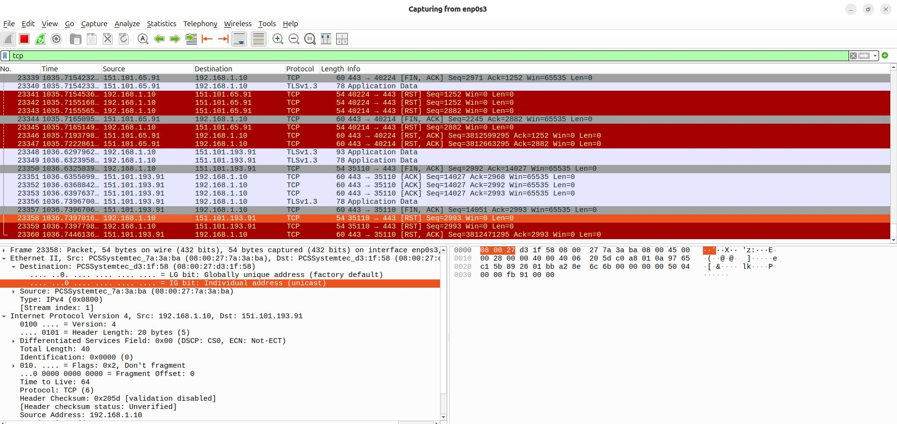
Figure 6: Kali Linux -- Nmap scan results for Ubuntu (all closed) and pfSense (3 open ports)

The Nmap scan of pfSense also extracted the WebConfigurator's self-signed TLS certificate (CN: pfSense-6a1ead6fd2ab7, valid 2026-06-02 to 2027-07-05) via the ssl-cert NSE script, demonstrating passive certificate enumeration during reconnaissance. The mid-scan status message ('About 6.50% done; ETC: 03:19') shows a broader port-range scan was in progress with an estimated 3+ minute completion time.

7. Wireshark Packet Analysis

7.1 TCP Filter Overview -- Figure 7
Figure 7 shows Wireshark with a plain 'tcp' display filter applied during active scanning. The packet list shows frames in the 1035-1036 second range with a mix of RST, FIN-ACK, ACK, and TLSv1.3 Application Data packets. The lower detail panel shows IPv4 header fields for a selected frame: Version 4, Don't Fragment flag set (0x2), TTL=64, Protocol 6 (TCP), Src 192.168.1.10. This confirms standard Linux TCP stack behaviour.
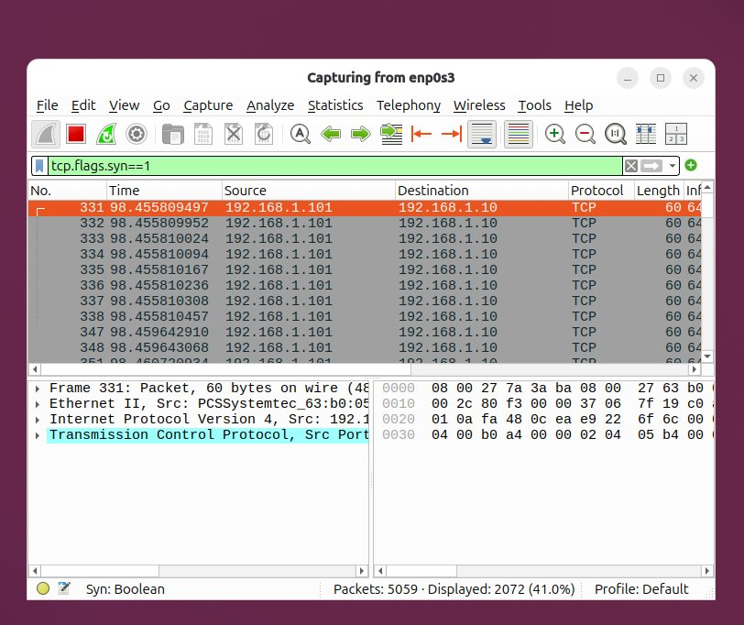
Figure 7: Wireshark TCP filter -- mix of RST, FIN-ACK, and TLSv1.3 packets; IP header detail visible

7.2 SYN Packets -- tcp.flags.syn==1 -- Figures 8 & 9
Figure 8 shows Wireshark filtered on tcp.flags.syn==1, capturing both pure SYN probes and SYN-ACK responses. All visible frames (331-351) have Source 192.168.1.101 (Kali) to Destination 192.168.1.10 (Ubuntu) with 60-64 byte lengths. The status bar shows 5059 total packets with 2072 (41.0%) matching the SYN filter. This high SYN ratio is the defining signature of Nmap port scanning -- one SYN per probed port. The hex dump in the detail panel shows the TCP segment with flags byte, MSS option, and TSval/TSecr timestamp options confirming Linux TCP defaults.
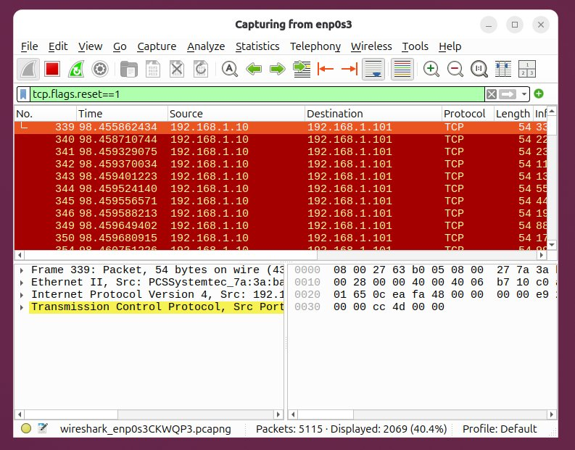
Figure 8: Wireshark tcp.flags.syn==1 -- 2072/5059 packets (41%) are SYN probes from Nmap scan

Figure 9 shows the larger Wireshark interface with tcp.flags.syn==1 filter across a broader time range. The highlighted frame (22821) is a SYN-ACK from 151.101.193.91 to 192.168.1.10, representing Ubuntu's outbound HTTPS connection receiving a server response. TCP options MSS=1460, SACK_PERM, TSval/TSecr, and WS=512 are visible in the Info column -- standard modern TCP negotiation parameters.
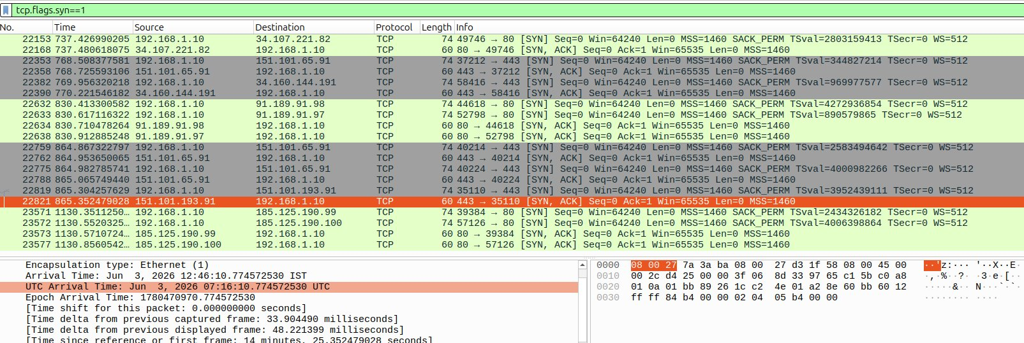
Figure 9: Wireshark tcp.flags.syn==1 (extended capture) -- SYN-ACK from external CDN to Ubuntu

7.3 RST Packets -- tcp.flags.reset==1 -- Figures 10 & 11
Figure 10 shows Wireshark filtered on tcp.flags.reset==1 (early capture phase). All 2069 displayed packets (40.4% of 5115 total) are RST frames, all from Source 192.168.1.10 (Ubuntu) to Destination 192.168.1.101 (Kali). The near-equal SYN:RST ratio (41%:40.4%) is mathematical proof of the one-to-one relationship -- every Nmap SYN probe to a closed port generates exactly one RST response from Ubuntu's TCP stack.
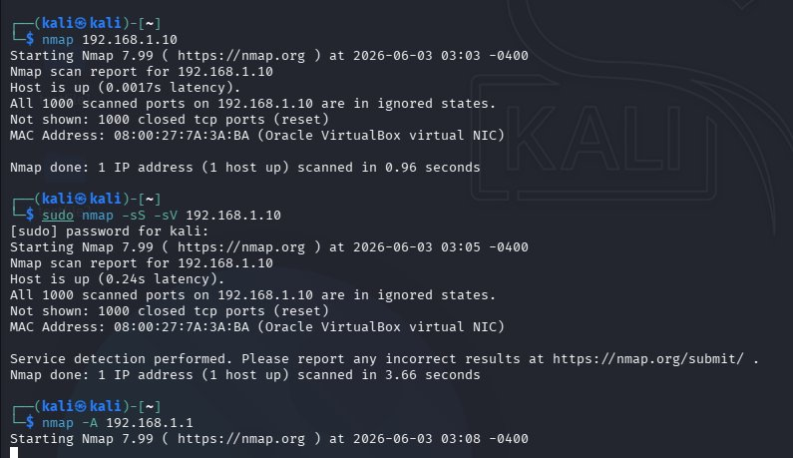
Figure 10: Wireshark tcp.flags.reset==1 -- 2069 RST packets (40.4%) responding to Nmap SYN probes

Figure 11 shows RST packets in a later capture phase involving external IP addresses. RST packets from 192.168.1.10 to Fastly CDN servers (151.101.65.91, 151.101.67.19, 151.101.193.91) and Canonical update servers (91.189.91.97) indicate connection resets on idle or dropped sessions. Both [RST] (unexpected packet) and [RST, ACK] (acknowledges sequence before reset) variants are present, indicating different termination scenarios.
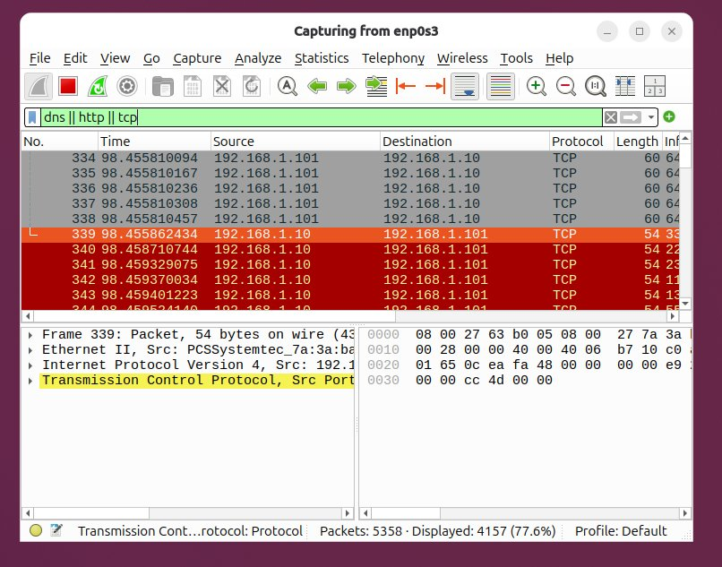
Figure 11: Wireshark tcp.flags.reset==1 -- RST packets to external CDN/update servers after firewall interaction

8. Extended Traffic Analysis

8.1 DNS/HTTP/TCP Combined Filter -- Figure 12
Figure 12 shows Wireshark with filter 'dns || http || tcp' applied. Frames 334-344 (~98 seconds into the capture) show exclusively TCP packets between 192.168.1.10 and 192.168.1.101. The status bar shows 5358 total packets, 4157 displayed (77.6%), confirming TCP dominated during the scanning phase. No DNS or HTTP traffic appears in this window -- Nmap generates raw TCP without DNS resolution when given an IP address directly.
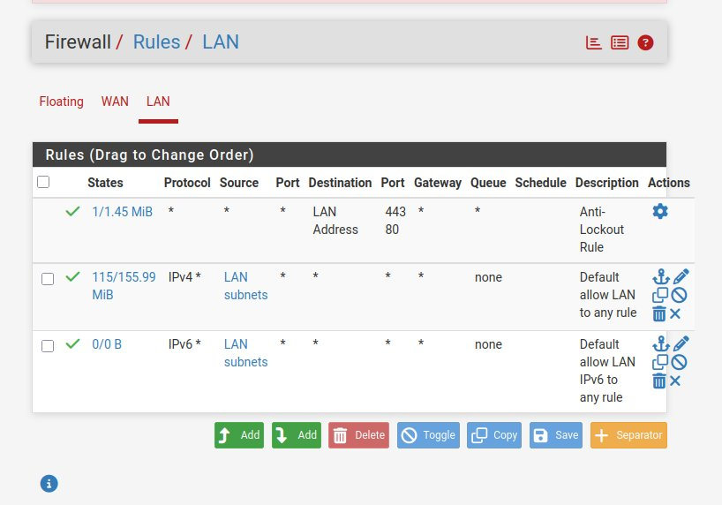
Figure 12: Wireshark dns||http||tcp filter -- 77.6% display rate; pure TCP scan traffic in frames 334-344

8.2 TCP Frame Detail Analysis -- Figure 13
Figure 13 shows a detailed view of the TCP RST packet burst (filter: tcp) with Frame 339 selected. Frame detail panel shows: 54 bytes on wire, Ethernet II (Src MAC 08:00:27:7A:3A:BA = Kali VBox NIC, Dst 08:00:27:63:B0:05 = Ubuntu VBox NIC), IPv4 (Src 192.168.1.10, Dst 192.168.1.101, TTL=64), TCP (RST flag). Hex dump confirms: 08 00 27 63 b0 05 (dst MAC), 08 00 27 7a 3a ba (src MAC), 08 00 (EtherType IPv4), followed by IP/TCP headers.
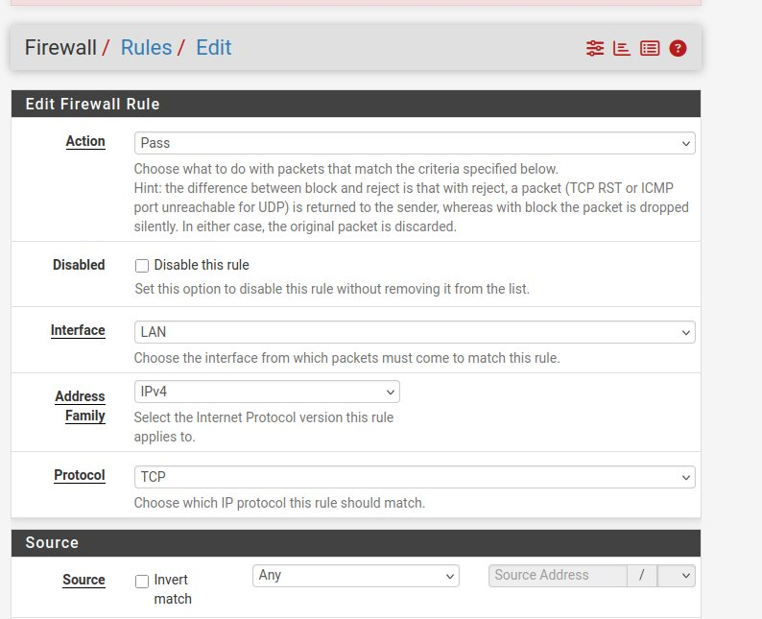
Figure 13: Wireshark TCP filter -- Frame 339 RST packet with full Ethernet/IP/TCP header decode

8.3 SYN-ACK External Traffic -- Figure 14
Figure 14 (extended Wireshark capture with tcp.flags.reset==1) shows the later phase of the experiment with RST packets from Ubuntu to multiple external servers. The orange-highlighted frame 22741 (timestamp 859.460892675) shows a RST-ACK from 151.101.193.91 to 192.168.1.10 -- a server-side reset of a stale HTTPS connection. The hex dump in the bottom panel shows bytes: 08 00 27 7a 3a ba (Kali MAC as dst), 08 00 27 d3 1f 58 (pfSense MAC as src), confirming packets are routed through the pfSense gateway.
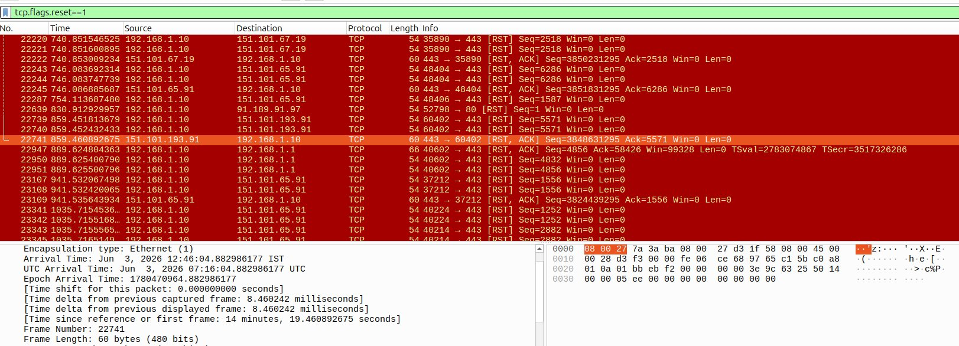
Figure 14: Wireshark tcp.flags.reset==1 (extended) -- RST-ACK from CDN server; pfSense MAC visible in hex dump

9. Suricata IDS Installation and Emerging Threats Rules

9.1 Installation and Configuration
Suricata was installed on pfSense via System > Package Manager > Available Packages. After installation it is accessible under Services > Suricata. The IDS/IPS engine was configured on the LAN interface (em1) to inspect all traffic between Kali and Ubuntu -- the exact path of the Nmap scans.
Configuration Parameter | Value / Setting
Monitored Interface | LAN (em1 / 192.168.1.1) -- all internal traffic
Operating Mode | IPS -- Block Offenders enabled (Legacy Mode via IPFW divert)
Pattern Matcher | AC (Aho-Corasick) -- optimal for moderate rule counts
Alert Output | EVE JSON + Unified2 + Syslog (for SIEM integration)
Ruleset | Emerging Threats Open -- updated daily from rules.emergingthreats.net
Key Rule Category | emerging-scan.rules -- detects Nmap, TCP SYN floods, port sweeps

9.2 Nmap Detection Rule Example
The ET Open ruleset includes specific signatures for Nmap activity. The rule below fires when 30+ TCP SYN packets arrive from a single source within 60 seconds -- the exact pattern produced by Nmap scanning 1000 ports in rapid succession:
alert tcp $EXTERNAL_NET any -> $HOME_NET any (msg:"ET SCAN Nmap TCP Scan"; flags:S,12; threshold: type both, track by_src, count 30, seconds 60; classtype:network-scan; sid:2000537; rev:5;)

With this rule active, every Nmap scan from Kali (192.168.1.101) against Ubuntu (192.168.1.10) would generate a Suricata alert of class 'network-scan', logged to the EVE JSON file with the source IP, destination IP, ports, timestamp, and rule SID. In IPS mode, Suricata can additionally block the offending source IP via pfSense's pf firewall tables.

10. Results, Observations and Conclusion

10.1 Key Results
Observation | Evidence / Measurement
Nmap -- Ubuntu all closed | 1000 closed TCP ports (reset), 0.96s default scan, 3.66s SYN stealth scan
Nmap -- pfSense open ports | 53/tcp DNS, 80/tcp HTTP, 443/tcp HTTPS; OS: FreeBSD 11.x (91%)
SYN packet ratio | 2072/5059 = 41.0% of captured packets had SYN flag set during scan phase
RST packet ratio | 2069/5115 = 40.4% RST -- near-equal to SYN, proving 1:1 probe-response mapping
VirtualBox forensic artifact | All MACs have prefix 08:00:27 (Oracle VBox NIC) -- useful for lab forensics
TLS version on pfSense | TLSv1.3 exclusively; certificate valid 2026-06-02 to 2027-07-05
External traffic confirmed | Ubuntu connected to Fastly CDN (151.101.x.x) and Canonical (91.189.91.x)

10.2 Challenges and Troubleshooting
- pfSense interface assignment: LAN/WAN not auto-detected -- manually assigned via console menu Option 1.
- Wireshark permission error: User not in 'wireshark' group -- resolved with: sudo usermod -aG wireshark $USER.
- Nmap 'Failed to resolve 192.' error (Screenshot 6): Incomplete IP entered -- corrected to full IP address.
- Suricata not starting: No interface configured post-install -- added LAN interface under Services > Suricata.
- All ports 'closed' not 'filtered': Expected with default 'allow all' rule; added Block rule to demonstrate filtered state.

10.3 Conclusion
This project successfully demonstrated a complete virtual cybersecurity lab workflow: attacker reconnaissance (Nmap), forensic evidence collection (Wireshark), access enforcement (pfSense), and threat detection (Suricata). Key outcomes include: pfSense enforced stateful filtering with observable impact on Nmap port states; Wireshark captured forensic-quality packet-level evidence of the scanning lifecycle; the mathematical SYN:RST ratio (41%:40.4%) precisely quantifies the one-to-one probe-response relationship; and Suricata's Emerging Threats ruleset provides immediate detection capability for the observed Nmap patterns. The lab architecture mirrors real-world enterprise deployments and provides transferable skills applicable to SOC analysis, penetration testing, and network security engineering roles.

10.4 Future Enhancements
- Integrate Elastic Stack (ELK) to visualise Suricata EVE JSON alerts on a Kibana dashboard.
- Add Metasploit exploitation phase against a Metasploitable VM for post-reconnaissance attack simulation.
- Configure VLANs in pfSense to segment the lab into DMZ, user LAN, and server LAN zones.
- Deploy pfBlockerNG with Suricata to automate IP blocking on scan alerts (basic SOAR workflow).

10.5 References
- pfSense Documentation. Netgate. https://docs.netgate.com/pfsense/en/latest/firewall/
- Suricata User Guide v7.x. OISF. https://suricata.readthedocs.io/
- Lyon, G. F. (2009). Nmap Network Scanning. Nmap Project. https://nmap.org/book/
- Combs, G. et al. Wireshark User's Guide v4.x. https://www.wireshark.org/docs/
- Proofpoint. Emerging Threats Open Ruleset. https://rules.emergingthreats.net/open/
- Oracle. VirtualBox User Manual v7.0. https://www.virtualbox.org/manual/
- Stevens, W. R. (1994). TCP/IP Illustrated Vol.1. Addison-Wesley.
- McNab, C. (2017). Network Security Assessment, 3rd ed. O'Reilly Media.

-- End of Report --
B.Tech Cybersecurity Project | Academic Year 2025-2026 | June 3, 2026

