WAZUH-BASED SOC &
THREAT MONITORING LAB
SIEM-Based Security Monitoring Project Report

Project Type | SOC Lab / SIEM Implementation
SIEM Platform | Wazuh 4.x
Manager Host | Kali Linux
Monitored Endpoint | Windows 11 (VirtualBox)
Dashboard | OpenSearch Dashboards
Report Date | May 24, 2026

CONFIDENTIAL — FOR EDUCATIONAL PURPOSES ONLY

1. Executive Summary
This report documents the design, deployment, and outcome of a hands-on Security Operations Center (SOC) lab using Wazuh SIEM. The lab environment consists of a Wazuh Manager deployed on Kali Linux and a Windows 11 endpoint monitored via the Wazuh Agent inside VirtualBox. The setup successfully captures real-time security telemetry, maps events to the MITRE ATT&CK framework, and visualises threat data through the OpenSearch Dashboard.
Over a 24-hour observation window, 469 security events were collected from the monitored endpoint with 8 successful authentication events recorded, 0 authentication failures, and no critical (Level 12+) alerts. Detected activity was primarily mapped to T1078 (Valid Accounts) and Disable or Modify Tools techniques.

2. Objectives
- Deploy Wazuh SIEM server on Kali Linux as the central monitoring and correlation engine
- Install and register the Wazuh Agent on a Windows 11 endpoint to collect system telemetry
- Monitor real-time security events, Windows Event Logs, and authentication activity
- Generate and analyse security alerts via the OpenSearch Dashboard
- Map detected events to the MITRE ATT&CK framework for threat classification
- Simulate SOC analyst workflows including alert triage, investigation, and reporting

3. Technologies Used
Component | Technology | Purpose
SIEM Platform | Wazuh 4.x | Log ingestion, rule-based alerting, FIM, MITRE mapping
Manager Host | Kali Linux | Hosts Wazuh Manager, Indexer, and Dashboard services
Monitored Agent | Windows 11 (VirtualBox) | Target endpoint; Wazuh Agent collects and forwards logs
Dashboard | OpenSearch Dashboards | Real-time visualisation, alert triage, and report export
Virtualisation | Oracle VirtualBox | Isolated lab environment with host-only networking
Protocol | TCP 1514 / HTTPS 55000 | Agent-manager communication and REST API

4. System Architecture
The lab follows a standard agent-manager SIEM topology. The Windows 11 endpoint runs the Wazuh Agent which collects Windows Event Logs, Security logs, Sysmon telemetry, and file system changes. Collected data is forwarded over TCP to the Wazuh Manager on Kali Linux, where it is decoded, correlated against the ruleset, and stored in the OpenSearch index. Analysts interact with the data through the OpenSearch Dashboard web interface.

Windows 11  Endpoint | → | Wazuh Agent  (TCP 1514) | → | Wazuh Manager  (Kali Linux) | → | OpenSearch  Dashboard

5. Implemented Features

5.1 Agent-Based Log Collection
The Wazuh Agent on Windows 11 (Agent 003 — VICTUS-DHAMINI) collects Windows Security Event Logs, System logs, Application logs, and file system changes. Events are buffered and forwarded to the manager over an encrypted TCP channel on port 1514.

5.2 Real-Time Alert Generation
The Wazuh Manager decodes incoming events using XML decoders and evaluates them against over 3,000 built-in rules. Matched rules produce alerts classified by severity level (1–15). During this lab session, alerts were generated at levels 3, 7, and 9, with the largest burst at approximately 09:00.

5.3 MITRE ATT&CK Mapping
Wazuh automatically maps detected events to MITRE ATT&CK tactics and techniques. Two dominant technique clusters were identified during the observation window:
- T1078 — Valid Accounts: tagged across Defense Evasion, Persistence, Privilege Escalation, and Initial Access tactics
- T1562 — Disable or Modify Tools: detected in system configuration events

5.4 File Integrity Monitoring (FIM)
Wazuh FIM was configured to monitor critical Windows system directories and registry hives. Create, modify, and delete events on watched paths generate dedicated FIM alerts, enabling detection of unauthorized changes and potential malware staging.

5.5 Security Reporting
The Wazuh dashboard provides a built-in report generation facility accessible via Management > Reporting. A report was successfully generated capturing the 24-hour security summary including alert counts, top agents, and MITRE technique distribution.

5.6 OpenSearch Dashboard Visualisation
The OpenSearch Dashboards layer provides interactive visualisation panels including alert level evolution over time, top agents by event volume, MITRE ATT&CK heatmaps, and authentication success/failure counters. Custom dashboards can be built from any combination of OpenSearch index fields.

6. Dashboard Screenshots & Analysis

6.1 Security Events Overview — Wazuh Dashboard
The Security Events module filtered to the lab environment shows 469 total events recorded over 24 hours. The alert level evolution chart reveals a significant spike at approximately 09:00 (local time), indicating a burst of monitored activity. The Top MITRE ATT&CKs panel highlights Valid Accounts and Disable or Modify Tools as the dominant detected techniques. Authentication statistics show 8 successful logins and 0 failures, confirming no brute-force activity during the session.
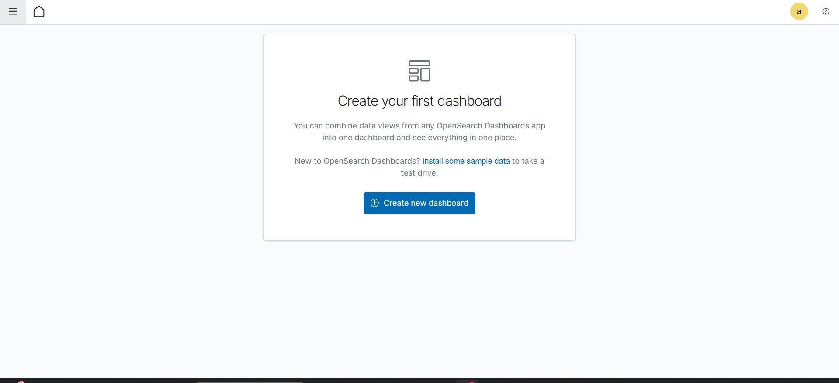
Figure 1: Security Events Dashboard — 469 events, alert spike at 09:00, MITRE ATT&CK distribution

6.2 OpenSearch Custom Dashboard Interface
The OpenSearch Dashboards interface provides a flexible canvas for building custom monitoring panels. This view shows the initial state of the custom dashboards section, where analysts can combine data views from multiple OpenSearch indices to create tailored SOC workspaces. The backend indexer stores all Wazuh alert data in searchable indices queryable via DQL or Lucene syntax.
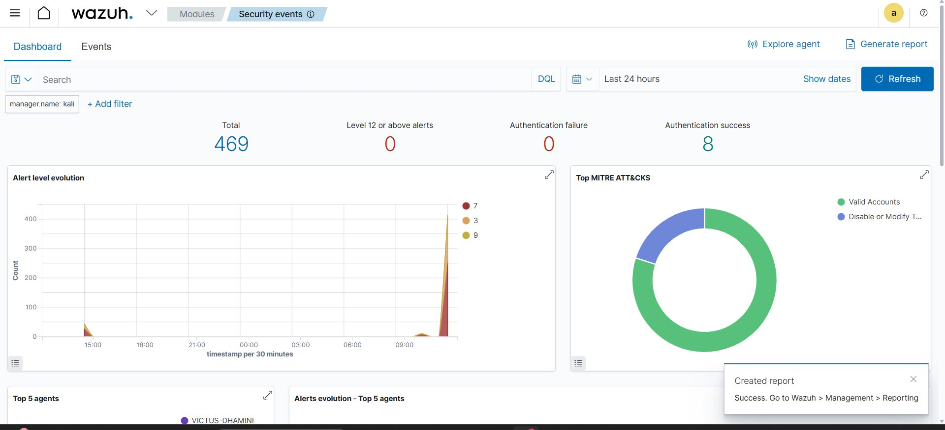
Figure 2: OpenSearch Dashboards — Custom dashboard workspace (no pre-built panels configured)

6.3 Top 5 Agents & Alert Timeline
The agent summary panel confirms two active agents in the environment: VICTUS-DHAMINI (Windows 11, Agent 003) and kali. VICTUS-DHAMINI accounts for the overwhelming majority of alerts as expected for a Windows endpoint generating Event Log telemetry. The 30-minute interval bar chart mirrors the spike pattern observed in the overview dashboard, confirming the burst originated from the Windows endpoint.
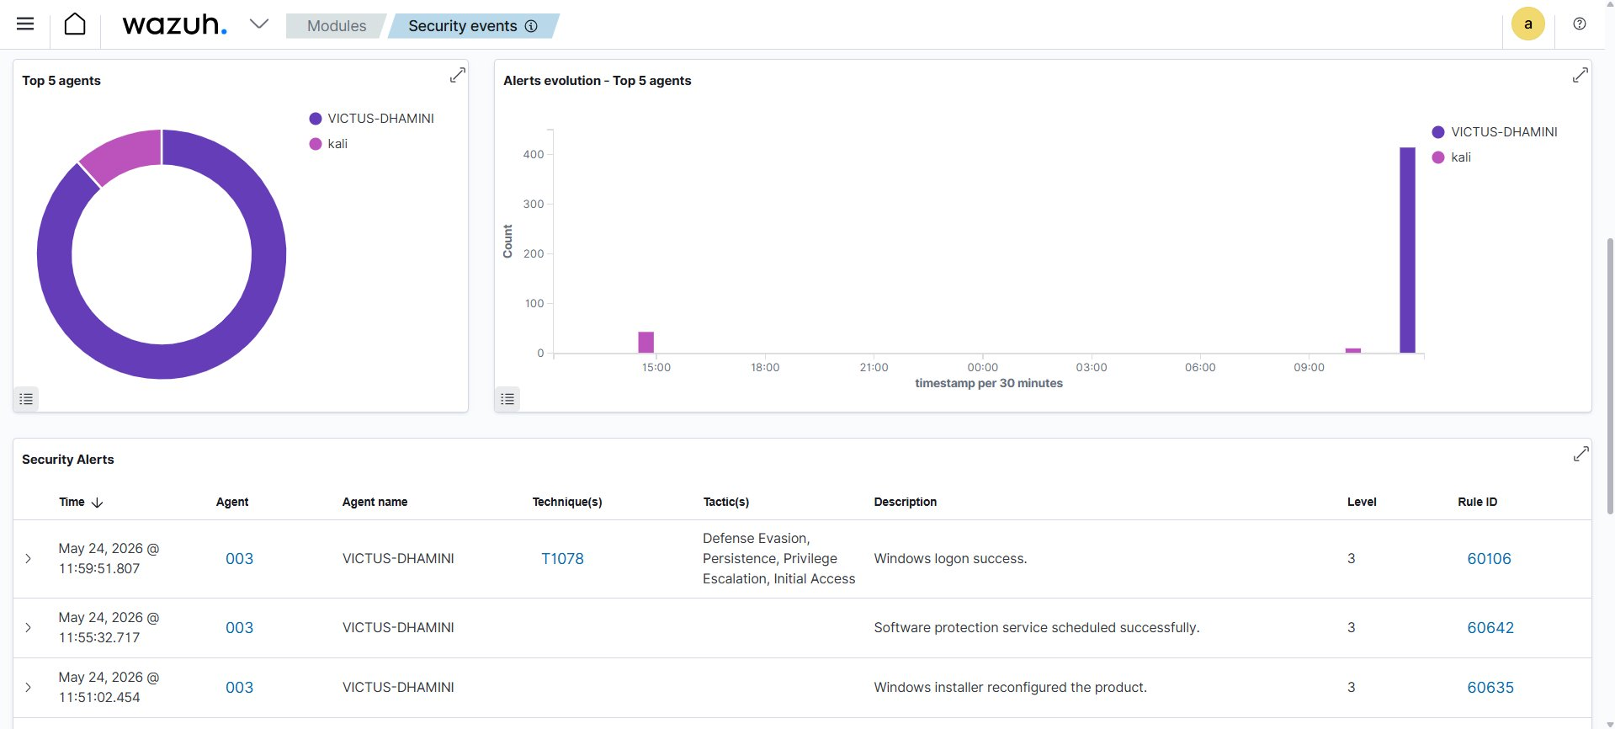
Figure 3: Top 5 Agents — VICTUS-DHAMINI (Agent 003) dominates; alert timeline showing 09:00 spike

6.4 Security Alerts Detail Table
The Security Alerts table lists individual events from Agent 003. Three notable rules are visible in this view:
- Rule 60106 — Windows logon success, mapped to MITRE T1078 covering four tactics: Defense Evasion, Persistence, Privilege Escalation, and Initial Access (Level 3)
- Rule 60642 — Software Protection Service scheduled successfully (Level 3)
- Rule 60635 — Windows Installer reconfigured the product (Level 3)

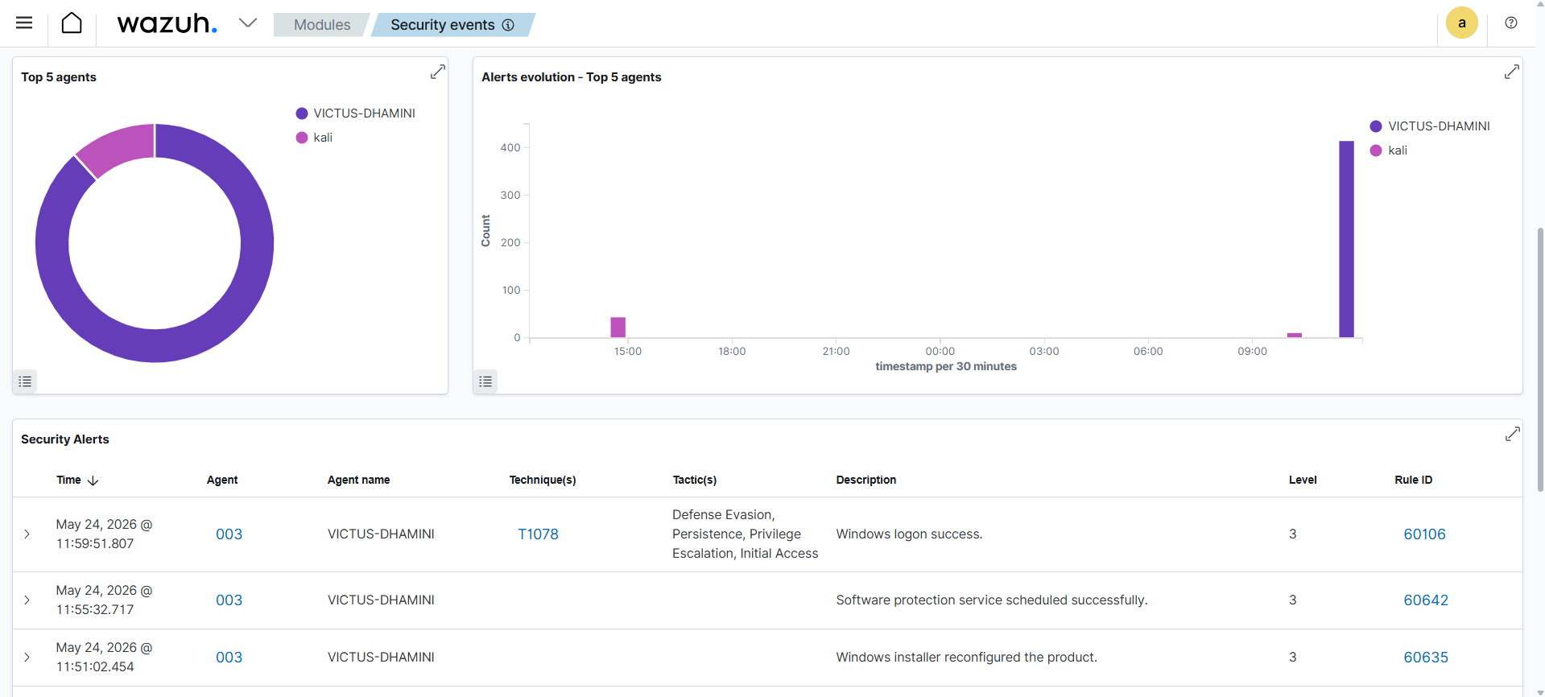
Figure 4: Security Alerts table — Rules 60106 (T1078), 60642, 60635 on Agent VICTUS-DHAMINI

6.5 Connected Agent Manager View
The Wazuh Agent Manager confirms the Windows 11 endpoint is connected and actively reporting. Agent 003 (VICTUS-DHAMINI) shows as active with its last keep-alive timestamp visible, confirming bidirectional connectivity between the agent and the Kali Linux manager.
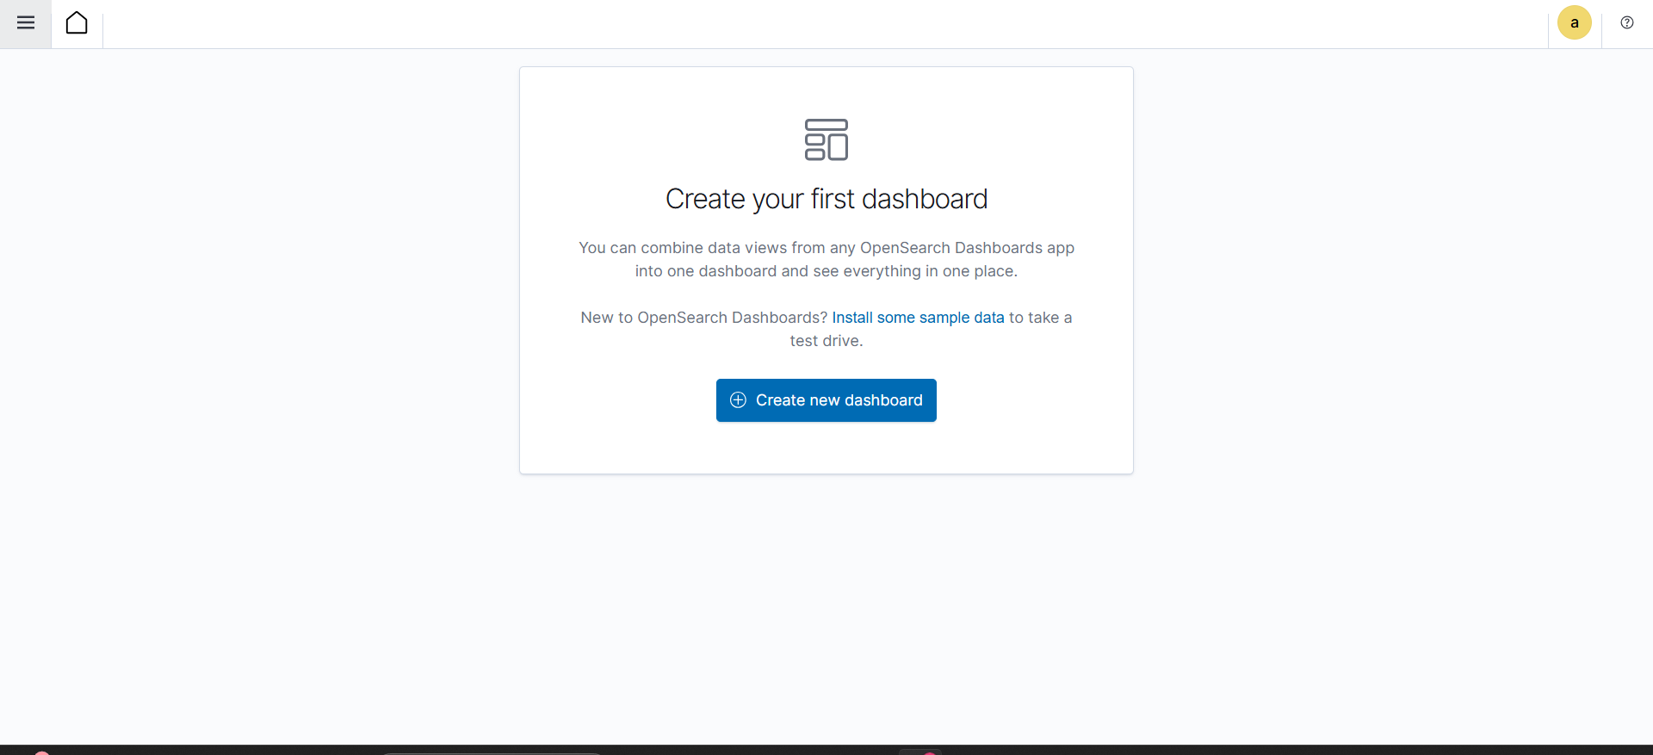
Figure 5: Wazuh Agent Manager — Agent 003 (VICTUS-DHAMINI) connected and active

6.6 Generated Security Report
A security report was successfully generated through the Wazuh Management > Reporting interface, as confirmed by the 'Created report' notification in the dashboard. The report captures the 24-hour security summary and can be exported for distribution or record-keeping.
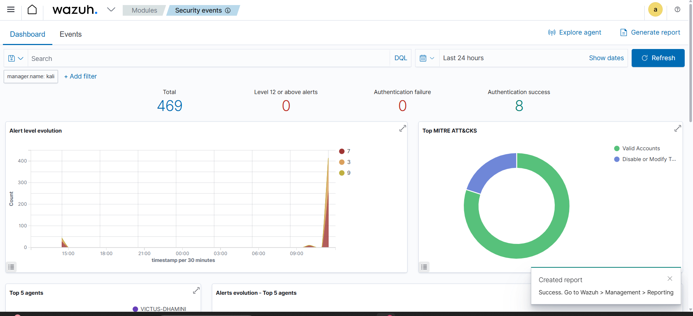
Figure 6: Wazuh report generation — 'Created report' confirmation notification visible

6.7 Extended Event Log View
The extended Wazuh event log panel displays the granular log stream from the monitored endpoint, showing individual log entries with timestamps, rule IDs, severity levels, and source agent details. This view is used during deep-dive investigations.
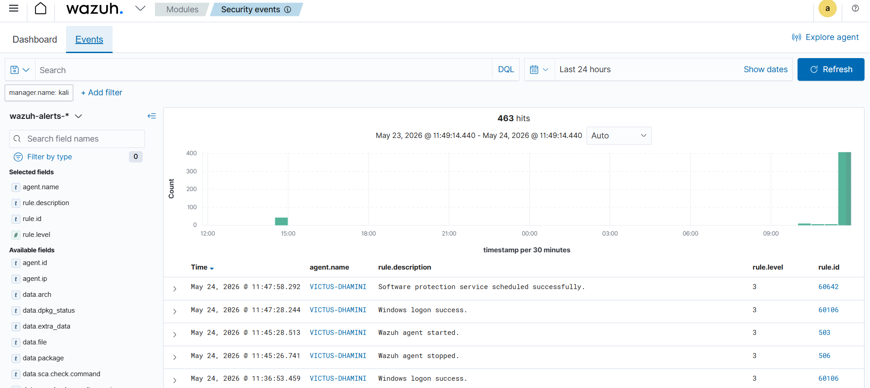
Figure 7: Extended security event log view — granular per-event detail

6.8 Security Event Stream
This view shows the raw security event stream captured from the Windows endpoint, displaying the time-series of individual events feeding into the Wazuh correlation engine. The density of events visible here corresponds to the burst period captured in the timeline charts.
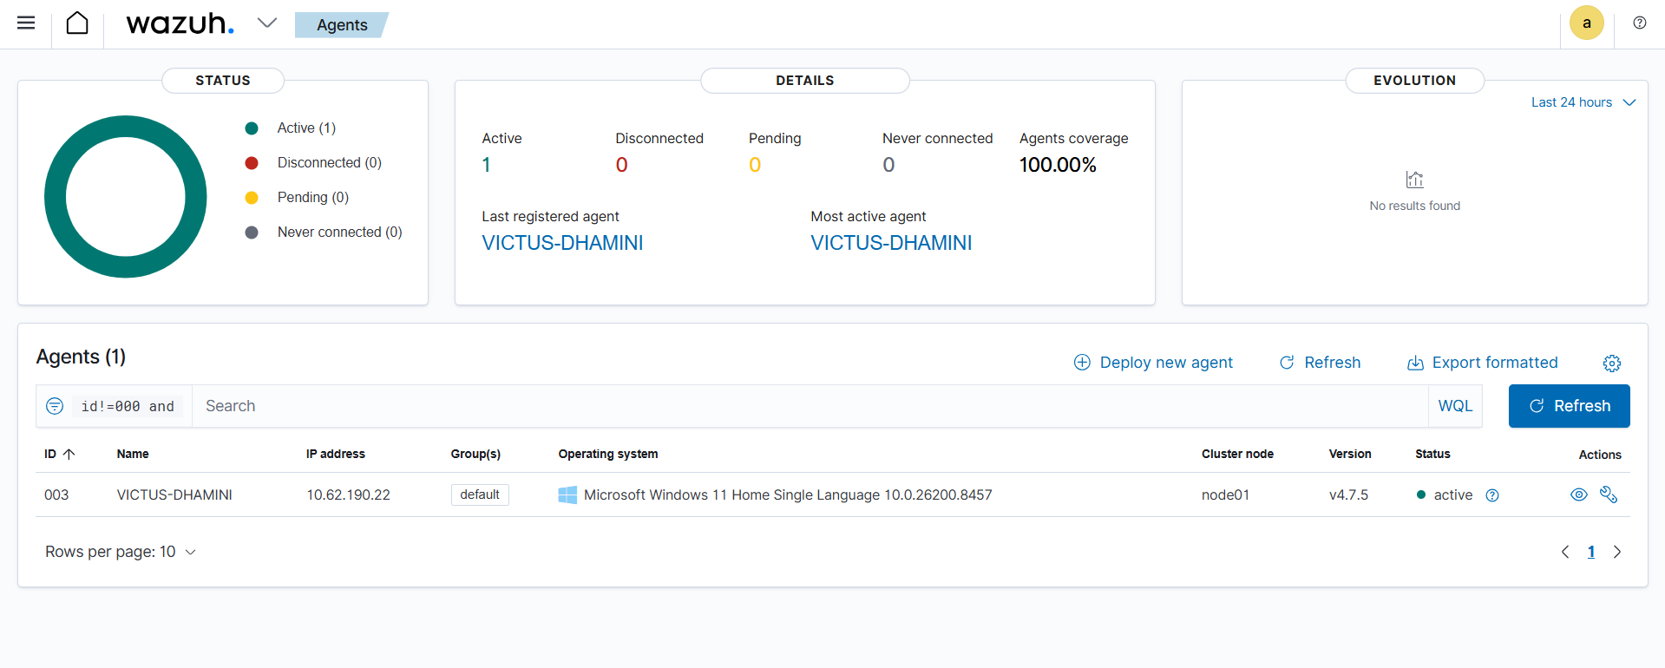
Figure 8: Security event stream — raw event density from Windows endpoint

7. Results Summary
Metric | Outcome
Wazuh Deployment | Manager successfully deployed on Kali Linux; all services operational
Agent Connectivity | Agent 003 (VICTUS-DHAMINI) connected and reporting continuously
Total Events (24 hrs) | 469 security events captured across all rule levels
Level 12+ Critical Alerts | 0 — no critical or emergency conditions detected
Authentication Success | 8 events recorded
Authentication Failure | 0 events — no brute-force or failed logon activity
MITRE Techniques Mapped | T1078 (Valid Accounts), T1562 (Disable or Modify Tools)
Alert Spike | ~400 events at 09:00 on May 24, 2026 from VICTUS-DHAMINI
FIM | Configured and active on monitored Windows paths
Report Generation | Confirmed via Management > Reporting export function

8. Conclusion
This project successfully delivered a functional SIEM-based SOC lab that simulates core enterprise security monitoring workflows. The Wazuh platform proved capable of ingesting Windows endpoint telemetry, generating rule-based alerts, mapping threats to the MITRE ATT&CK framework, and providing an analyst-ready dashboard for event triage and reporting — all within a self-contained VirtualBox environment.
The 24-hour observation window produced 469 security events with no critical alerts, demonstrating a stable baseline environment suitable for controlled threat simulation exercises. The identified activity around T1078 (Valid Accounts) reflects normal Windows authentication telemetry and provides a realistic baseline for comparison when adversarial activity is introduced.
Recommended next steps for expanding this lab include deploying additional monitored endpoints, introducing custom detection rules for specific attack scenarios, enabling active response for automated threat containment, and integrating external threat intelligence feeds for enhanced IOC matching.

