Wazuh-Based SOC and Threat Monitoring Lab
Project Overview
This project demonstrates the setup of a Security Operations Center (SOC) lab using Wazuh SIEM on Kali Linux to monitor a Windows 11 endpoint. The system performs log collection, security monitoring, and real-time alert generation through the Wazuh dashboard.

Objectives
- Set up Wazuh SIEM on Kali Linux
- Connect a Windows 11 endpoint using Wazuh Agent
- Monitor endpoint logs and activities
- Generate and analyze security alerts
- Understand SOC and SIEM workflows

Technologies Used
- Kali Linux
- Wazuh SIEM
- Windows 11
- VirtualBox
- OpenSearch Dashboard

System Architecture
Windows Endpoint → Wazuh Agent → Kali Linux Wazuh Manager → Dashboard Monitoring

Implemented Features
- Endpoint monitoring
- Real-time alert generation
- Security event analysis
- Threat hunting dashboard
- File Integrity Monitoring (FIM)
- Agent-based log collection

Project Screenshots
Security Events Dashboard
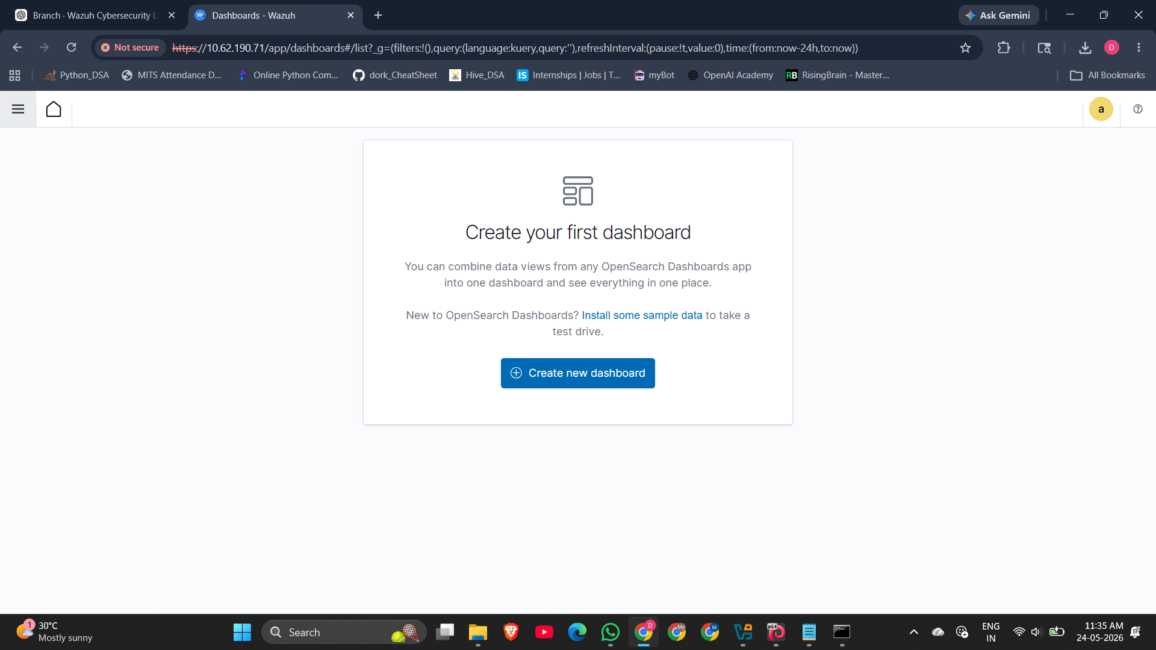
Security Events Dashboard
Generated Security Report
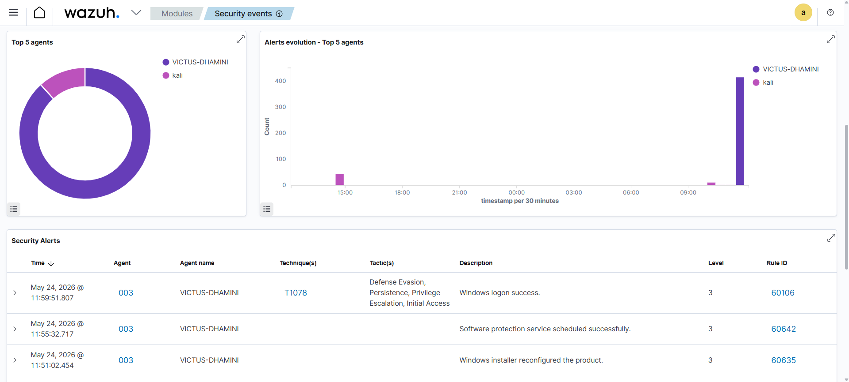
Generated Security Report
Security Event Logs
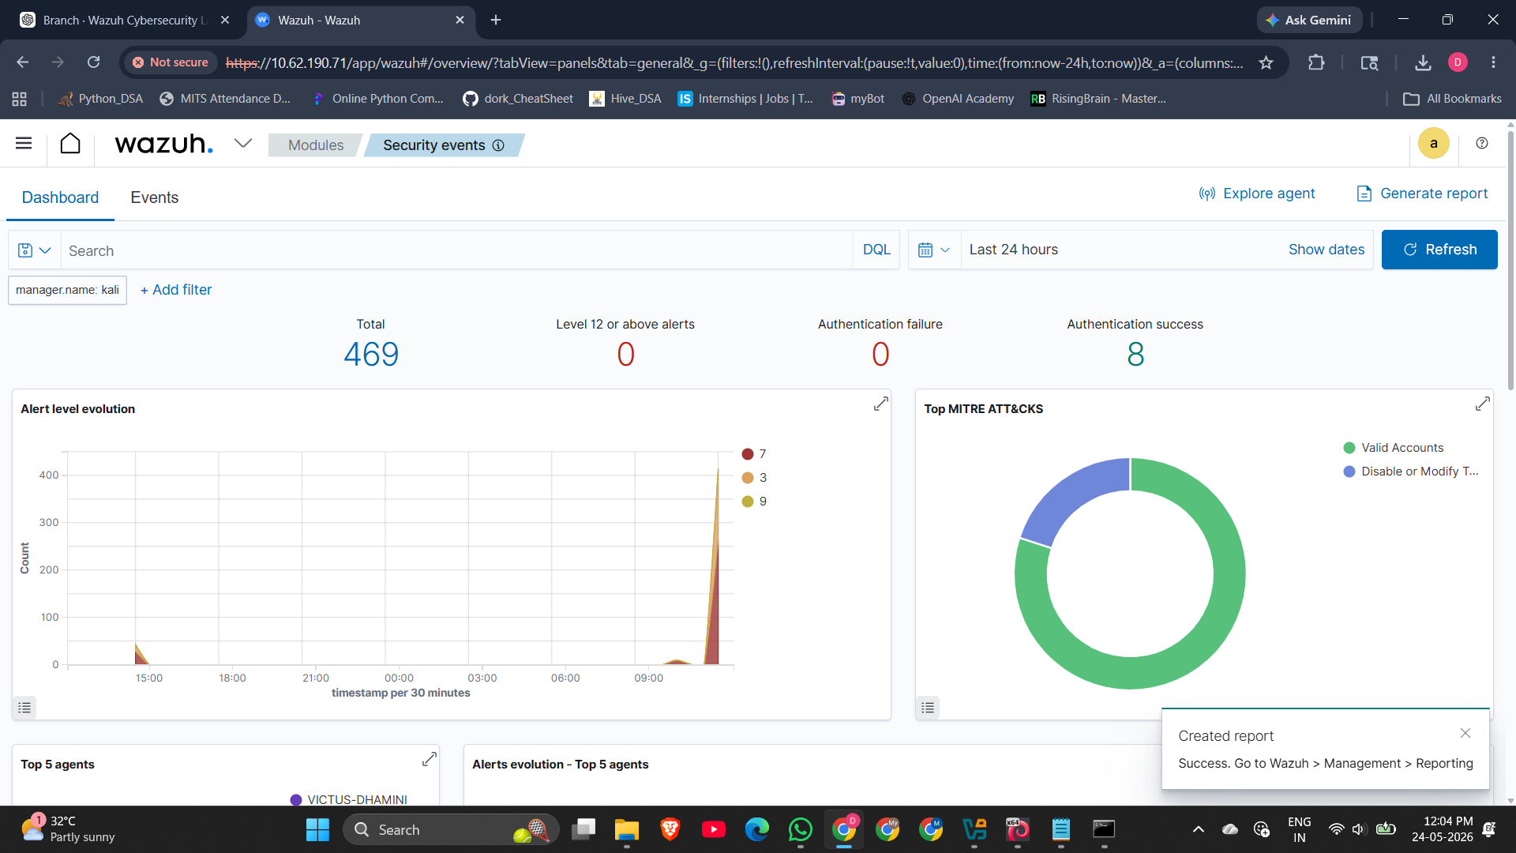
Security Event Logs
Connected Active Agent
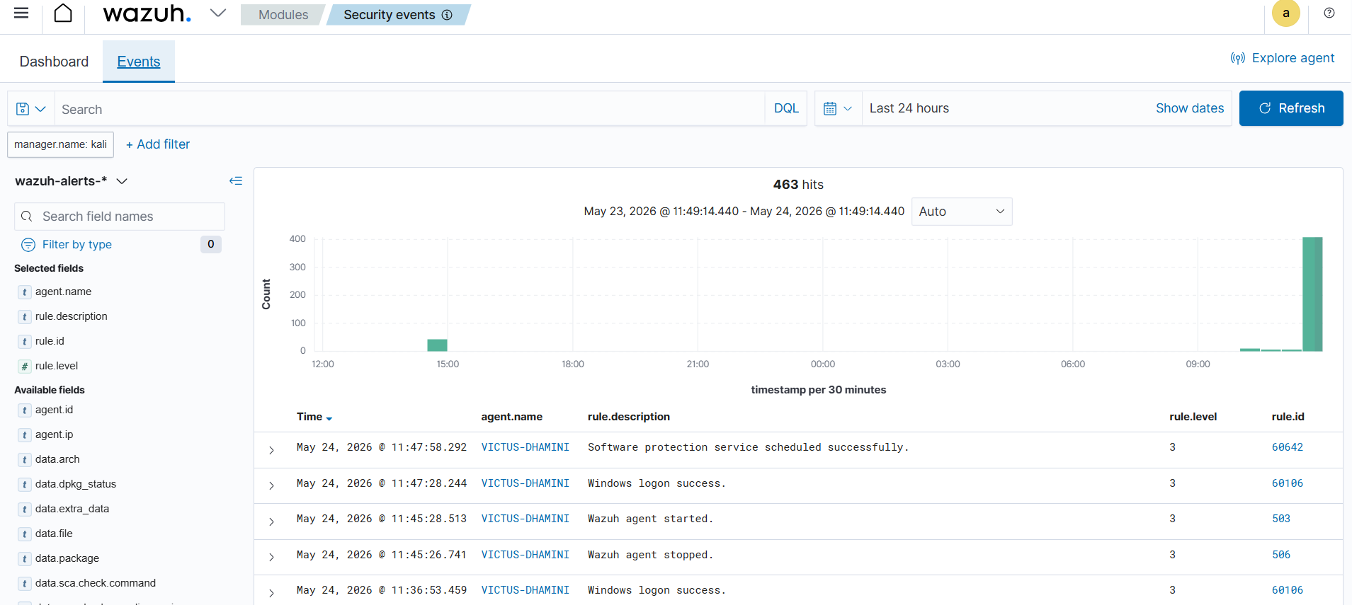
Connected Active Agent
OpenSearch Dashboard Interface
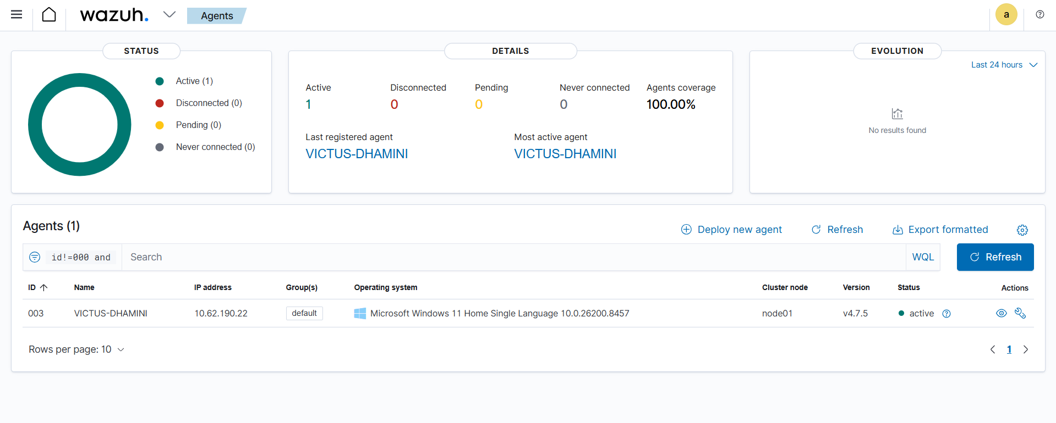
OpenSearch Dashboard Interface

Results
The Wazuh SIEM environment was successfully configured. The Windows 11 endpoint connected successfully to the Kali Linux Wazuh Manager. Security alerts and event logs were generated and monitored through the dashboard. The project demonstrates practical SOC monitoring and SIEM operations.

Conclusion
This project provided hands-on experience in SIEM deployment, endpoint monitoring, log analysis, and real-time threat detection using Wazuh. It simulates a basic SOC environment used in enterprise cybersecurity operations.

