GAMMA-UNWIND
Automated Scanner + Alerts
Setup and user guide
Version 0.8.9 · built 25 Oct 2026

A scanner that finds option setups near support and resistance zones and sends you alerts on Telegram. Alerts are information only. You decide and place your own trades.
Contents

1. Read this first
Important: Alerts are information, not advice. GAMMA-UNWIND is a scanner. It watches the market with a fixed set of rules and tells you when those rules are met. It does not know your money, your goals or your risk.
It never places, changes or closes an order — it has no way to. You decide whether to trade, how much and when to exit, and you place every order yourself in your broker's app.
- Options can lose most or all of their value quickly, especially close to expiry. Only trade with money you can afford to lose.
- The rules give signals that fail as well as signals that work. Nothing in this guide promises any result.
- Prices in an alert are the prices at the moment of the alert. The market may have moved by the time you read it.
- Stop-loss and target levels are the rule's reference levels. The alerts tell you when a level is reached; what you do is your decision.
- Alerts only exist while the app is running on your computer, with a valid broker login and an internet connection.
The alerts use plain words: TRADE ALERT, premium, stop loss, target, exit. They never tell you to place an order.

2. What GAMMA-UNWIND does
GAMMA-UNWIND — Automated Scanner + Alerts runs on your own computer during market hours. On every trading day it:
- Marks support and resistance zones for every stock in NSE's F&O segment, from daily candles, and finer zones from 1-hour candles for the stop loss.
- Builds your three lists (Breakdown, Breakout, Carry): the stocks trading close to a zone and, for each one, the option strikes where the most open interest (OI) sits.
- Watches those option contracts live, tick by tick, and checks its rules every time a 5-minute candle closes.
- When every check holds on one candle, sends a TRADE ALERT to your Telegram group: the contract, its premium, the stop loss and four targets (sections 3 and 4).
- Follows each alert: a message when a target is reached and when the trade exits (stop loss, trailing stop or the expiry-eve exit).
This version runs one scanner: the same rules for every list and every client.

What it is not
- Not a trading app. It cannot place orders. Your broker login is used only to read market data.
- Not a tip service. Every alert comes from the same written rules (section 3), applied the same way to every stock.
- Not a cloud service. It runs on your computer. Your market data, settings and history stay there.

Where you see it
- The dashboard — opens in your web browser at http://127.0.0.1:8760 (only on your own computer).
- Your Telegram group — the morning lists, the TRADE ALERTs and their follow-ups, on your phone.

3. The strategy in plain words
The idea fits in one sentence: when a stock sits right at a support or resistance zone, and the option traders who were defending that level start to leave, the option can move fast. The scanner looks for exactly that moment and tells you.
A TRADE ALERT has no fixed holding time: the trade runs until its stop loss, its last target or the expiry-eve exit (section 4), whichever comes first. It can last minutes or several days.

3.1 Zones: support and resistance
A zone is a price band where the stock turned before. A support zone sits below the price (falls stopped there before); a resistance zone sits above it (rises stopped there). The app finds them from daily candles, using swing highs and lows, and redraws them every day at 09:20 and 16:00. A zone is removed once a daily candle closes through it.
The same method on 1-hour candles gives finer zones close to the price. They set the stock stop of a trade (section 4.1).

3.2 Your lists
A stock goes on a list when it trades within 2.5% of a zone: just above a support zone (then the app watches its put options, PE) or just below a resistance zone (its call options, CE). For each stock it looks at the out-of-the-money strikes within 2.5% of the zone and keeps two strikes: the ones with the highest OI, tagged HOI-1 and HOI-2 (HOI-1 has the most OI). So every stock on a list is two option contracts, watched one by one, and the stock still gets at most two TRADE ALERTs a day (section 3.4).
Strikes too thin to trade cleanly are skipped. A strike stays a candidate only when at least 50 lots are open in it (its OI) and it traded for at least ₹1 lakh in the previous session (the quantity traded × the closing price). There is no minimum price for the list: a cheap strike that trades well stays. A strike that fails is replaced by the next strike by OI.
- At the checks every 15 minutes during the day, a strike that has already traded more today than in the whole previous session is judged on today's trading.
- If your broker does not report the previous session's trading for option contracts, that test is skipped and only the OI test applies.
The lists are built before the market opens (09:10) and again at 09:20, then checked again every 15 minutes until 14:45. Each check adds stocks that have come near a zone; a stock is never removed during the day.
There are three lists:
List | What it holds
Breakdown | Puts (PE) on stocks just above a support zone
Breakout | Calls (CE) on stocks just below a resistance zone
Carry | Contracts that were on the two lists above, kept on in the following days while they still qualify, until shortly before their expiry. Its alerts are tagged CARRY STRIKE.

The lists use the current month's contracts, and move to the next month's when the current month has 4 trading days or fewer left.

3.3 OI unwinding
Open interest (OI) is the number of option contracts that are still open. Near a support zone, many traders write put options at strikes just below the price, expecting the support to hold. While they stay, the OI at those strikes is high — a kind of wall.
When the stock presses on the support and those writers start closing their positions, the OI at those strikes falls from its peak. That is OI unwinding. It shows the wall is getting thinner, and if the support gives way the put premiums can expand quickly. Near resistance it is the mirror image, with calls.
The app measures the fall from today's highest OI for that contract. On the Breakdown and Breakout lists a fall of 8% counts as unwinding (the rule allows 1 percentage point of tolerance: a fall of 7% already counts).
On the Carry list the OI was built up over several days, so the rule is different: the OI is at least 5% below today's peak, and at least 25% of the OI added while the contract was being built up has gone again.

3.4 The TRADE ALERT, step by step
Every 5 minutes, when a candle closes, the app checks five things on every watched contract. A TRADE ALERT is sent when all five hold on the same candle:
Check | In plain words
A — OI unwinding | OI has fallen from today's peak as in 3.3: 8% on the Breakdown and Breakout lists, the Carry rule on the Carry list.
B — Premium jump | The option's close is more than 4% above the close of the candle before.
C — Volume | The volume beats its average of the last 20 candles on this candle or on one of the two before it, and this candle traded.
D — Breakout from a quiet range | The close breaks out of a quiet stretch, in one of two ways (one is enough): above a tight range of 4 to 12 candles that was no taller than the option's usual movement (its ATR over 14 candles), or above the high of an NR7 candle — one of the last three candles whose range was the narrowest of 7 in a row.
S — The stock agrees | For a call (CE): the stock's 5-minute close is above its average price of the day (VWAP) and above its close 15 minutes earlier. For a put (PE): below both.

That candle must also have traded at least two lots, with the premium at ₹1.00 or more.
The premium on the alert is the option's close of that 5-minute candle; the alert comes right after the candle closes. There is nothing more to wait for.
The alert window. The first candle that can give an alert is the 09:20 candle (it closes at 09:25, after the 09:20 list post); the last is the 15:10 candle, closing at 15:15. After 15:15 no new alert is sent; trades already open are followed until the F&O market closes at 15:40.
At most two alerts per stock per day, across its calls and puts and all your lists. A second one comes only after the first trade on that stock has fully closed, and only when every check holds again.
A trade carried from an earlier day holds that stock: it gives no new alert until that trade has fully closed.
- F&O ban: a stock on NSE's F&O ban list for the day gives no alert. If the app cannot read the day's ban list, it sends no alert at all until it can — it never guesses that a stock is not banned.
- Results day: a stock that reports its results today can still give an alert; the alert says RESULTS TODAY.

3.5 What the scanner does not know
- News, corporate actions or anything outside prices, volume and OI (it only flags a results day).
- Your positions, your capital or what you did with an earlier alert.
- Where the market will go. It reports a pattern; it does not predict.

4. Stop loss and targets
Every TRADE ALERT comes with a stop loss and four targets, fixed at the moment of the alert, and the app follows it: a follow-up message arrives when a target is reached and when the trade exits. The same rules apply to every list:
Level | Rule
Premium | The option's close of the alert candle (section 3.4). The targets and an option stop are worked out from it.
Stop loss | On the stock: a 5-minute close of the stock at or through the near edge of its 1-hour zone — see 4.1. A contract with no 1-hour zone gets a stop on the option instead: the premium −40%.
T1 | Premium +25%. A part (25%) of the position is booked; the stop moves up to your cost (the premium of the alert).
T2 | Premium +50%. A part (25%) of the position is booked; the stop moves up to T1.
T3 | Premium +75%. A part (25%) of the position is booked; the stop moves up to T2.
T4 | Premium +100%. The last part (25%) is booked and the trade is closed — unless its trailing stop closed it first (4.2).
Expiry-eve exit | On the trading day before the contract's expiry, whatever is still open is closed at 15:15.

Targets are worked out from the premium on the alert and rounded up to the contract's tick (the smallest price step), so a target is never below its %. A % stop on the option is rounded down to the tick.
There is no other time limit: a trade can carry into the next days until one of the levels above ends it.

4.1 The stock stop
The stop loss of a trade watches the stock, not the option: the near edge of the 1-hour zone on the other side of the trade, fixed when the alert is sent.
- A call (CE): the top of the support zone below the stock. The trade ends when a 5-minute close of the stock is at or below it.
- A put (PE): the bottom of the resistance zone above the stock. The trade ends when a 5-minute close of the stock is at or above it.
- No 1-hour zone: the alert shows an option price instead (the premium −40%); the trade ends on a 5-minute close of the option at or below it.
The stock stop stays active for the whole trade, also after the targets have moved the option stop up (4.2): whichever is reached first ends the trade. The exit is at the next 5-minute candle's open; the follow-up message gives the price.

4.2 After each target: the stop moves up
The plan splits the position into four equal parts and books one at each target. A target counts as reached when a 5-minute candle's high touches it.
- After T1 the option stop moves up to your cost (the premium of the alert).
- After T2 the option stop moves up to T1.
- After T3 the option stop moves up to T2.
- A moved stop ends the trade on a 5-minute close of the option at or below it.
- After T3 the last part also trails: its stop follows the highest close since the alert, 3 times the option's usual 5-minute movement (its ATR over 14 candles) below it, and never moves down. The last part ends at T4 or at that trailing stop.
The group gets no separate message when the stop moves: the dashboard shows the current stop. With one lot the position cannot be split: the follow-ups tell you each target and the exit, and what you do is your decision.

5. What the alerts look like
Alerts go to your Telegram group: the morning list posts, the TRADE ALERTs and their follow-ups, and the day summary. The pictures below are the real messages, drawn by the app's own message code from example data (the contracts and prices are examples); on your phone they look the same, in your Telegram theme.
Every message starts with a line saying what it is, with its own symbol. An alert then shows the contract and its numbers, with a tap-to-copy contract line under them; the list posts are split into short sections with titles.

5.1 The morning list posts (09:20)
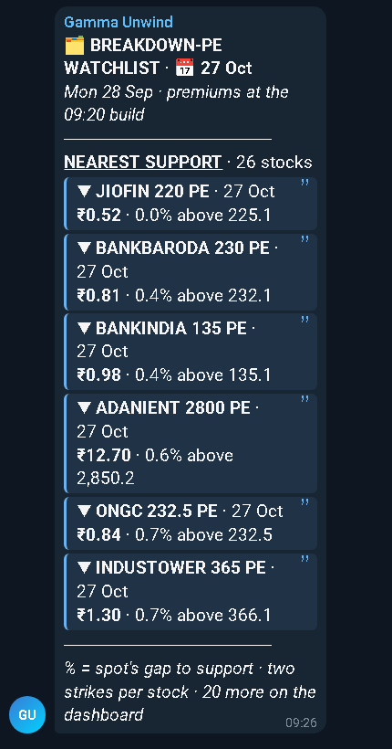  The 09:20 post of one list (example). | Posted once the 09:20 lists are built: one post per list. These lists always appear in this order, on the dashboard and in Telegram: Breakdown, Breakout. A list with no stocks today sends no post. The Carry list has no morning post: it is on the dashboard.  - The 6 contracts nearest their zone, numbered, nearest first. The last line says how many more are on the dashboard (Watchlists page).  - Each row: the stock, its strike (HOI-1 or HOI-2: a stock can have two rows) and the option price; under it, how far the stock is from its zone edge in %, and the zone edge price.  - The second line says where the prices come from: premiums at the 09:20 build means the price when the list was built, not a live price.  - Being on a list is not an alert: an alert comes only when the five checks of section 3.4 hold.

5.2 Stocks added during the day
From 09:30 to 14:45 the app checks the prices again every 15 minutes. A stock that has come near a zone joins its list at once on the dashboard (Watchlists page) and can give alerts from then on, like any other. Stocks already on a list stay there: nothing is removed during the day.
The new stocks are also posted to your Telegram group in short ADDED posts at 10:15, 11:15, 12:15, 13:15 and 14:15: each one lists the stocks added since the post before it. No post is sent when nothing was added. A stock added after 14:15 is shown on the dashboard only.

5.3 A TRADE ALERT
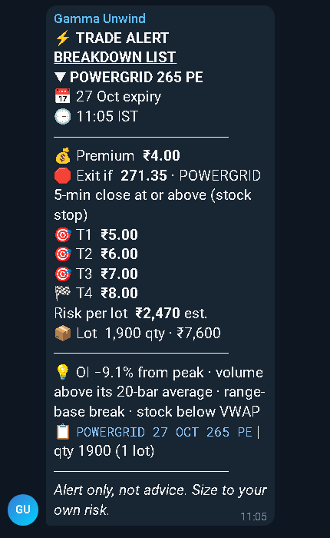  A TRADE ALERT (example). | - TRADE ALERT and the list it comes from (for example BREAKDOWN LIST); a tag line when one applies: RESULTS TODAY (the stock reports results today) or CARRY STRIKE (5.4).  - The contract, its expiry date and the time of the alert (IST).  - Premium: the option's close of the alert candle (section 3.4).  - Exit if: the stop loss — the stock level and the stock it is watched on (stock stop, section 4.1), or, for a contract with no 1-hour zone, an option price (option at or below).  - T1 … T4: the four targets as prices (section 4).  - Risk per lot: what one lot would lose if the stop is hit; est. when it is an estimate from the option's implied volatility.  - Lot: the lot size and what one lot costs at the premium.  - Why: the OI fall from its peak, the volume, the kind of breakout (range-base break or NR7 break) and the stock against its VWAP.  - 📋 contract line (for example POWERGRID 27 OCT 265 PE): tap it in Telegram to copy the contract name, then paste it into your broker's search. The line ends with the quantity of one lot.  - Then Alert only, not advice.

5.4 A Carry alert: CARRY STRIKE
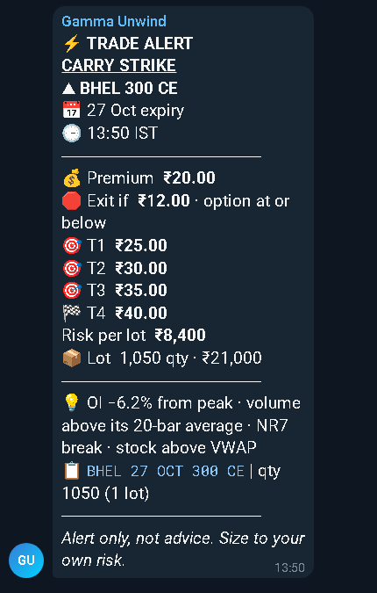  A TRADE ALERT on the Carry list (example). | A contract on the Carry list gives the same TRADE ALERT, under its list line and tagged CARRY STRIKE. Its OI check is the Carry rule of section 3.3; everything else — the checks, the stop loss, the targets and the follow-ups — is the same as on the other lists.  This example is a contract with no 1-hour zone: its stop is an option price, the premium −40% (section 4.1).

5.5 Follow-ups
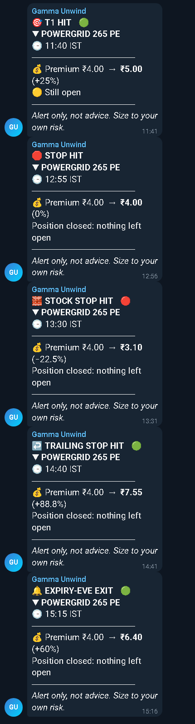  Follow-ups: one of each kind (examples). | After each alert the group gets one message for each target reached and one for the exit. Each names the contract and the time, and shows the premium of the alert against the price now, with the change in %:  - T1 … T4 HIT: that target was reached and its part booked; Still open while part of the position is left.  - STOP HIT: the option stop was reached — the % stop of a contract without a 1-hour zone, or the stop moved up after a target.  - STOCK STOP HIT: the stock closed through its stop level (section 4.1).  - TRAILING STOP HIT: the trailing stop of the last part was reached (section 4.2).  - EXPIRY-EVE EXIT: closed on the trading day before the contract's expiry (section 4).  The message that ends a trade reads Position closed: nothing left open.

5.6 The day summary
After the F&O close, at about 15:45, one post sums up the day: the day's TRADE ALERTs with the targets reached and the exits so far.

5.7 Messages in your personal chat
If you set a personal chat id (section 7.4), your bot also sends you token reminders (before your broker login expires), the 09:00 readiness card (chapter 20), a one-line note each time the app starts, and system notes (for example, when the app moved to a new group id). Without it, token reminders and system notes appear on the dashboard only, and the readiness card goes to the group.

6. What you need
- A computer that stays on and awake from about 09:00 to 16:15 on trading days (chapter 19 shows how the app helps): Windows 10 or 11 (64-bit), a Mac with macOS 12 or newer (Apple Silicon or Intel; the Mac package brings its own Python), or Linux with Python 3.13. At least 4 GB of memory and 2 GB of free disk space (market data builds up over time). Windows is tested by us; each macOS version is run on a real Mac before it is published; the Linux package has been checked for errors but not run (sections 9 and 10).
- A steady internet connection.
- Telegram on your phone (and optionally on the computer).
- A broker account with API access and market data — one of the brokers below.
Broker | Status | Market-data cost (checked Sept / Oct 2026) | Daily login
Dhan | Verified | ₹499 a month for the Data API (one Dhan page says free; check Dhan's current price) | Paste today's token
Zerodha (Kite Connect) | BETA | ₹500 a month (Kite Connect with market data; the free personal API has no market data) | Log in on the broker's site, paste the redirect URL
Upstox | BETA | free | Log in on the broker's site, paste the redirect URL
Angel One (SmartAPI) | BETA | free | Type today's authenticator code + PIN
Fyers | BETA | free | Log in on the broker's site, paste the redirect URL
Kotak Neo | BETA | free | Type today's authenticator code + PIN
Groww | BETA | ₹499 a month (Groww Trade API) | Type today's authenticator code
Nuvama | BETA | free for the first year (Nuvama's offer, September 2026) | Log in on the broker's site, paste the redirect URL
Shoonya | BETA | not stated in Shoonya's API documentation (ask Shoonya) | Paste today's token
Flattrade | BETA | free (Flattrade's API documentation, October 2026) | Paste today's token

Prices are as we found them in September and October 2026; check your broker's current price.
Verified and BETA: Verified means we run the app on this broker every day. BETA means the connection was built from the broker's public documentation and tested against sample data, but not yet on a real account of that broker. If you use a BETA broker, run Check Setup (sections 8–10) before your first market day, and tell us what it reports.
Daily login: no broker is logged in automatically. Each morning you either paste a token, paste the address your browser lands on after you log in to the broker yourself, or type the 6-digit code from your authenticator app — section 12 shows the steps for each broker.
Important: Nuvama needs a static IP address. Nuvama accepts API calls only from a static public IP address registered with Nuvama. Most home internet connections do not have one: arrange it with your internet provider and register it with Nuvama before you choose Nuvama (section 11).
Your broker is not in the list? Then this version cannot connect to it.

6.1 Values and commands at a glance
Everything you fill in or type during setup, on one page. Each row points to the section with the steps. Bold marks what is required; this style is exactly what you type, click or copy.
The values that go into .env:
Value | The line in .env | Where you get it
Your bot token (required) | TELEGRAM_BOT_TOKEN= | @BotFather in Telegram (section 7.1)
Your group id (required) | TELEGRAM_GROUP_ID= | The getUpdates page in your browser (section 7.3)
Your personal chat id (optional) | TELEGRAM_PERSONAL_CHAT_ID= | The same page (section 7.4)
Your broker (required) | BROKER= | One of dhan, zerodha, upstox, angel, fyers, kotak, groww, nuvama, shoonya, flattrade (chapter 11)
Your broker's keys (required) | The block for your broker | Your broker's website (chapter 11 shows each key, per broker)

Each trading morning, before 09:00: a fresh broker login on the dashboard Broker login page (chapter 12). The page writes it into .env for you.
The commands and buttons:
To | Windows | Linux / macOS (type in the app folder)
Set up once | Copy .env.example and rename the copy to .env (section 8) | chmod +x *.sh, then ./setup.sh (Linux needs the chmod; sections 9 and 10)
Check your setup | Double-click Check Setup.cmd | ./check.sh
Start the app | Double-click Start GAMMA.cmd | ./start.sh
Open the dashboard | Tray → Open dashboard, or http://127.0.0.1:8760 | http://127.0.0.1:8760 in your browser
Stop the app | Tray → Quit, or double-click Stop GAMMA.cmd | ./stop.sh
Update (outside market hours) | Double-click Update GAMMA.cmd (chapter 17) | ./update.sh (chapter 17)
Check the Mac package | — | ./mac_check.sh (macOS only, section 10.4)

If Check Setup reports a port other than 8760, use that port in the dashboard address.

7. Telegram: your bot and your group
The app sends alerts through your own Telegram bot into your own group. Set these up first — you need three values for the .env file: the bot token, the group id and (optionally) your personal chat id.

7.1 Create your bot
- In Telegram, search for @BotFather (the official one has a blue check mark) and open it.
- Send /newbot.
- Give it a display name, for example My Gamma Alerts.
- Give it a username that ends in bot, for example my_gamma_alerts_bot.
- BotFather replies with a token like 123456789:AAE…. This goes into TELEGRAM_BOT_TOKEN.
Important: Anyone with the bot token can post as your bot. Keep it private. If it ever leaks, send /revoke to @BotFather, pick your bot, and put the new token in .env.

7.2 Create a standard group and add the bot
- In Telegram tap New Group (not "New Channel"). This creates a standard group.
- Add your bot as a member (search for its username), and anyone else you want to see the alerts.
- Give the group a name, for example Gamma Alerts, and create it.
Keep the group private and simple: no public link. A standard group is all the app needs. Already using a group with Topics (a forum)? That works too: chapter 21 shows how to send the alerts into one topic.

7.3 Find the group id
- In the group, send the message /start@your_bot_username (use your bot's username).
- On your computer, open https://api.telegram.org/bot<TOKEN>/getUpdates in a web browser, with your own bot token in place of <TOKEN>.
- Look for your group's name. Next to it is "chat":{"id":-4987654321,"title":"Gamma Alerts","type":"group"}. The number with its minus sign is the group id:
TELEGRAM_GROUP_ID=-4987654321
- If the page shows only {"ok":true,"result":[]}, send another message in the group and refresh the page.
A standard group's id is a negative number such as -4987654321. A supergroup's id starts with -100. The app accepts both; a positive number or anything else is refused, and the dashboard shows why.

7.4 Optional: your personal chat id
- Open a private chat with your bot and send /start.
- Refresh the getUpdates page. Find "chat":{"id":123456789,…,"type":"private"}. That positive number goes into TELEGRAM_PERSONAL_CHAT_ID.
Leave it empty if you prefer; token reminders and system notes then appear on the dashboard only.

7.5 If Telegram upgrades your group
Telegram sometimes turns a standard group into a supergroup by itself — for example when you give it a public link, make the chat history visible to new members, turn on Topics, or when it grows large. The group gets a new id starting with -100, and messages sent to the old id fail.
You do not need to do anything. When Telegram reports the upgrade, the app switches to the new id, saves it into .env (TELEGRAM_GROUP_ID), sends the same message again, and leaves you a note on the dashboard (and in your personal chat, if set). One follow-up may then arrive as a new message instead of a reply, because message links do not carry over to the new group.

7.6 Keep copying allowed
The 📋 contract line of an alert (section 5.3) is copied with a tap, which needs copying to be allowed in the group. In the group settings, leave Restrict saving content turned off.

8. Setup on Windows 10 / 11
The Windows package is portable: it carries its own copy of Python, so nothing is installed and nothing else on your computer changes. It has been tested on Windows 11.
Everything you type or click is shown like this: type it exactly as shown, or click the button or menu item with that name.
- Download the ZIP file, named like GAMMA-UNWIND-client-0.8.9-win64.zip.
- Unblock it first: right-click the ZIP → Properties → tick Unblock at the bottom → OK. This stops Windows from warning about every script inside.
- Extract it to a short path: right-click → Extract All… → type C:\GAMMA → Extract. Long folder paths can break the app, so avoid Desktop or Downloads. If extraction stops with WinError 206 or "The filename or extension is too long", the folder path is too long: extract to C:\GAMMA.
- Open the new folder. You will see Start GAMMA.cmd, Stop GAMMA.cmd, Check Setup.cmd, Update GAMMA.cmd and .env.example.
- Create your .env file: copy .env.example and rename the copy to exactly .env. (Turn on View → File name extensions in File Explorer first, so Windows does not save it as .env.txt.)
- Open .env with Notepad and fill it in: the Telegram values (chapter 7) and your broker (chapter 11). Save it.
- Double-click Check Setup.cmd. It checks your .env, your Telegram ids, your broker keys and whether the port is free, and prints a table. Note the port it reports (default 8760). Fix anything it marks as a problem, then run it again. On the first day it reminds you that there is no broker login yet — that is expected: you log in after Start (step 10).
- Double-click Start GAMMA.cmd. A small GAMMA icon appears in the system tray near the clock (it may be hidden under the ^ arrow). On the very first start your Telegram group receives one connected card (chapter 20).
- Right-click the tray icon → Open dashboard, or open http://127.0.0.1:8760 in your browser (use the port Check Setup told you, if it is not 8760).
- On the dashboard, open the Broker login page and log in to your broker (chapter 12). From then on, do this once each trading morning before 09:00.
- Optional but recommended: tray icon → tick Wake PC at 08:55 (chapter 19).
Tip: Changed .env later? A change takes effect on Stop → Start (tray → Stop service, then Start service). A new broker login needs no restart: on the Broker login page it takes effect within seconds.
Note: If Windows shows "Windows protected your PC", click More info → Run anyway — but only for the package you received from us. Unblocking the ZIP (step 2) usually prevents this.

8.1 The tray menu
Hover over the tray icon to see its tooltip: whether the service runs and, on trading days, awake until 15:50 (chapter 19).
Menu item | What it does
Service: … | Shows whether the app is running (grey, not clickable).
Open dashboard | Opens the dashboard in your browser.
Start service / Stop service | Starts or stops the scanner without closing the tray icon.
Run 09:20 now (also Run a refresh now / Run 16:00 now) | Runs that step of the day (zones and the watchlist) now instead of at its time — useful after a late start.
Pause alerts | Stops sending to your Telegram group. Entries are still recorded and shown on the dashboard.
Wake PC at 08:55 | A tick box: wakes this PC from sleep at 08:55 on weekdays (chapter 19).
Token: … | Shows how healthy your broker login is (grey, not clickable).
Open logs folder | Opens the folder with the app's log files (useful when asking for help).
Quit | Stops the scanner and removes the tray icon.

8.2 Stopping, updating, removing
To stop: tray icon → Quit, or double-click Stop GAMMA.cmd.
To update to a new version: double-click Update GAMMA.cmd, outside market hours. It downloads, checks and installs the new version in the same folder and keeps your .env, history and logs — chapter 17.
To remove:
- If Wake PC at 08:55 is ticked in the tray menu, untick it first (that removes its Windows task).
- Stop the app.
- Delete the folder. Your .env holds your secrets, so make sure it is deleted too.

9. Setup on Linux
Important: Not tested by us on a Linux machine. The Linux package uses the same app as Windows, and its scripts were checked for errors, but we have not run it on Linux. If something does not work, tell us what you saw.

9.1 Python 3.13
The app needs Python 3.13 exactly — not 3.14: some of the libraries it uses have no ready-made 3.14 build yet. Check with python3.13 --version; it must print Python 3.13 and a number. ./setup.sh refuses any other version and names the one it found. If 3.13 is missing:
- Ubuntu / Debian: add the deadsnakes repository, then install:
sudo add-apt-repository ppa:deadsnakes/ppa
sudo apt update
sudo apt install python3.13 python3.13-venv
- Fedora: sudo dnf install python3.13
- Other distributions: install Python 3.13 from your package manager or from python.org.

9.2 Install and start
- Extract the ZIP into your home folder and open a terminal there:
unzip GAMMA-UNWIND-client-0.8.9-linux.zip -d ~/gamma
cd ~/gamma/GAMMA-UNWIND-client-0.8.9-linux
- Run the setup script. It checks for Python 3.13, creates a private Python environment in .venv, installs the exact package versions the app needs, and creates .env from .env.example with owner-only permissions:
chmod +x *.sh
./setup.sh
- Fill in .env (sections 7 and 11) with any text editor, for example:
nano .env
- Check your setup. Note the port it reports (default 8760); on the first day it reminds you that there is no broker login yet — that is expected:
./check.sh
- Start the app:
./start.sh
- The dashboard opens in your browser; if not, open http://127.0.0.1:8760 (use the port Check Setup told you, if it is not 8760). The app keeps running in the background after you close the terminal; its output goes to logs/console.log.
- On the dashboard, open the Broker login page and log in to your broker (chapter 12). From then on, do this once each trading morning before 09:00.
- To stop it:
./stop.sh
There is no tray icon on Linux or macOS. Start the app each trading morning with ./start.sh (it refuses to start a second copy) and stop it with ./stop.sh. A change to .env takes effect on Stop → Start (./stop.sh, then ./start.sh); a new broker login on the Broker login page takes effect within seconds. To update to a new version, run ./update.sh outside market hours (chapter 17).
Tip: Make sure your computer does not suspend during market hours (check your desktop's power settings).

10. Setup on macOS
The macOS package needs macOS 12 (Monterey) or newer and carries its own Python inside its folder (the python folder), with every library already in place. Nothing is downloaded or installed during setup, and a Python on your Mac — any version, or none — is neither used nor changed.
Note: Each macOS version of the app is run on a real Mac with ./mac_check.sh (section 10.4) before it is published.

10.1 Which ZIP: Apple Silicon or Intel
Open the Apple menu → About This Mac. A line Chip (for example Apple M1, M2, M3 or M4) means Apple Silicon; a line Processor naming Intel means Intel. Download the ZIP for your chip:
Your Mac | The ZIP
Apple Silicon (M1 or newer) | GAMMA-UNWIND-client-0.8.9-macos-arm64.zip
Intel | GAMMA-UNWIND-client-0.8.9-macos-x86_64.zip

The wrong one is refused with a message that names the right one. (The Intel ZIP also runs on Apple Silicon through Rosetta, but the Apple Silicon ZIP is the one to use there.)

10.2 Install and start
- Open Terminal (Applications → Utilities). Extract the ZIP into a new folder in your home folder and go into it (Apple Silicon shown; for Intel use the -macos-x86_64 name):
unzip GAMMA-UNWIND-client-0.8.9-macos-arm64.zip -d ~/gamma
cd ~/gamma/GAMMA-UNWIND-client-0.8.9-macos-arm64
- Run the setup script. It prints your chip, your macOS version and the bundled Python (version and path), clears the macOS download flag of this folder (below), and creates .env from .env.example with owner-only permissions:
./setup.sh
- Fill in .env (sections 7 and 11) with any text editor, for example:
nano .env
- Check your setup. Note the port it reports (default 8760); on the first day it reminds you that there is no broker login yet — that is expected:
./check.sh
- Start the app:
./start.sh
- The dashboard opens in your browser; if not, open http://127.0.0.1:8760 (use the port Check Setup told you, if it is not 8760). The app keeps running in the background after you close Terminal; its output goes to logs/console.log.
- On the dashboard, open the Broker login page and log in to your broker (chapter 12). From then on, do this once each trading morning before 09:00.
- To stop it:
./stop.sh
There is no tray icon on macOS. Start the app each trading morning with ./start.sh (it refuses to start a second copy) and stop it with ./stop.sh. A change to .env takes effect on Stop → Start (./stop.sh, then ./start.sh); a new broker login on the Broker login page takes effect within seconds. To update to a new version, run ./update.sh outside market hours (chapter 17).

10.3 First run: the macOS download flag (Gatekeeper)
macOS marks every file that came from a download, and refuses to run a marked program it cannot verify. ./setup.sh clears that mark for the GAMMA-UNWIND folder only. If macOS still says a file "cannot be opened because the developer cannot be verified" (or "is damaged"), click Cancel — never Move to Trash — then clear the mark once yourself and run ./setup.sh again:
xattr -dr com.apple.quarantine ~/gamma/GAMMA-UNWIND-client-0.8.9-macos-arm64
For a single file you can also right-click (Control-click) it in Finder → Open → Open; for this folder, the command above is the one that works.

10.4 The Mac check
One command checks the whole package on your Mac: your chip, your macOS version, the bundled Python (version and path), every program file, and every library, loaded with the bundled Python. It starts nothing and changes nothing:
./mac_check.sh
The last line reads MAC CHECK PASS followed by the version, the chip and a build id, or MAC CHECK FAIL followed by the reason. When we ask you to test a new version, or when something does not work, copy the whole output of the Terminal window and send it to us.

10.5 Coming from an older version on the Mac (0.8.1 or earlier)
Older macOS versions of the app ran on a Python installed on your Mac. Do not run `./update.sh` in the old folder: it would still use that Python. Move to the new ZIP once, in a new folder:
- Download the new ZIP for your chip (section 10.1) and extract it into a new folder (section 10.2, step 1).
- Stop the old one: in the old folder, run ./stop.sh.
- Copy your .env and the whole data folder from the old folder into the new one.
- In the new folder run ./setup.sh, then ./check.sh, then ./start.sh.
- When the new one runs, delete the old folder. From then on ./update.sh in the new folder updates it in place.
Tip: Keep the Mac awake during market hours: System Settings → Energy (or Battery) → prevent automatic sleeping when the display is off, or run caffeinate -dims in a Terminal window.

11. Filling in .env for your broker
.env is a plain text file in the app's folder that holds your Telegram values and your broker details — one setting per line. Rules:
- Write each line as NAME=value — no spaces around =, no quotes.
- Fill in only the block for your broker; leave the others empty or delete them.
- Save as plain text. The file name must be exactly .env.
- A saved change to .env takes effect on Stop → Start (tokens: within seconds via the Broker login page, chapter 12).
- Where a Redirect URL below shows port 8760, use the port Check Setup told you (default 8760). Fyers is the exception: its Redirect URL is a Fyers page, not your computer.
The top of the file is the same for everyone:
# 1. Telegram (required)
TELEGRAM_BOT_TOKEN=123456789:AAE-your-bot-token
TELEGRAM_GROUP_ID=-4987654321
# optional:
TELEGRAM_PERSONAL_CHAT_ID=
# 2. Broker: dhan | zerodha | upstox | angel | fyers | kotak | groww | nuvama | shoonya | flattrade
BROKER=dhan
BROKER is one of: dhan, zerodha, upstox, angel, fyers, kotak, groww, nuvama, shoonya, flattrade. Then fill in the block for that broker, below. Two optional features are switched on with lines you add by hand, not in the template: TELEGRAM_TOPIC_ID (chapter 21) and GAMMA_LAN / GAMMA_LAN_PASSWORD (chapter 18).
Your broker, from start to every morning:
1. At your broker → | 2. In .env → | 3. Check Setup → | 4. Start → | 5. Each morning
Turn on API access (and market data) and note the keys the section for your broker names. | Set BROKER= and copy your broker's keys into its block. | Run it and fix what it marks. On the first day it says your broker's token is missing (no …_ACCESS_TOKEN yet): that is expected. | Start the app and open the dashboard. | Before 09:00, log in on the Broker login page (chapter 12).

Every broker at a glance (the sections below give the steps):
Broker | You fill in once | Each morning | The app fills in
Dhan | DHAN_CLIENT_ID | Paste today's token (DHAN_ACCESS_TOKEN) | —
Zerodha (Kite Connect) (BETA) | KITE_API_KEY, KITE_API_SECRET | Log in on the broker's site, paste the redirect URL | KITE_ACCESS_TOKEN
Upstox (BETA) | UPSTOX_API_KEY, UPSTOX_API_SECRET, UPSTOX_REDIRECT_URI | Log in on the broker's site, paste the redirect URL | UPSTOX_ACCESS_TOKEN
Angel One (SmartAPI) (BETA) | ANGEL_API_KEY, ANGEL_CLIENT_CODE | Type today's authenticator code + PIN | ANGEL_ACCESS_TOKEN, ANGEL_FEED_TOKEN
Fyers (BETA) | FYERS_APP_ID, FYERS_SECRET_KEY, FYERS_REDIRECT_URI | Log in on the broker's site, paste the redirect URL | FYERS_ACCESS_TOKEN
Kotak Neo (BETA) | KOTAK_CONSUMER_KEY, KOTAK_UCC, KOTAK_MOBILE | Type today's authenticator code + PIN | KOTAK_ACCESS_TOKEN, KOTAK_BASE_URL, KOTAK_FEED_URL
Groww (BETA) | GROWW_API_KEY | Type today's authenticator code | GROWW_ACCESS_TOKEN
Nuvama (BETA) | NUVAMA_API_KEY, NUVAMA_API_SECRET, NUVAMA_STATIC_IP | Log in on the broker's site, paste the redirect URL | NUVAMA_ACCESS_TOKEN
Shoonya (BETA) | SHOONYA_USER_ID | Paste today's token (SHOONYA_ACCESS_TOKEN) | —
Flattrade (BETA) | FLATTRADE_USER_ID | Paste today's token (FLATTRADE_ACCESS_TOKEN) | —

11.1 Dhan — verified
You need: a Dhan account with API access and market data (its cost is on the next line).
• To copy into .env once: DHAN_CLIENT_ID (the table below says what it is).
• Today's token from Dhan each morning (section 12.4 shows where), pasted on the Broker login page or into DHAN_ACCESS_TOKEN.
Where: web.dhan.co. Market data: ₹499 a month for the Data API (one Dhan page says free; check Dhan's current price). Daily login: paste today's token (chapter 12).
Set up once, for Dhan:
- Log in at web.dhan.co and open your profile (top right).
- Open the DhanHQ Trading APIs section. Make sure the Data API is active for your account — without it the app gets no market data (Check Setup then reports Dhan error DH-902).
- Note your Client ID and put it in DHAN_CLIENT_ID.
- Generate an access token and paste it into DHAN_ACCESS_TOKEN (or on the dashboard Broker login page once the app is running).
The keys in .env for Dhan:
Key | Needed? | What goes in it
BROKER | Yes | dhan
DHAN_CLIENT_ID | Yes | Your Dhan client ID (shown in your Dhan profile).
DHAN_ACCESS_TOKEN | Yes | Today's access token (see the daily routine). The Broker login page writes it here for you.

Your Dhan block in .env (the values after = are examples: put your own in their place; leave a line empty after = where the table says the app fills it in):
BROKER=dhan
DHAN_CLIENT_ID=1100000001
DHAN_ACCESS_TOKEN=eyJ0eXAiOiJKV1QiLCJhbGciOi...
How the scanner works with Dhan: Full live data: OI, volume and trade time on every tick. This is the broker the app was built and tested on.

11.2 Zerodha (Kite Connect) — BETA
BETA: Built from Zerodha's public documentation and tested against sample data only — not yet run on a real Zerodha account. Run Check Setup before your first market day. Menu names on the broker's site may differ from the ones here.
You need: a Zerodha account with API access and market data (its cost is on the next line).
• To copy into .env once: KITE_API_KEY and KITE_API_SECRET (the table below says what each one is).
• Your own Zerodha login (user ID, password and two-factor step) each morning, in your own browser.
• Nothing to get for KITE_ACCESS_TOKEN: the app fills it in at your daily login.
Where: developers.kite.trade. Market data: ₹500 a month (Kite Connect with market data; the free personal API has no market data). Daily login: log in on the broker's site, paste the redirect URL (chapter 12).
Set up once, for Zerodha:
- Sign in at developers.kite.trade and create a Kite Connect app (the paid plan with market data).
- When Kite asks for a Redirect URL, enter http://127.0.0.1:8760/auth/zerodha/callback, with the port Check Setup told you (default 8760).
- Copy the app's API key into KITE_API_KEY and its API secret into KITE_API_SECRET.
The exact values to enter in Zerodha's app form:
Field on Zerodha's form | Enter exactly
Redirect URL | http://127.0.0.1:8760/auth/zerodha/callback

The keys in .env for Zerodha:
Key | Needed? | What goes in it
BROKER | Yes | zerodha
KITE_API_KEY | Yes | The API key of your Kite Connect app.
KITE_API_SECRET | For the daily login | The API secret of your Kite Connect app. Each morning the app uses it once to turn the redirect URL you paste into today's token. Kite shows no ready token on its website, so without the secret there is no daily login.
KITE_ACCESS_TOKEN | Written by the Broker login page | Today's access token. Leave it blank: the login on the Broker login page writes it here.

Your Zerodha block in .env (the values after = are examples: put your own in their place; leave a line empty after = where the table says the app fills it in):
BROKER=zerodha
KITE_API_KEY=abcd1234efgh5678
KITE_API_SECRET=abcdef0123456789abcdef0123456789
KITE_ACCESS_TOKEN=
How the scanner works with Zerodha (Kite Connect): Live OI and volume in the feed. Zerodha has no option-chain service, so the 09:20 list build reads Zerodha's instrument file plus quotes and takes a little longer.

11.3 Upstox — BETA
BETA: Built from Upstox's public documentation and tested against sample data only — not yet run on a real Upstox account. Run Check Setup before your first market day. Menu names on the broker's site may differ from the ones here.
You need: an Upstox account with API access and market data (its cost is on the next line).
• To copy into .env once: UPSTOX_API_KEY, UPSTOX_API_SECRET and UPSTOX_REDIRECT_URI (the table below says what each one is).
• Your own Upstox login (user ID, password and two-factor step) each morning, in your own browser.
• Nothing to get for UPSTOX_ACCESS_TOKEN: the app fills it in at your daily login.
• Another way: the Upstox Analytics token (no daily login), in section 12.4.
Where: Upstox developer apps. Market data: free. Daily login: log in on the broker's site, paste the redirect URL (chapter 12).
Set up once, for Upstox:
- Open the Upstox developer apps page and create an app.
- As its Redirect URL, enter http://127.0.0.1:8760/auth/upstox/callback, with the port Check Setup told you (default 8760), and put the same text in UPSTOX_REDIRECT_URI.
- Copy its API key into UPSTOX_API_KEY and its API secret into UPSTOX_API_SECRET.
- Using the Analytics token instead (see the daily routine)? Then only UPSTOX_ACCESS_TOKEN is needed; leave the three keys above empty.
The exact values to enter in Upstox's app form:
Field on Upstox's form | Enter exactly
Redirect URL | http://127.0.0.1:8760/auth/upstox/callback

The keys in .env for Upstox:
Key | Needed? | What goes in it
BROKER | Yes | upstox
UPSTOX_API_KEY | For the daily login | The API key of your Upstox app. Needed only for the daily login (not with the Analytics token).
UPSTOX_API_SECRET | For the daily login | The API secret of your Upstox app. The app uses it once each morning to turn the redirect URL you paste into today's token. Not needed with the Analytics token.
UPSTOX_REDIRECT_URI | For the daily login | The Redirect URL you entered on your Upstox app, exactly as entered. With it the Broker login page shows the Upstox login link. Not needed with the Analytics token.
UPSTOX_ACCESS_TOKEN | Written by the Broker login page | Today's access token, written here by the login on the Broker login page — or your 1-year Analytics token, pasted here (see the daily routine).

Your Upstox block in .env (the values after = are examples: put your own in their place; leave a line empty after = where the table says the app fills it in):
BROKER=upstox
UPSTOX_API_KEY=a1b2c3d4-....
UPSTOX_API_SECRET=x9y8z7...
UPSTOX_REDIRECT_URI=http://127.0.0.1:8760/auth/upstox/callback
UPSTOX_ACCESS_TOKEN=
How the scanner works with Upstox: Live OI and volume in the feed; option chain from Upstox's own service.

11.4 Angel One (SmartAPI) — BETA
BETA: Built from Angel One's public documentation and tested against sample data only — not yet run on a real Angel One account. Run Check Setup before your first market day. Menu names on the broker's site may differ from the ones here.
You need: an Angel One account with API access and market data (its cost is on the next line).
• To copy into .env once: ANGEL_API_KEY and ANGEL_CLIENT_CODE (the table below says what each one is).
• An authenticator app on your phone, set up for your Angel One login (the steps below).
• Your PIN or MPIN, typed each morning in PIN / MPIN; used once and never saved.
• Nothing to get for ANGEL_ACCESS_TOKEN and ANGEL_FEED_TOKEN: the app fills them in at your daily login.
Where: smartapi.angelone.in. Market data: free. Daily login: type today's authenticator code + PIN (chapter 12).
Set up once, for Angel One:
- Sign in at smartapi.angelone.in and create an app for market data; copy its API key.
- Turn on TOTP (authenticator-app login) for your Angel One account and add it to an authenticator app on your phone (for example Google Authenticator or Microsoft Authenticator). The app you install shows a new 6-digit code every 30 seconds.
- Put the API key and your client code in .env.
The keys in .env for Angel One:
Key | Needed? | What goes in it
BROKER | Yes | angel
ANGEL_API_KEY | Yes | The API key of your SmartAPI app.
ANGEL_CLIENT_CODE | Yes | Your Angel One client code (your login ID).
ANGEL_ACCESS_TOKEN | Written by the Broker login page | Today's session token. Leave it blank: the login on the Broker login page writes it here.
ANGEL_FEED_TOKEN | Leave blank: the app fills it in | Today's live-feed token. Leave it blank: the same login fills it in.

Your Angel One block in .env (the values after = are examples: put your own in their place; leave a line empty after = where the table says the app fills it in):
BROKER=angel
ANGEL_API_KEY=AbCdEfGh
ANGEL_CLIENT_CODE=A1234567
ANGEL_ACCESS_TOKEN=
ANGEL_FEED_TOKEN=
How the scanner works with Angel One (SmartAPI): Live OI and volume in the feed. Angel's history candles carry no OI, so right after a start the app takes one quote snapshot to know the OI.

11.5 Fyers — BETA
BETA: Built from Fyers's public documentation and tested against sample data only — not yet run on a real Fyers account. Run Check Setup before your first market day. Menu names on the broker's site may differ from the ones here.
You need: a Fyers account with API access and market data (its cost is on the next line).
• To copy into .env once: FYERS_APP_ID, FYERS_SECRET_KEY and FYERS_REDIRECT_URI (the table below says what each one is).
• Your own Fyers login (user ID, password and two-factor step) each morning, in your own browser.
• Nothing to get for FYERS_ACCESS_TOKEN: the app fills it in at your daily login.
Where: myapi.fyers.in. Market data: free. Daily login: log in on the broker's site, paste the redirect URL (chapter 12).
Set up once, for Fyers:
- Sign in at myapi.fyers.in and create an API app.
- As its Redirect URL, enter FYERS's own page https://trade.fyers.in/api-login/redirect-uri/index.html exactly (the FYERS form refuses an address on your own computer such as 127.0.0.1), and put the same text in FYERS_REDIRECT_URI.
- Copy its App ID into FYERS_APP_ID and its Secret key into FYERS_SECRET_KEY.
The exact values to enter in Fyers's app form:
Field on Fyers's form | Enter exactly
Redirect URL | https://trade.fyers.in/api-login/redirect-uri/index.html

The keys in .env for Fyers:
Key | Needed? | What goes in it
BROKER | Yes | fyers
FYERS_APP_ID | Yes | The App ID of your Fyers API app. Apps made from 1 April 2026 end in -200; an app made before then works for data only.
FYERS_SECRET_KEY | For the daily login | The secret key of your Fyers API app. Each morning the app uses it once to turn the redirect URL you paste into today's token.
FYERS_REDIRECT_URI | For the daily login | The Redirect URL you entered on your Fyers app, exactly as entered: FYERS's own page https://trade.fyers.in/api-login/redirect-uri/index.html. With it the Broker login page shows the Fyers login link.
FYERS_ACCESS_TOKEN | Written by the Broker login page | Today's access token. Leave it blank: the login on the Broker login page writes it here.

Your Fyers block in .env (the values after = are examples: put your own in their place; leave a line empty after = where the table says the app fills it in):
BROKER=fyers
FYERS_APP_ID=XB12345-200
FYERS_SECRET_KEY=ABCD1234EF
FYERS_REDIRECT_URI=https://trade.fyers.in/api-login/redirect-uri/index.html
FYERS_ACCESS_TOKEN=
How the scanner works with Fyers: Live OI and volume in the feed (Fyers' live feed carries OI); option chain from Fyers' own service.

11.6 Kotak Neo — BETA
BETA: Built from Kotak Neo's public documentation and tested against sample data only — not yet run on a real Kotak Neo account. Run Check Setup before your first market day. Menu names on the broker's site may differ from the ones here.
You need: a Kotak Neo account with API access and market data (its cost is on the next line).
• To copy into .env once: KOTAK_CONSUMER_KEY, KOTAK_UCC and KOTAK_MOBILE (the table below says what each one is).
• An authenticator app on your phone, set up for your Kotak Neo login (the steps below).
• Your PIN or MPIN, typed each morning in PIN / MPIN; used once and never saved.
• Nothing to get for KOTAK_ACCESS_TOKEN, KOTAK_BASE_URL and KOTAK_FEED_URL: the app fills them in at your daily login.
Where: the Trade API section of your Kotak Neo account. Market data: free. Daily login: type today's authenticator code + PIN (chapter 12).
Set up once, for Kotak Neo:
- In Kotak Neo open More → TradeAPI → API Dashboard and create an application; copy the key it shows into KOTAK_CONSUMER_KEY.
- Turn on TOTP (authenticator-app login) for your Kotak Neo account and add it to an authenticator app on your phone.
- Put your client code (UCC) and your registered mobile number in .env.
The keys in .env for Kotak Neo:
Key | Needed? | What goes in it
BROKER | Yes | kotak
KOTAK_CONSUMER_KEY | Yes | The key Kotak Neo shows on its API Dashboard (More → TradeAPI → API Dashboard; Kotak may call it an access token or a consumer key).
KOTAK_UCC | Yes | Your Kotak client code (UCC).
KOTAK_MOBILE | Yes | The mobile number registered with Kotak. The daily login needs it.
KOTAK_ACCESS_TOKEN | Written by the Broker login page | Today's session id. Leave it blank: the login on the Broker login page writes it here.
KOTAK_BASE_URL | Leave blank: the app fills it in | Your account's API address. Leave it blank: the login fills it in.
KOTAK_FEED_URL | Leave blank: the app fills it in | Your account's live-feed address. Leave it blank: the login fills it in.

Your Kotak Neo block in .env (the values after = are examples: put your own in their place; leave a line empty after = where the table says the app fills it in):
BROKER=kotak
KOTAK_CONSUMER_KEY=abcDEF123...
KOTAK_UCC=AB123
KOTAK_MOBILE=+919800000000
KOTAK_ACCESS_TOKEN=
KOTAK_BASE_URL=
KOTAK_FEED_URL=
How the scanner works with Kotak Neo: Live OI and volume in the feed. Kotak's history candles carry no OI yet, so right after a start the app takes one quote snapshot to know the OI.

11.7 Groww — BETA
BETA: Built from Groww's public documentation and tested against sample data only — not yet run on a real Groww account. Run Check Setup before your first market day. Menu names on the broker's site may differ from the ones here.
You need: a Groww account with API access and market data (its cost is on the next line).
• To copy into .env once: GROWW_API_KEY (the table below says what it is).
• An authenticator app on your phone, set up for your Groww login (the steps below).
• Nothing to get for GROWW_ACCESS_TOKEN: the app fills it in at your daily login.
Where: Groww Trade API. Market data: ₹499 a month (Groww Trade API). Daily login: type today's authenticator code (chapter 12).
Set up once, for Groww:
- Subscribe to the Groww Trade API and open its API keys page.
- Create a TOTP token. Copy the token into GROWW_API_KEY, and add the QR code Groww shows to an authenticator app on your phone.
The keys in .env for Groww:
Key | Needed? | What goes in it
BROKER | Yes | groww
GROWW_API_KEY | For the daily login | Your Groww TOTP token from Groww's API keys page. It is used as the API key; there is no API secret and no PIN for this login.
GROWW_ACCESS_TOKEN | Written by the Broker login page | Today's access token. Leave it blank: the login on the Broker login page writes it here.

Your Groww block in .env (the values after = are examples: put your own in their place; leave a line empty after = where the table says the app fills it in):
BROKER=groww
GROWW_API_KEY=eyJraWQi...
GROWW_ACCESS_TOKEN=
How the scanner works with Groww: Groww's live feed carries prices only, so the app asks Groww for OI and volume every 60 seconds. An alert can reach you up to about that much later, and candle highs and lows are sampled.

11.8 Nuvama — BETA
BETA: Built from Nuvama's public documentation and tested against sample data only — not yet run on a real Nuvama account. Run Check Setup before your first market day. Menu names on the broker's site may differ from the ones here.
You need: a Nuvama account with API access and market data (its cost is on the next line).
• A static public IP address registered with Nuvama (step 1 below).
• To copy into .env once: NUVAMA_API_KEY, NUVAMA_API_SECRET and NUVAMA_STATIC_IP (the table below says what each one is).
• Your own Nuvama login (user ID, password and two-factor step) each morning, in your own browser.
• Nothing to get for NUVAMA_ACCESS_TOKEN: the app fills it in at your daily login.
Where: the API Connect section of your Nuvama account. Market data: free for the first year (Nuvama's offer, September 2026). Daily login: log in on the broker's site, paste the redirect URL (chapter 12).
Set up once, for Nuvama:
- First, the static IP. Nuvama accepts API calls only from a static public IP address that you have registered with Nuvama. Most home connections do not have one: arrange a static IP with your internet provider, register it with Nuvama, and put it in NUVAMA_STATIC_IP. Choose Nuvama only once this is in place.
- Register for Nuvama's API Connect and create an app; copy its API key into NUVAMA_API_KEY and its API secret into NUVAMA_API_SECRET. Leave the app's redirect URL at Nuvama's default.
The keys in .env for Nuvama:
Key | Needed? | What goes in it
BROKER | Yes | nuvama
NUVAMA_API_KEY | Yes | The API key of your Nuvama API Connect app.
NUVAMA_API_SECRET | Yes | The API secret of your Nuvama app. Each morning the app uses it once to turn the redirect URL you paste into today's session.
NUVAMA_STATIC_IP | Yes | The static public IP address you registered with Nuvama. Nuvama refuses API calls from any other address, so the app must run on the internet connection that has this IP.
NUVAMA_ACCESS_TOKEN | Leave blank: the app fills it in | Today's session. Leave it blank: the login on the Broker login page fills it in (it is three values joined together that Nuvama never shows you, so it cannot be typed by hand).

Your Nuvama block in .env (the values after = are examples: put your own in their place; leave a line empty after = where the table says the app fills it in):
BROKER=nuvama
NUVAMA_API_KEY=NV-xxxx
NUVAMA_API_SECRET=xxxxxxxx
NUVAMA_STATIC_IP=203.0.113.25
NUVAMA_ACCESS_TOKEN=
How the scanner works with Nuvama: Nuvama allows about 3 requests a second, so the app reads prices, OI and volume by asking Nuvama for each contract about every 75 seconds instead of using a live feed. Updates are therefore slower than with a live-feed broker, and an alert can reach you more than a minute later. Nuvama has the thinnest public documentation of the brokers in this guide.

11.9 Shoonya — BETA
BETA: Built from Shoonya's public documentation and tested against sample data only — not yet run on a real Shoonya account. Run Check Setup before your first market day. Menu names on the broker's site may differ from the ones here.
You need: a Shoonya account with API access and market data (its cost is on the next line).
• To copy into .env once: SHOONYA_USER_ID (the table below says what it is).
• Today's token from Shoonya each morning (section 12.4 shows where), pasted on the Broker login page or into SHOONYA_ACCESS_TOKEN.
• For Shoonya's own API login each morning: your Shoonya password and second factor, and the vendor code and API key Shoonya gives you with API access. They do not go in .env: the app never uses them.
Where: Shoonya's API documentation. Market data: not stated in Shoonya's API documentation (ask Shoonya). Daily login: paste today's token (chapter 12).
Set up once, for Shoonya:
- Ask Shoonya to turn on API access for your account (see Shoonya's API documentation). Shoonya's own API login, not this app, gives you a session token each morning.
- Put your Shoonya user ID in SHOONYA_USER_ID.
- Get today's session token (see the daily routine) and paste it into SHOONYA_ACCESS_TOKEN (or on the dashboard Broker login page once the app is running).
The keys in .env for Shoonya:
Key | Needed? | What goes in it
BROKER | Yes | shoonya
SHOONYA_USER_ID | Yes | Your Shoonya user ID (the ID you log in with).
SHOONYA_ACCESS_TOKEN | Yes | Today's session token (see the daily routine). The Broker login page writes it here for you.

Your Shoonya block in .env (the values after = are examples: put your own in their place; leave a line empty after = where the table says the app fills it in):
BROKER=shoonya
SHOONYA_USER_ID=AB12345
SHOONYA_ACCESS_TOKEN=a1b2c3d4e5f6...
How the scanner works with Shoonya: Live OI and volume in the feed. Shoonya's history candles give no volume the app can rely on, so the volume average of section 3.4 fills from today's live 5-minute candles: on Shoonya, alerts can start only from about 10:55 each day. Shoonya's feed carries no trade time either, so each price is timed when it reaches your computer. Check Setup lists both as notes; nothing to fix. If Shoonya ever sends a volume the app cannot read as whole lots, the app stops using it for the rest of that day, so no new alert comes until the next trading day (chapter 14). The first lists of the day can take much longer on Shoonya; it is best for a small number of stocks.

11.10 Flattrade — BETA
BETA: Built from Flattrade's public documentation and tested against sample data only — not yet run on a real Flattrade account. Run Check Setup before your first market day. Menu names on the broker's site may differ from the ones here.
You need: a Flattrade account with API access and market data (its cost is on the next line).
• To copy into .env once: FLATTRADE_USER_ID (the table below says what it is).
• Today's token from Flattrade each morning (section 12.4 shows where), pasted on the Broker login page or into FLATTRADE_ACCESS_TOKEN.
• For Flattrade's own token tool each morning: the API key and its secret of your Flattrade account (step 1 below), and your own Flattrade login in your browser (the tool turns that login into today's token). The key and the secret do not go in .env: the app needs neither.
Where: Flattrade's API documentation. Market data: free (Flattrade's API documentation, October 2026). Daily login: paste today's token (chapter 12).
Set up once, for Flattrade:
- Create an API key for your Flattrade account (see Flattrade's API documentation). Flattrade's own token tool uses that key and its secret to make each day's token; this app needs neither, so they do not go in .env.
- Put your Flattrade user ID (client code) in FLATTRADE_USER_ID.
- Get today's token (see the daily routine) and paste it into FLATTRADE_ACCESS_TOKEN (or on the dashboard Broker login page once the app is running).
The keys in .env for Flattrade:
Key | Needed? | What goes in it
BROKER | Yes | flattrade
FLATTRADE_USER_ID | Yes | Your Flattrade user ID (your client code).
FLATTRADE_ACCESS_TOKEN | Yes | Today's token (see the daily routine). The Broker login page writes it here for you.

Your Flattrade block in .env (the values after = are examples: put your own in their place; leave a line empty after = where the table says the app fills it in):
BROKER=flattrade
FLATTRADE_USER_ID=FT012345
FLATTRADE_ACCESS_TOKEN=a1b2c3d4e5f6...
How the scanner works with Flattrade: Live OI and volume in the feed. Flattrade's history candles give no volume the app can rely on, so the volume average of section 3.4 fills from today's live 5-minute candles: on Flattrade, alerts can start only from about 10:55 each day. Flattrade's feed carries no trade time either, so each price is timed when it reaches your computer. Check Setup lists both as notes; nothing to fix. If Flattrade ever sends a volume the app cannot read as whole lots, the app stops using it for the rest of that day, so no new alert comes until the next trading day (chapter 14).
Keys marked Written by the Broker login page or Leave blank are filled in by the app when you log in each morning (chapter 12); you do not need to get them yourself.

12. Daily login for the access token
Brokers let an app read market data only with a login that expires every day (an exchange rule). So once each trading morning, before 09:00, you give the app a fresh login on the dashboard Broker login page. At 09:00 the app checks that the login is there (chapter 20). The app never logs in to your broker by itself, on a schedule or otherwise, and it never stores your password, PIN or authenticator codes.
Broker | Each morning | Login lasts
Dhan | Paste today's token | 24 hours from the moment you generate it
Zerodha (Kite Connect) (BETA) | Log in on the broker's site, paste the redirect URL | until 06:00 the next morning
Upstox (BETA) | Log in on the broker's site, paste the redirect URL | daily token: until 03:30 the next morning; Analytics token: 1 year
Angel One (SmartAPI) (BETA) | Type today's authenticator code + PIN | until early the next morning (sources differ: 05:00 or midnight)
Fyers (BETA) | Log in on the broker's site, paste the redirect URL | until 06:00 the next morning
Kotak Neo (BETA) | Type today's authenticator code + PIN | not stated by Kotak
Groww (BETA) | Type today's authenticator code | not stated by Groww
Nuvama (BETA) | Log in on the broker's site, paste the redirect URL | about 12 hours (sources differ)
Shoonya (BETA) | Paste today's token | not stated by Shoonya
Flattrade (BETA) | Paste today's token | until 05:00 the next morning

12.1 The Broker login page
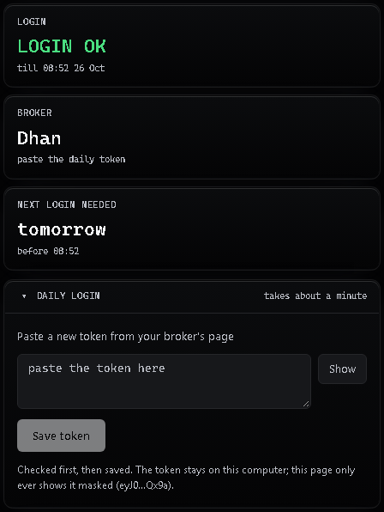  The Broker login page (Dhan, example). | - Open the dashboard (http://127.0.0.1:8760, or tray → Open dashboard).  - Click Broker login in the left menu.  - At the top are three tiles: Login (green LOGIN OK while more than an hour is left, amber LOGIN ENDS HH:MM in the last hour, amber LOG IN AGAIN once it has ended or your broker refused it, grey LOGIN - while the app cannot tell yet: it has just started, no login is saved yet, or your broker did not answer the check; under it, the exact time it lasts until, or "log in again below"), Broker (your broker and how it logs in) and Next login needed (the day and the time before which you log in again).  Below them, the Daily login box is the way in for your broker:  - A login form — only for brokers that have one: a box for the address your browser landed on after you logged in to the broker (the redirect URL, or the code in it), or boxes for today's 6-digit authenticator code and your PIN, and a Log in button. What you type there is used once for that login and never saved. Under it, Or paste a token takes a ready token instead.  - A paste box — Paste a new token from your broker's page, with a Save token button (Dhan, Shoonya, Flattrade and the Upstox Analytics token).  On a wide window a second column sits beside it: the same steps in short, your Recent logins, and a Telegram check of your chat ids.

12.2 Pasting a token, step by step
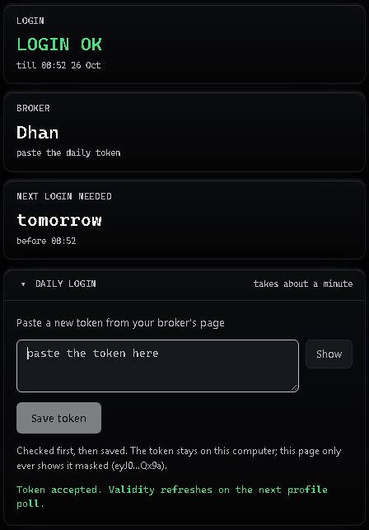  An accepted paste (example). | - Copy today's token from your broker's website (12.4 shows where, per broker).  - Click into the box under Paste a new token from your broker's page and paste it (Ctrl+V). The box hides the token; under it you see its first and last four characters and its length, so you can check you copied all of it. Show reveals it.  - Press Save token.  - Wait for the green line Token accepted. Within a few seconds the Login tile shows a green LOGIN OK with the time the new login lasts until, and Next login needed shows when you log in again.  "Checked first, then saved" — the words next to the button — is what happens in between: the app first asks your broker whether the new token works. Only when the broker accepts it does the app write it into your .env and switch the live data over to it. A token the broker refuses changes nothing: the previous login stays in place.

12.3 When a paste fails
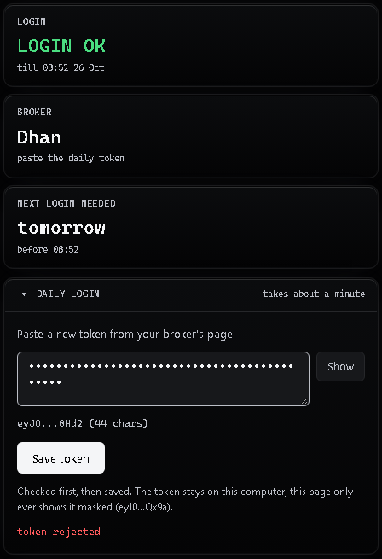  A refused paste (example). | A red line under the button, such as token rejected, means the broker refused the token. Nothing was saved and nothing else changed.  - Only part of the token was copied. Compare the length under the box with the token on the broker's page; copy it again in full.  - It is yesterday's token, or one generated for another account. Generate a new one and paste that.  - A redirect URL or code that failed was pasted too late or twice: the code in it works once and expires within minutes. Log in to the broker again and paste at once.  - An authenticator code that failed had already changed (it changes every 30 seconds), or the PIN was wrong. Type the code your app shows right now.  Still refused? Run Check Setup (chapter 14): it tests the login and says what is wrong.

A ready token can also be pasted straight into .env; it then takes effect on Stop → Start. A redirect URL or an authenticator code cannot go into .env: those work on the Broker login page only.
Tip: Logged in after 09:20? The morning watchlist may not have been built. On Windows, open the tray menu → Run 09:20 now; the list is then built and posted as usual.

12.4 Your broker, each morning

Dhan
On the Broker login page you use: the box Paste a new token from your broker's page and the Save token button.
- Before 09:00, on web.dhan.co: profile → DhanHQ Trading APIs → generate a new access token.
- Paste it on the dashboard Broker login page and press Save token — or replace the value of DHAN_ACCESS_TOKEN in .env and save the file.
Login life: 24 hours from the moment you generate it. Log in again every trading morning; the Login and Next login needed tiles on the Broker login page show until when it lasts.

Zerodha (Kite Connect)
On the Broker login page you use: the link the broker's login page, the box Redirect URL (or the code in it), and the Log in button.
- Before 09:00, open the dashboard Broker login page and click the broker's login page. (The link appears once KITE_API_KEY is in .env.)
- Log in to Zerodha in your browser as you always do — your own user ID, password and two-factor step. The app takes no part in this.
- Zerodha then sends your browser to the Redirect URL of your Zerodha app. Whatever that page shows — even a message that the page cannot be reached — copy the full address from the address bar.
- Paste it into Redirect URL (or the code in it) on the Broker login page and press Log in straight away: the code in it works only once and expires within minutes.
- The app exchanges it once, using KITE_API_SECRET from .env, checks the new login with Zerodha and writes it into KITE_ACCESS_TOKEN. Nothing you pasted is saved.
Login life: until 06:00 the next morning. Log in again every trading morning; the Login and Next login needed tiles on the Broker login page show until when it lasts.

Upstox
On the Broker login page you use: the link the broker's login page, the box Redirect URL (or the code in it), and the Log in button.
- Before 09:00, open the dashboard Broker login page and click the broker's login page. (The link appears once UPSTOX_API_KEY and UPSTOX_REDIRECT_URI are in .env.)
- Log in to Upstox in your browser as you always do — your own user ID, password and two-factor step. The app takes no part in this.
- Upstox then sends your browser to the Redirect URL of your Upstox app. Whatever that page shows — even a message that the page cannot be reached — copy the full address from the address bar.
- Paste it into Redirect URL (or the code in it) on the Broker login page and press Log in straight away: the code in it works only once and expires within minutes.
- The app exchanges it once, using UPSTOX_API_SECRET from .env, checks the new login with Upstox and writes it into UPSTOX_ACCESS_TOKEN. Nothing you pasted is saved.
Login life: daily token: until 03:30 the next morning; Analytics token: 1 year. Log in again every trading morning; the Login and Next login needed tiles on the Broker login page show until when it lasts.
The Upstox Analytics token (no daily login)
Option: Upstox also offers a read-only Analytics token that lasts 1 year and covers live data, history and the option chain. Create it on the Upstox developer page and paste it once into UPSTOX_ACCESS_TOKEN (on the Broker login page with Save token, or in .env); the daily login is then not needed. There is no separate key for it.
The caveat: NSE's rules say every API session must be logged out daily. We found no Upstox or NSE text that explains how a 1-year token fits that rule, so Upstox could change or withdraw it at any time. If the Broker login page shows it as expired or rejected, use the daily login again. It is offered as an option, not as the default.

Angel One (SmartAPI)
On the Broker login page you use: the boxes 6-digit code from your authenticator app and PIN / MPIN, and the Log in button.
- Before 09:00, open the dashboard Broker login page.
- Type the 6-digit code your authenticator app shows for Angel One, and your Angel One PIN, then press Log in.
- The app logs in once with them, checks the new token and writes it (and the live-feed token) into .env. The code and the PIN are used for that one login and are never saved.
The code changes every 30 seconds: type the one your authenticator app shows right now.
Login life: until early the next morning (sources differ: 05:00 or midnight). Log in again every trading morning; the Login and Next login needed tiles on the Broker login page show until when it lasts.

Fyers
On the Broker login page you use: the link the broker's login page, the box Redirect URL (or the code in it), and the Log in button.
- Before 09:00, open the dashboard Broker login page and click the broker's login page. (The link appears once FYERS_APP_ID and FYERS_REDIRECT_URI are in .env.)
- Log in to Fyers in your browser as you always do — your own user ID, password and two-factor step. The app takes no part in this.
- Fyers then opens its own page https://trade.fyers.in/api-login/redirect-uri/index.html, which shows your auth code. Copy either the full address from the address bar or just the auth code.
- Paste it into Redirect URL (or the code in it) on the Broker login page and press Log in straight away: the code works only once and expires within minutes.
- The app exchanges it once, using FYERS_SECRET_KEY from .env, checks the new login with Fyers and writes it into FYERS_ACCESS_TOKEN. Nothing you pasted is saved.
Login life: until 06:00 the next morning. Log in again every trading morning; the Login and Next login needed tiles on the Broker login page show until when it lasts.

Kotak Neo
On the Broker login page you use: the boxes 6-digit code from your authenticator app and PIN / MPIN, and the Log in button.
- Before 09:00, open the dashboard Broker login page.
- Type the 6-digit code your authenticator app shows for Kotak Neo, and your Kotak MPIN, then press Log in.
- The app logs in once with them, checks the new session and writes it into .env. The code and the MPIN are used for that one login and are never saved.
The code changes every 30 seconds: type the one your authenticator app shows right now.
Login life: not stated by Kotak. Log in again every trading morning; the Login and Next login needed tiles on the Broker login page show until when it lasts.

Groww
On the Broker login page you use: the box 6-digit code from your authenticator app, and the Log in button.
- Before 09:00, open the dashboard Broker login page.
- Type the 6-digit code your authenticator app shows for Groww, then press Log in.
- The app logs in once with it, checks the new token and writes it into .env. The code is used for that one login and is never saved.
The code changes every 30 seconds: type the one your authenticator app shows right now.
Login life: not stated by Groww. Log in again every trading morning; the Login and Next login needed tiles on the Broker login page show until when it lasts.

Nuvama
On the Broker login page you use: the link the broker's login page, the box Redirect URL (or the code in it), and the Log in button.
- Before 09:00, open the dashboard Broker login page and click the broker's login page. (The link appears once NUVAMA_API_KEY is in .env.)
- Log in to Nuvama in your browser as you always do — your own user ID, password and two-factor step. The app takes no part in this.
- Nuvama then sends your browser to the Redirect URL of your Nuvama app. Whatever that page shows — even a message that the page cannot be reached — copy the full address from the address bar.
- Paste it into Redirect URL (or the code in it) on the Broker login page and press Log in straight away: the code in it works only once and expires within minutes.
- The app exchanges it once, using NUVAMA_API_SECRET from .env, checks the new login with Nuvama and writes it into NUVAMA_ACCESS_TOKEN. Nothing you pasted is saved.
Login life: about 12 hours (sources differ). Log in again every trading morning; the Login and Next login needed tiles on the Broker login page show until when it lasts.

Shoonya
On the Broker login page you use: the box Paste a new token from your broker's page and the Save token button.
- Before 09:00, log in with Shoonya's own API login (Shoonya's official API tools, ShoonyaApi-py) using your Shoonya user ID, password and second factor, and the vendor code and API key Shoonya gives you with API access. It answers with today's session token (Shoonya calls it susertoken). The app takes no part in this.
- Paste the token on the dashboard Broker login page and press Save token — or replace the value of SHOONYA_ACCESS_TOKEN in .env and save the file.
- Shoonya does not say when its session token ends. When it is refused, get a new token the same way and paste it.
Login life: not stated by Shoonya. Log in again every trading morning. The app cannot read when a Shoonya token ends, so the tiles show no end time; once Shoonya refuses it, the top bar shows LOG IN AGAIN.

Flattrade
On the Broker login page you use: the box Paste a new token from your broker's page and the Save token button.
- Before 09:00, make today's token with Flattrade's own token tool (Flattrade's token generator): you log in to Flattrade in your browser yourself, and the tool turns that login into today's token. The app takes no part in this.
- Paste the token on the dashboard Broker login page and press Save token — or replace the value of FLATTRADE_ACCESS_TOKEN in .env and save the file.
- The token ends at 05:00 every morning, so you need a new one each trading day.
Login life: until 05:00 the next morning. Log in again every trading morning. The app cannot read when a Flattrade token ends, so the tiles show no end time; once Flattrade refuses it, the top bar shows LOG IN AGAIN.
Important: If the login runs out during market hours, the top bar shows an amber LOG IN AGAIN (in its last hour LOGIN ENDS HH:MM - log in again, plus one Telegram reminder) and the scanner pauses until you log in again. No signals are produced while it waits.

13. A trading day, and a tour of the dashboard
The whole day at a glance. Setup happens once; from the next morning the day repeats from the morning broker login.
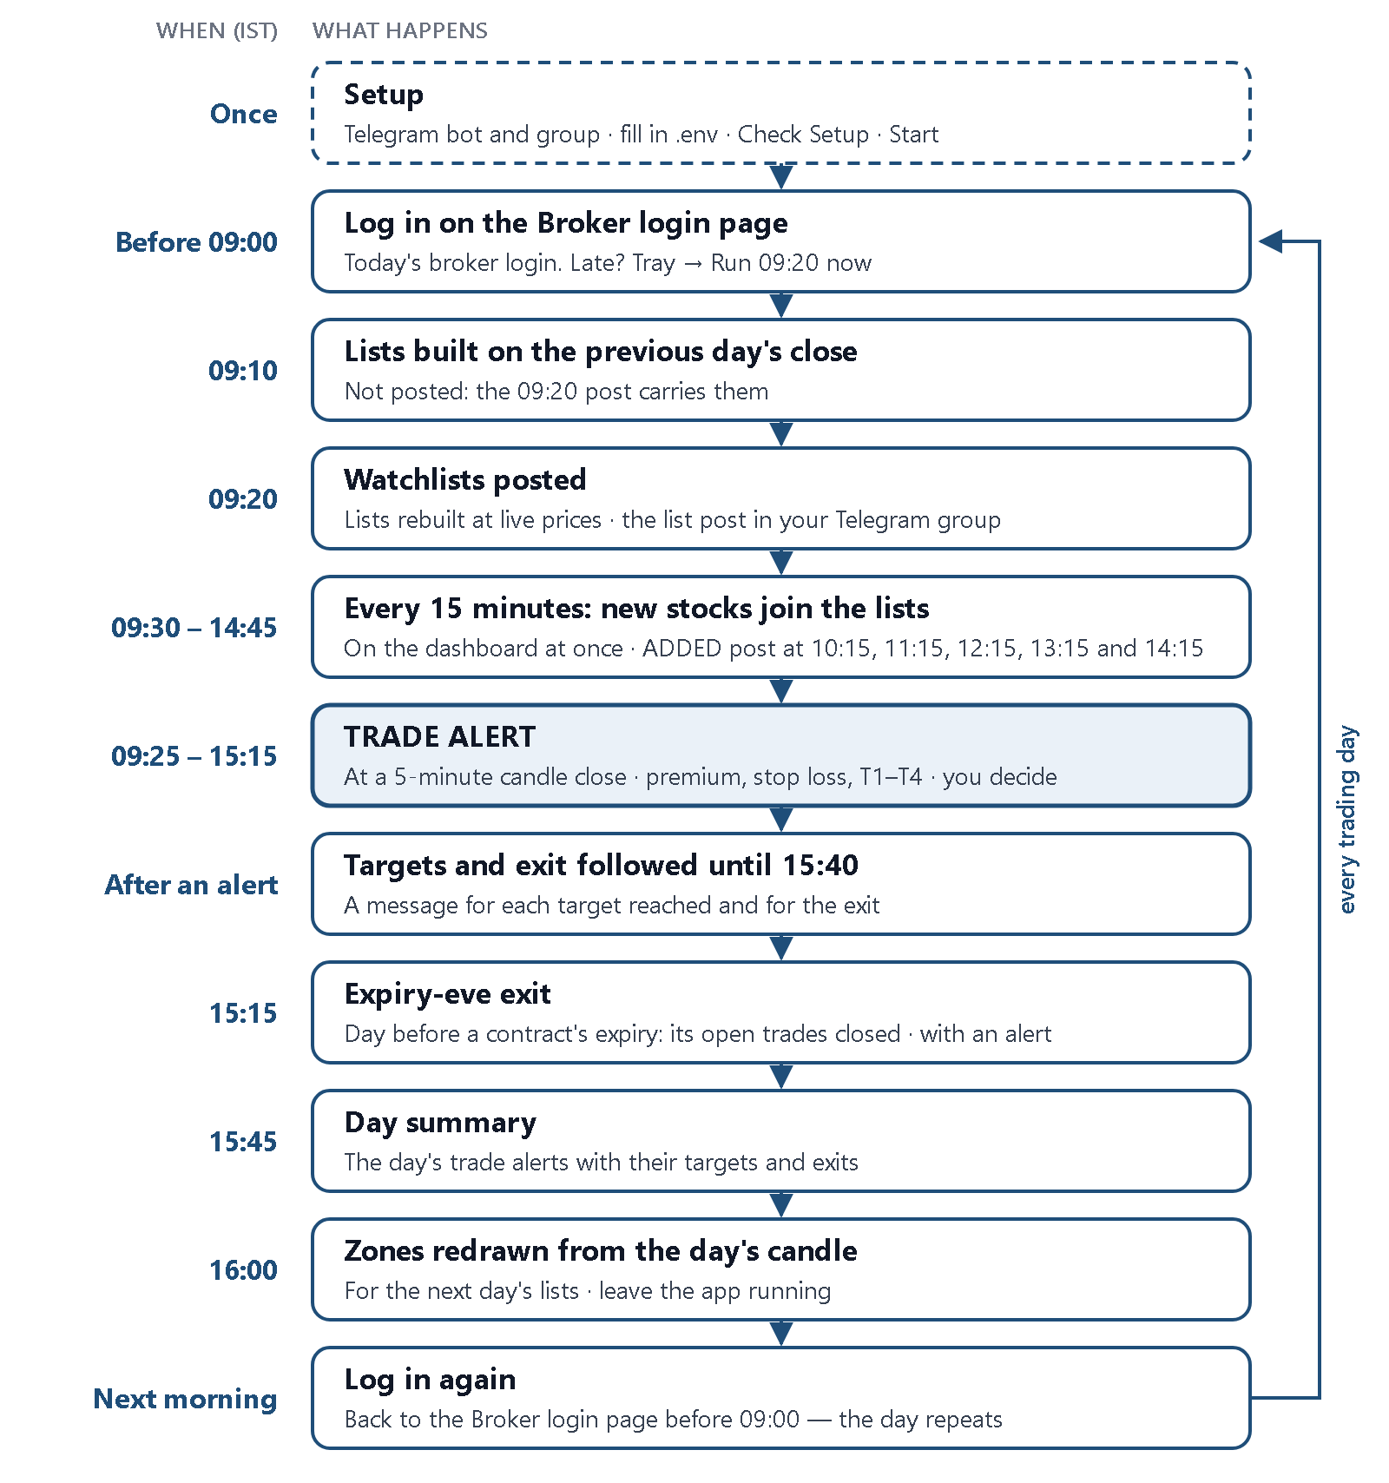
A trading day with GAMMA-UNWIND: what you do, and what arrives in your Telegram group.
The same day hour by hour:
Time (IST) | What the app does | What you do
08:55 | With Wake PC at 08:55 ticked (Windows), the PC wakes from sleep and the app starts (chapter 19). | —
Before 09:00 | — | Log in on the dashboard Broker login page (chapter 12). Make sure the app is running: the dashboard opens and the top bar shows LOGIN OK and ALERTS ON (MARKET CLOSED until 09:15, then MARKET OPEN). Logged in after 09:20? Tray → Run 09:20 now.
09:00 | The readiness check: a READY or NOT READY card (chapter 20). | NOT READY? Fix the first problem the card names.
09:10 | The lists are first built on the previous day's closing prices (not posted: the 09:20 post carries them). Only after a NOT READY: the check runs again, and an all-clear card follows once everything passes. | —
09:15 | Market opens. The app starts building 5-minute candles for every watched contract. | —
09:20 | Zones are marked and the lists are built; the list posts arrive in Telegram. | Glance at the lists: they are the contracts that can give an alert today.
09:25–15:15 | TRADE ALERTs at 5-minute candle closes (section 3.4), and the follow-ups of open trades (targets, exits), as they happen. | Read each alert and decide for yourself.
09:30–14:45 | Every 15 minutes the prices are checked again: stocks that have come near a zone join the lists on the dashboard at once (nothing is removed). At 10:15, 11:15, 12:15, 13:15 and 14:15 the stocks added since the last post are posted to Telegram (ADDED). | Glance at each ADDED post the same way as the morning list.
15:15–15:40 | No new alert after 15:15. Open trades are still followed until the F&O market closes at 15:40; a trade that is still open carries on to the next day. | —
15:15 | Only on the trading day before a contract's expiry: every trade still open on that contract is closed (the expiry-eve exit, section 4). | —
15:45 | The day summary post. | —
16:00–16:15 | Zones are redrawn from the day's candle for the next day's lists. | Leave the app running until about 16:15.
Evening | Nothing. On market holidays the app stays idle all day. | Stop the app, or leave it running.

13.1 The dashboard
Open http://127.0.0.1:8760. The top bar shows the app's version, three status chips — MARKET OPEN or MARKET CLOSED, LOGIN OK in green (in its last hour an amber LOGIN ENDS HH:MM - log in again), an amber LOG IN AGAIN, or a grey LOGIN - while the app cannot tell yet whether your login works (chapter 14), ALERTS ON or ALERTS PAUSED — the time (IST) and the Pause alerts button. Pause alerts stops the posts to your Telegram group while the app keeps scanning and records every alert on the dashboard; the same button, now Resume alerts, turns them back on.
There is no stop button on the dashboard: stop the app from the tray (Stop service or Quit, chapter 8) or, on Linux / macOS, with ./stop.sh.
The left menu lists the pages, then two switches: Light mode, and Live panel — a panel on the right of every page with your Open trades, the rows the scanner marks close to an alert, Entries today and a Health box. Switch it off for more room.
Two marks appear on many rows. Checks shows the five checks of section 3.4 as the letters A B C D S: a filled letter passed at the last 5-minute close, an outlined one did not, a dashed one has no data yet; beside them, how many passed (for example 4 of 5). Level reads ENTRY TRIGGERED (a TRADE ALERT was sent), NEAR ENTRY (the scanner marks the row close to an alert) or WATCH. Only a TRADE ALERT is sent to Telegram; NEAR ENTRY and WATCH rows are on the dashboard only.
Page | What it shows
Overview | The essentials. One health line at the top: the market (open or closed), Telegram alerts, your broker login and today's readiness check (chapter 20). It reads Everything is running, or how many things need you, each with what to do: Telegram alerts that cannot be sent, a broker login that has expired, or a readiness check that found a problem. Four tiles: Entries today (with the time of each alert), Open trades (how many are trailing and how many stops were hit today), On your lists (the contracts on each list) and Trading days to expiry. Then The day so far (the session, and when the lists next update), Closest to entry (the rows nearest an alert, with their Checks, OI off high, To zone and Level), Watchlists at a glance (the first rows of each list) and Today's trade alerts (Time, Contract, List, Price, Stop, Risk per lot and the price Now; click a row for the Entries page).
Watchlists | Today's contracts, one table per list, each headed with its expiry, the trading days left and how many contracts it holds. Above the lists: HOI-1 (the strike with the highest open interest next to the zone; the default), HOI-2 (the next one) or Both; an Entry level switch (All levels, NEAR ENTRY, WATCH or Traded); and the list buttons ALL and one per list. Your HOI pick is remembered on that device. Columns: Stock, Strike, Price, To zone, OI off high (the fall from today's OI peak; on the Carry list Build unwound, the share of the built-up OI that has gone), Checks and Level / trade. A row that has moved away from its zone is dimmed with out of band since HH:MM (it can still give an alert); a row added during the day says when and why. Click a row to open its contract.
Entries | Your targets (T1 … T4 in %, from config/v1_targets.yaml; restart to apply), your Open trades (Contract, List, Price, Stop, Next target, Status), and Today's trade alerts in time order, one card each: click one for its contract page. The list buttons show one list or all of them; Copy table and Export CSV copy or save the day's alerts.
Contract | One contract: Entry (the price, one lot and the risk per lot), Stop · whichever comes first — the stock stop (for example POWERGRID 5-min close at or above 271.35) and, once T1 is reached, the option stop as well (section 4) — Targets · option price (T1 … T4; a reached one is ticked with its %), the Price and open interest chart with the alert and the targets marked, The trade (Now, P&L, Entry, what is booked and the next target) and Why it fired (its Checks, OI off high and To zone at the alert).
Levels | The stocks near a support or resistance zone, in one table with three tabs: Near support, Near resistance and Both (a stock squeezed between both zones), each with its count; your pick is remembered on that device. Each row: the distance to the zone in % and in rupees, a bar showing where the price sits between support (S) and resistance (R), and an On a list chip naming the list that holds an option of that stock today (click it to open that contract).
Broker login | Your broker login: three tiles (Login, Broker, Next login needed), the Daily login box with the login form or the paste box (chapter 12), the steps, your recent logins and a check of your Telegram ids. Not shown on another device (chapter 18).

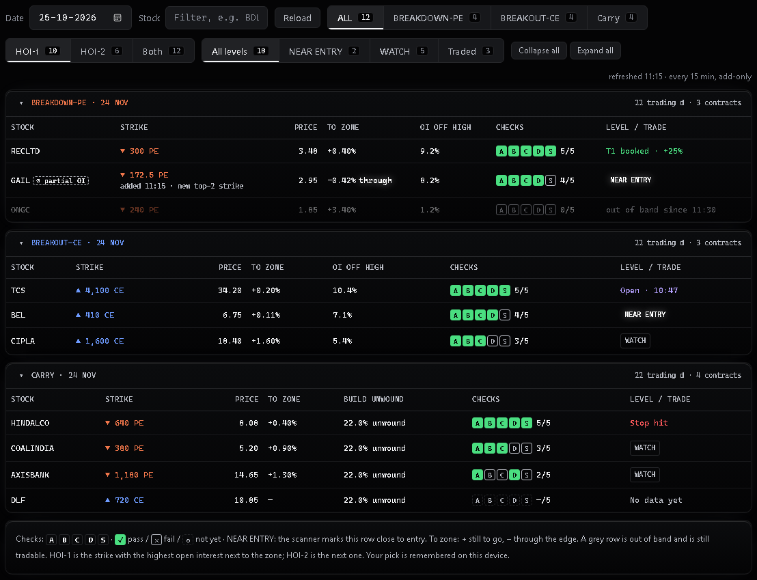
Watchlists: the HOI and Entry level switches, the list buttons, and one table per list headed with its expiry, trading days left and contract count (your dashboard, example data).
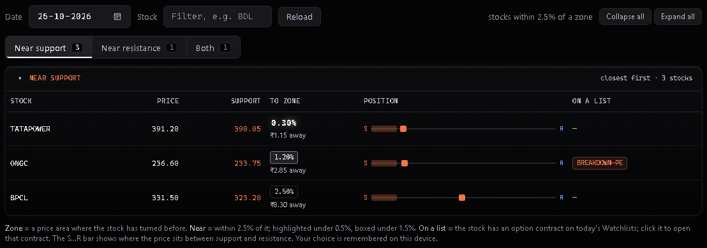
Levels: the Near support tab, with the distance to the zone in % and in rupees, the S…R bar and the On a list column (your dashboard, example data).

14. Troubleshooting
Start with Check Setup (Windows: Check Setup.cmd; Linux / macOS: ./check.sh), the dashboard's Broker login page and the logs folder (Windows: tray → Open logs folder; Linux / macOS: the logs folder). Then:
What you see | Usually means | What to do
The dashboard does not open at http://127.0.0.1:8760 | The app is not running, or is still starting. | Check the tray icon (Windows) or run ./start.sh again (Linux / macOS). Give it 20 seconds.
The app stops at once; Check Setup says the port is busy | Another program — often a second copy of GAMMA — is using port 8760. | Quit the other copy (tray → Quit, or Stop GAMMA.cmd / ./stop.sh) and start again.
An amber LOG IN AGAIN at the top of the dashboard (in market hours also an amber Action needed: log in again on the Broker login page line on the Overview; outside market hours the Overview line reads broker: log in again in red) | Your broker login expired or was rejected. Signals pause until you log in again. | Do the daily login routine (section 12).
A grey LOGIN - at the top of the dashboard | The app cannot tell yet whether your broker login works: it has just started and not checked yet, no login is saved yet, or your broker did not answer the check (a network or broker problem). It is not a refused login. | It changes by itself at the app's next login check once your broker answers, or within seconds when you log in on the Broker login page (section 12). If it stays grey, run Check Setup: it tests the login and says what is wrong.
The Broker login page refuses the pasted redirect URL | Only part of the address was copied, or it was pasted too late (the code in it expires within minutes and works once). | Log in to the broker again, copy the whole address and paste it at once.
The Broker login page refuses the authenticator code | The code had already changed (it changes every 30 seconds), or the PIN was wrong. | Type the code your app shows right now, with the correct PIN.
Check Setup prints scanner DEGRADED: … polled every … s | Your broker gives OI and volume by polling instead of a live feed (Groww and Nuvama; chapter 11), so an alert can come up to that many seconds late. | Nothing to fix: the scanner runs. It is how this broker works.
Check Setup prints … has no usable history candles: no warm-up, signals from the 20th live bar (~10:55); no alert comes before about 10:55 | Your broker's history candles give no volume the app can rely on (Shoonya and Flattrade; chapter 11), so the volume average of section 3.4 fills from today's live 5-minute candles first. | Nothing to fix: the scanner runs from about 10:55 every day. It is how this broker works.
Check Setup prints … feed carries no trade time: ticks stamped at receive time | Your broker's live feed sends no time of trade (Shoonya and Flattrade), so the app times each price when it arrives. | Nothing to fix.
Check Setup prints WARN scanner: … volume could not be read reliably today (not a whole number of lots): volume checks are off, so no new alerts until tomorrow | Your broker sent a volume that is not a whole number of lots (Shoonya and Flattrade), so the app stopped trusting its volume for today. | Nothing to fix: alerts return the next trading day. If it repeats, send us Check Setup's output.
No Telegram messages; the dashboard shows chat not found or a Telegram error | Wrong group id, the bot is not in the group, or the bot token is wrong. | Redo sections 7.1–7.3. The group id is negative; keep its minus sign.
A group id problem banner at start | The group id is empty, positive or not a number. | Put the negative group id from section 7.3 in TELEGRAM_GROUP_ID.
No watchlist post at 09:20 | The broker login had expired before 09:20, or it is a market holiday. | Log in on the Broker login page, then tray → Run 09:20 now (Windows). You can also check the Levels page.
A NOT READY card at 09:00 | One of the seven readiness checks failed; the card names the first one under FIX FIRST. | Fix that one (chapter 20). At 09:10 the app checks again and sends an all-clear once everything passes.
Check Setup warns that the group is a forum and TELEGRAM_TOPIC_ID is blank | Your group uses Topics; the alerts land in its General topic. | Nothing breaks. To send them to one topic, set TELEGRAM_TOPIC_ID (chapter 21).
The PC was asleep at 09:00; no alerts that morning | Windows put the PC to sleep overnight. | Tick Wake PC at 08:55 in the tray menu (chapter 19).
The update ended with a code other than 0 or 1 | See the code table in chapter 17. | Codes 2, 3, 4 and 6 changed nothing that stays: run it again later. Code 5: download the full ZIP.
The iPad or phone shows the login page and the password is refused | A typing mistake, or GAMMA_LAN_PASSWORD was changed (that logs every device out). | Type the password from .env again. After 5 wrong tries in a minute, wait a minute (chapter 18).
TRADE ALERTs on the dashboard but not in Telegram | Alerts are paused, or Telegram refused the message. | Untick Pause alerts in the tray (or press the pause button again); check the Telegram rows above.
No alerts at all on a quiet day | Nothing met the rules. This is normal. | Check that the top bar shows MARKET OPEN and LOGIN OK.
Rows marked NEAR ENTRY on the dashboard, but no alert | The scanner marks a row close to an alert; an alert comes only when all five checks of section 3.4 hold on one candle. This is normal. | Nothing to fix.
No alert for several days on a BETA broker, although the feed is live | The broker may report volume in a different unit, so the volume checks (section 3.4) never pass. | Tell us, with the Check Setup output; it is a BETA wiring issue.
Nuvama: every login or data call is refused | The app is not running on the internet connection with the static IP you registered with Nuvama, or that IP is not in .env. | Run the app on that connection and check NUVAMA_STATIC_IP (section 11).
Windows saved the file as .env.txt | File name extensions were hidden. | Turn on View → File name extensions and rename it to .env.
Linux: setup.sh says Python 3.13 is required | Python 3.13 is not installed (3.14 is not supported yet). | Install Python 3.13 (section 9.1) and run ./setup.sh again; a .venv folder made by another version is replaced by itself.
macOS: setup.sh stops with a message | The macOS version is older than 12, the ZIP is for the other chip, or macOS blocked the bundled Python. | Do what the message says (it names the ZIP for your chip); for a blocked Python see section 10.3. Still stuck: send the whole output of ./mac_check.sh (section 10.4).

When you ask for help, send the Check Setup output and the files from the logs folder. The app is designed never to write your tokens or secrets into its logs — still, glance through them before you share. Never send your .env file to anyone.

14.1 If GAMMA does not start
You double-clicked Start GAMMA and no tray icon appeared, or a box said "GAMMA could not start". The app wrote down what happened; Check Setup reads it and tells you what to do.
- Double-click Check Setup.cmd (Linux / macOS: run ./check.sh). It checks the folder GAMMA runs from, its program files, your .env, the port, your Telegram ids and your broker login.
- If it offers to fix something for you (for example create .env, or delete left-over stop files), it lists the fixes and asks once. Type Y and press Enter to let it; anything else changes nothing. It only touches files inside the GAMMA folder.
- Read the summary it prints, then open the report it names: logs\setup-report-<date>-<time>.txt. The part What you need to do lists numbered steps for each problem.
- Do those steps and run Check Setup again, until the summary shows no problem.
- If a problem remains, send us that report file (the .txt). Check Setup hides your tokens and passwords in it. Do not send your .env file.
Tip: Common first-start causes: GAMMA was started from inside the ZIP or a temporary folder (extract the ZIP to C:\GAMMA first), your antivirus removed a program file, Windows marked the files as downloaded (right-click the ZIP → Properties → Unblock before extracting), or the folder sits somewhere Windows does not let the app write, such as Program Files. If extracting the ZIP stopped with WinError 206 or "The filename or extension is too long", the folder path was too long: extract to a short folder such as C:\GAMMA.

15. Your targets: where to change them
The four targets of section 4 are the one part of the rules you can set yourself. They are in one small file in the app's folder: config/v1_targets.yaml. Your dashboard and the alerts in your group use the numbers in it.
Setting | Shipped value | What it is
t1_pct | 25 | Target 1: the premium + this many % (25 = +25%).
t2_pct | 50 | Target 2: the premium + this many %.
t3_pct | 75 | Target 3: the premium + this many %.
t4_pct | 100 | Target 4: the premium + this many %.

Before you change anything: A change makes your alerts differ from everyone else's.
The four numbers must each be above zero and in order: T1 below T2, T2 below T3, T3 below T4. A missing or wrong number stops the app at start, with a message that says what is wrong.
Change only the number after the colon. Keep the rest of the line exactly as it is.
An update replaces this file with the standard targets. Your old copy is kept in data/update/backup-<old version>/config/; set your numbers again in the new file afterwards (chapter 17).

15.1 How to make a change, and how to undo it
- Make a copy of config/v1_targets.yaml and name it v1_targets.yaml.original.
- Open config/v1_targets.yaml with Notepad (Windows), TextEdit in plain-text mode (macOS) or nano (Linux).
- Change the numbers you want. Save the file.
- Stop → Start the app (Windows: tray → Stop service, then Start service; Linux / macOS: ./stop.sh, then ./start.sh). The change takes effect only after this.
- If the app does not start, the file has a typo or the numbers are out of order — the reason is in the logs (Windows: tray → Open logs folder; Linux / macOS: the logs folder). Undo the change as below.
To undo:
- Copy v1_targets.yaml.original back over config/v1_targets.yaml (or take the file from the original ZIP).
- Stop → Start the app, as in step 4 above.

16. Privacy and security
- Your .env holds secrets: your Telegram bot token and your broker keys and tokens (and, if you use it, GAMMA_LAN_PASSWORD). With some of them, a person could read your account. Never share the file, never post a screenshot of it, and delete it when you remove the app.
- The dashboard is only on your computer unless you switch on the home-network option. It listens on 127.0.0.1 — other devices, even on your home Wi-Fi, cannot open it. With GAMMA_LAN=1 and a password (chapter 18) it also listens on this PC's home-network address, behind a login.
- Nothing leaves your computer except to your broker (for market data and your login), to Telegram (your alerts) and to NSE (two small daily downloads of public NSE files: the F&O ban list and the results calendar) — plus, only when you run the updater, a download of the newest version from our releases site (chapter 17). There is no account with us, no tracking and no cloud copy.
- The app cannot trade. It has no order function for any broker; your broker login is used to read market data only.
- Market data and the day's history are stored in the data folder, logs in the logs folder, both inside the app's folder.

17. Updating
A new version installs itself into the same folder, with one launcher. Run it outside market hours (after 16:15, or before 08:45): the app stops for about a minute while the files are swapped.
System | Run
Windows | Double-click Update GAMMA.cmd in the GAMMA folder.
Linux / macOS | In a terminal in the GAMMA folder: ./update.sh

Important: On a Mac, coming from 0.8.1 or earlier: do not use ./update.sh in the old folder — move to the new macOS ZIP once, as in section 10.5.
- The updater shows your version and the newest one, then asks:
- Type y and press Enter to go ahead. Anything else (or just Enter) changes nothing.
Updating stops GAMMA-UNWIND for about a minute (no alerts meanwhile). Update now? [y/N]
- It downloads the new version and checks it against its published checksum, then checks every file in it. Nothing in your folder has changed yet.
- It stops GAMMA-UNWIND, swaps the program files one by one, starts it again and waits until the new version answers. It then prints the line GAMMA-UNWIND updated <old version> -> <new version>; /api/status reports version <new version>.
- Read the last lines: they say where your previous version is kept, and what happened to config/strategy.yaml (below).

17.1 What an update keeps
- Never touched: your .env, the data folder (history, today's login, the home-network login key, the first-start marker) and the logs folder. Windows: the bundled python folder stays too.
- The previous version is kept in data/update/backup-<old version>/.
- `config/strategy.yaml` is replaced by the new version's copy. Your previous copy is kept next to it as config/strategy.yaml.bak-<old version>. If you had changed a setting in it, the updater prints: "Your edits are in config/strategy.yaml.bak-<old version>: re-apply the settings you changed". Make the same change in the new file, then Stop → Start.
- `config/v1_targets.yaml` is replaced by the standard targets. Your previous copy is kept with the rest of the old version in data/update/backup-<old version>/config/v1_targets.yaml. If you had changed your targets (chapter 15), set them again in the new file (or copy your numbers from that backup), then Stop → Start.

17.2 How it ends: the exit codes
The updater ends with a number (Windows prints it; Linux / macOS: echo $? right after). What each one means:
Code | Meaning | What you do
0 | Updated: the new version is running and /api/status reports it | nothing
1 | Nothing to do: already current, the question answered no, or a source checkout ("run git pull") | nothing
2 | The download did not verify (sha256 / size of the ZIP, or a file against its MANIFEST); nothing changed | run it again later; if it repeats, report it
3 | No network, the releases site did not answer, or this copy has no releases address; nothing changed | check the internet connection, run it again
4 | GAMMA-UNWIND did not stop: the port is still in use; nothing changed | tray > Quit (or Stop GAMMA), then run it again
5 | The new version needs a different bundled Python (Windows) or library list (Linux/macOS) | download the full ZIP and follow the Updating chapter
6 | The update failed after the swap began; the previous version was restored and started again | run it again later; if it repeats, report it with logs/

17.3 The full-ZIP way (code 5)
- Download the new ZIP and extract it to a new short folder (for example C:\GAMMA-new), as in chapter 8.
- Stop the old one (tray → Quit, or Stop GAMMA.cmd; Linux / macOS: ./stop.sh).
- Copy your .env and the whole data folder from the old folder into the new one.
- If you changed config/strategy.yaml or your targets in config/v1_targets.yaml (chapter 15), make those changes again in the new folder.
- Start the new one. When it runs, delete the old folder.

18. Dashboard on another device
By default the dashboard opens only on the PC that runs GAMMA-UNWIND. On a phone, use the Telegram cards: they carry everything that matters during the day. For an iPad or a laptop at home, you can switch on the home-network option: the dashboard then also opens over your home Wi-Fi, behind a password.

18.1 Switching it on
- Open .env and add these two lines at the end (they are not in .env.example: you add them by hand). Choose a password of at least 12 characters that you use nowhere else:
GAMMA_LAN=1
GAMMA_LAN_PASSWORD=a-long-password-you-use-nowhere-else
- Save .env, then Stop → Start the app (tray → Stop service, then Start service).
- Windows asks whether Python may accept connections: allow Private networks only, never Public.
- Find this PC's home-network address: tray → Open logs folder, open gammad.log and look for the line dashboard on http://192.168.x.x:8760 (the numbers are your PC's).
- On the iPad or laptop, open that address, for example http://192.168.1.20:8760, in the browser. A login page asks for the password: type your GAMMA_LAN_PASSWORD and press Log in. The device stays logged in for 30 days.
- GAMMA_LAN=1 without a password does nothing: the dashboard stays on this PC only, and Check Setup reports it as a problem to fix.
- Check Setup warns when GAMMA_LAN_PASSWORD is shorter than 12 characters.
- After 5 wrong passwords within a minute the login page refuses for a minute.
- Changing GAMMA_LAN_PASSWORD logs every device out.
- To switch it off: set GAMMA_LAN=0 (or delete the two lines), then Stop → Start.

18.2 What another device can and cannot do
A logged-in device sees everything the dashboard shows and can use its buttons (send a card to Telegram, pause alerts, run a list build). It cannot open the Broker login page or log in to your broker: that page stays hidden on another device, so the daily broker login is always done at the PC itself. No device can stop the app from the dashboard; the tray (or ./stop.sh) does that.
Important: The home network is not encrypted. The dashboard traffic between the other device and the PC is plain HTTP on your home Wi-Fi: the password and the login travel unencrypted, and anyone who can watch that Wi-Fi could read them. Use it only on a home network you trust — never on office, hotel or public Wi-Fi. Everyone on the same network can reach the login page; the password is the only thing between them and your dashboard.

18.3 Your own web address: not supported
Not supported: Putting the dashboard on your own web address is not supported. Some users publish the dashboard through a tunnel or proxy (Cloudflare Tunnel, ngrok, Tailscale, nginx and the like) to open it from anywhere. GAMMA-UNWIND does not support or help with this. Such a tool runs on your PC and can make outside visitors look like the PC itself. If you do it anyway, you must set GAMMA_LAN_PASSWORD in .env. Without it, GAMMA-UNWIND refuses every visitor that comes through a proxy. With it, every visitor must log in, and the Token page, the broker login and the Stop button stay hidden. A proxy that hides that it is a proxy cannot be detected: then the dashboard, and the Token page where your broker login is pasted, are open to anyone who finds the address. Use a long password that you use nowhere else. Never share the address. Check Setup lists every web address the dashboard was reached through. For a phone, use the Telegram cards; for an iPad at home, use the home-network option (GAMMA_LAN=1) instead.
When a visitor comes through such a tool while no GAMMA_LAN_PASSWORD is set, the dashboard shows only a page saying remote access needs GAMMA_LAN_PASSWORD, and nothing else.
If you put a reverse proxy in front of it anyway: A reverse proxy in front of the app (for example nginx, Caddy or IIS) must send the X-Forwarded-For header with the visitor's address. Without it the app cannot tell that the visitor comes from outside: it treats every visitor as this PC, and asks for no password.

19. Keep the PC awake, and Wake PC at 08:55
A sleeping computer sends no alerts. Two things help, both on Windows:

19.1 Kept awake during the market day
While the app runs, on a trading day, from 08:50 to 15:50 IST, it keeps Windows from going to sleep. There is nothing to switch on; the tray icon's tooltip then says awake until 15:50. Outside that window, and on holidays and weekends, your normal power settings apply. The screen may still switch off; that is fine.

19.2 Wake PC at 08:55
If your PC sleeps overnight, tick Wake PC at 08:55 in the tray menu. It creates one Windows task for your user, named GAMMA-UNWIND-WAKE (no administrator rights needed), that on Monday to Friday at 08:55 IST:
- wakes the PC from sleep, and
- starts GAMMA-UNWIND (if it is already running, nothing changes). The keep-awake window of 19.1 then holds the PC awake from 08:50.
- It cannot switch on a PC that is shut down. Put the PC to sleep at night instead of shutting it down.
- On an NSE holiday that falls on a weekday it wakes the PC too; that is harmless: the keep-awake window is not held, and the PC goes back to sleep.
- To stop it, untick Wake PC at 08:55: that removes the task. Nothing else in Windows is changed.
Tip: The PC does not wake? Windows may have wake timers switched off: Control Panel → Power Options → Change plan settings → Change advanced power settings → Sleep → Allow wake timers → Enable (on a laptop, for "Plugged in"). Keep a laptop plugged in.
Linux and macOS have no tray menu: use the power settings of chapters 9 and 10.

20. The 09:00 readiness card
At 09:00 on every trading day the app checks that it is ready for the market and sends you one card: READY or NOT READY. It goes to your personal chat (section 7.4), or to the group when you have not set a personal chat id.
Check (as the card names it) | Passes when
Broker token | Your broker login is valid until at least 15:40 IST today.
Settings (.env) | Your .env can be read without an error.
Telegram | Your bot answers and your group is reachable. A forum group with no topic set passes with a warning (chapter 21).
Broker connection | Your broker accepts the current login.
Disk space | At least 500 MB free on the drive of the data folder.
PC clock | The PC's clock is within 60 seconds of Telegram's.
Data folder | The app can write into its data folder.

- READY arrives silently: every check passed.
- NOT READY arrives with sound. Its first line names the first problem; FIX FIRST says what is wrong; CHECKS lists all seven.
- 09:10: only after a NOT READY, the app checks again. Once everything passes it sends a silent READY · all clear card. If something still fails, no second card comes: the Readiness tile on the dashboard's Overview page shows the current result.

20.1 The first-start card and the start line
- The very first time your install starts, your group gets one card, with sound: GAMMA-UNWIND <version> connected, with what will be posted there. It is sent once per install (an update keeps it that way).
- Every later start sends one silent line to your personal chat: GAMMA-UNWIND <version> started, with the time. Without a personal chat id nothing is sent, and a quick run of restarts sends at most one line every 10 minutes.

21. TELEGRAM_TOPIC_ID for forum groups
A standard group (chapter 7) needs nothing here. If your group has Topics turned on (Telegram calls it a forum), every alert lands in its General topic, unless you name another topic with TELEGRAM_TOPIC_ID in .env. Blank means General.
Check Setup, and the 09:00 readiness card, warn you when the group is a forum and the key is blank:
the group is a forum (topics) and TELEGRAM_TOPIC_ID is blank: cards land in General; set the topic id in .env

21.1 Finding the topic id
- In the topic you want the alerts in, send a message, for example /start@your_bot_username.
- Open the getUpdates page of section 7.3 in your browser and refresh it.
- Find your message. Next to it is "message_thread_id":8 — that number (here 8) is the topic id. (Another way: in Telegram, right-click or long-press a message in the topic → Copy Message Link; in a link like https://t.me/c/1234567890/8/15 the middle number, 8, is the topic id.)
- Add the line to .env and save it:
TELEGRAM_TOPIC_ID=8
- Stop → Start the app. Check Setup no longer warns.
The key is not in .env.example: you add it by hand. A value that is not a number is ignored (the alerts go to General, and the log says why).

22. Glossary
Word | Meaning
1-hour zone | A zone found on 1-hour candles. Its near edge is the stock stop of a trade (section 4.1).
ATR | Average True Range: how much a price usually moves in one candle.
Authenticator code | The 6-digit code an authenticator app on your phone shows for your broker account; it changes every 30 seconds.
Candle | The open, high, low and close of the price over a fixed time, here 5 minutes.
Carry list | Contracts from your other lists kept on in the following days (section 3.2). Its alerts are tagged CARRY STRIKE.
CE / PE | Call option / put option. A call usually gains when the stock rises; a put usually gains when the stock falls.
DTE | Days to expiry: trading days left until the contract expires.
Expiry | The last day an option contract trades.
Expiry-eve exit | Every trade still open is closed at 15:15 on the trading day before its contract's expiry.
HOI-1, HOI-2 | The strikes with the highest and the second-highest OI in the zone band: the two strikes each stock carries on your lists.
Lot | The fixed number of shares one option contract covers.
NR7 | A candle whose high-to-low range is the narrowest of 7 in a row: a sign of a quiet market before a move.
OI (open interest) | The number of option contracts still open.
OI unwinding | OI falling from its peak as traders close their positions.
OTM | Out of the money: a put strike below the stock price, or a call strike above it.
Premium | The price of the option. On an alert: the option's close of the alert candle.
Readiness check | The seven checks at 09:00 that end in a READY or NOT READY card (chapter 20).
Redirect URL | The address your broker sends your browser to after you log in. It carries a one-time code the app turns into your daily login.
RESULTS TODAY | A tag on an alert: the stock reports its results today.
Risk per lot | What one lot would lose if the stop loss is hit; est. marks an estimate from the option's implied volatility.
SL | Stop loss: the level at which the trade is considered failed (section 4).
Strike | The price at which an option is set.
T1 … T4 | The four targets: the premium +25%, +50%, +75%, +100%, from config/v1_targets.yaml (chapter 15).
Tick | The smallest step an option price can move: ₹0.05, or ₹0.01 for options on stocks trading below ₹250.
Token | Your broker's daily login key that lets the app read market data.
Topic | A sub-chat inside a Telegram forum group; TELEGRAM_TOPIC_ID picks the one the alerts go to (chapter 21).
TRADE ALERT | The alert that every check of section 3.4 holds on one 5-minute candle, with the premium, the stop loss and the targets.
Traded value | How much money changed hands in a contract in one session: the quantity traded × the price.
Trailing stop | A stop that follows the price up and never moves down: the stop of the last part after T3 (section 4.2).
VWAP | The day's volume-weighted average price of the stock.
Zone | A price band where the stock turned before: support below the price, resistance above.

Important: GAMMA-UNWIND is a scanner that sends alerts. It gives information, not advice, and places no orders. You decide and place your own trades.

