**INTRODUCTION:**

***Overview:***

I am Sunitha D. I am the leader of Naan Mudhalvan project. My project is “Unearthing the

Environmental Impact of Human Activity: A Global Co2 Emission Analysis”. Here are my team

Members: Krishnapriya S, Roshini S, Shabitha Banu I, Shehanaz F. We explained about Co2

Emission over by continents, countries, years, per capita and also over time. We give

Complete information about the project in Dashboard (dashboard 1,2and3). This project

Explained about how unearthing the environmental impact of human activity, due to global

Co2 emissions. In our project, we included some details about Continents wise Contribution

By Internal factors, Overall contribution by India in Co2 emission, etc…,

***Purpose:***

The purpose is to provide information on the biggest cause of Co2 Emission and what releases Co2

Emission and how does Co2 affect human health, and this project is used to understand and easily

About the co2 emission.

**PROBLEM DEFINITION AND DESIGN THINKING:**

***EMPATHY MAP:***

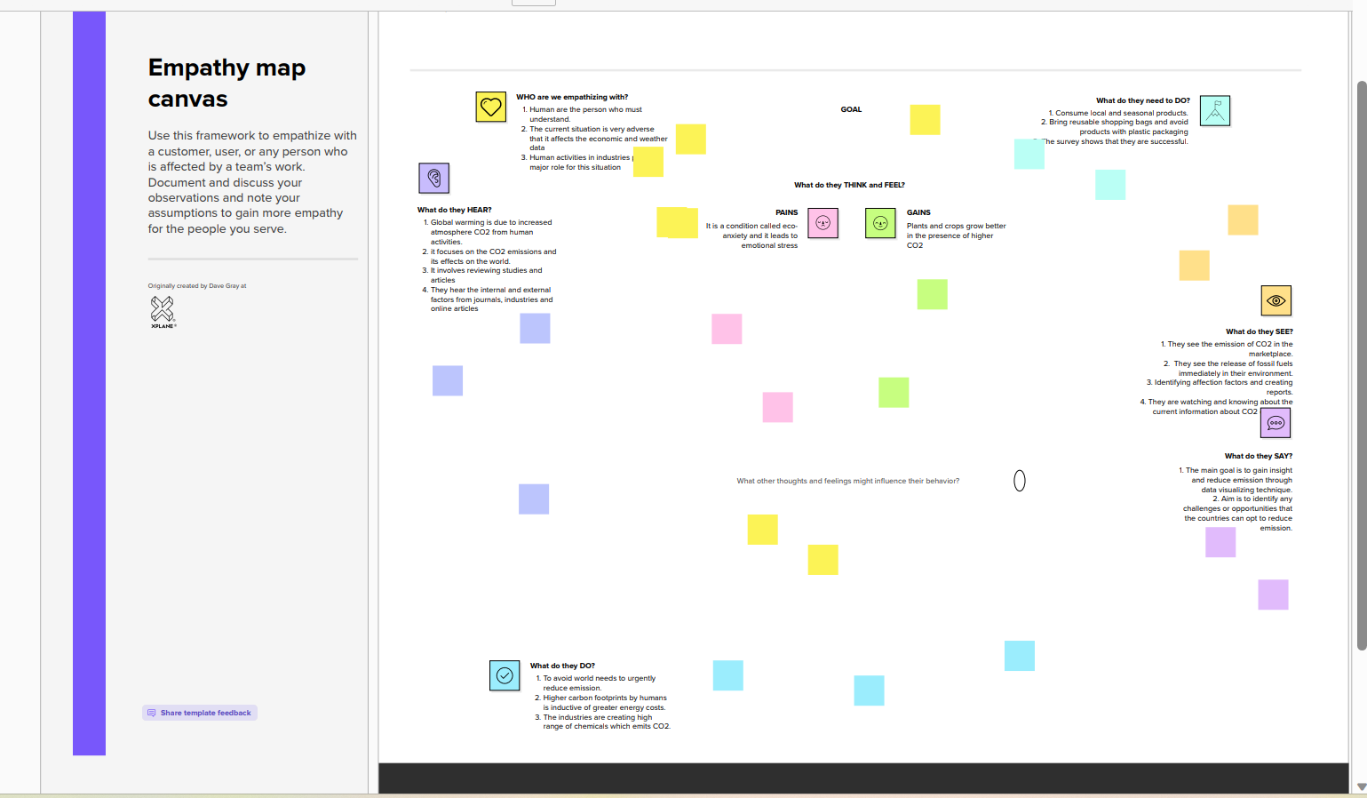

IDEATION AND BRAINSTORM:

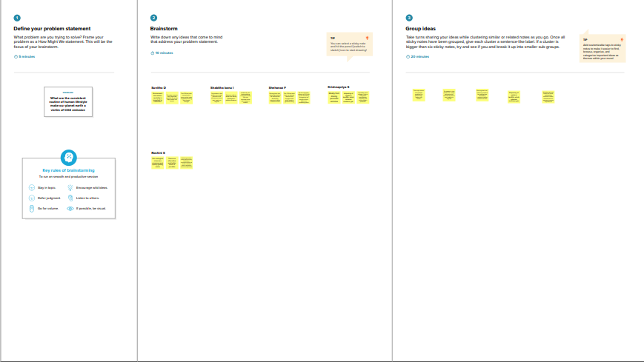

**RESULT:**

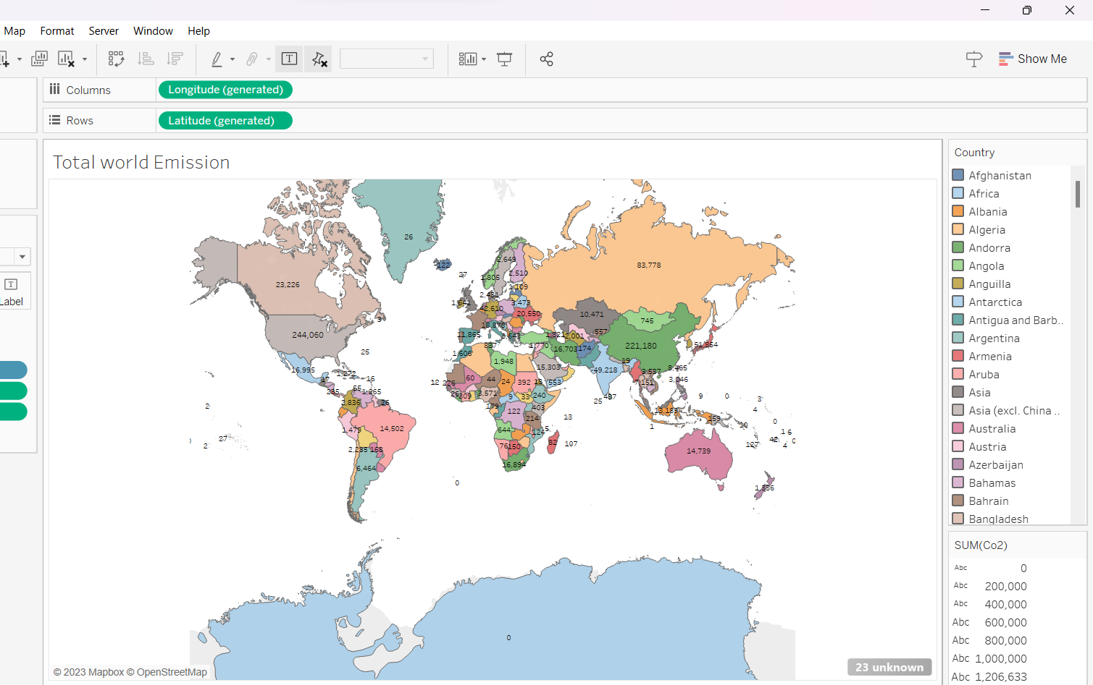

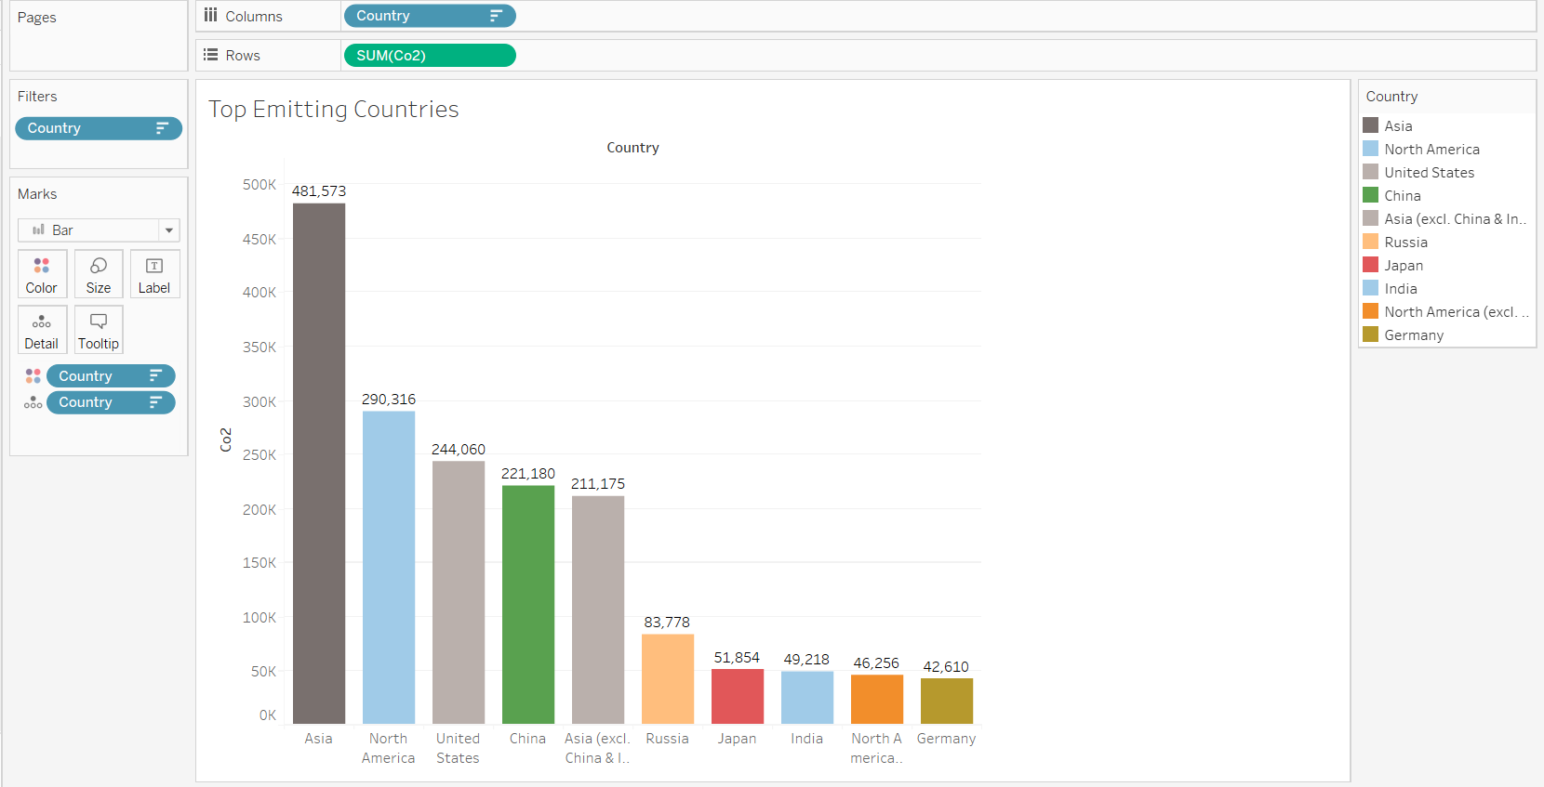

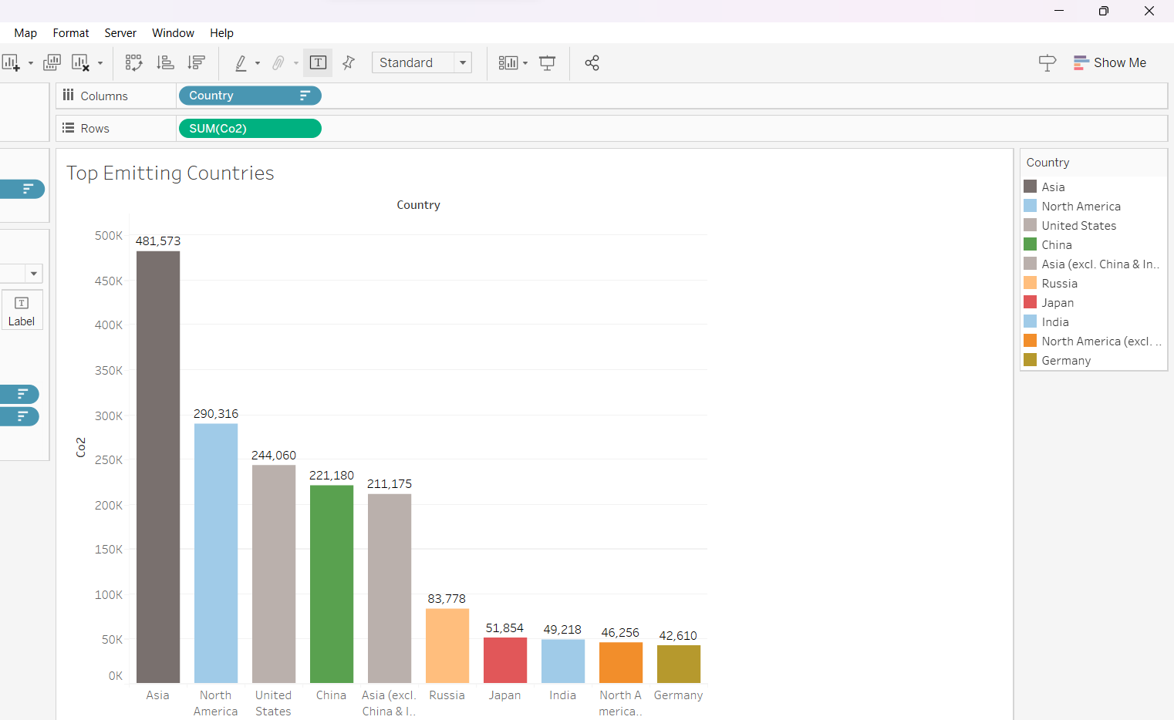

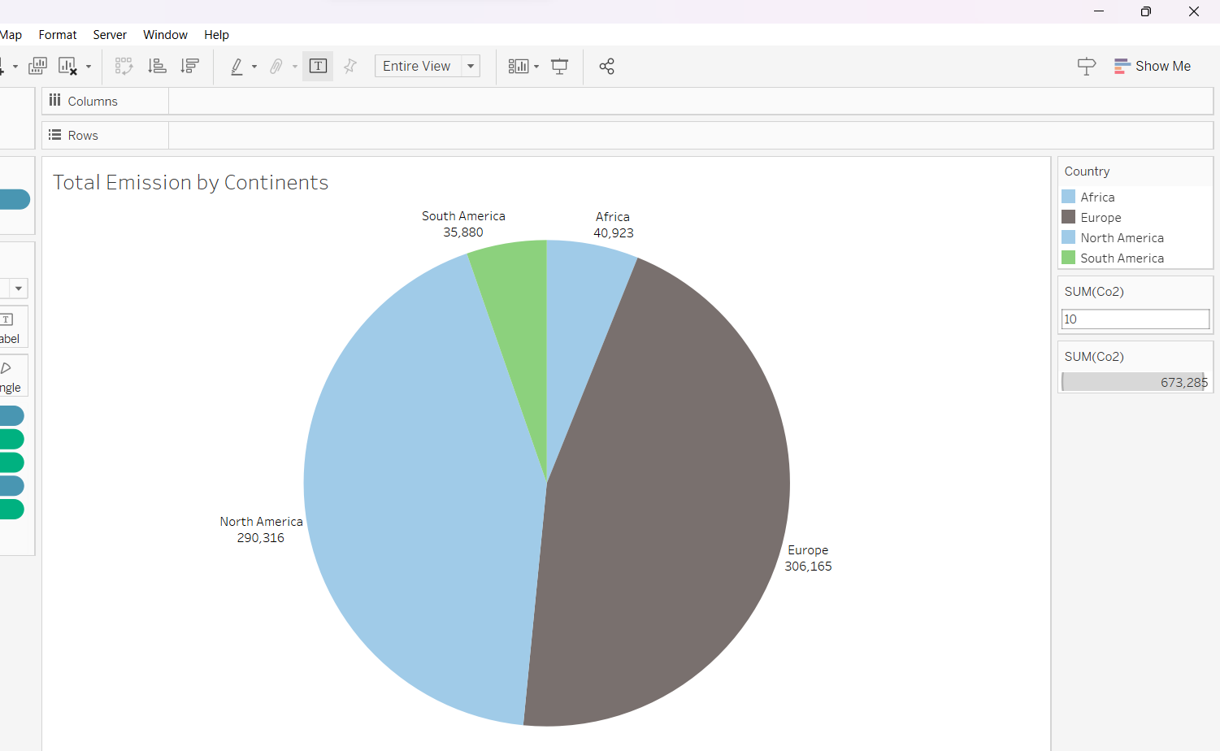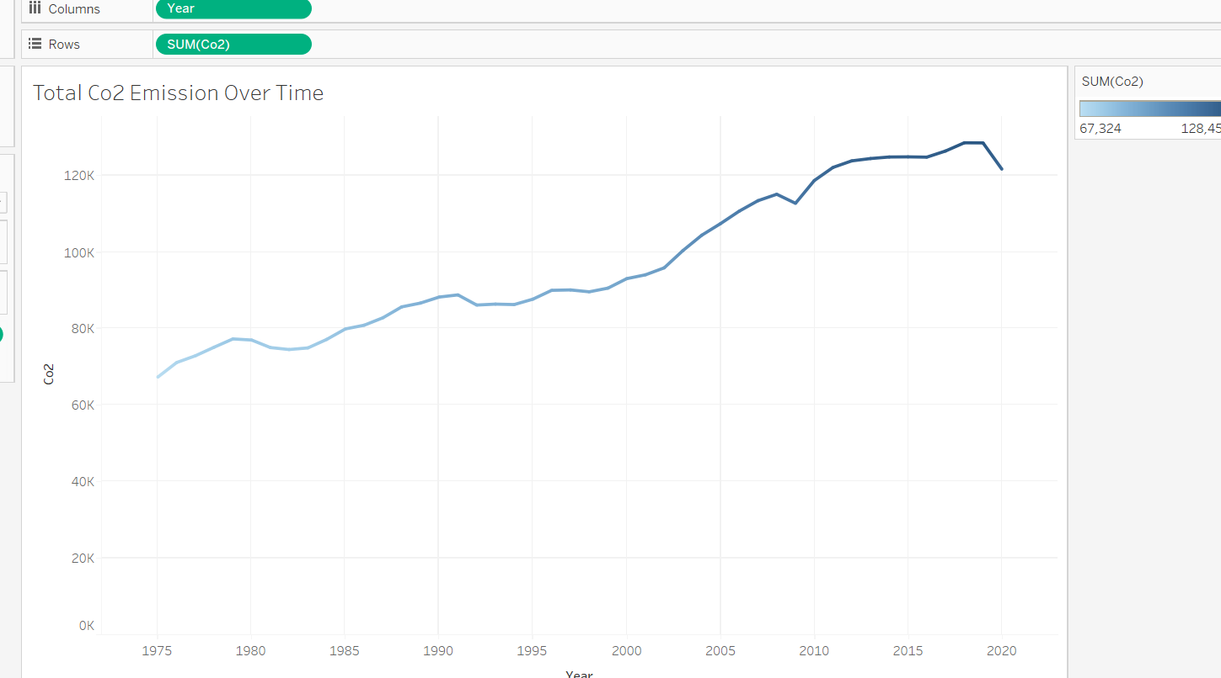

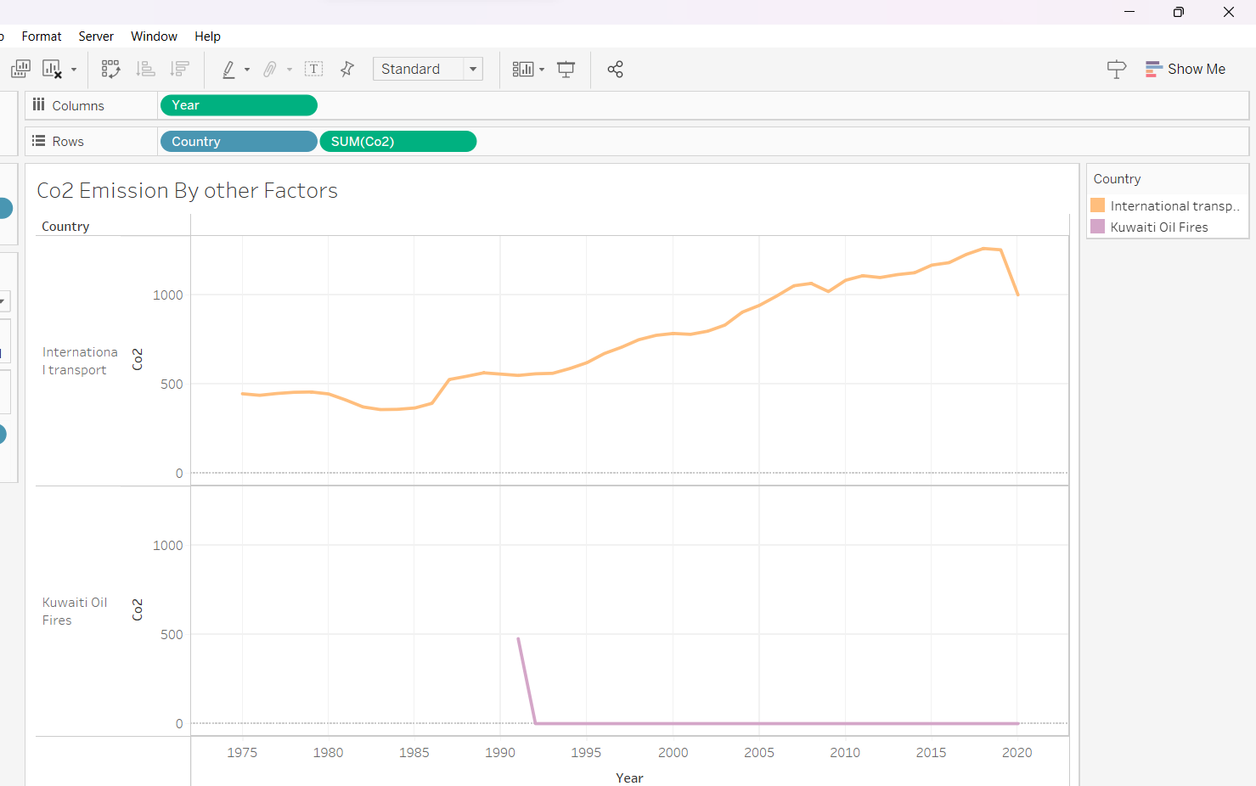

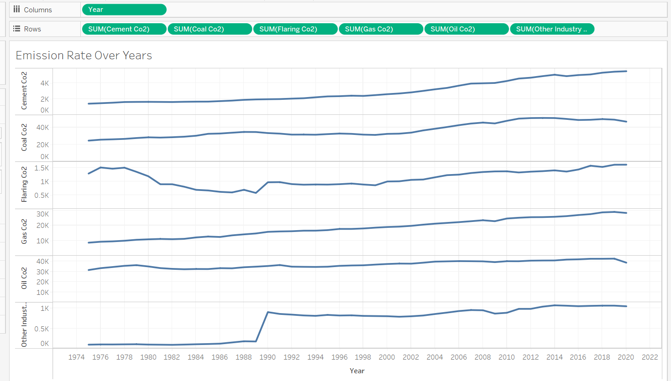

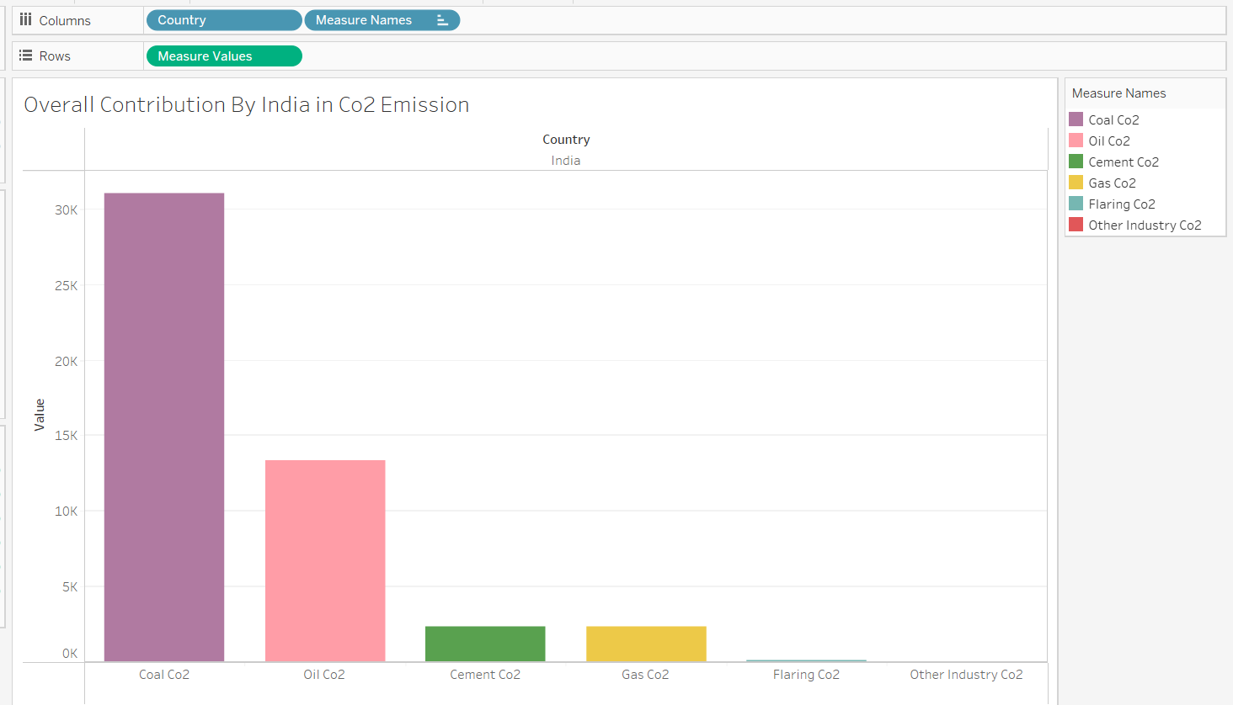

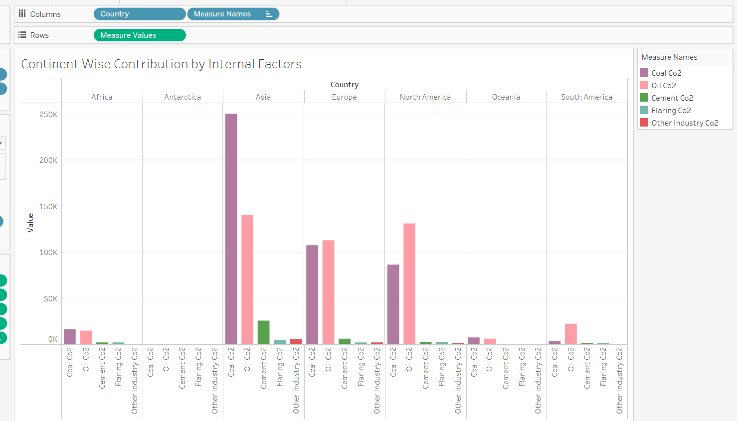

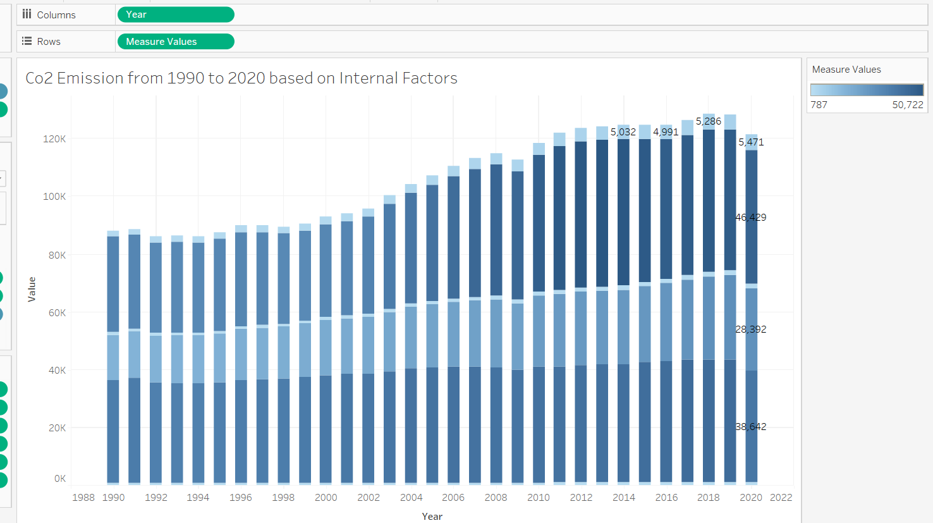

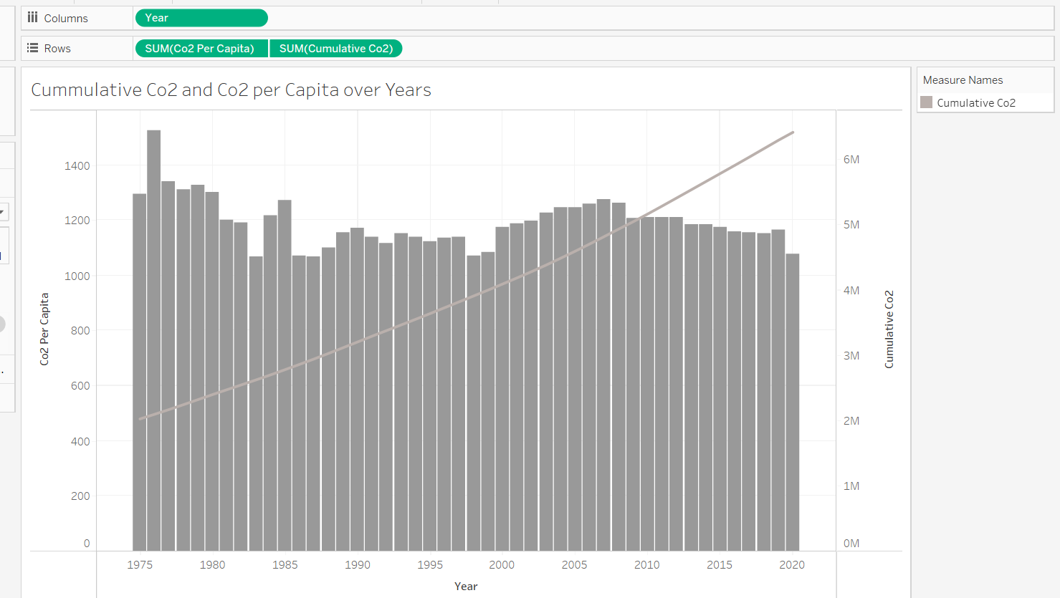

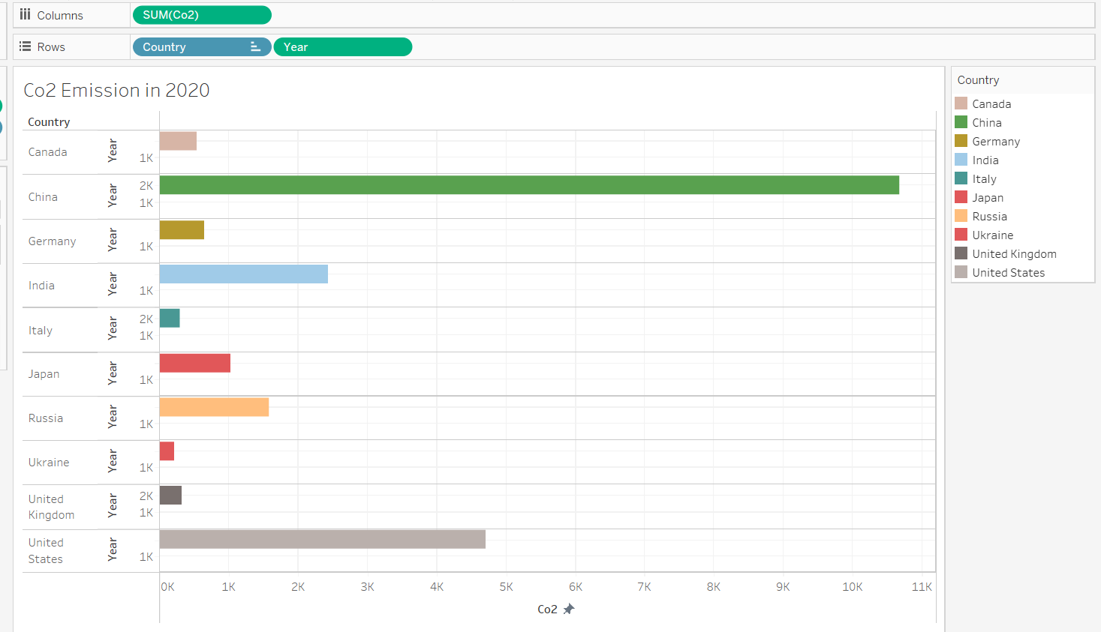

**ADVANTAGES AND DISADVANTAGES:**

**ADVANTAGES:**

1. **Green plants grow faster with more Co2**
2. **Many also become more drought-resistant because Co2 levels allow plants to use water more efficiently.**

**DISADVANTAGES:**

1. **High carbon dioxide levels can cause poor air quality.**
2. **It can even extinguish pilot lights on gas-powered appliances.**

**CONCLUSION:**

**The rising level of atmosphere Co2 could be the one global natural resource that is progressively**

**Increasing food production and total biological output, in a world of otherwise diminishing natural resources**

**Of land, water, energy, minerals, and fertilizer.**

**SOURCE CODE:**

[**https://www.climate.gov**](https://www.climate.gov)

**visit the above website to know about the total development of world population.**

**THANK YOU..**