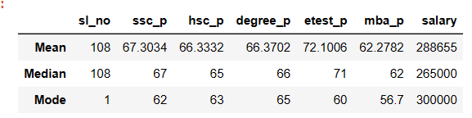

As per the above information, students score is average when compared to entrance test. Entrance test average is far good. average salary of all students is 288655

Median also retrieves similar data as mean. Entrance score is much better when compared to other scores. median of the salary of all students is 265000. It is getting differ from men since it has little bit Outliers

Most of the candidates scored 62 in ssc,63 in hsc, 65 in degree, 60 in entrance test and 56.7 in mba

And most of the students are getting salary of 30000.