AREDN Documentation for Mikrotik devices and Yealink telephones

Andreas Spiess, HB9BLA

# Flash Mikrotik devices

## Preparations

The small Mikrotik box or square Access Point (AP) will hereafter be referred to as "target devices." Green are the notes for the AP.

Deactivate Wi-Fi on the PC and copy the «Installation_Directory» to a known place on your PC. Since all the necessary files for the target devices are available, you don't have to download anything else. Unless you want to check the newest version of the files on <http://downloads.arednmesh.org/firmware/html/stable.html> .

Unpack the target device, including the power supply, two short network cables, and the AP's PoE adapter (Y cable)

Supply power to the target device.

Two files are required for an initial installation, BIN and ELF. As said, they are already in your directory. Both target devices need the same .elf file.

The name of the hap router is: RB912UAG-5HPnD, and the .bin file has a 16M-ac in the name.

The name of the AP is: RBSXTsq-5HPnD, and the file has a 16M with no ac in the name.

Then download the Tiny PXE Server (http://erwan.labalec.fr/tinypxeserver/pxesrv.zip ), unpack it, and save it in a directory (also available in our directory).

Rename the .elf file to rb.elf and save it in the «Files» folder of the PXE server (overwrite if necessary). In our directory, this is already done.

## Change PC to a fixed IP address

Type

ncpa.cpl

into Windows search  
  
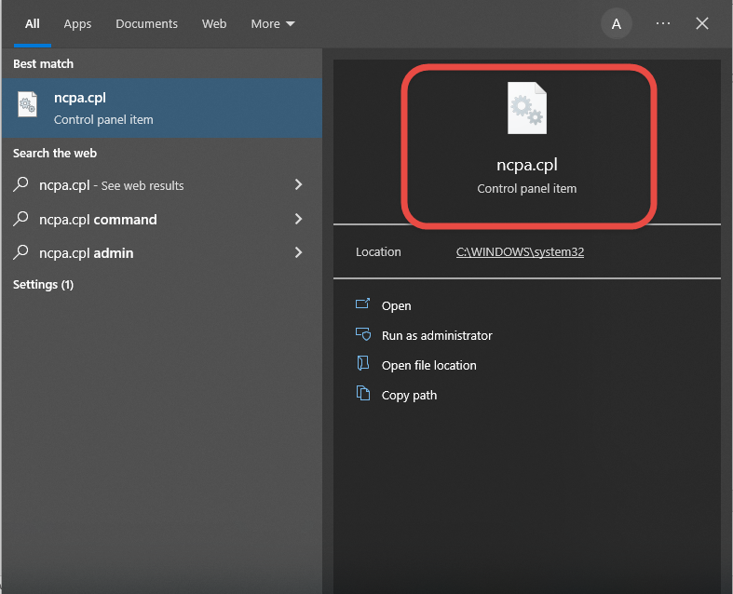

Select "Ethernet"  
Ein Bild, das Text enthält.

Select «Properties»:  
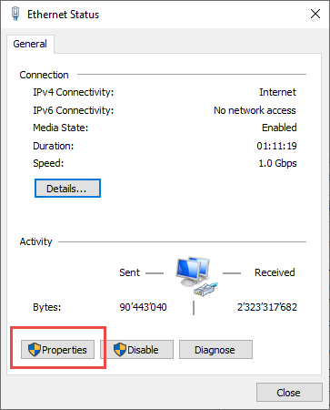

Select IPV4:  
Ein Bild, das Text enthält.

Input IP address 192.168.1.50:  
Ein Bild, das Text enthält.

## Flash elf file to target device

Connect port 1 of the hap router (labeled with Internet) to the PC, supply the router with power and wait until the top red LED is off and the green LED above with the number 1 flickers. Possibly Windows detects a new network. Then a larger blue window will appear on the right side of the screen, mentioning the new network. Confirm with OK. The whole thing takes about 3 minutes.

Do the same with the AP. Use the PoE injector (Y-cable) for the power supply. The power supply unit of the router also works here (both are 24V).

Start Tiny PXE Server (double click on the pxesrv.exe file in the «pxesrv» directory). You might get this warning:

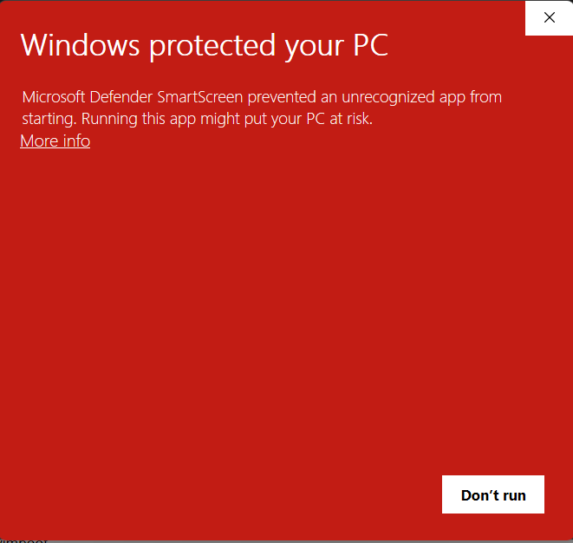 Ein Bild, das Text enthält.

Press «More info» and let the program run.

Now de-energize the target device (pull the power cable).

In the Tiny PXE Server window, select the IP address entered on the Ethernet adapter from the drop-down box (192.168.1.50). If this IP address cannot be selected, close the Tiny PXE Server and start it again. If it still doesn't work, check the IP4 adapter settings and start again.

Find and select rb.elf in the «Boot File» section. This file can be found in the «…\pxesrv\files» folder.

Uncheck «Filename if user class...». No additional settings are necessary.

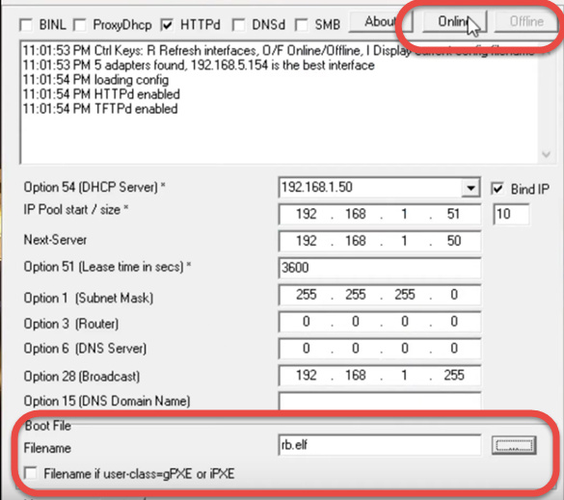

Now switch the Tiny PXE Server to «Online» in the upper right corner.

Then press the reset button in the target device with a pointed object (e.g., paper clip or toothpick) and then plug in the power cable to the target device. Check the log window. Immediately after the bottom line says "Do ReadFile:rb.elf ………" release the reset button and switch the Tiny PXE Server to "Offline." This procedure takes about 20 seconds. The target device now boots with the AREDN firmware. Don't keep the reset button pressed for too long, or you'll have to start over!

Switch the Ethernet adapter on the PC back to the "automatic IP address." Plug the Ethernet cable into port 2 on your router. After about two minutes, the process should be finished.

With the AP, the Ethernet cable remains in the only socket. The rest is the same

Optional: Check with ipconfig whether our PC has received «local.mesh».

## Flash AREDN Firmware

Now open a browser and enter 192.168.1.1. The picture should look something like this.

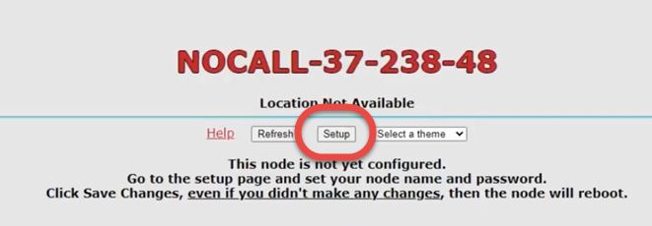

If not, back to start

Now let's install the actual firmware on the target device.

Click on setup and enter username/password:

User: root

Password: hsmm

The following view appears: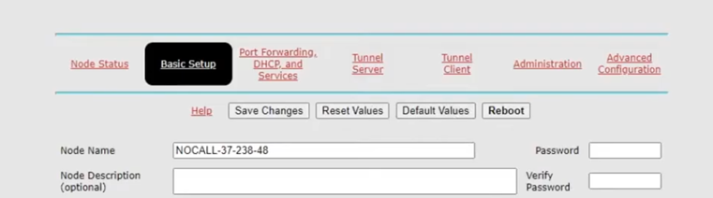

Click on «Administration»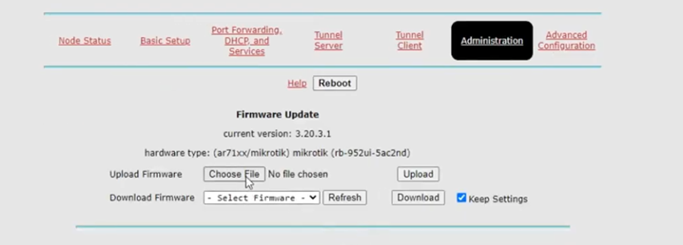

Now uncheck «Keep current setup» (or similar) and select the firmware.

Names of the files as discussed above (file names similar to «aredn-3.22.12.0-ar71xx-mikrotik-rb-nor-flash-16M-ac-squashfs-sysupgrade.bin»):

The router's filename contains a 16M-ac .

The filename of the AP contains a 16M with no ac.

Click «Upload.» The actual firmware is now loaded into the target device. The target device boots several times, and it takes about 10 minutes.

Once the software has been installed, Windows can again bring up a blue window on the right-hand side.

## Configure AREDN

Open the browser and enter the following line http://localnode.local.mesh:8080 (or 192.168.1.1)

If there is no answer, the process is not yet complete. Try again and again. If you still can't connect after 15 minutes, go back and start again.

The necessary settings can be made under «Basic Setup.»

User: root

Password: hsmm

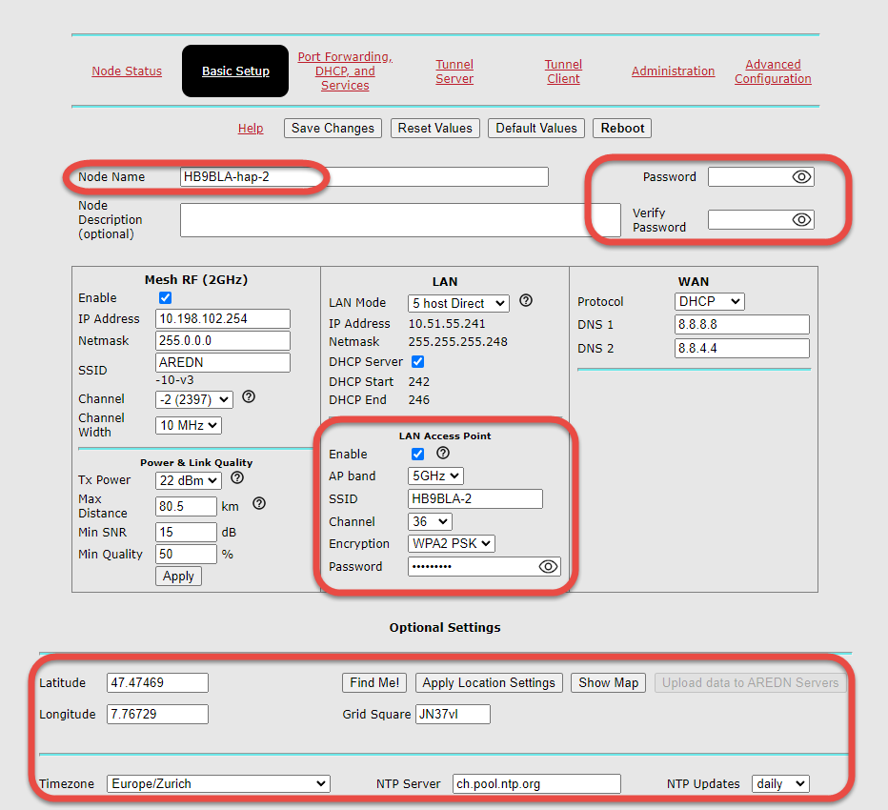

* A new password must be set before the first save. Otherwise, the changes will not be saved
* For the node name, please enter your call sign and an additional designation

Only on the hap router:

* Also, enter your call sign for SSID, and set a password. Remember this SSID name and the password, you will need it later to connect the WLAN. Tick «LAN Access Point»
* Fill in «Optional Settings»

Then reboot the target device.

## Set up a tunnel to the AREDN network (only necessary if you connect via an Internet tunnel)

This chapter only applies to the hap router.

Connect port 1 (Internet) to the Internet.

From now on, you can access the router via Wi-Fi from your PC by looking for the right WLAN and connecting your PC to the router:

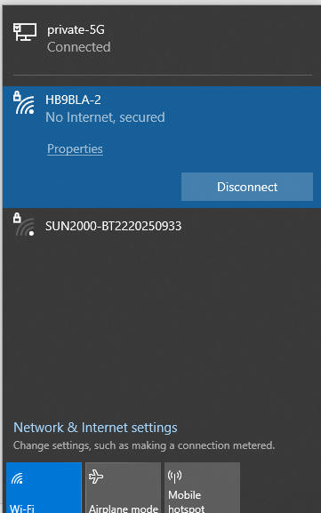

You should get the tunnel data from your tunnel server responsible:

Server: his server address

PwD: The password he assigned to your tunnel

Network: The address of your tunnel

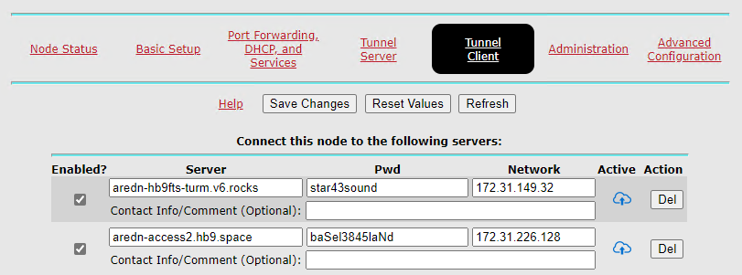

172.31.229.148

hisServer.com

Tick «enable» and press «Save changes.»

Your tunnel should be active after a short time (blue cloud with an arrow).

You are now connected to the AREDN network. Go to «Node-Status» / «Mesh Status» and enjoy the success.

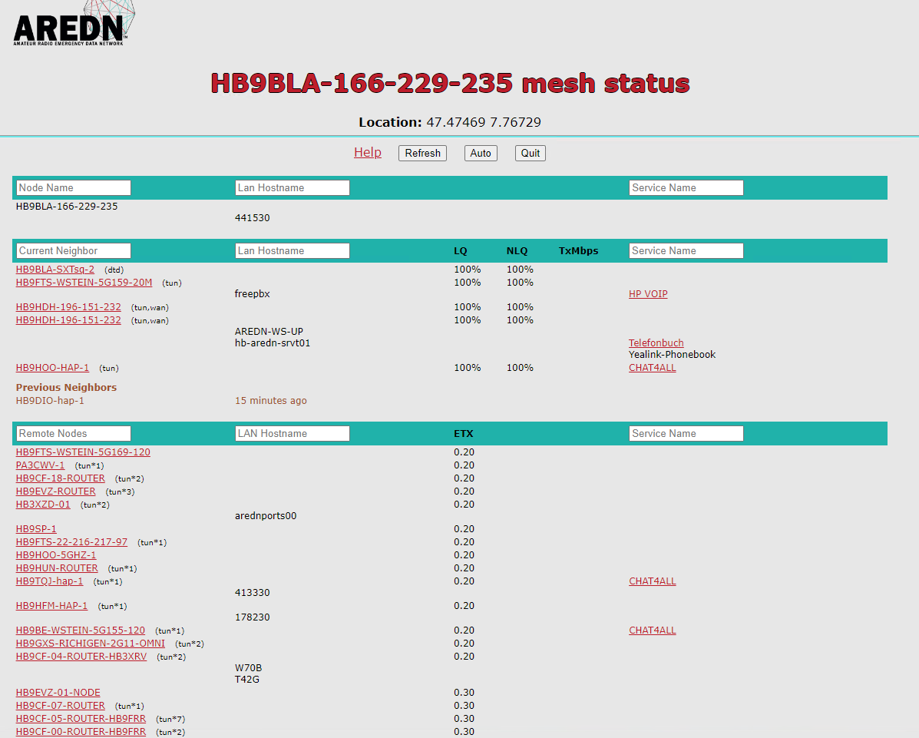

Note the LAN address:

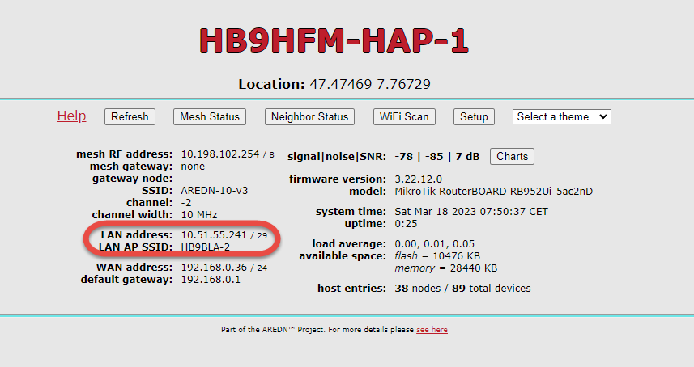

# Setting up the phone book

The installation of the phonebook is described in the document “Installation of phonebook replication on hap router.pdf”. It can be done before or after you set up your phone.

## Connect the phone to the router

First, you need an official telephone number. It is your PLZ plus 30 if you are the first AREDN user in your PLZ. Please check the phonebook:

<https://docs.google.com/spreadsheets/d/1g33BHSXMC8T4Cmfz_Zq-XxtPP17dtEBexF2i4KKe_Mc/edit?usp=sharing>

and enter your information at the bottom. It will be reviewed and accepted.

Now connect your phone to the router and wait until it has received an IP address. Make a note of its MAC address ("Menu" button on the phone and then "Info" button)

Go back to the router setup and go to port forwarding. Fill in everything as shown below:  
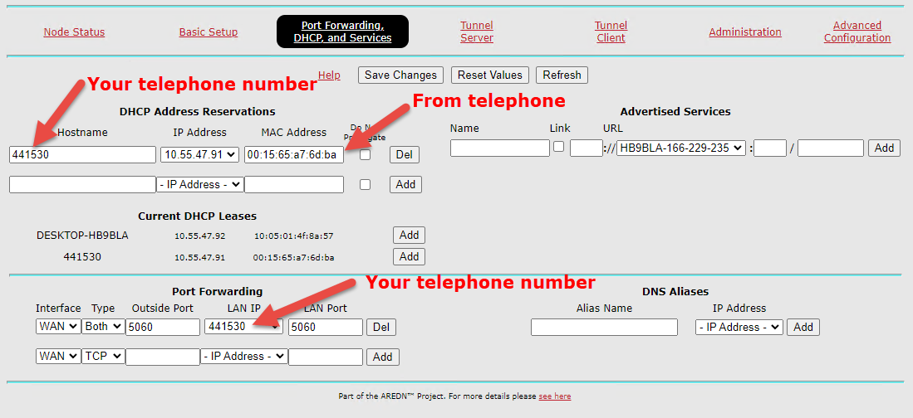

Save changes.

The setup of the target device is now finished.

# Yealink Telephone

## Flash

Continue to «Configure phone» if you already can access your phone's setup with admin/admin.

Download corresponding files from: <http://yealink.provu.co.uk/fw/recovery/> or from the Yealink support site (<https://support.yealink.com/en/portal/docList?archiveType=software&productCode=9f64db103d0b41be> for the T46, for example)

Install and start TFTPd64. Choose the ethernet adapter of your PC and connect your telephone to the home network.

Choose the directory with the downloaded files.  
Ein Bild, das Text enthält.

Power the Yealink with the speaker button pressed, wait till you can enter an IP address, and fill in the IP address of the TFTP server (IP of PC above). Make sure you use a free IP address in the same subnet for the telephone (e.g., 192.168.0.230 )

The telephone loads the files and updates.

Then do a factory reset by holding down the OK button for 10 seconds

Now you can continue with the standard setup in the next chapter

## Configure phone

Enter the IP address of the telephone in the browser (to be found on the telephone under Menu🡪Status).

Username: admin

Password: admin

Set a new password if you want.

We now go through the individual menu items.

### Accounts

The accounts are used to work with a PBX. The provider of the PBX has to enable your telephone number and provide you with the address and credentials.

If you have no access to a PBX, or only want to work with direct addressing, you have to install SIProxy (see Document “Installation of phonebook replication on hap router.pdf”). Sipserver 1 is then “localnode.local.mesh”. User and password are not important in this case.

Account 1:

If you have access to a PBX, Enter credentials and IP address (SIP server) provided by your PBX operator  
.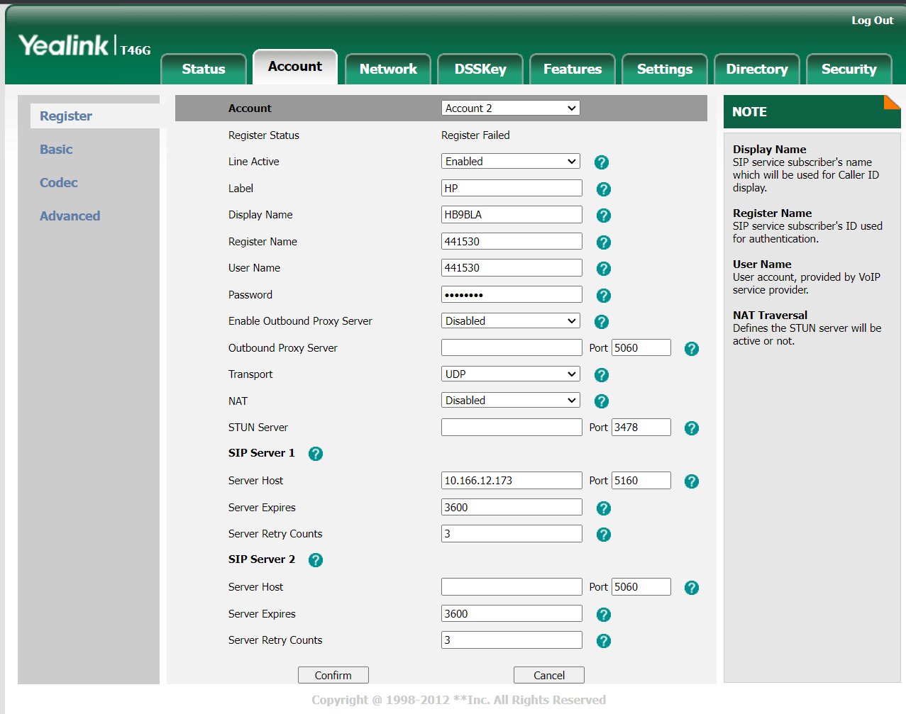

Account (example)

Line Activity: Enabled

Label: Name of PBX (you are free to choose)

Display Name: Your callsign

Register name: Your telephone number

User Name: Given by the PBX Operator

Password: Given by the PBX operator

SIP server 1

Server Host: Given by the PBX Operator

port 5060 (default)

Rest OK. Press "confirm"

## Directory

Ein Bild, das Text, Screenshot, Software, Webseite enthält.

Here are the entries for copy-paste

http://localnode.local.mesh/phonebook_yealink_direct.xml

<http://localnode.local.mesh/phonebook_yealink_pbx.xml>

## Directory Settings

## You can name your phone book as you wish.

## Ein Bild, das Text, Screenshot, Software, Webseite enthält. Automatisch generierte Beschreibung

Integrate your remote phonebook. Otherwise, it is not shown in the display

## Settings

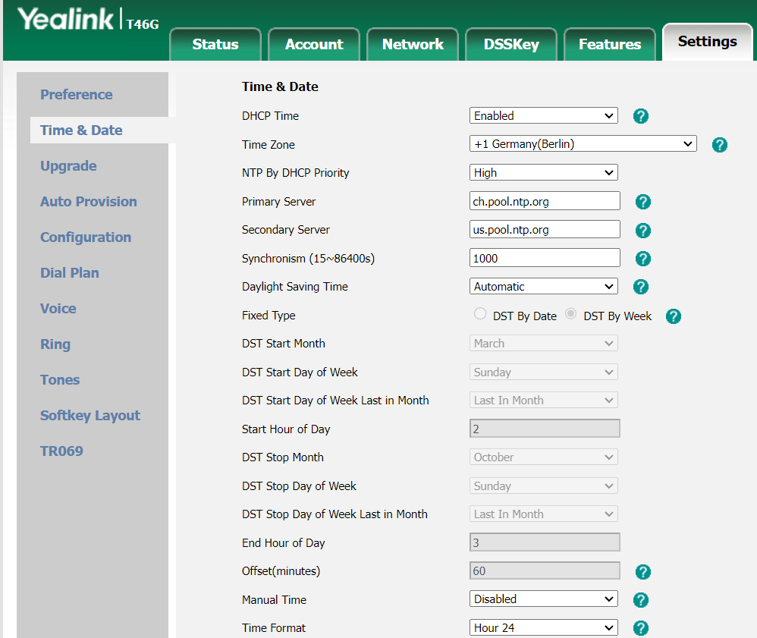

Chose the appropriate NTP server and time zone for your country

## Auto provisioning

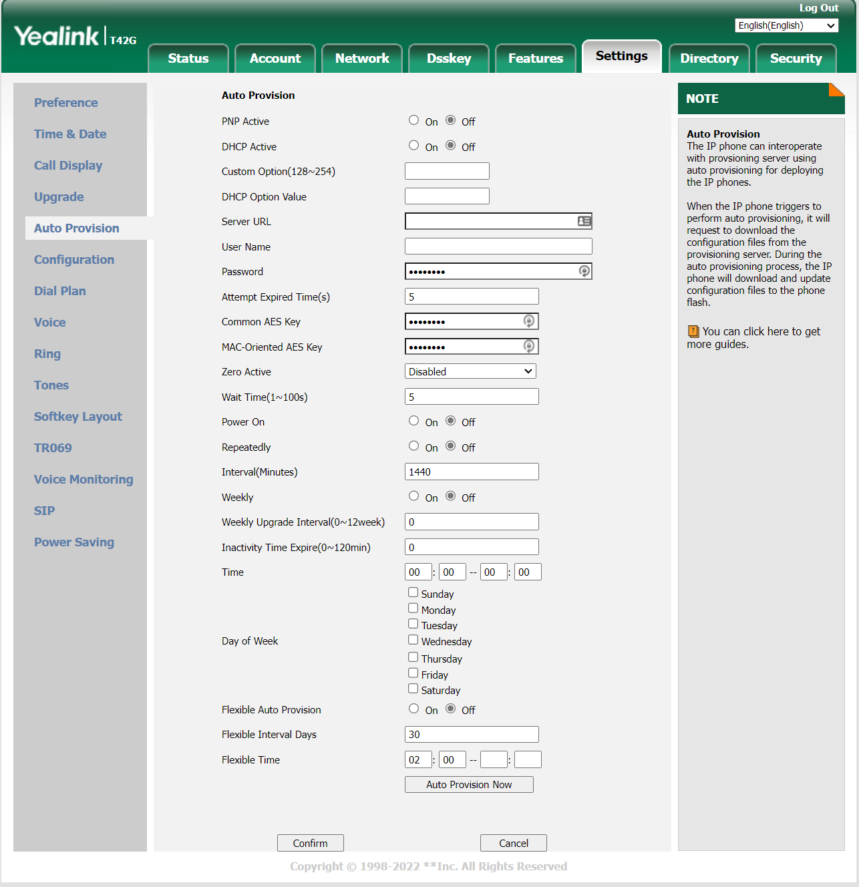

Set everything to "off."

Now your phone is configured, and you can make your first call.

# Configure Access point for telephone usage

If you want to connect your telephone directly to an access point (without a hap router), you need to set "Provide default route to LAN devices" to on  
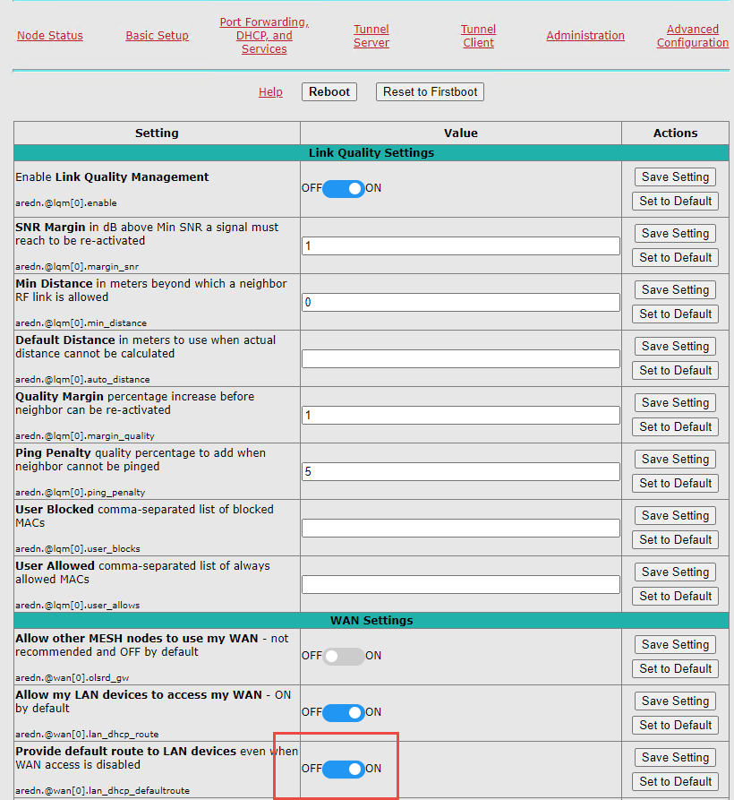

Otherwise, it will not work. This is not needed for the hap routers.