**Domain Description / Abstract :**

The Government of India approached the BITSian community to build a vaccine database system for the upcoming vaccination drive.  
So, Team R_A_A_N proposed the following specifications and requirements:

* Every CITIZEN has a Unique Aadhar number, Name, Date of birth, Gender, Address, Mobile Number, Medical Comorbidities, and Vaccination Status. The Address is composed of an address line, city, state and postal zip. The CITIZEN is expected to fill in a secondary phone number as well for better communication.
* Every VACCINE has a name, a fixed cost set by the government authorities, an efficiency rate, and a manufacturer producing the vaccine. Every Vaccine has a fixed interval between both doses, which is set by the medical authorities.
* Every CITIZEN has a VACCINATION_RECORD, which contains the details of Dose_1 and Dose_2. The details of each dose include the name of the vaccine taken, the vaccination center ID, the date of vaccination. Each dose also contains a Vaccination certificate, which is generated after successfully receiving a particular vaccine shot.
* Every VACCINATION_CENTRE has a Unique Centre_ID, Name, Address ( composed of address line, state, city, zip code, and nearest landmark), the number of vaccines currently available, and the number of vaccine shots administered to date, a set of SUPPLIERS supplying the vaccine.

**Constraints**:

* Each VACCINATION_CENTER has a workforce(staff). Each STAFF has a unique medical id, role, and years of experience.
* Every Citizen has a single Vaccination_Record.
* All vaccination_record must have a unique citizen allotted to it.
* All STAFF is CITIZENS, but vice versa is not true.
* Every VACCINATION_CENTER must have at least one SUPPLIER of the vaccine administered at that particular center.
* A SUPPLIER may supply to more than one VACCINATION_CENTER.
* The Amount of VACCINE a SUPPLIER supplies to a particular center is fixed.
* A CITIZEN can book a VACCINATION_CENTER, using his Mobile Number and Aadhar ID.
* A CITIZEN can book only one VACCINATION_CENTER for a particular dose of the vaccine at a time. He can modify the CENTER later if required. A booking is characterized by a Booking ID and a Booking Date.
* Dose_1 and Dose_2 of the vaccine administered to a CITIZEN must be the same.
* All medical staff at a VACCINATION_CENTER must be fully vaccinated.

**Optional Feature:**

As responsible citizens of the country, the R_A_A_N members decided to create a separate database to store the COVID_CASES data, so that the government can easily and efficiently carry out the Vaccination Drive and also manage the increasing number of cases in the country.

* For every STATE in the country, we store the number of active cases and the number of recovered cases, number of deaths. positivity rate and the total number of vaccine doses administered till now.

**GUI Level constraints and functionalities:**

There will be a separate Login for citizens and a separate login for the vaccination center. The users can book their slots only after logging into their accounts. A vaccination center must update the status of vaccination of an individual after it administers the dose.

The users will be able to see the covid dashboard in a separate section, to make them aware and conscious of their surrounding area for the active caseload and vaccination status. A user must pay from the dashboard before going for the vaccine shot. Users can download their vaccination certificate from the dashboard once he is vaccinated.

**GUI Layout:**

1. **Login page:**

* **User Login**
* **Vaccination Center Login**

1. **User Dashboard:**

* **Vaccination Booking**
* **Certificate Download**
* **Covid Cases Section**

1. **Vaccination Center:**

* **Users to be Vaccinated on a Particular Day. The medical staff updates the status after the shot has been administered.**
* **Request the supplier for the vaccine shots after the quantity goes below a threshold level.**

**Technologies Used:**

* React JS
* Express JS
* Node JS
* SQL

**Co-Vax**

**Vaccination Booking Service**

**Presented By:**

**Akshat Khaitan (2020A7PS2055H)**

**Yadav Ankit Ramesh (2020A7PS2046H)**

**Rishi Poddar (2020A7PS1195H)**

**Nagadhanush K V (2020A7PS2090H)**

**Entity Relation Diagram**

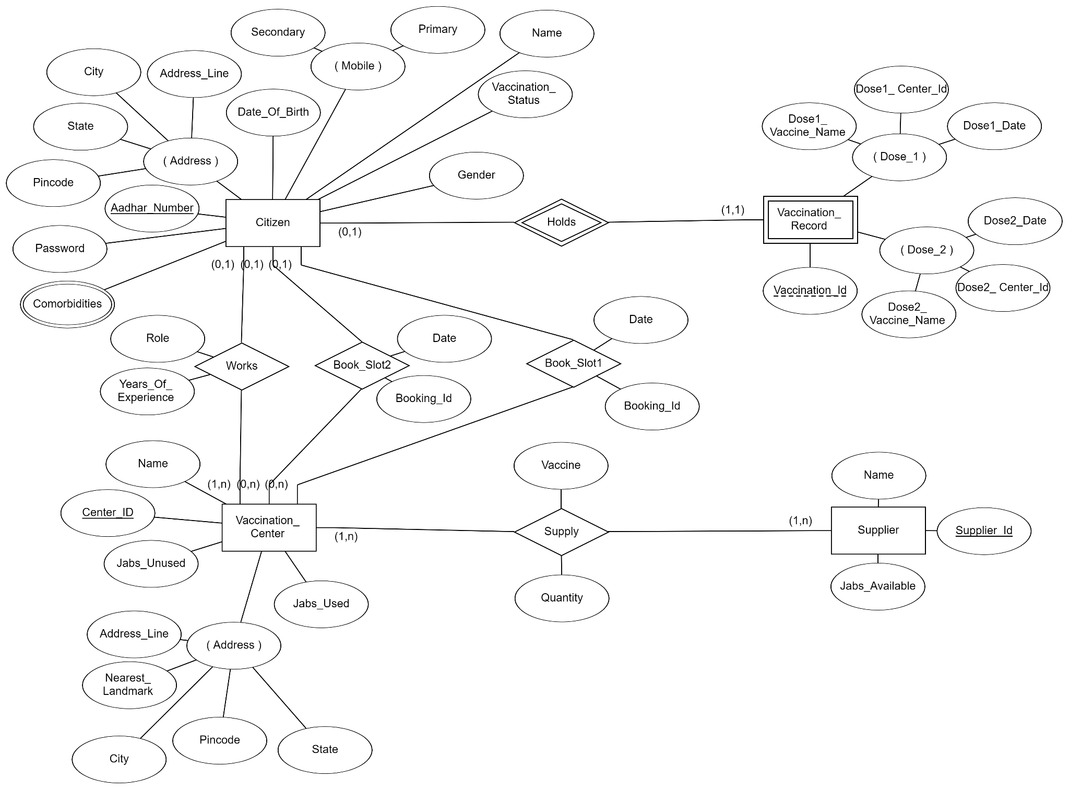

**Relational Schema**

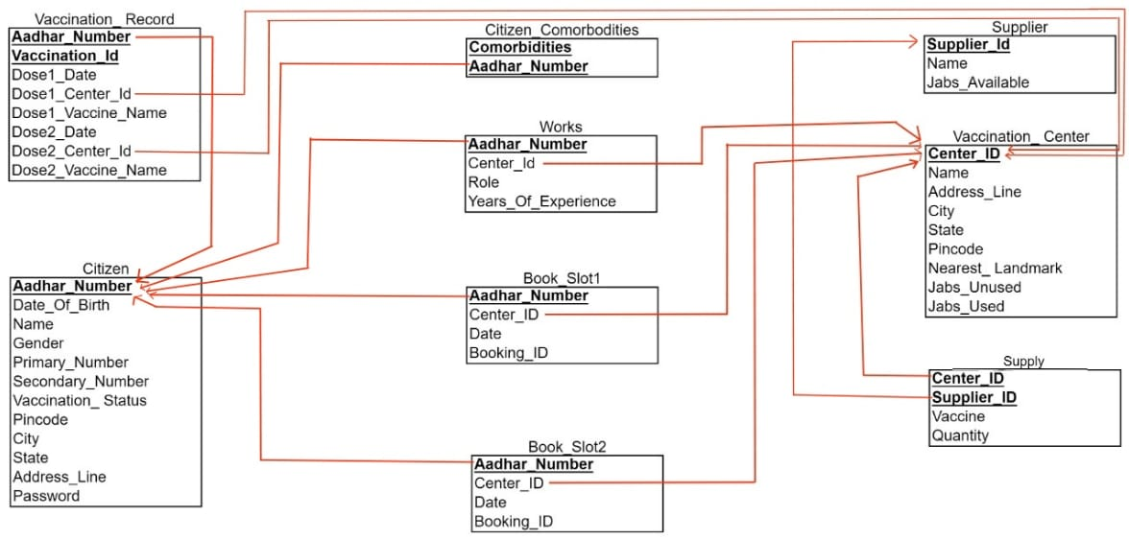

**Functional Dependencies and BCNF form :**

The tables obtained from the relational schema of the ER diagram are

* Citizen
* Citizen_Comorbidities
* Vaccination_Center
* Vaccination_Record
* Supplier
* Supply
* Works
* Book_Slot1
* Book_Slot2

1) Citizen (Aadhar_Number, Password, Name, Gender, Vaccination_Status, Date_Of_Birth, Primary_Mobile, Secondary_Mobile, Address Line, City, State, Pincode)

The FDs for the Citizen table are

* Aadhar_Number —> Password, Name, Gender, Vaccination_Status, Date_Of_Birth, Primary_Mobile, Secondary_Mobile, Address Line, City, State, Pincode
* Pincode —> City, State
* Address_Line, City, State —> Pincode

Candidate Key=Aadhar_Number

The relation is not in BCNF since Pincode is not a super key. So the BCNF decomposition results in the following tables:

* Citizen1 (Aadhar_Number, Password, Name, Gender, Vaccination_Status, Date_Of_Birth, Primary_Mobile, Secondary_Mobile, Address Line, Pincode)
* Citizen2 (Pincode, City, State)

The above tables are in BCNF.

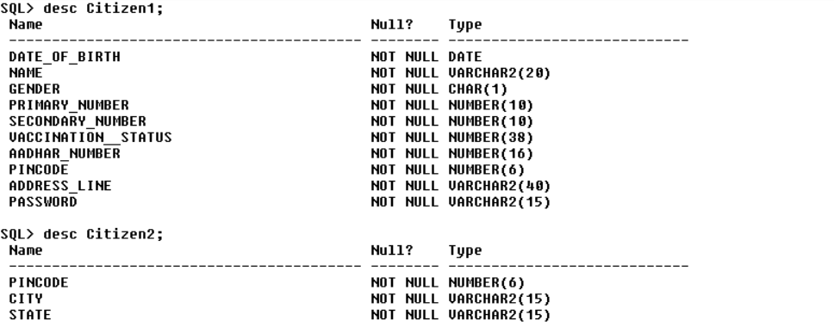

2) Citizen_Comorbidities(Aadhar_Number, Comorbidities)

Both the attributes combined gives the primary key. Hence the relation is in BCNF.

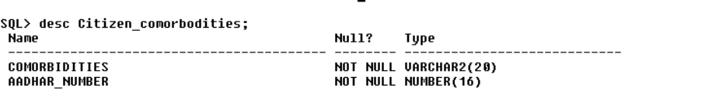

3) Vaccination_Center(Center_Id, Name, Jabs_Used, Jabs_Unused, Address Line, Nearest_Landmark, City, State, Pincode)

The FDs for this table are

* Center_Id —> Name, Jabs_Used, Jabs_Unused, Address Line, Nearest_Landmark, City, State, Pincode
* Pincode —> City, State
* Address_Line, City, State —> Pincode

Candidate Key=Center_Id

The relation is not in BCNF since Pincode is not a super key. So the BCNF decomposition results in the following tables:

* Vaccination_Center1 (Center_Id, Name, Jabs_Used, Jabs_Unused, Address Line, Nearest_Landmark, Pincode)
* Vaccination_Center2 (Pincode, City, State)

The above tables are in BCNF.

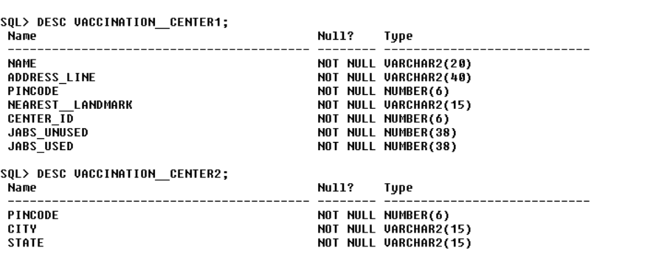

4) Vaccination_Record (Aadhar_Number, Vaccination_Id, Dose1_Vaccine_Name, Dose1_Center_Id, Dose1_Date, Dose2_Vaccine_Name, Dose2_Center_Id, Dose2_Date)

The FDs for this table are

* Aadhar_Number, Vaccination_Id —> Dose1_Vaccine_Name, Dose1_Center_Id, Dose1_Date, Dose2_Vaccine_Name, Dose2_Center_Id, Dose2_Date

Aadhar_Number and Vaccination_Id combined give the primary key. Since in all the FDs the LHS is a super key, the relation is in BCNF.

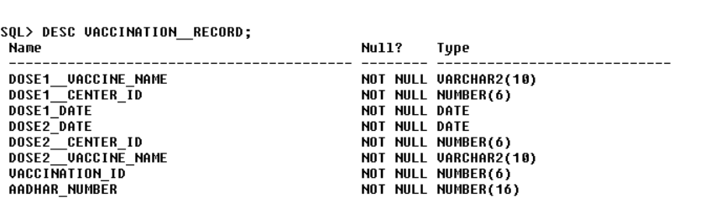

5) Supplier(Supplier_Id, Name, Jabs_Available)

The FDs for this table are

* Supplier_Id —> Name, Jabs_Available

Supplier ID is the primary key. Since in all the FDs the LHS is a super key, the relation is in BCNF.

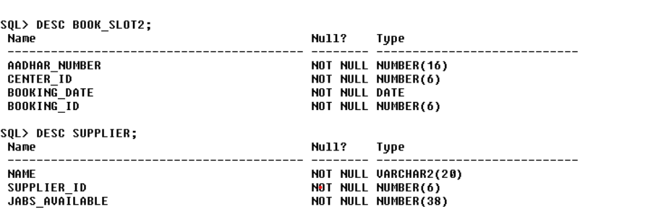

6)Supply(Center_Id, Supplier_Id, Vaccine, Quantity)

The FDs for this table are

* Center_Id, Supplier_Id —> Vaccine, Quantity

Center_Id and Supplier_Id combined give the primary key. Since in all the FDs the LHS is a super key, the relation is in BCNF.

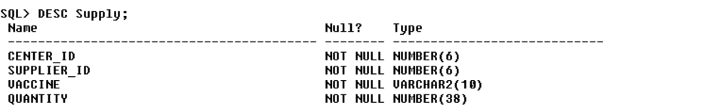

7)Works(Aadhar_Number, Center_Id, Role, Years_Of_Experience)

The FDs for this table are

* Aadhar_Number —> Center_Id, Role, Years_Of_Experience

Aadhar_Number is the primary key. Since in all the FDs the LHS is a super key, the relation is in BCNF.

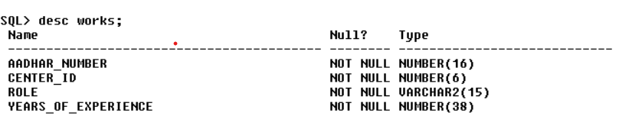

8)Book_Slot1 (Aadhar_Number, Center_Id, Date, Booking_Id)

The FDs for this table are

* Aadhar_Number —> Center_Id, Date, Booking_Id

Aadhar_Number is the primary key. Since in all the FDs the LHS is a super key, the relation is in BCNF.

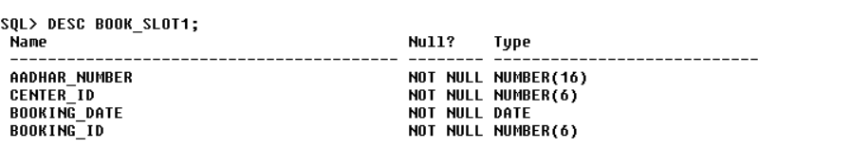

9)Book_Slot2 (Aadhar_Number, Center_Id, Date, Booking_Id)

The FDs for this table are

* Aadhar_Number—> Center_Id, Date, Booking_Id

Aadhar_Number is the primary key. Since in all the FDs the LHS is a super key, the relation is in BCNF.



**SNAPSHOTS OF THE UI:**

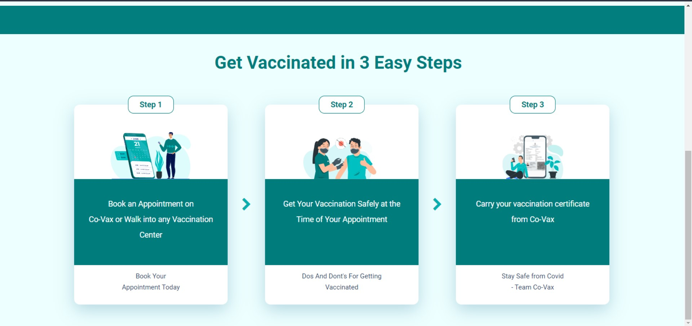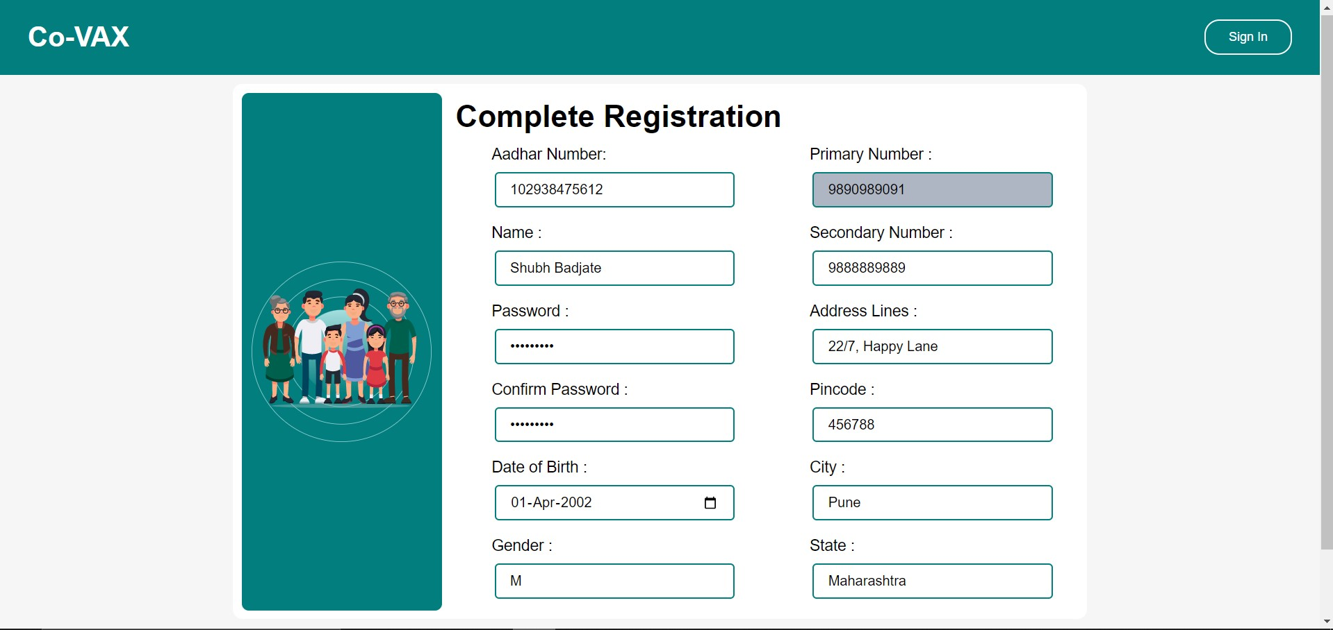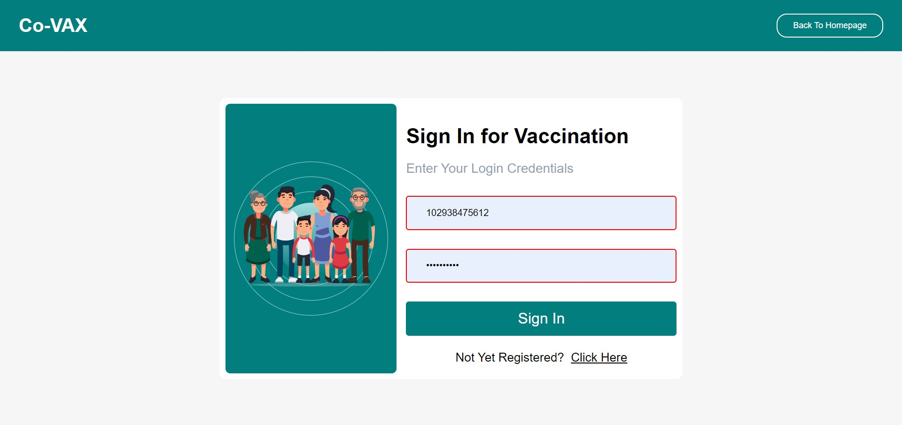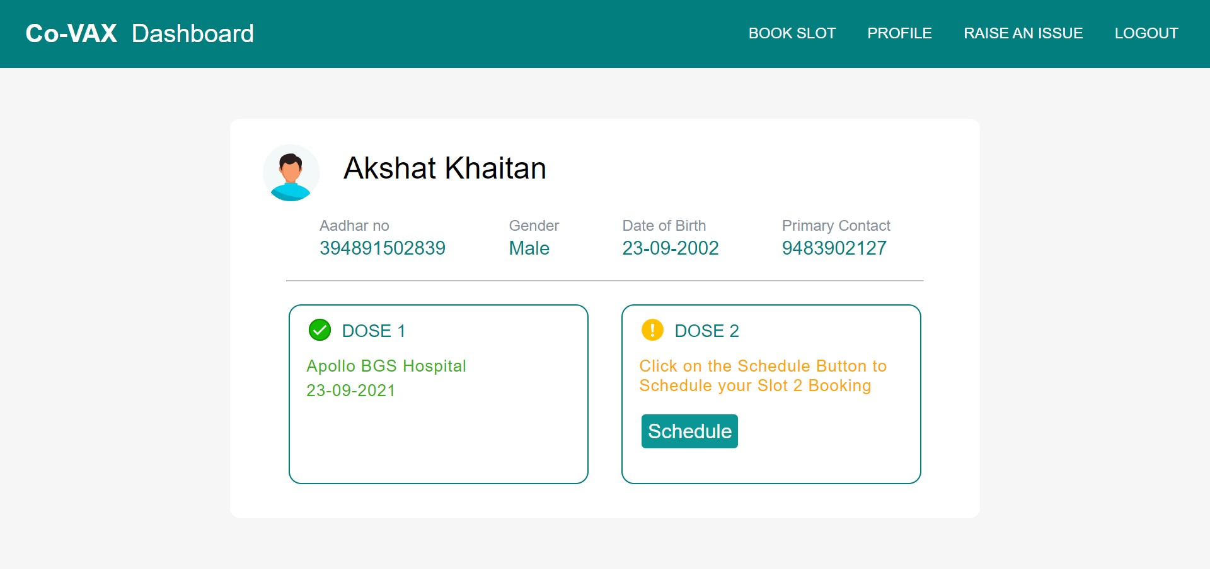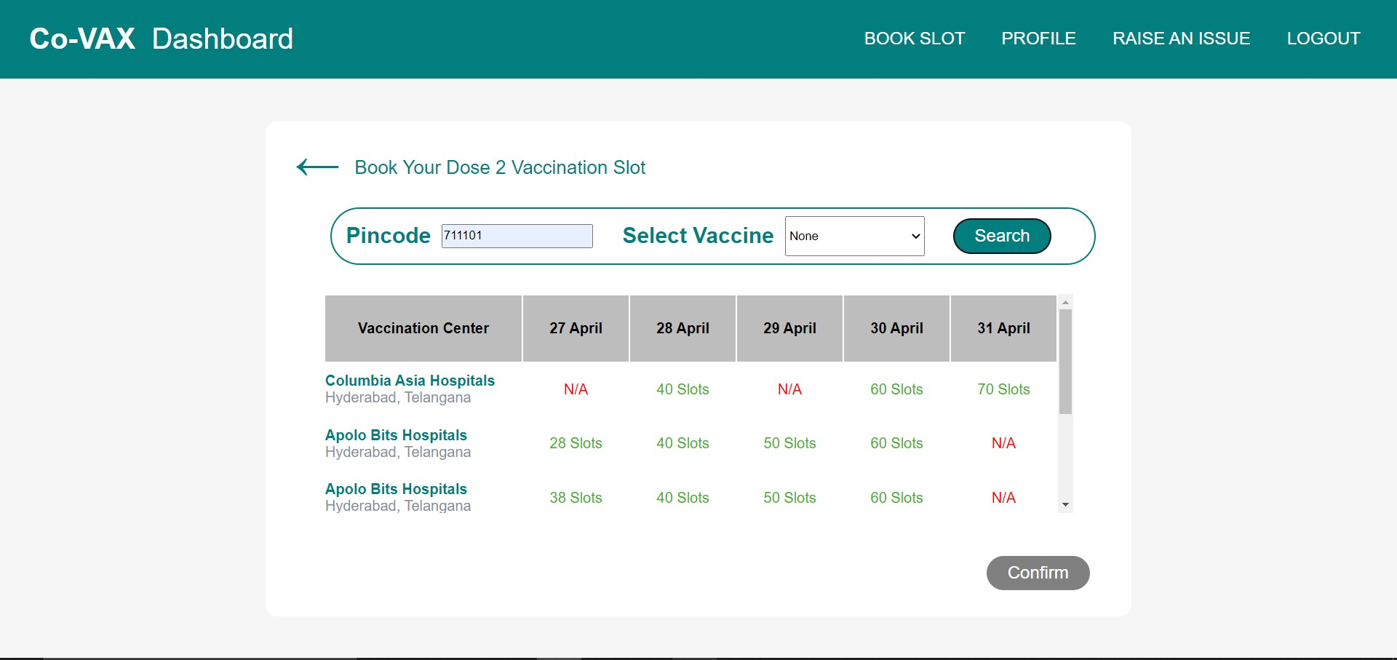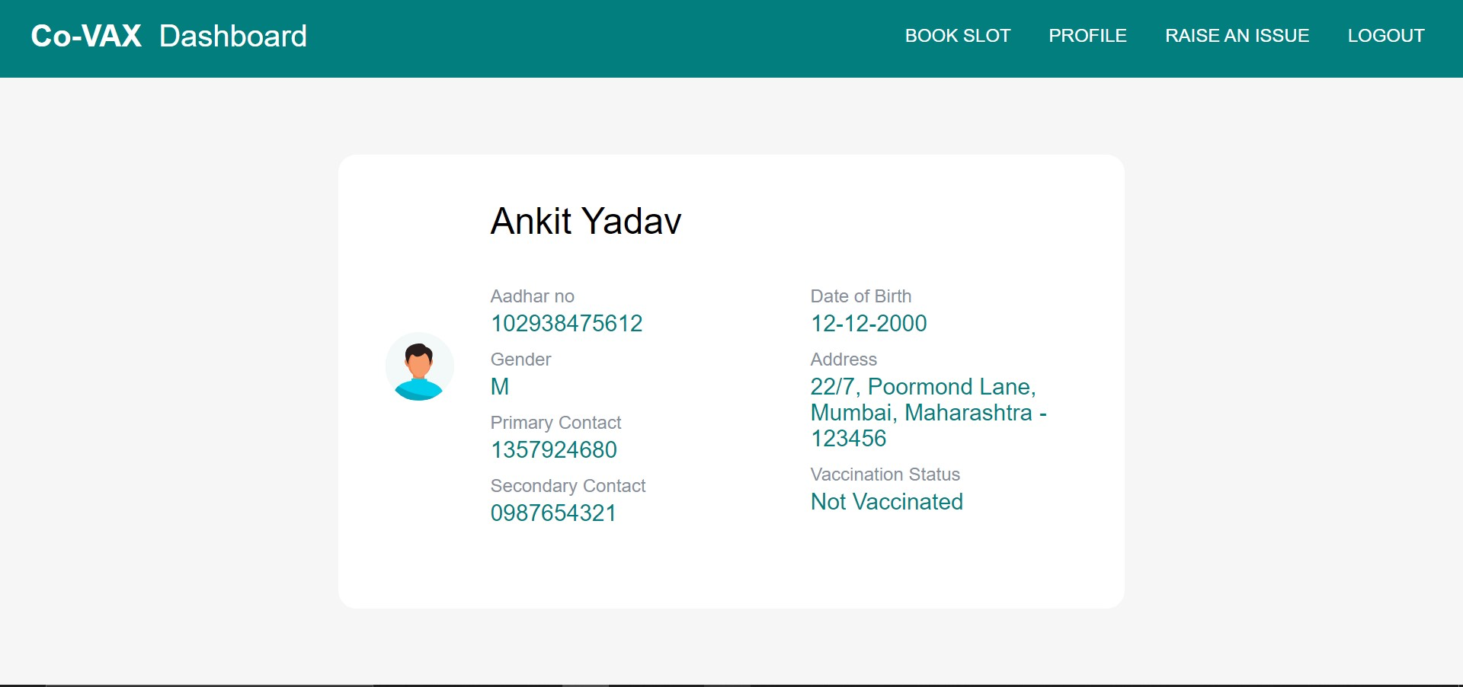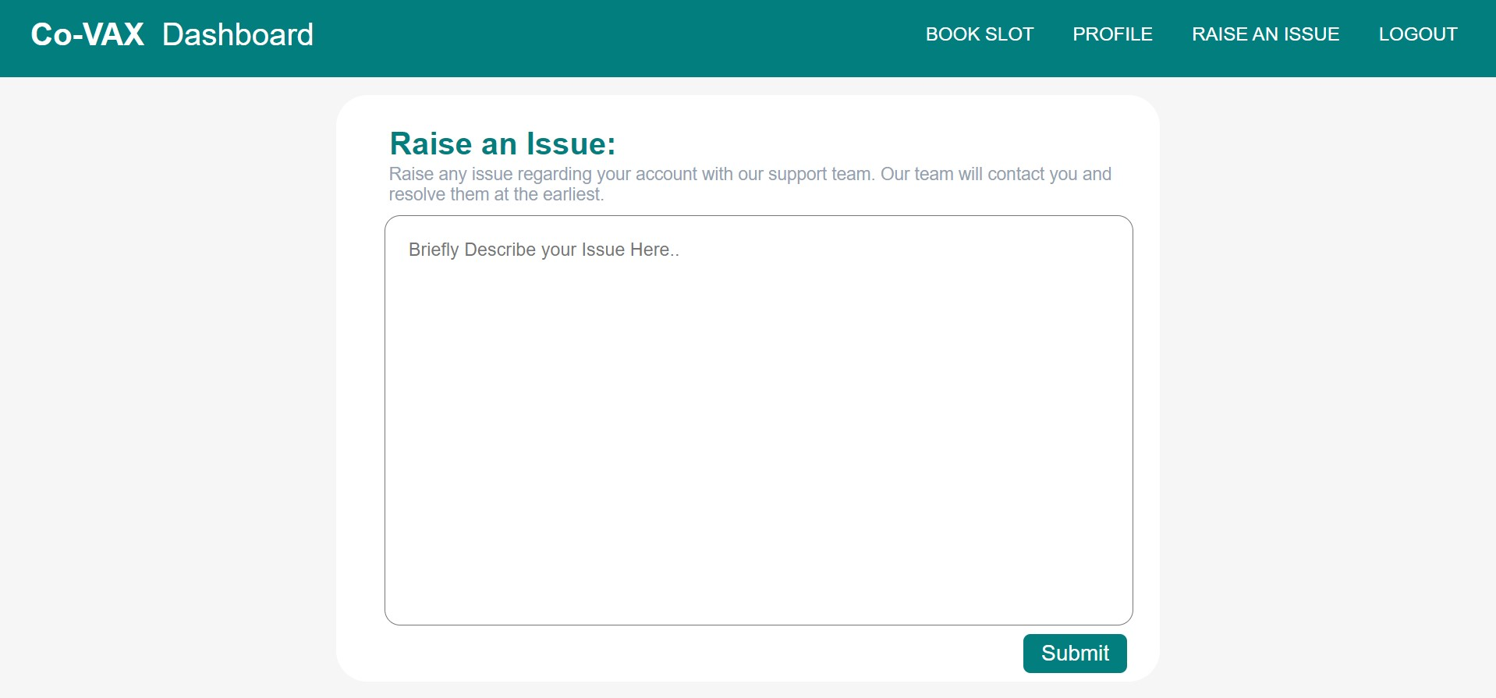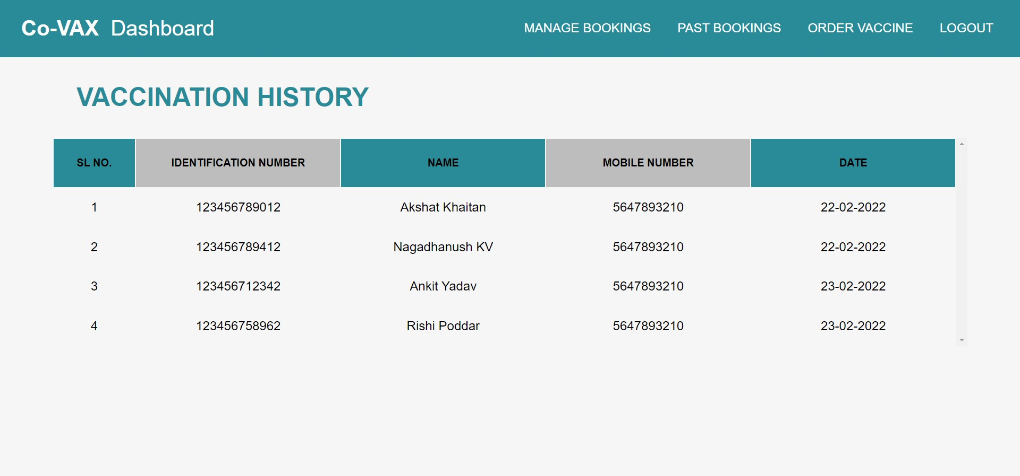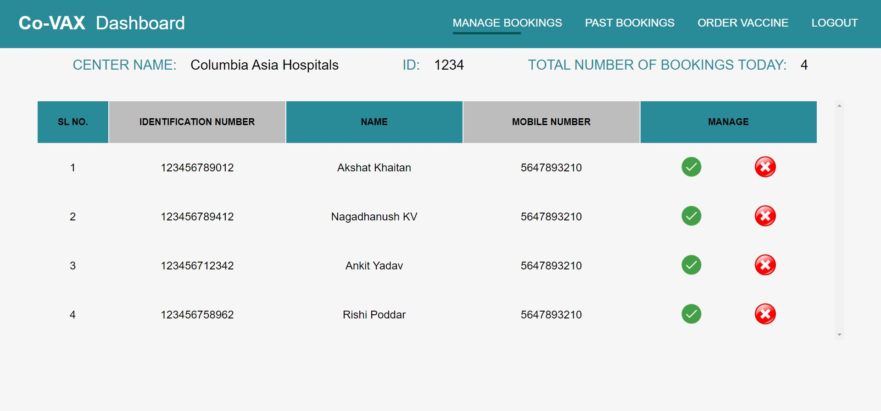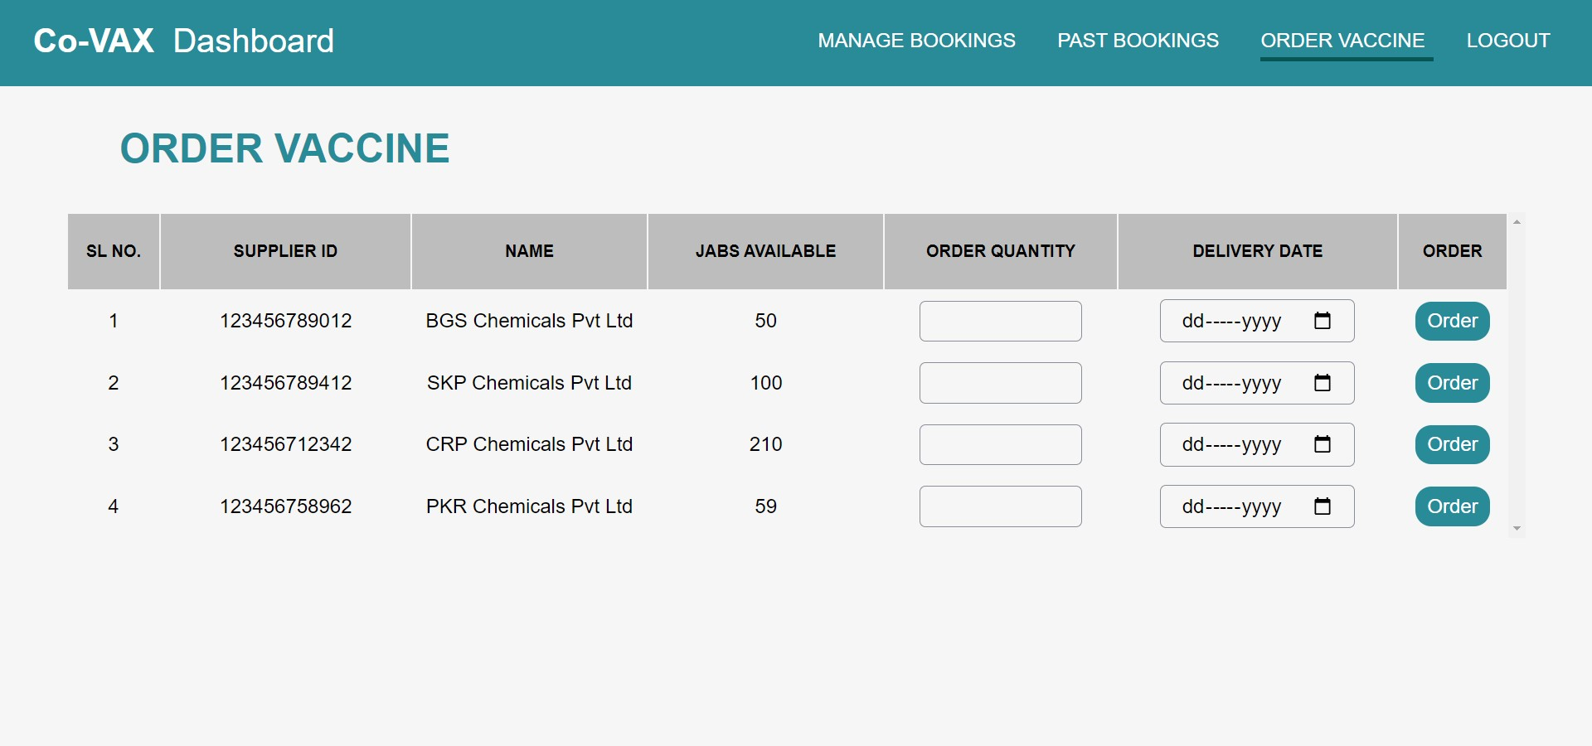

**SNAPSHOT OF THE BACKEND TABLES :**

