EDGE DETECTION – DOG
Edge detection:
A technique used to identify points in a image where Intensity changes sharply .

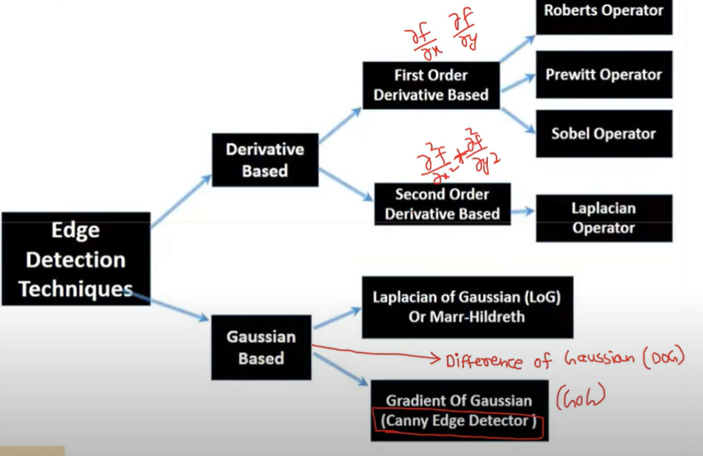
METHODS
    - Sobel Operator
    - Perwitt Operator
    - Robert Operator
    - Canny
    - LoG
    - DoG

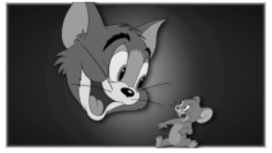
↓
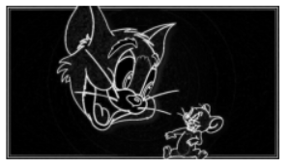

DOG - APPROXIMATION OF LoG
DoG is a method where we blur the image twice using two different Gaussian filters and then subtract one blurred image from the other. This highlights regions where intensity changes.

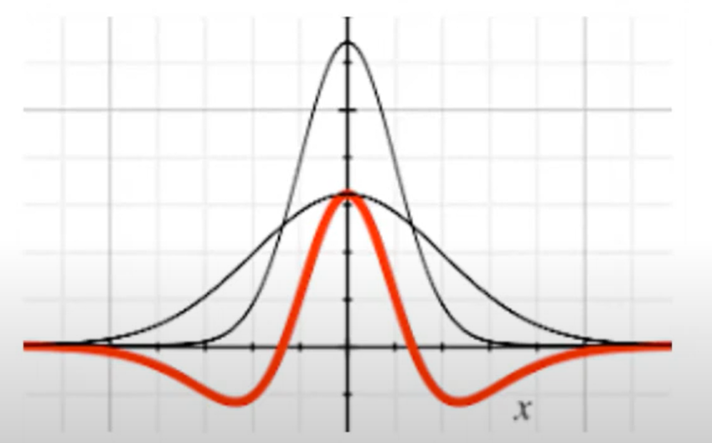

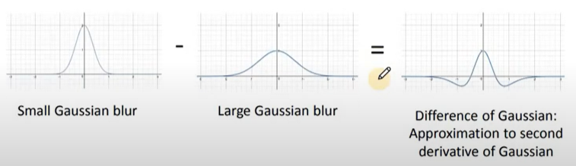

In signal processing, gaussian function is called as low pass filter which implies higher frequencies get suppressed leaving the lower frequencies alone ……
The suppression is determined by standard deviation of gaussian function.
Two gaussian filters are subtracted using different deviation
    - endup with band pass filter
- The frequencies are area of high contrast which corresponds to edges

PROCEDURE
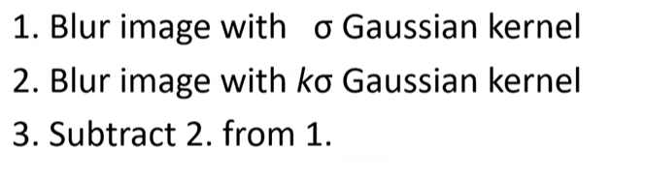
LAPLACIAN:
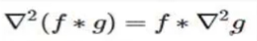
DOG:

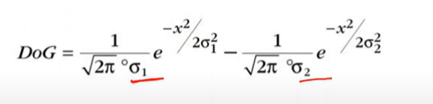
By keeping the results of Gaussian filtering applied to an image, we can extract edges simply by taking the difference between successive filtered images, without needing to calculate image derivatives directly.

Implementation:
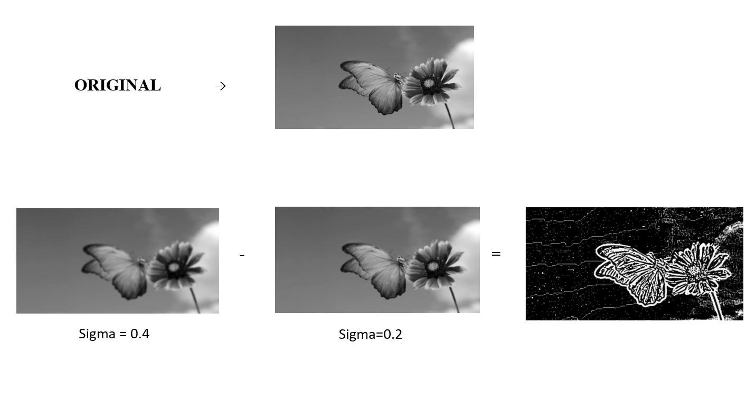
When DoG is preferred:
- Performance & Speed
LoG (Laplacian of Gaussian) requires computing second-order derivatives, which is computationally more expensive.
DoG (Difference of Gaussians) just needs two Gaussian blurs and a subtraction — it's faster and easier to implement.
- DoG is preferred in feature detection pipelines (e.g., SIFT) because it helps in identifying scale-invariant feature
- DoG is a computationally efficient approximation of LoG.

APPLICATIONS:
Feature Detection (e.g., SIFT)
- DoG is a core step in SIFT (Scale-Invariant Feature Transform).
- It helps in detecting keypoints (corners, blobs) at multiple scales.
- Important for matching features between images in different sizes and orientations.
Used in object recognition, image stitching, and panorama creation.

Edge Detection
- DoG highlights regions of rapid intensity change (edges).
- Cleaner edges than traditional derivative-based filters (like Sobel).
Useful in preprocessing for segmentation or contour detection.

Biological Vision Models
- Mimics how the human retina detects contrasts using center-surround receptive fields.
Used in computational neuroscience and biologically-inspired vision systems.

Robotics and Real-Time Vision
- DoG is fast and lightweight, so it's ideal for embedded vision systems and robots.
Used in navigation, object tracking, and environmental mapping.

Image Compression & Enhancement
- Can be used to enhance details or reduce noise before encoding.
- Also useful in texture analysis or detecting fine structures.

