Access S3 from Private EC2 instance using VPC Endpoint:  
===============================================

Creating a custom VPC in Mumbai region

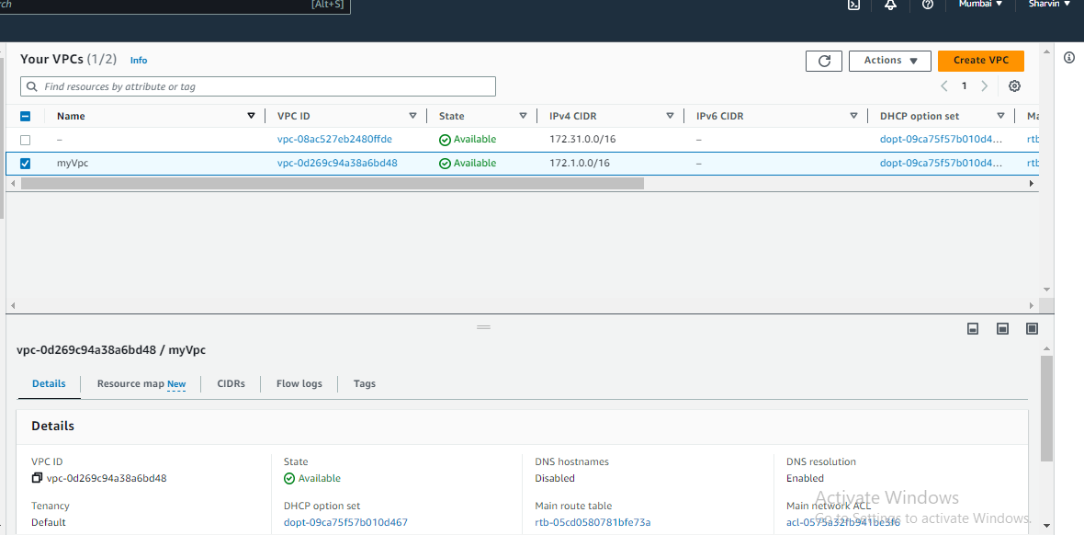

Dividing the VPC into smaller unit called as Subnets .Public and Private to launch a instance in it

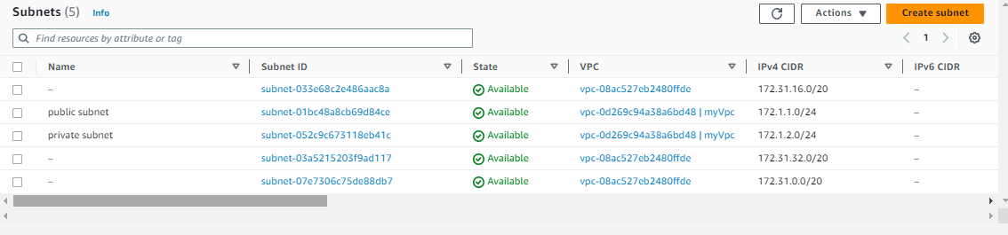

Created a IGW and attached to the VPC

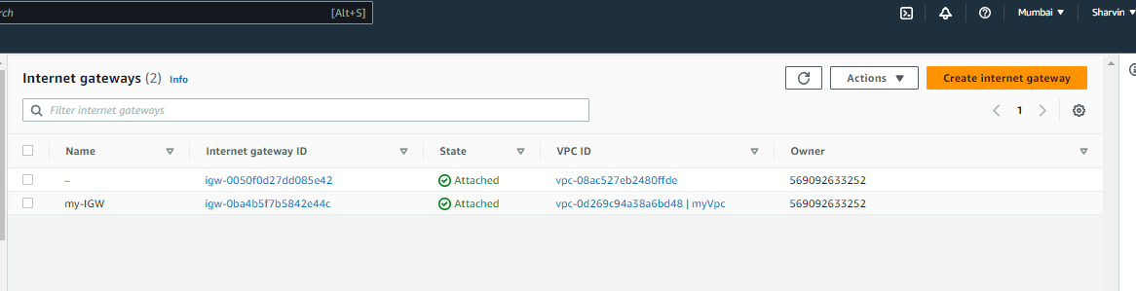

Created a 2 route tables and associated with respective subnet association

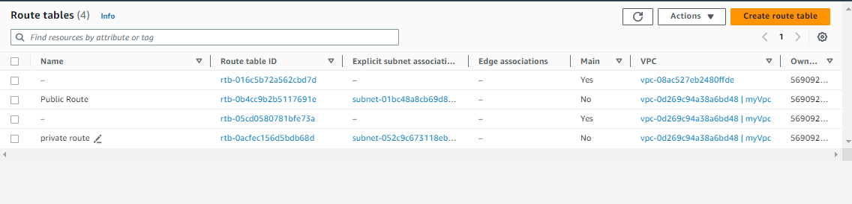

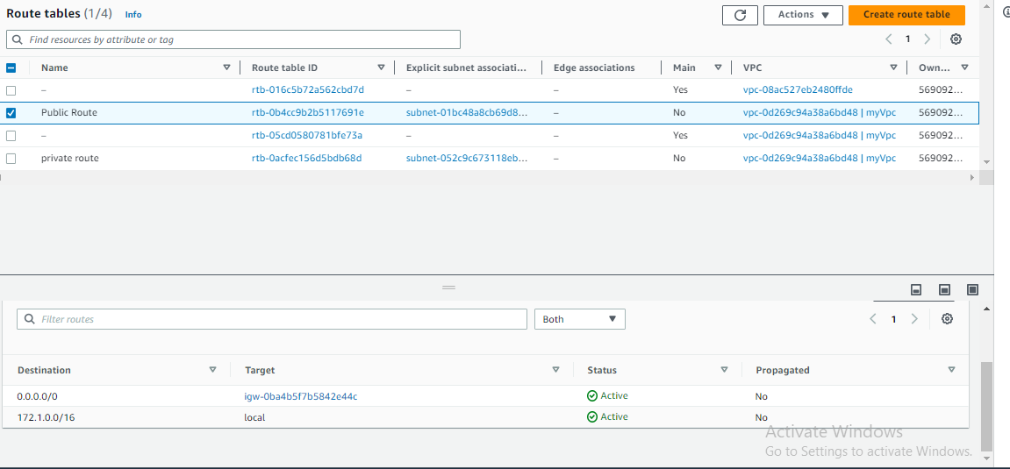

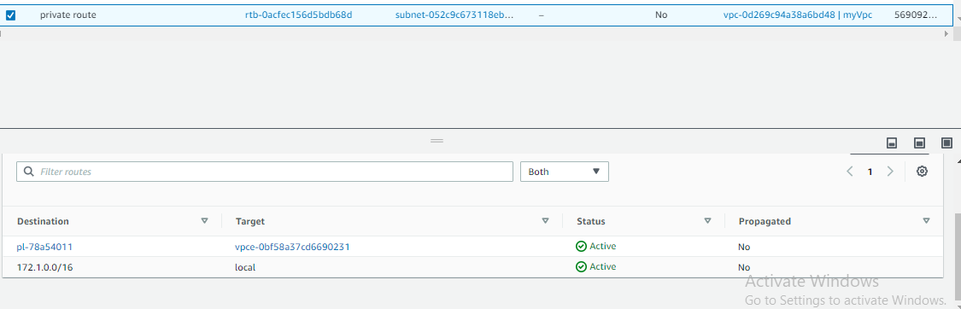

Created a instance in both public and private instance   
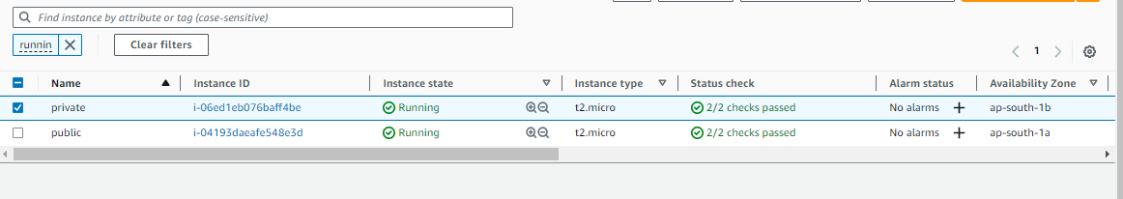  
Created a VPc endpoint to access the S3 from private instance without transverse to public network

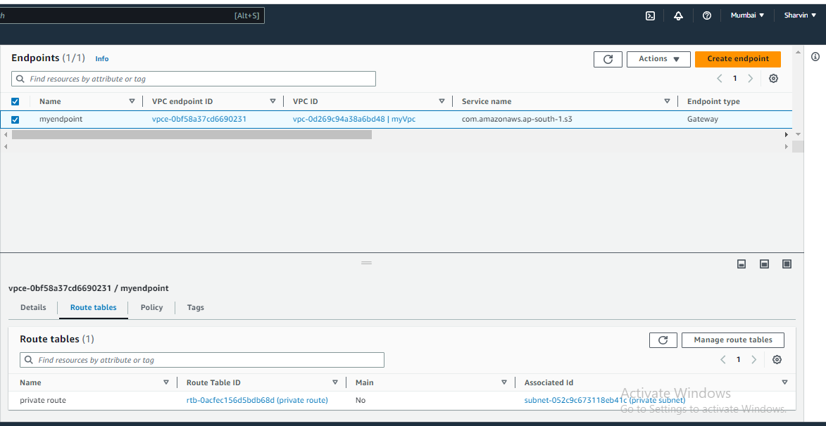

Connecting public instance via SSH using Keypair  
Then with help of pem key of private instance , SSH into private instance from Public machine  
Able to access the s3 without leaving a amazon network

