**AUTOMATED GREENHOUSE MONITORING AND CONTROL SYSTEM**

**22ECC51-Embedded System and IoT**

**A mini Project Report**

**Submitted by**

**Dhanasri G**

**(22ECR041)**

**Dhanusha R**

**(22ECR042)**

**Dhanushkumaran R**

**(22ECR043)**

**DEPARTMENT OF ELECTRONICS AND COMMUNICATION ENGINEERING**



**KONGU ENGINEERING COLLEGE**

**PERUNDURAI-638060**

**Nov-2024**

**ABSTRACT**

This project presents an automated greenhouse monitoring and control system aimed at optimizing environmental conditions for crop growth in a controlled setting. Using the PIC16F877A microcontroller, the system continuously monitors essential parameters, including temperature, humidity, light intensity, and soil moisture, with sensors directly interfaced to the microcontroller.Key components include the DHT22 sensor for temperature and humidity, an LDR for detecting light levels, and a soil moisture sensor. Real-time data from these sensors is processed by the PIC16F877A, which compares readings with preset threshold values to activate necessary actions. Actuators are controlled to regulate heating, cooling, ventilation, lighting, and irrigation, minimizing manual labor and ensuring efficient resource use. This autonomous system triggers corrective actions when certain thresholds are exceeded, maintaining optimal conditions without the need for IoT connectivity. Additionally, by reducing human intervention, it conserves resources and promotes sustainable agricultural practices. This project demonstrates a cost-effective solution for precision agriculture, enhancing crop yield and quality by providing an automated, self-sustained approach for managing greenhouse conditions**.**

**TABLE OF CONTENTS**

|  |  |  |
| --- | --- | --- |
| **CHAPTER**  **NO** | **CONTENT** | **PAGE NO** |
| 1 | INTRODUCTION |  |
| 2 | METHODOLOGY AND PROGRAM |  |
| 3 | RESULT AND DISCUSSION |  |
| 4 | CONCLUTION |  |

**CHAPTER 1**

**INTRODUCTION**

In recent years, agriculture has faced challenges related to climate variability, resource scarcity, and the need for sustainable food production to support a growing population. Greenhouse cultivation offers a solution by allowing controlled environments where key conditions such as temperature, humidity, light, and soil moisture can be managed to optimize crop growth. This approach minimizes dependency on natural weather conditions and enables year-round cultivation, increasing crop yield and quality. However, traditional greenhouse management often involves manual intervention, which can be labor-intensive and less precise, leading to suboptimal use of resources. To address this, automation in greenhouse systems has become an area of interest, combining sensor-based monitoring with control mechanisms to maintain ideal conditions for plants with minimal human input. This project proposes an automated greenhouse monitoring and control system based on the PIC16F877A microcontroller. The system is designed to continuously measure key environmental factors with the help of sensors, including a DHT22 sensor for temperature and humidity, an LDR for light intensity, and a soil moisture sensor. The data collected from these sensors is processed in real-time by the microcontroller, which compares the readings with pre-set threshold values to determine the necessary actions. When specific conditions exceed or fall below the desired range, the system activates actuators to control heating, cooling, ventilation, lighting, and irrigation components, thereby maintaining an optimal environment for plant growth. By automating these control mechanisms, the system reduces human intervention and optimizes resource use, making it a cost-effective solution for precision agriculture. Unlike IoT-based systems, this design is standalone, requiring no internet connectivity, making it suitable for remote or rural areas where connectivity may be limited. This project demonstrates a practical approach to managing greenhouse environments efficiently, enhancing sustainability in agriculture by conserving water, energy, and other resources. Overall, the proposed system provides a robust solution for improving crop production in controlled cultivation environments, addressing both the productivity and sustainability challenges in modern agriculture.

**CHAPTER – 2**

**METHODOLOGY AND PROGRAM**

* **Sensor Selection and Integration**: Choose sensors suitable for greenhouse monitoring, including the DHT22 for temperature and humidity, an LDR for light intensity, and a soil moisture sensor for measuring the moisture content. Connect each sensor to specific input pins on the PIC16F877A microcontroller.
* **Microcontroller Configuration**: Program the PIC16F877A to read analog and digital signals from the connected sensors. Configure the ADC (Analog-to-Digital Converter) for accurate data conversion from sensors with analog outputs.
* **Threshold Setting**: Define threshold values for each parameter (temperature, humidity, light, and soil moisture) based on optimal plant growth conditions. Store these values in the microcontroller for comparison with real-time data.
* **Data Collection and Processin**g: Continuously collect data from sensors. Use the PIC16F877A to compare each reading with the predefined threshold values.
* **Decision-Making Logic**: Implement conditional statements in the microcontroller code to trigger specific actions if sensor readings exceed or fall below the set thresholds.
* **Actuator Control**: Interface actuators (fans, lights, and motor) with the microcontroller. Use relays to control these actuators, enabling the system to respond to environmental changes.
* **Automated Response Mechanism**: Program the microcontroller to activate or deactivate actuators based on sensor readings, maintaining ideal conditions within the greenhouse.
* **Testing and Calibration**: Test the system to ensure that sensor readings and actuator responses are accurate. Calibrate sensor thresholds as needed for reliable operation.
* **Data Logging**: Set up a basic data logging system, using an LCD display or storage, to view real-time readings and historical data for monitoring purposes.
* **System Validation and Optimization**: Evaluate the system’s performance in maintaining greenhouse conditions. Fine-tune threshold settings and response times to enhance the system’s efficiency and stability.

**PROGRAM**

#include <16F877A.h>

#device ADC=10

#FUSES NOWDT //No Watch Dog Timer

#FUSES PUT //Power Up Timer

#FUSES NOBROWNOUT //No brownout reset

#FUSES NOLVP //No low voltage prgming, B3(PIC16) or B5(PIC18) used for I/O

#use delay(crystal=4MHz)

#define LCD_ENABLE_PIN PIN_D0

#define LCD_RS_PIN PIN_D1

#define LCD_RW_PIN PIN_D2

#define LCD_DATA4 PIN_D4

#define LCD_DATA5 PIN_D5

#define LCD_DATA6 PIN_D6

#define LCD_DATA7 PIN_D7

#include <lcd.c>

#define DHT22_PIN PIN_B0

void start_signal();

int8 read_data();

void read_dht22(float *temperature, float *humidity);

int wait_for_response(int timeout_us);

void main()

{

setup_adc_ports(AN0_AN1_AN3);

setup_adc(ADC_CLOCK_INTERNAL);

float temperature = 0, humidity = 0;

lcd_init();

while(TRUE)

{

int16 sm, ldr;

set_adc_channel(0);

delay_us(10);

sm = read_adc();

if (sm > 900)

{

output_high(PIN_B4); // Turn ON pump or related device

}

else

{

output_low(PIN_B4);

}

printf(lcd_putc, "\fMoisture = %ld", sm);

delay_ms(500);

set_adc_channel(1);

delay_us(10);

ldr = read_adc();

if (ldr> 500)

{

output_high(PIN_B1);

}

else

{

output_low(PIN_B1);

}

printf(lcd_putc, "\nLight = %ld", ldr); // Display LDR value on LCD

delay_ms(1000);

read_dht22(&temperature, &humidity);

lcd_gotoxy(1, 1);

printf(lcd_putc, "\fTemp: %2.1f C", temperature);

lcd_gotoxy(1, 2);

printf(lcd_putc, "Hum: %2.1f %%", humidity);

delay_ms(1000);

if (humidity < 20 || temperature > 30)

{

output_high(PIN_B2);

}

else

{

output_low(PIN_B2);

}

delay_ms(2000);

}

}

void start_signal() {

output_low(DHT22_PIN);

delay_ms(20);

output_high(DHT22_PIN);

delay_us(40);

output_float(DHT22_PIN);

}

int wait_for_response(int timeout_us) {

int count = 0;

while(!input(DHT22_PIN)) {

if (count++ > timeout_us) return 0;

delay_us(1);

}

while(input(DHT22_PIN));

return 1;

}

int8 read_data() {

int8 i, data = 0;

for(i = 0; i < 8; i++) {

while(!input(DHT22_PIN));

delay_us(30);

if(input(DHT22_PIN)) {

data |= (1 << (7 - i));

while(input(DHT22_PIN));

}

}

return data;

}

void read_dht22(float *temperature, float *humidity) {

int8 data[5]; // Array to store 5 bytes of data

int16 raw_humidity, raw_temperature;

start_signal(); // Send the start signal to DHT22

if (!wait_for_response(1000)) { // Wait for response with timeout

*temperature = 0;

*humidity = 0;

return;

}

for(int i = 0; i < 5; i++) {

data[i] = read_data();

}

raw_humidity = (data[0] << 8) | data[1];

raw_temperature = (data[2] << 8) | data[3];

*humidity = raw_humidity/10.0;

*temperature = raw_temperature/10.0;

if(data[2] & 0x80) {

*temperature = -(*temperature); // Apply negative sign to temperature

}

int8 checksum = data[0] + data[1] + data[2] + data[3];

if (checksum != data[4]) {

*temperature = 0;

*humidity = 0;

}

}

**CHAPTER – 3**

**RESULT AND DISCUSSION**

1. **Simulation Output**

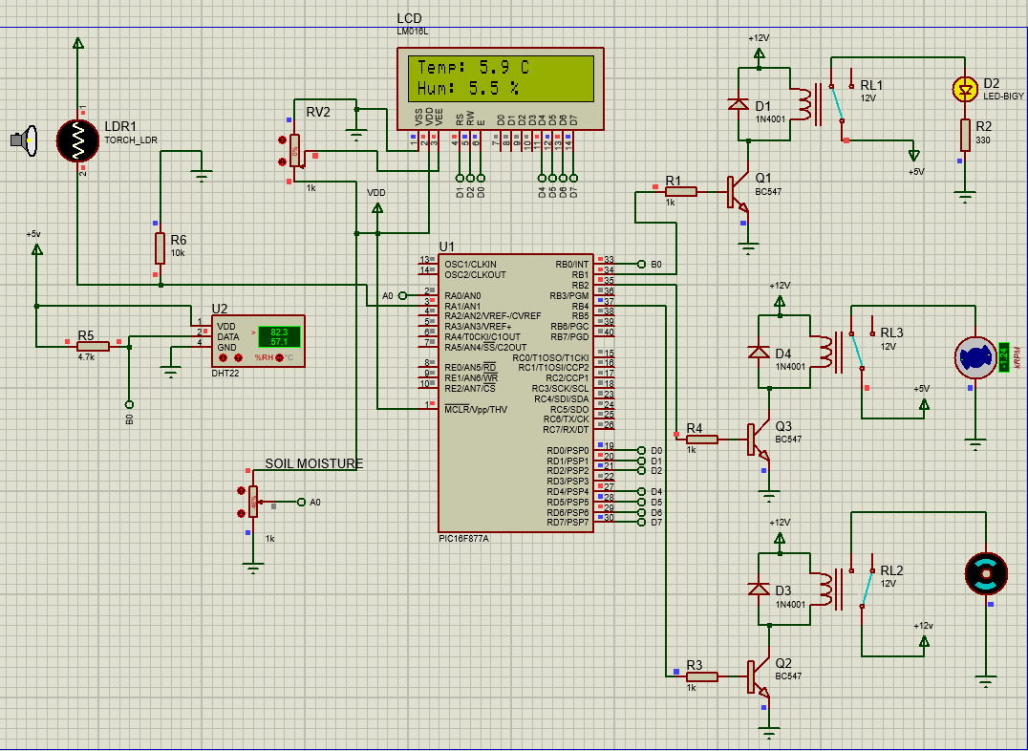

**2)Hardware Output**

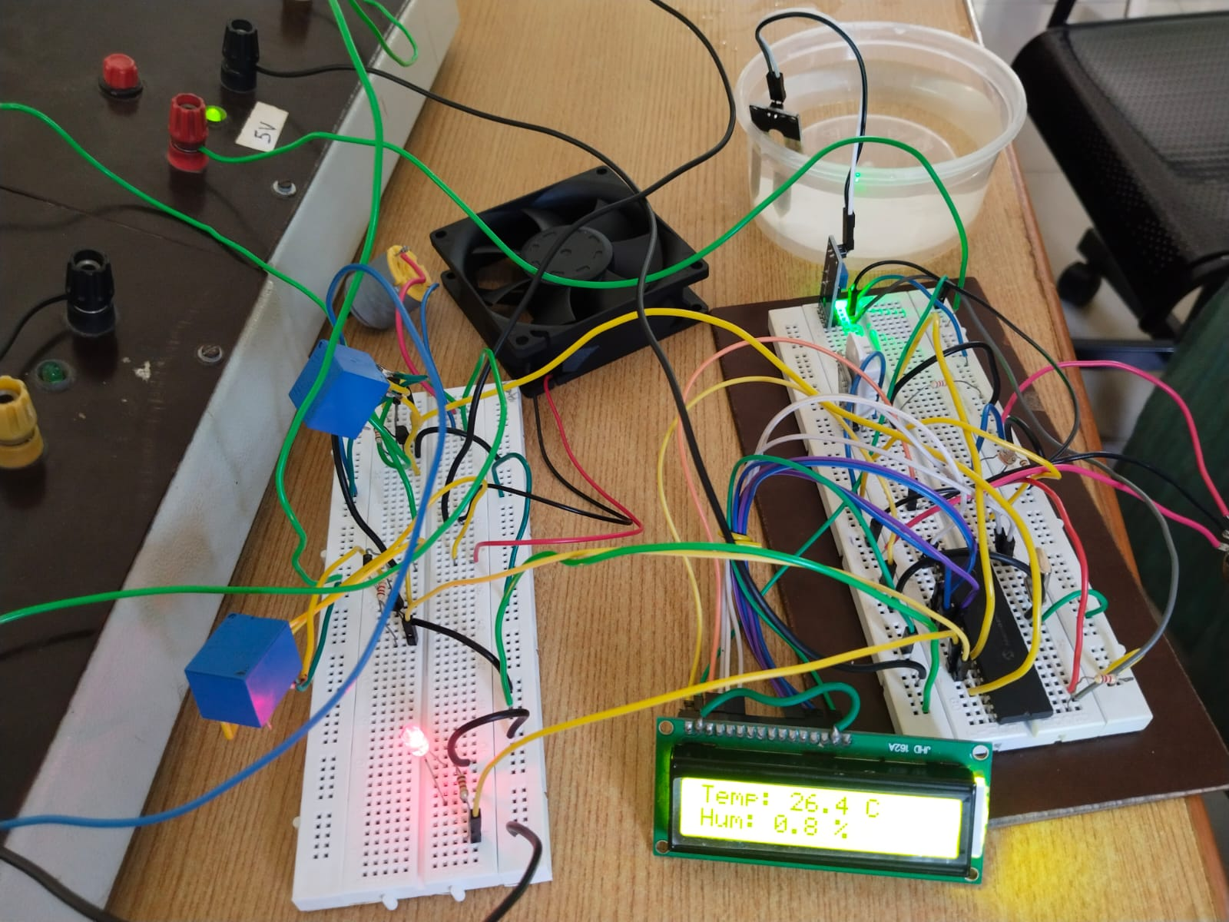

**VIDEO QR:**



**CHAPTER 4**

**CONCLUSION**

This project presents an automated greenhouse monitoring and control system using the PIC16F877A microcontroller to maintain optimal growing conditions with minimal manual intervention. By continuously monitoring temperature, humidity, light, and soil moisture, the system automates control of heating, cooling, ventilation, lighting, and irrigation. The automated response system ensures efficient resource use, reducing water and energy consumption while supporting crop yield and quality. This automation promotes sustainable agriculture, enabling precise environmental control for year-round cultivation, addressing challenges in agriculture due to climate variability and resource limitations. For Instance: Automated irrigation systems can conserve water by delivering precise amounts based on soil moisture data, while controlled lighting systems can reduce electricity consumption by adjusting to natural light availability. Ultimately, greenhouse monitoring systems are instrumental in modern agriculture, offering significant benefits such as increased productivity, reduced costs, and improved resource management. By leveraging these innovative technologies, farmers can achieve more sustainable and profitable farming practices, ensuring healthy crops and better-quality yields with less effort and fewer resources.