1. Import data into SPSS.
2. Go to Analyze then Descriptive Statistics and then Frequencies.
3. Select all qualitative variables (Use Ctrl for multiple selection) and move them to right window called variable(s).
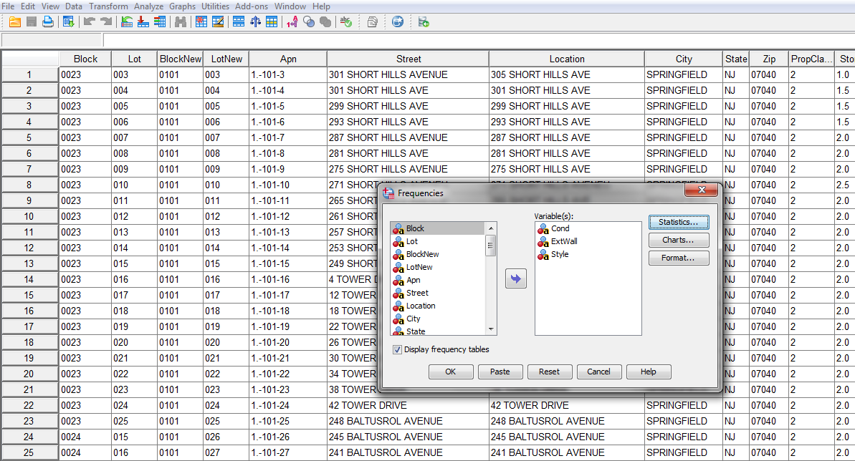
4. Make sure 'Display frequency tables' box is checked.
5. Go to statistics at the right (next to variable(s)) and make sure that nothing is selected in statistics.
6. Click OK and results will be displayed in the output window.
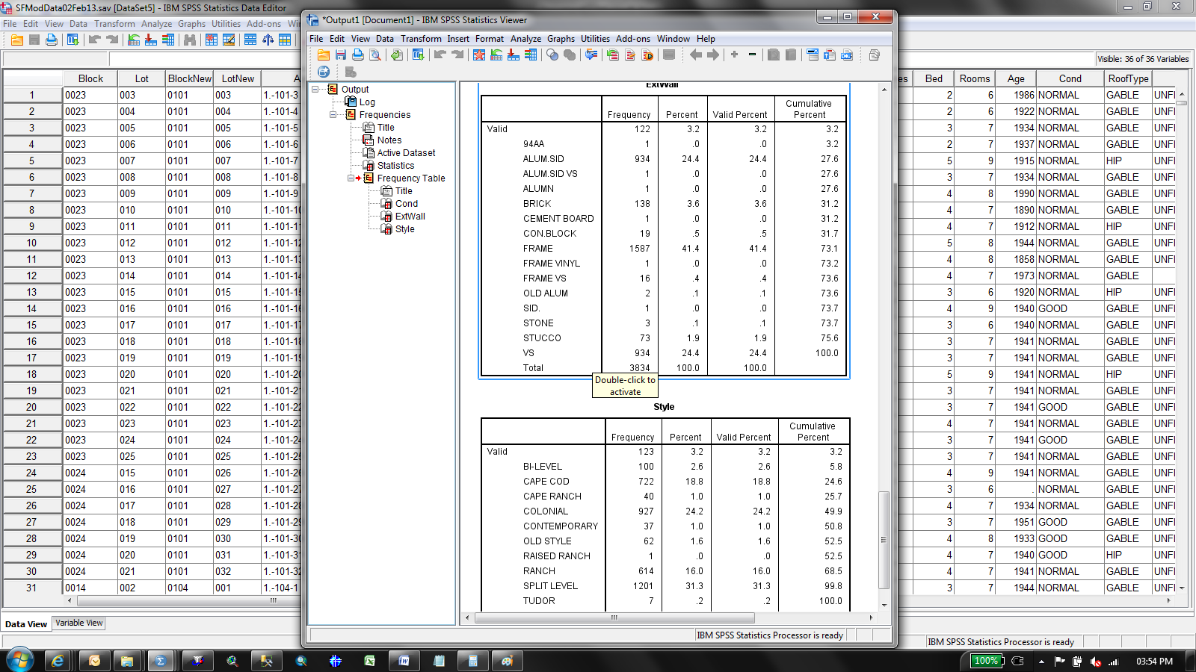
7. In the output window, left side, under frequency table, you can view the list variable names for which you run this statistics
8. Right click on the variable name and copy & paste it to the Spread Sheet. You may then remove percent , valid percent etc - these you may not want to include in your reports.
9. In the frequency output for each variables, the red one as shown below indicates the missing category and corresponding number in frequency is count of missing of that category. Likewise Green one is one of the types of category of ExtWall and count of records for that category is shown under frequency. For example, no of Good category for Cond variable is 1666, no of FrameVinyl for ExtWall variable is 1.
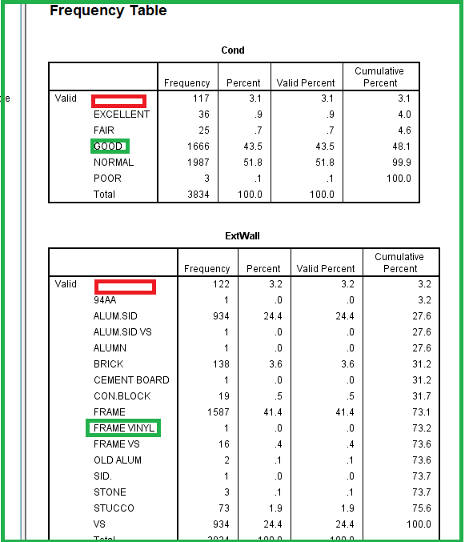

10. For quantitative variables, run means report in order to see if they have captured with zeros by including the min & max as your statistics options. If there is a zero, then select only those cases and run frequency, as shown above, to see the count of zero.
11. Go to Analyze then compare means and then means.
12. Select the quantitative variables and move it dependent list. Independent list can be left as a blank.
13. Then click on options to include Number of cases, minimum and maximum in the cell statistics and continue.
14. Click ok - it will generate means report in the output window as shown below.
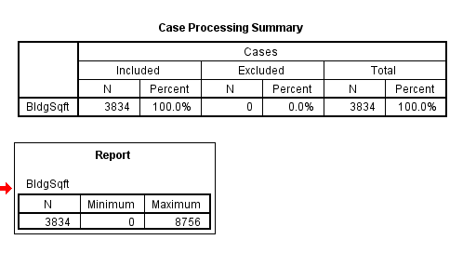
15. So there are a zeros in BldgSqft variable but not certain about the count. To know the count, select only zeros on the table and run frequency on them.
16. To select only zeros of BldgSqft for further frequency analysis, go to data in the task bar and choose select cases.
17. Select the variable from which you want to select the cases. Click on 'if Condition is satisfied' and if button. Selectcases:if window will now open. Select again the variable and move it to the box at the top as shown below.
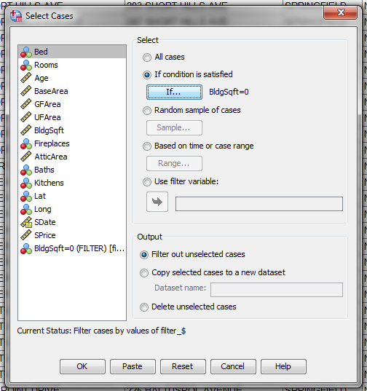

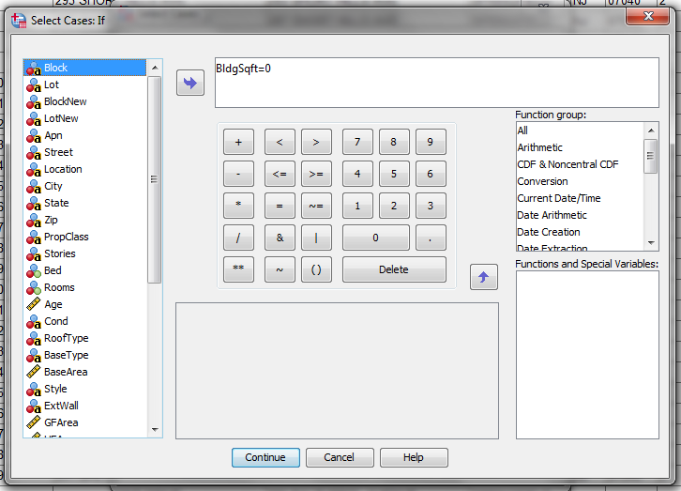
18. Then continue and OK. The zero cases will be selected at this stage.
19. Run a frequency on BldgSqft to see the count of Zero cases. As you run a frequency on BldgSqft, the output looks like as follows.
