Calculating Family Expenses in ServiceNow

Step 1: Create a New Table for Family Expenses
1. Go to: System Definition > Tables.
2. Click: New
3. Enter Details:
- Label: Family Expenses
- Name: u_family_expenses
- Auto Number: Yes (e.g., EXP0001)
- Extends: Task (or leave empty if standalone)
4. Click Submit.

Step 2: Add Fields to the Table
Go to the u_family_expenses table and add the following fields:
Field Label | Field Name | Type
Item Name | u_item_name | String
Category | u_category | Choice
Amount | u_amount | Currency
Date | u_date | Date
Notes | u_notes | String
Category Choices:
- Food
- Rent
- Utilities
- Education
- Medical
- Others

Step 3: Create a Form Layout
1. Go to: System UI > Forms
2. Design the layout to show:
- Item Name
- Category
- Amount
- Date
- Notes

Step 4: Create a Total Calculation Script
Let’s assume we want to calculate the monthly total for a given user or family.

Create a Script Include (Backend Logic)
1. Go to: System Definition > Script Includes
2. Click New
3. Fill in:
Name: CalculateMonthlyExpenses
Client Callable: True
Accessible from: All application scopes
Active: True
Add this code:
var CalculateMonthlyExpenses = Class.create();
CalculateMonthlyExpenses.prototype = {
initialize: function() {
},
getMonthlyTotal: function(month, year) {
var total = 0;
var gr = new GlideRecord('u_family_expenses');
gr.addQuery('MONTH(u_date)', month);
gr.addQuery('YEAR(u_date)', year);
gr.query();
while (gr.next()) {
total += parseFloat(gr.u_amount);
}
return total;
},
type: 'CalculateMonthlyExpenses'
};

Step 5: Client Script to Show Total on Form
1. Go to: Client Scripts for the table.
2. Click New and use:
// Client Script
function onLoad() {
var month = new Date().getMonth() + 1; // JavaScript months are 0-based
var year = new Date().getFullYear();
var ga = new GlideAjax('CalculateMonthlyExpenses');
ga.addParam('sysparm_name', 'getMonthlyTotal');
ga.addParam('month', month);
ga.addParam('year', year);
ga.getXMLAnswer(function(response) {
var total = response;
g_form.addInfoMessage('Total expenses for this month: ₹' + total);
});
}

Step 6: Create a Report
1. Go to: Reports > Create New
2. Name: Monthly Expense Report
3. Table: u_family_expenses
4. Type: Bar or Pie Chart
5. Group by: Category
6. Aggregation: Sum of Amount

Optional Enhancements
- Use a scheduled job to send email alerts if expenses exceed a certain threshold.
- Add user-based filtering if multiple family members use the same system.

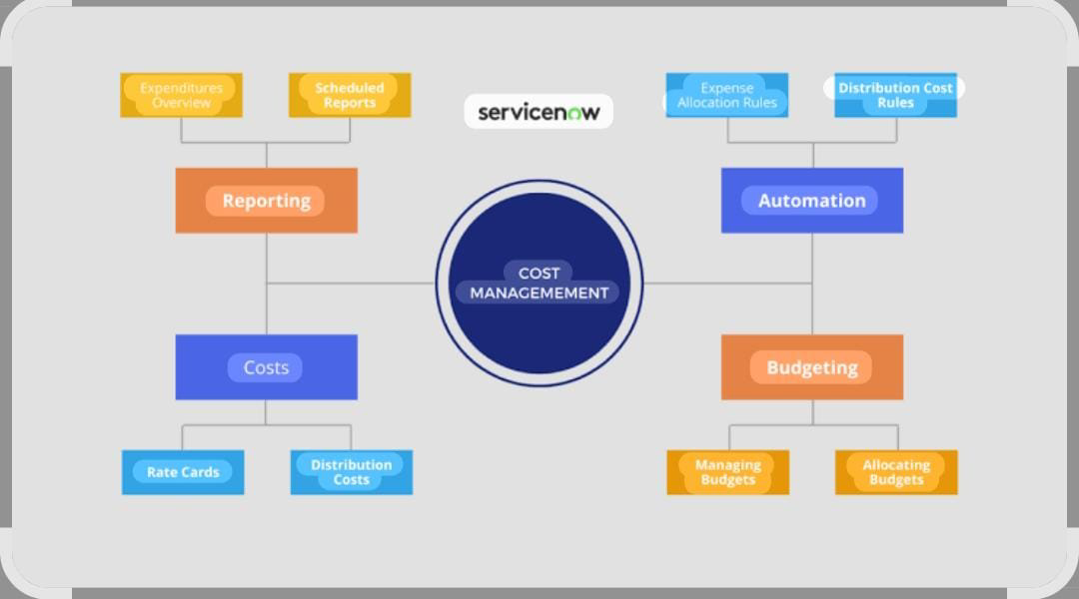

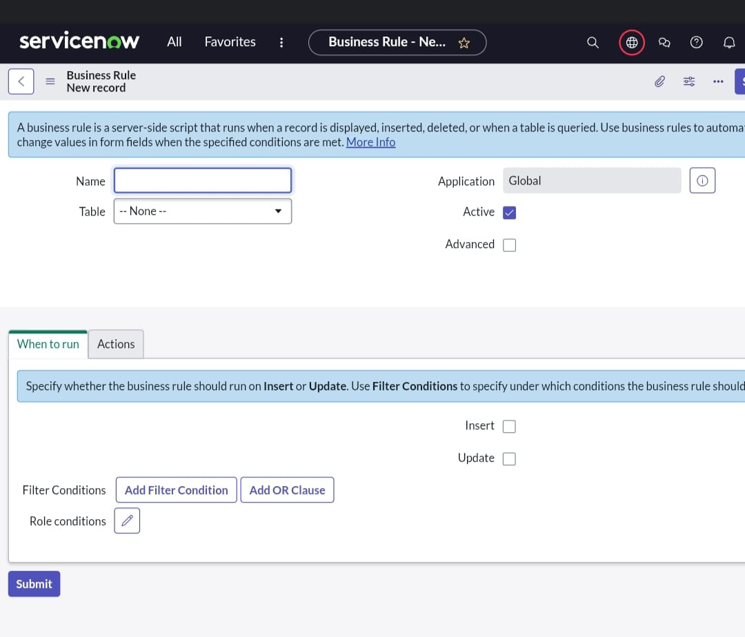

8. ADVANTAGES & DISADVANTAGES

Advantages:
- Automated expense summarization.
- Easy to add daily expenses.
- Report generation.
- Scalable for different family sizes.

Disadvantages:
Basic UI (ServiceNow default forms).
- Requires ServiceNow platform access.

9. CONCLUSION

The "Calculating Family Expenses" project successfully demonstrates how ServiceNow can be used beyond IT service management. It automates manual tasks, offers visibility into financial data, and helps families control their spending patterns.

Dataset Link:
GitHub & Project Demo Link:
https://github.com/dhanaLakshmi270121/Calculating-family-Expenses-Using-Service-Now-.git

