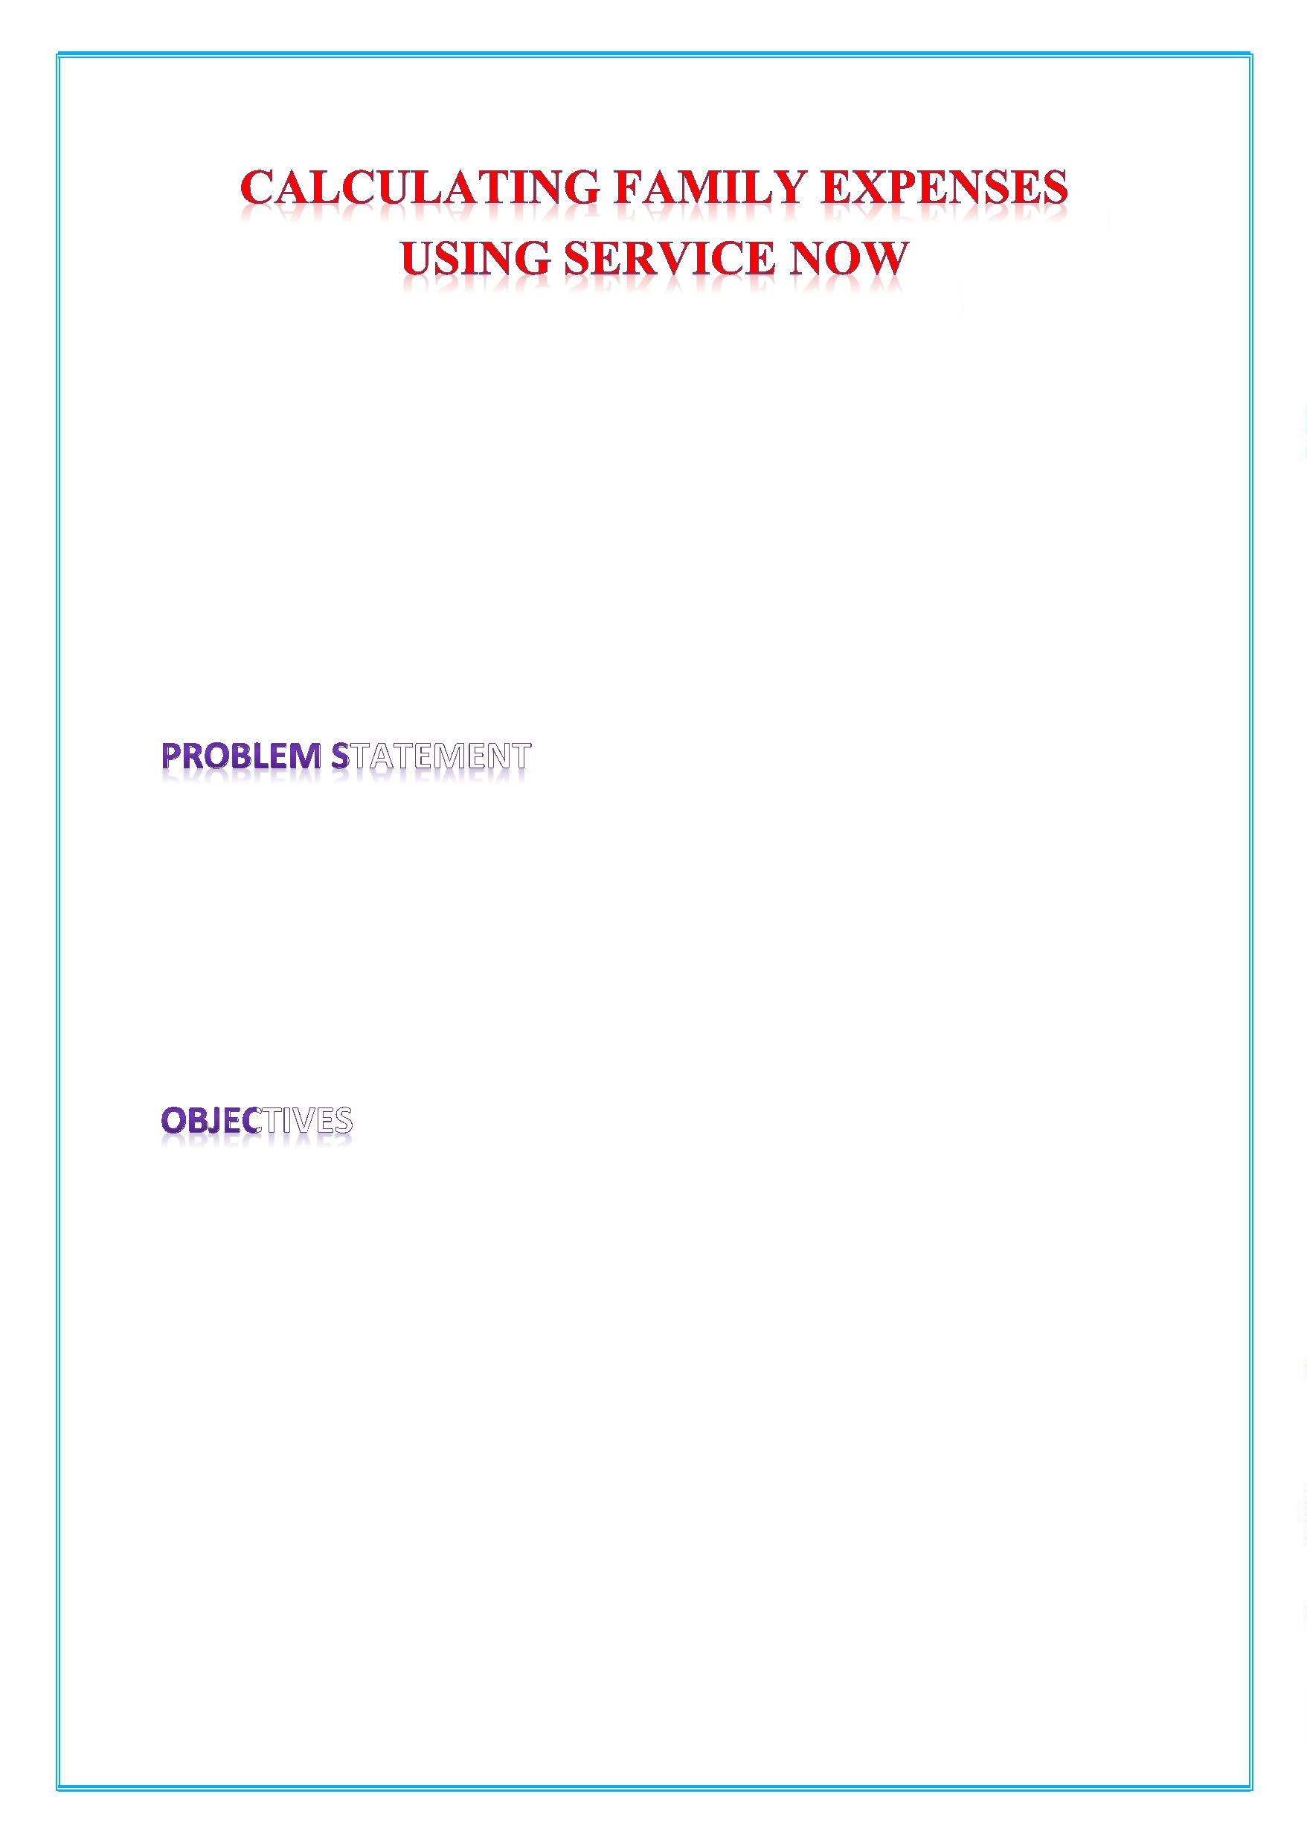
TEAM ID : NM2025TMID16319
Team Size : 4
Team Leader : Essath Nisha. E
Team Member : Gomathi . G
Team Member : Dhanalakshmi. D
Team Member : Sivadharshini. R
Managing family expenses can be a hassle, often involving disjointed
methods like spreadsheets, paper receipts, or various mobile apps
that don't offer a unified view. This leads to a lack of transparency,
difficulty in tracking spending, and a time-consuming process for
reconciling shared costs.
• Centralized Expense Submission: Create a portal or interface
family members can easily submit expense reports with details
category, amount, date, and a brief description.

- automatically routes expense reports to the appropriate family member
for approval (e.g., a parent or designated family accountant). This reduces manual effort and speeds up the reimbursement process.
• Real-Time Tracking and Visibility: Provide a dashboard where
family members can view the status of their submitted expenses
(e.g., pending, approved, rejected) and see a real-time summary
of their spending.

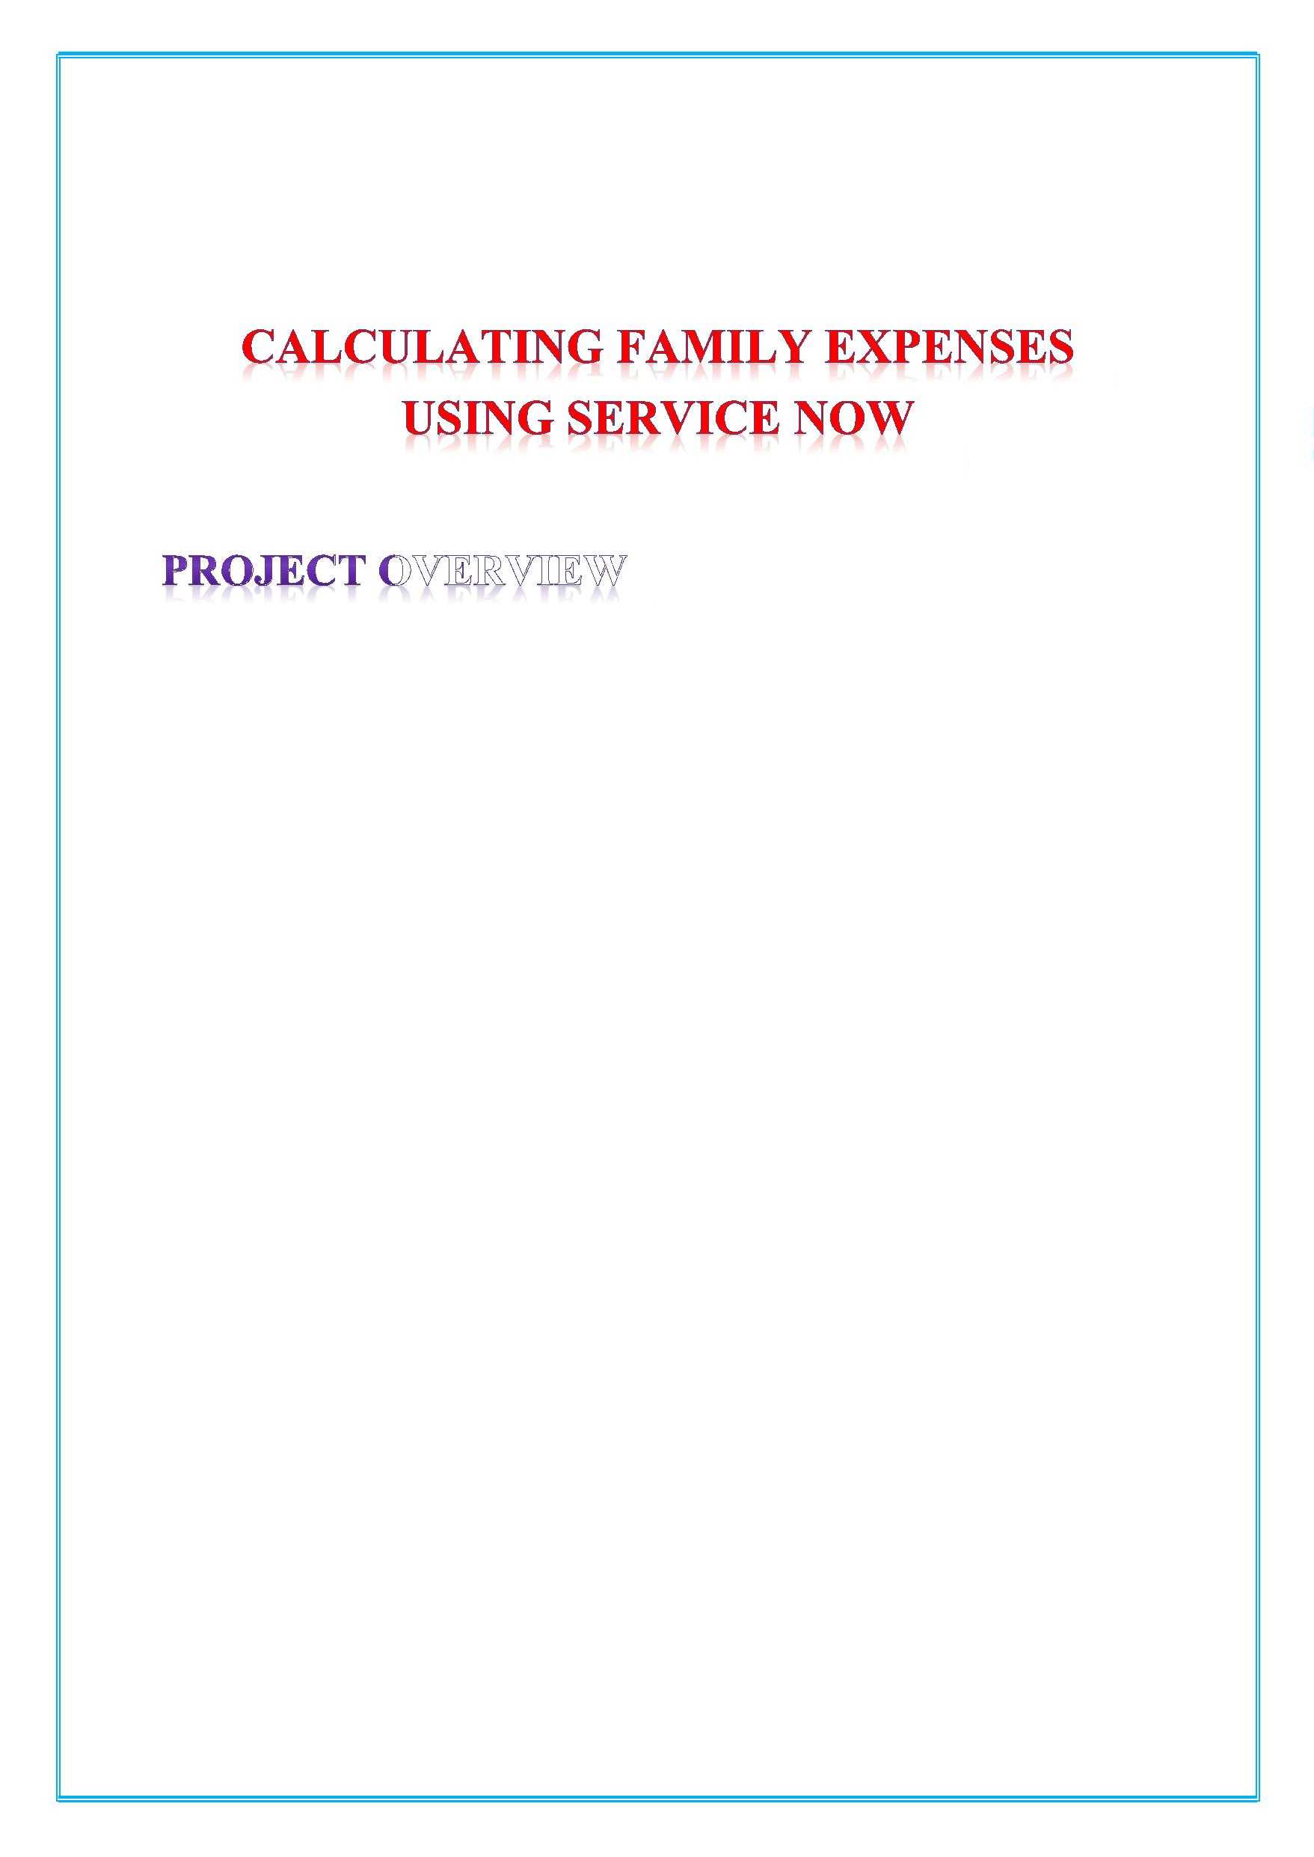
The project aims to develop a comprehensive expense
calculation system using ServiceNow . This system will
enable users to track and manage family expenses
efficiently. It will include features such as expense
categorization, budget setting, real-time tracking, and
reporting capabilities. Utilizing ServiceNow's robust
platform, the project will ensure seamless integration,
user-friendly interface, and scalability to accommodate
varying family sizes and financial complexities. The end
goal is to empower users with the tools they need to make
informed financial decisions and promote financial well-
being within the family unit.


Milestone 1: ServiceNow Instance
Activity 1: Setting up ServiceNow Instance
Setting up ServiceNow Instance
1. Sign up for a developer account on the ServiceNow
Developer site “https://developer.servicenow.com”.
2. Once logged in, navigate to the "Personal Developer
Instance" section.
3. Click on "Request Instance" to create a new
ServiceNow instance.
4. Fill out the required information and submit the
request.
5. You'll receive an email with the instance details once
it's ready.
6. Log in to your ServiceNow instance using the
provided credentials.
7. Now you will navigate to the ServiceNow.

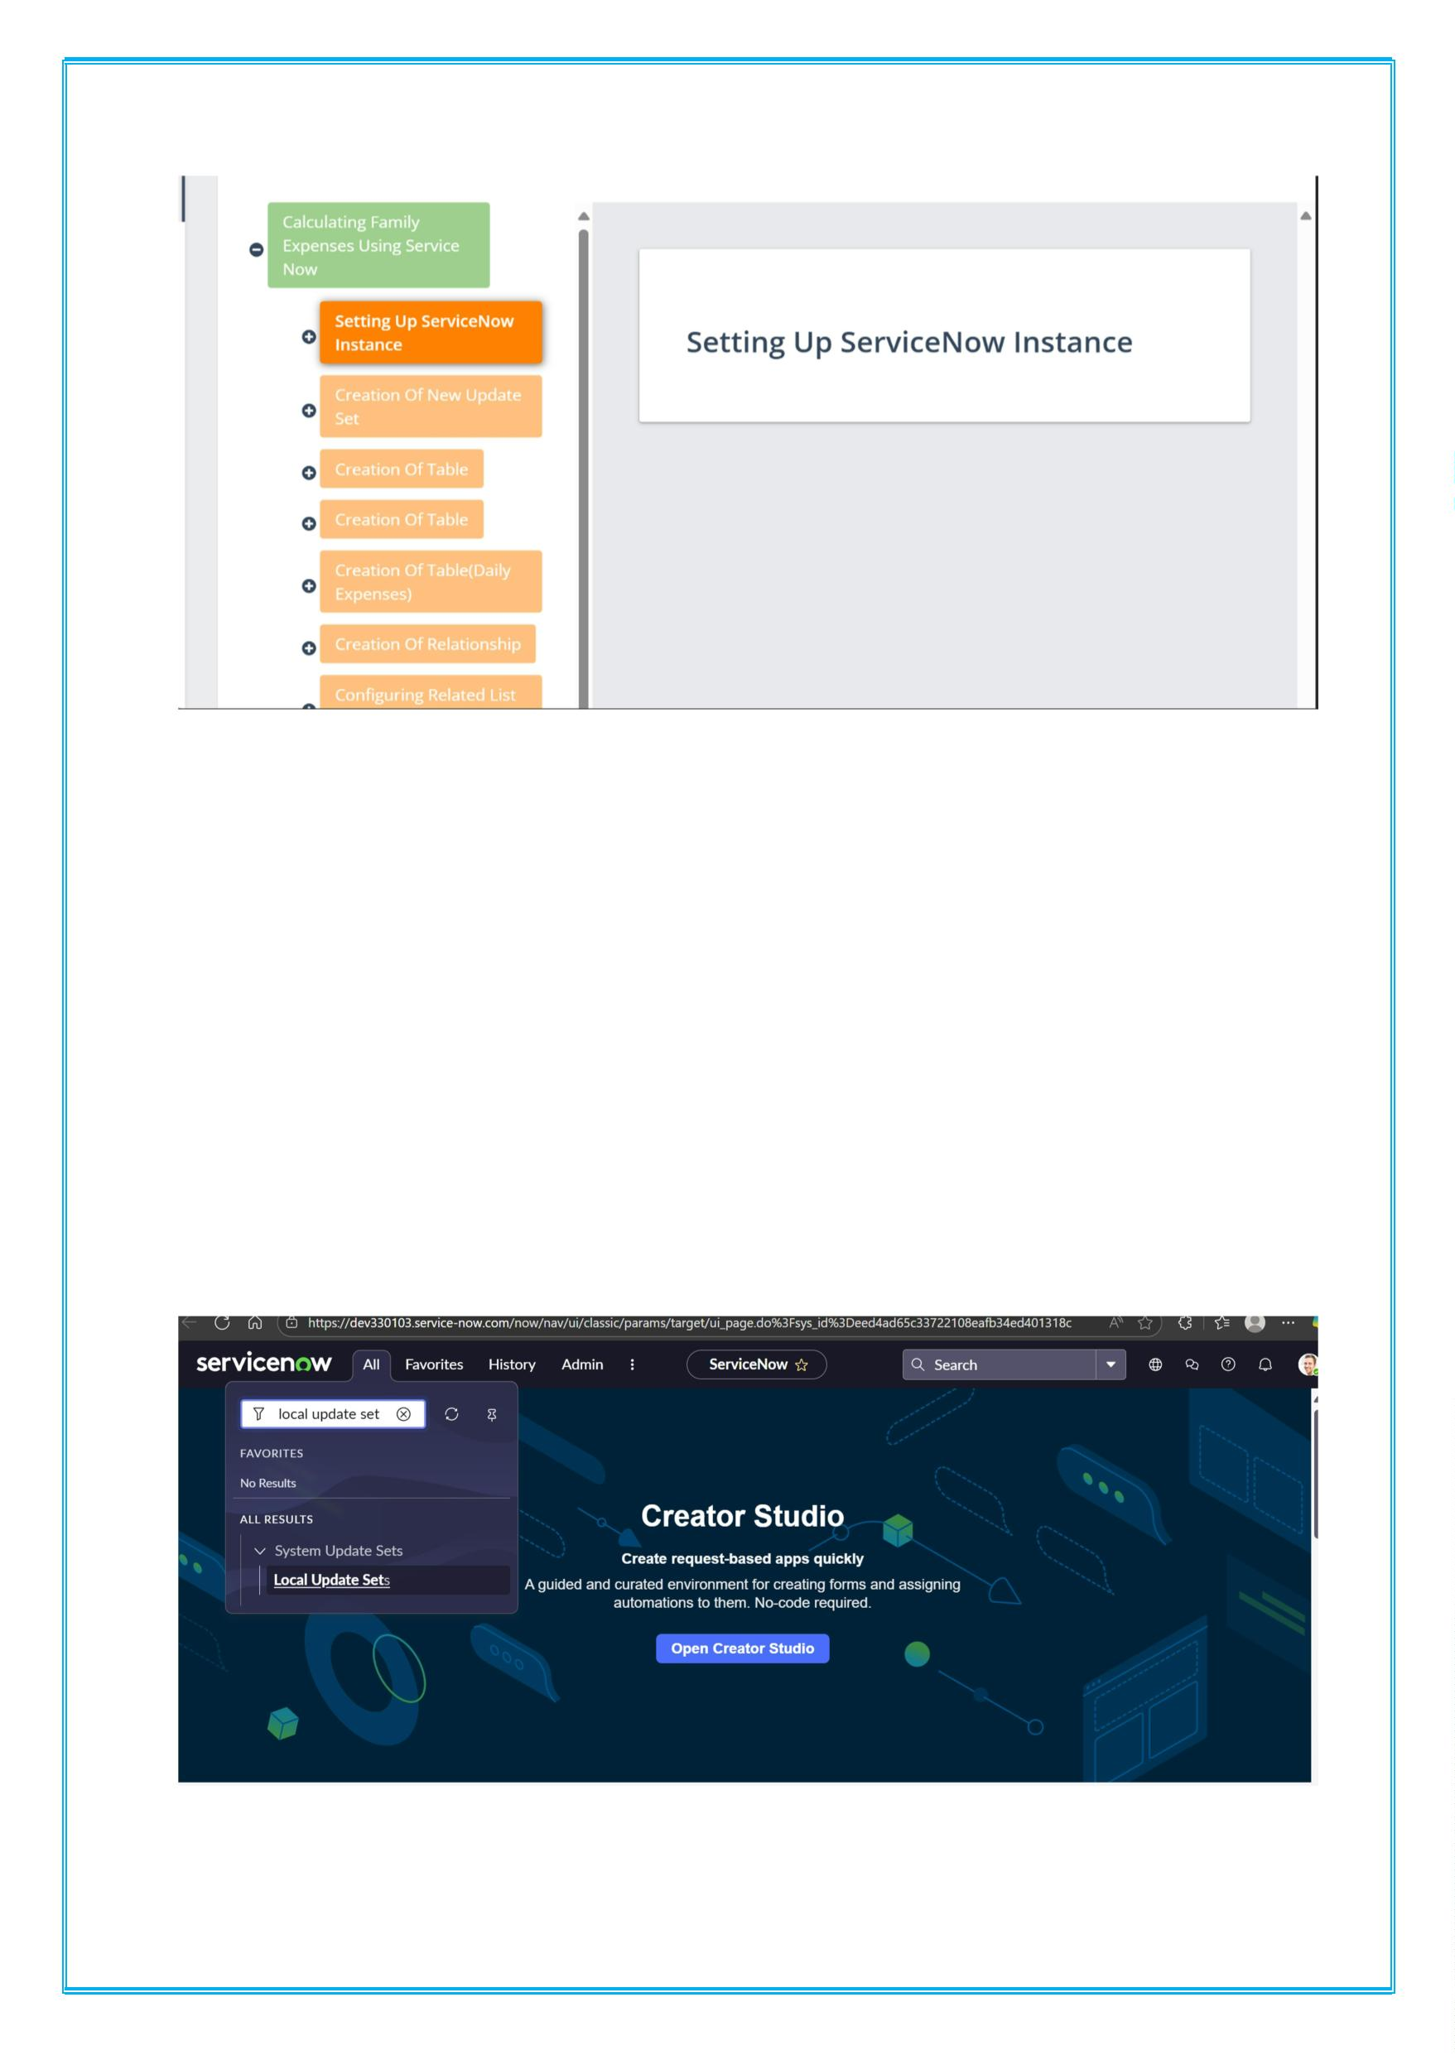
Milestone 2: Creation of New Update Set
Activity 1: Creation of New Update Set
1. Go to All >> In the filter search for Local Update set
> click on New.
1. Enter the Details as:

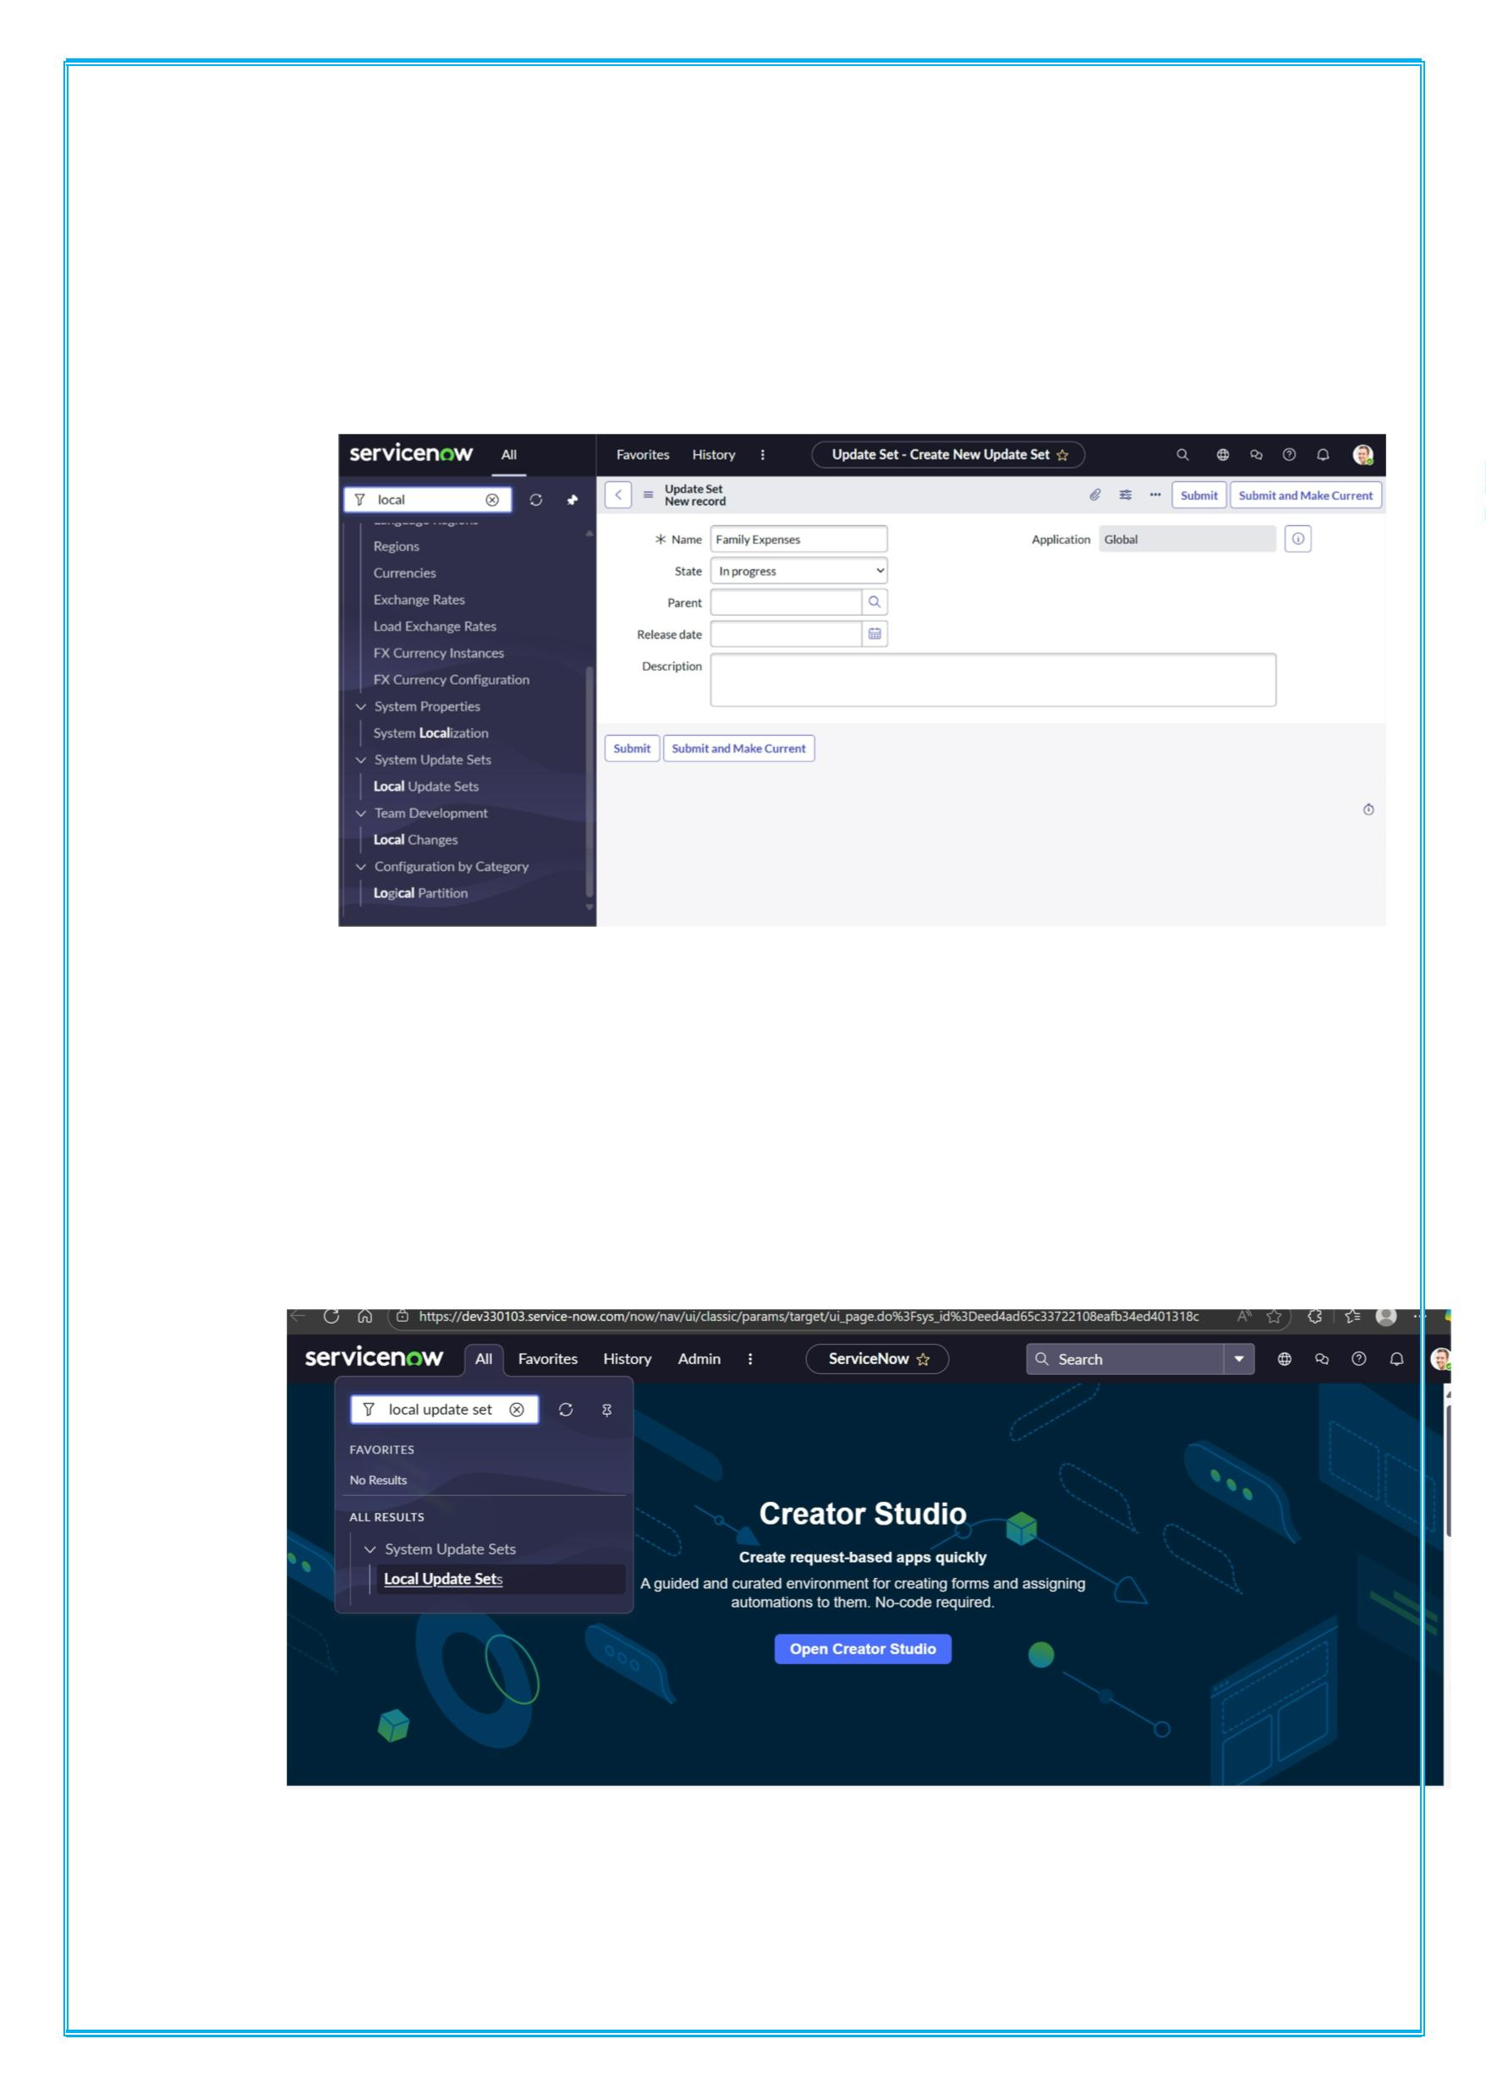
i Name: Family Expenses
2. Then click on Submit and Make current.
i
Milestone 3:New Update Set
Activity 1: Creation of New Update Set
1. Go to All >> In the filter search for Local Update set >
click on New.
a)
2. Enter the Details as:

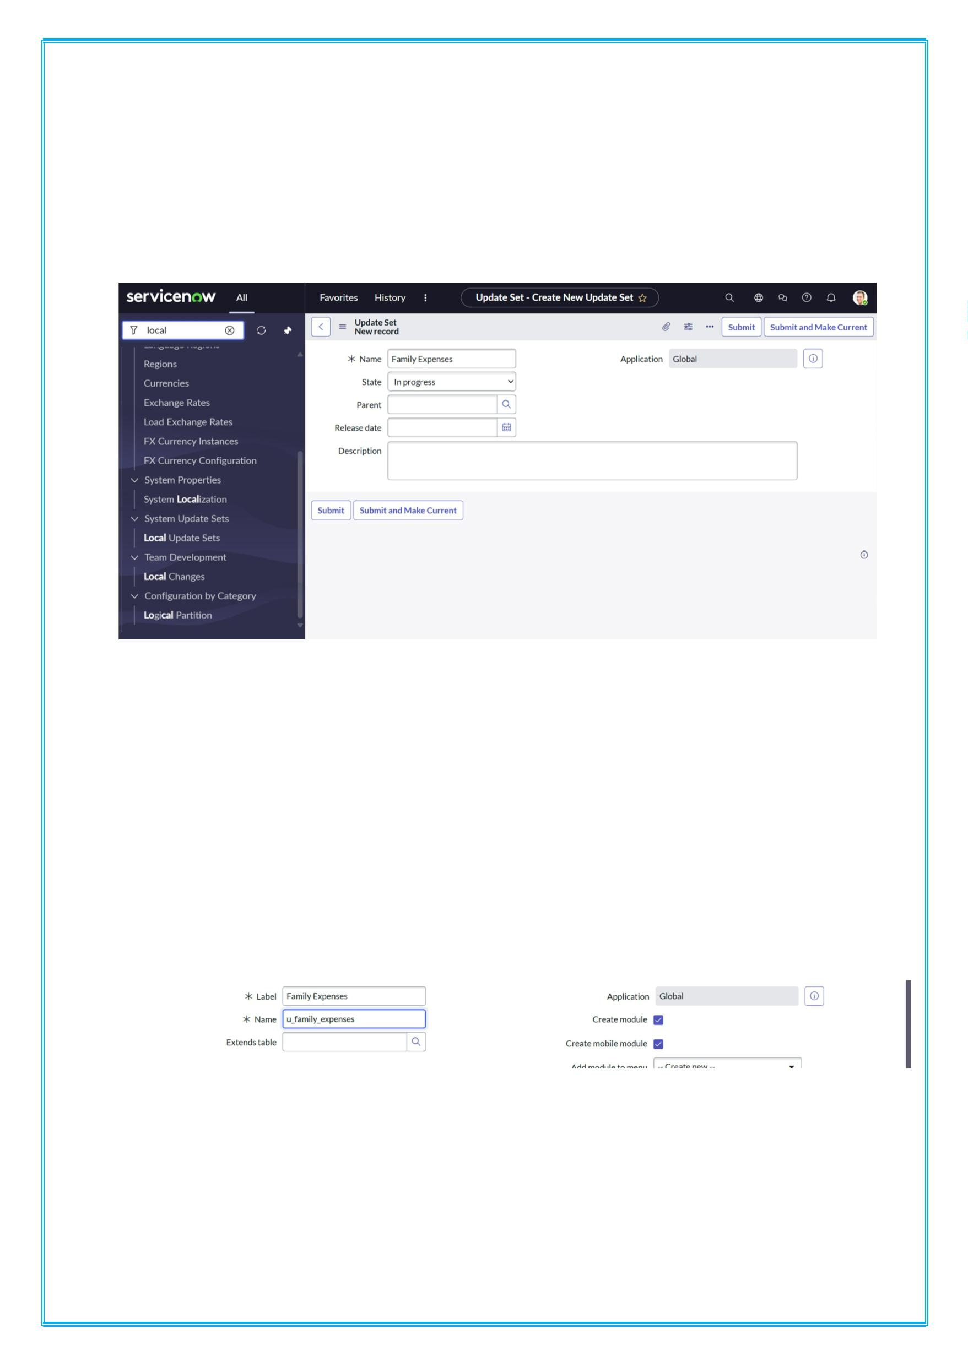
i Name: Family Expenses
3. Then click on Submit and Make current
Milestone 4: Tables
Activity 1: Creation of Family Expenses Table
1. Go to All > In the filter search for Tables > click on New.
2. Enter the Details:
i Label: Family Expenses
ii Name: Auto-Populated
iii New menu name: Family Expenditure
3.
4. Go to the Header and right click there>> click on Save.

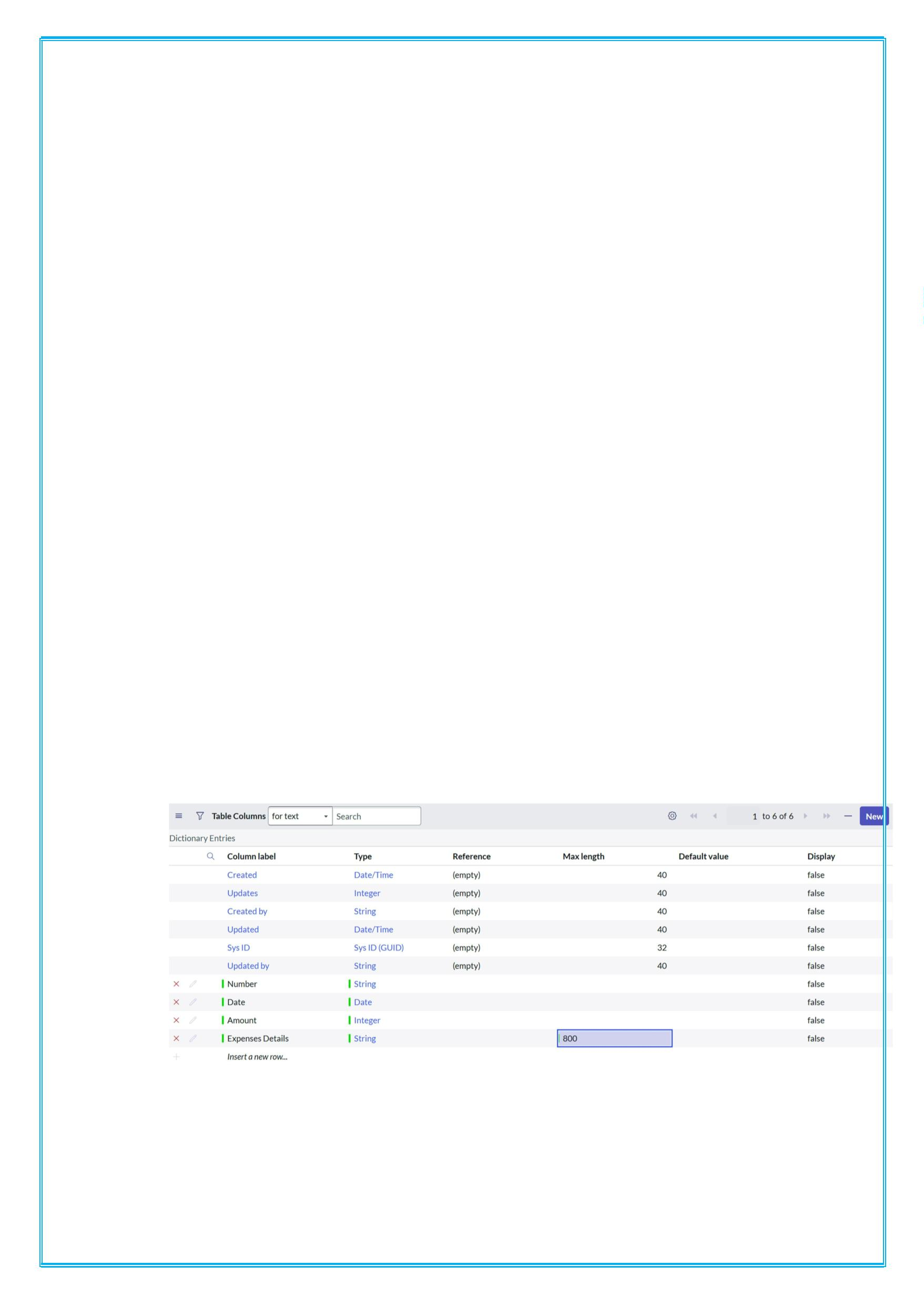
Creation of Columns (Fields)
1. Near Columns Double click near insert a new row.
2. Give the details as:
a) Column label: Number
b) Type: String
3. Double click on insert a new row again
4. Give the details as:
a) Column label: Date
b) Type: Date
5. Double click on insert a new row again
6. Give the details as:
a) Column label: Amount
b) Type: Integer
7. Double click on insert a new row again
8. Give the details as:
a) Column label: Expense Details
b) Type: String
c) Max length: 800
9.Go to the Header and right click there>> click on Save.

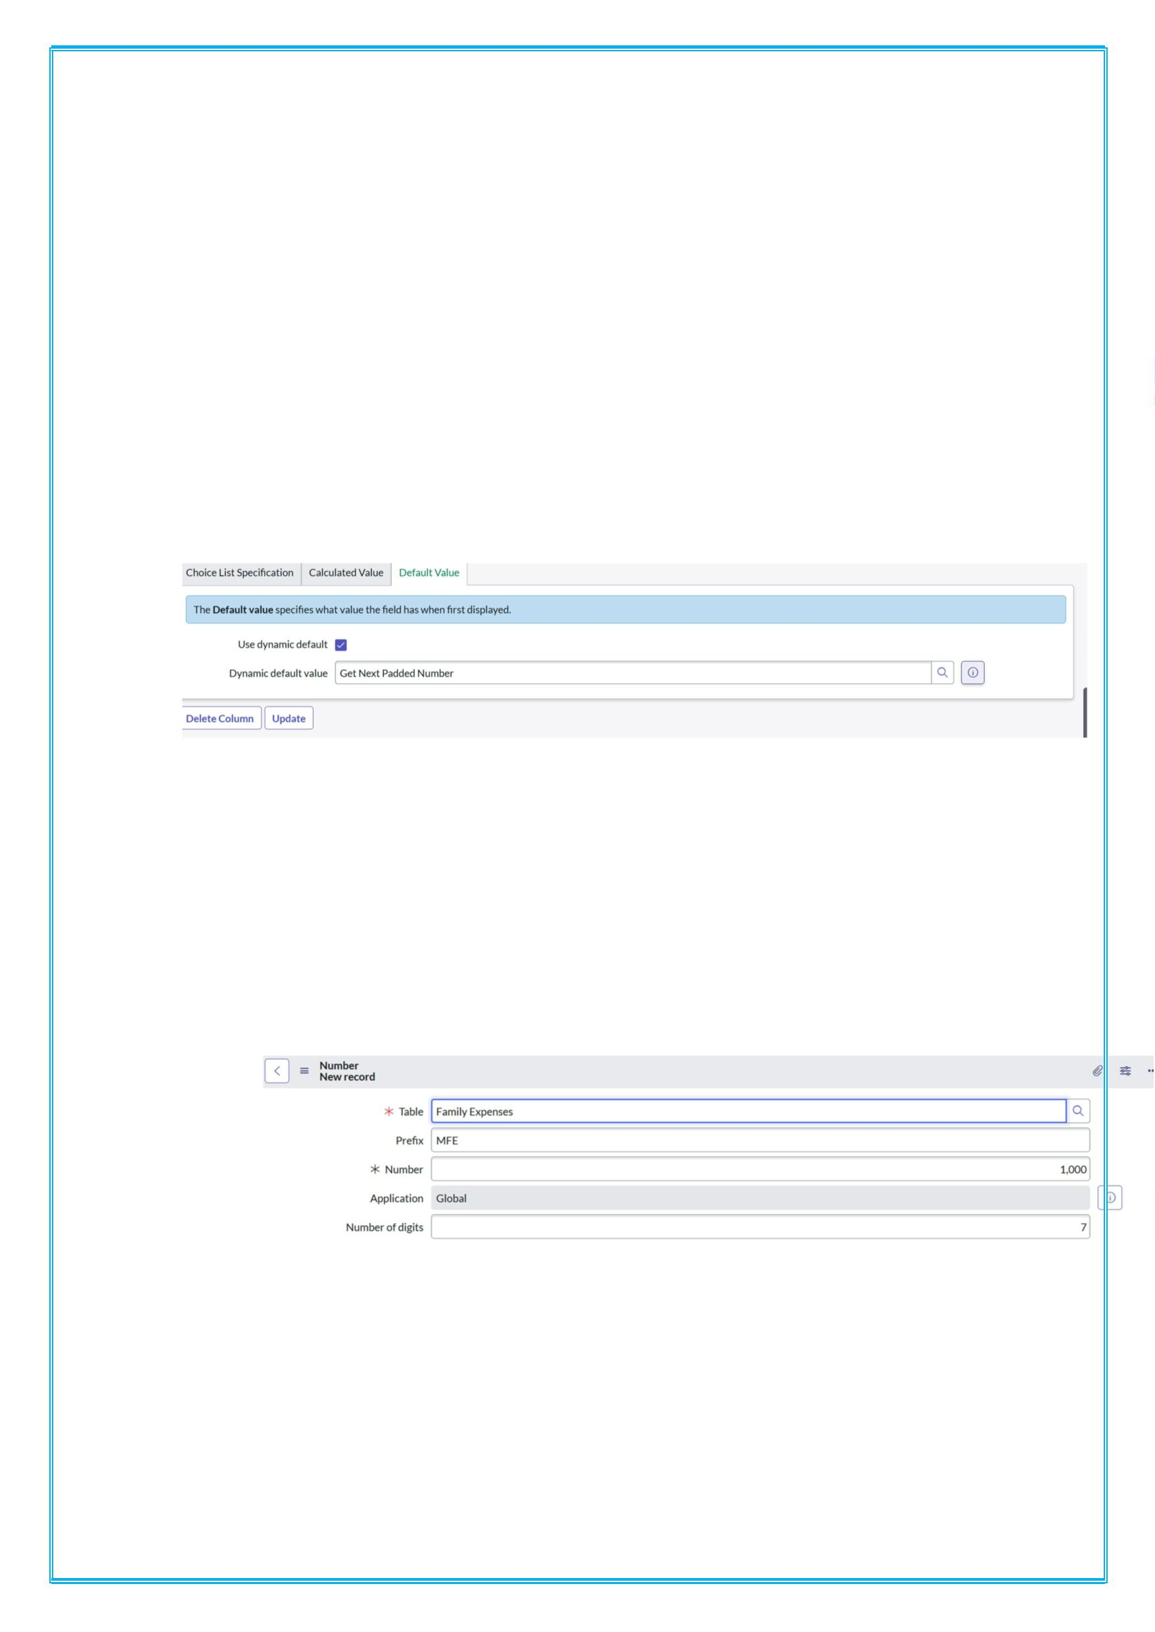
Making Number Field an Auto-Number
1. Double click on the Number Field/Column.
2. Go down and double click on Advanced view
3. In Default Value:
i Use dynamic default: check the box
ii Dynamic default value: Get Next Padded Number
4. Click on Update.
5.
6. Go to All >> In the filter search for Number
Maintenance >> select Number Maintenance
7. Click on New.
8. Enter the below Details:
i Table: Family Expenses
ii Prefix: MFE
iii
9. Click on Submit.
Configure the Form

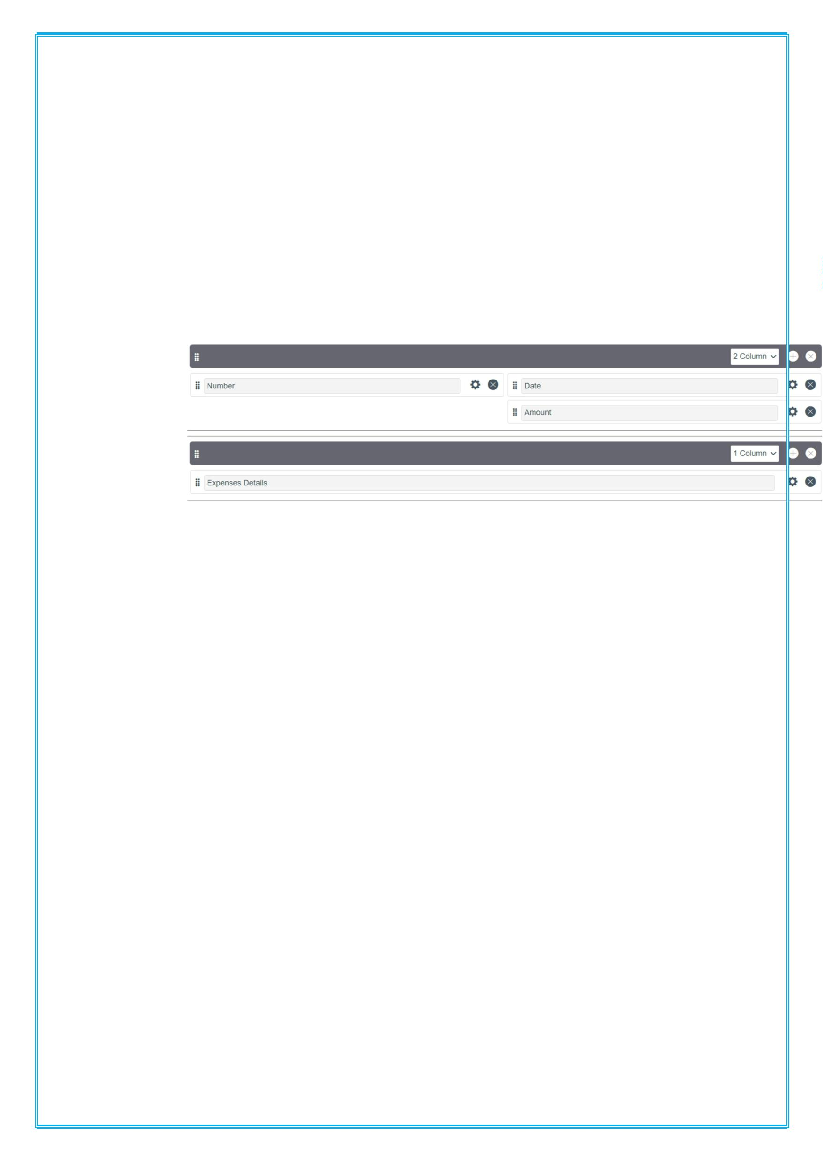
1. .Go to All >> In the filter search for Family Expenses
>> Open Family Expenses
2. Click on New
3. Go to the Header and right click there>> click on
Configure >> Select Form Design
4. Customize or Drag Drop the form as per your
requirement.
i
5.Make Number Read-Only Field by clicking on the gear
icon and checking Read-Only
6.Make Date, Amount Mandatory Field by clicking on the
gear icon and checking Mandatory
7.Click on Save
Milestone 5: Create of table
Activity 1: Creation of Daily Expenses Table
1. Go to All > In the filter search for Tables > click on
New.
2. Enter the Details:
i Label: Daily Expenses
ii Name: Auto-Populated
iii Add Module to menu: Family Expenditure

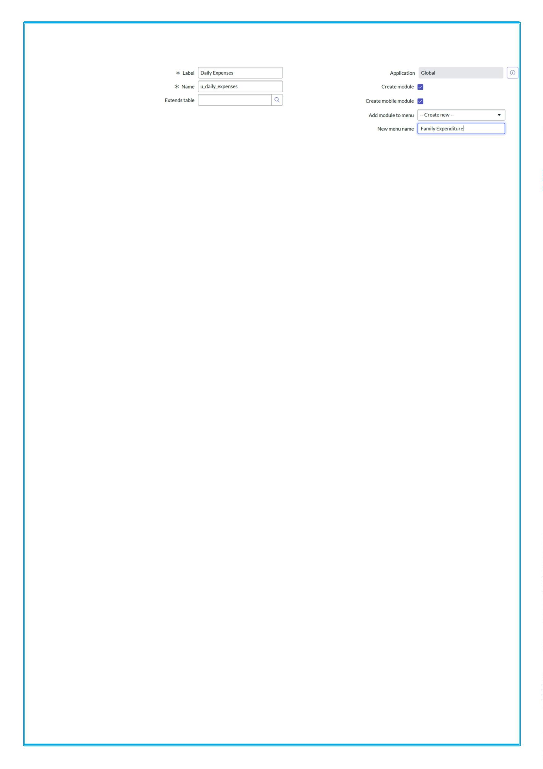
iv
3. Go to the Header and right click there>> click on Save.
Creation of Columns(Fields)
1. Near Columns Double click near insert a new row.
2. Give the details as:
a) Column label: Number
b) Type: String
3. Double click on insert a new row again
4. Give the details as:
a) Column label: Date
b) Type: Date
5. Double click on insert a new row again
6. Give the details as:
a) Column label: Expense
b) Type: Integer
7. Double click on insert a new row again
8. Give the details as:
a) Column label: Family Member Name
b) Type: Reference
c) Max length: 800
9. Double click on insert a new row again
10. Give the details as:
a) Column label: Comments
b) Type: String
c) Max length: 800

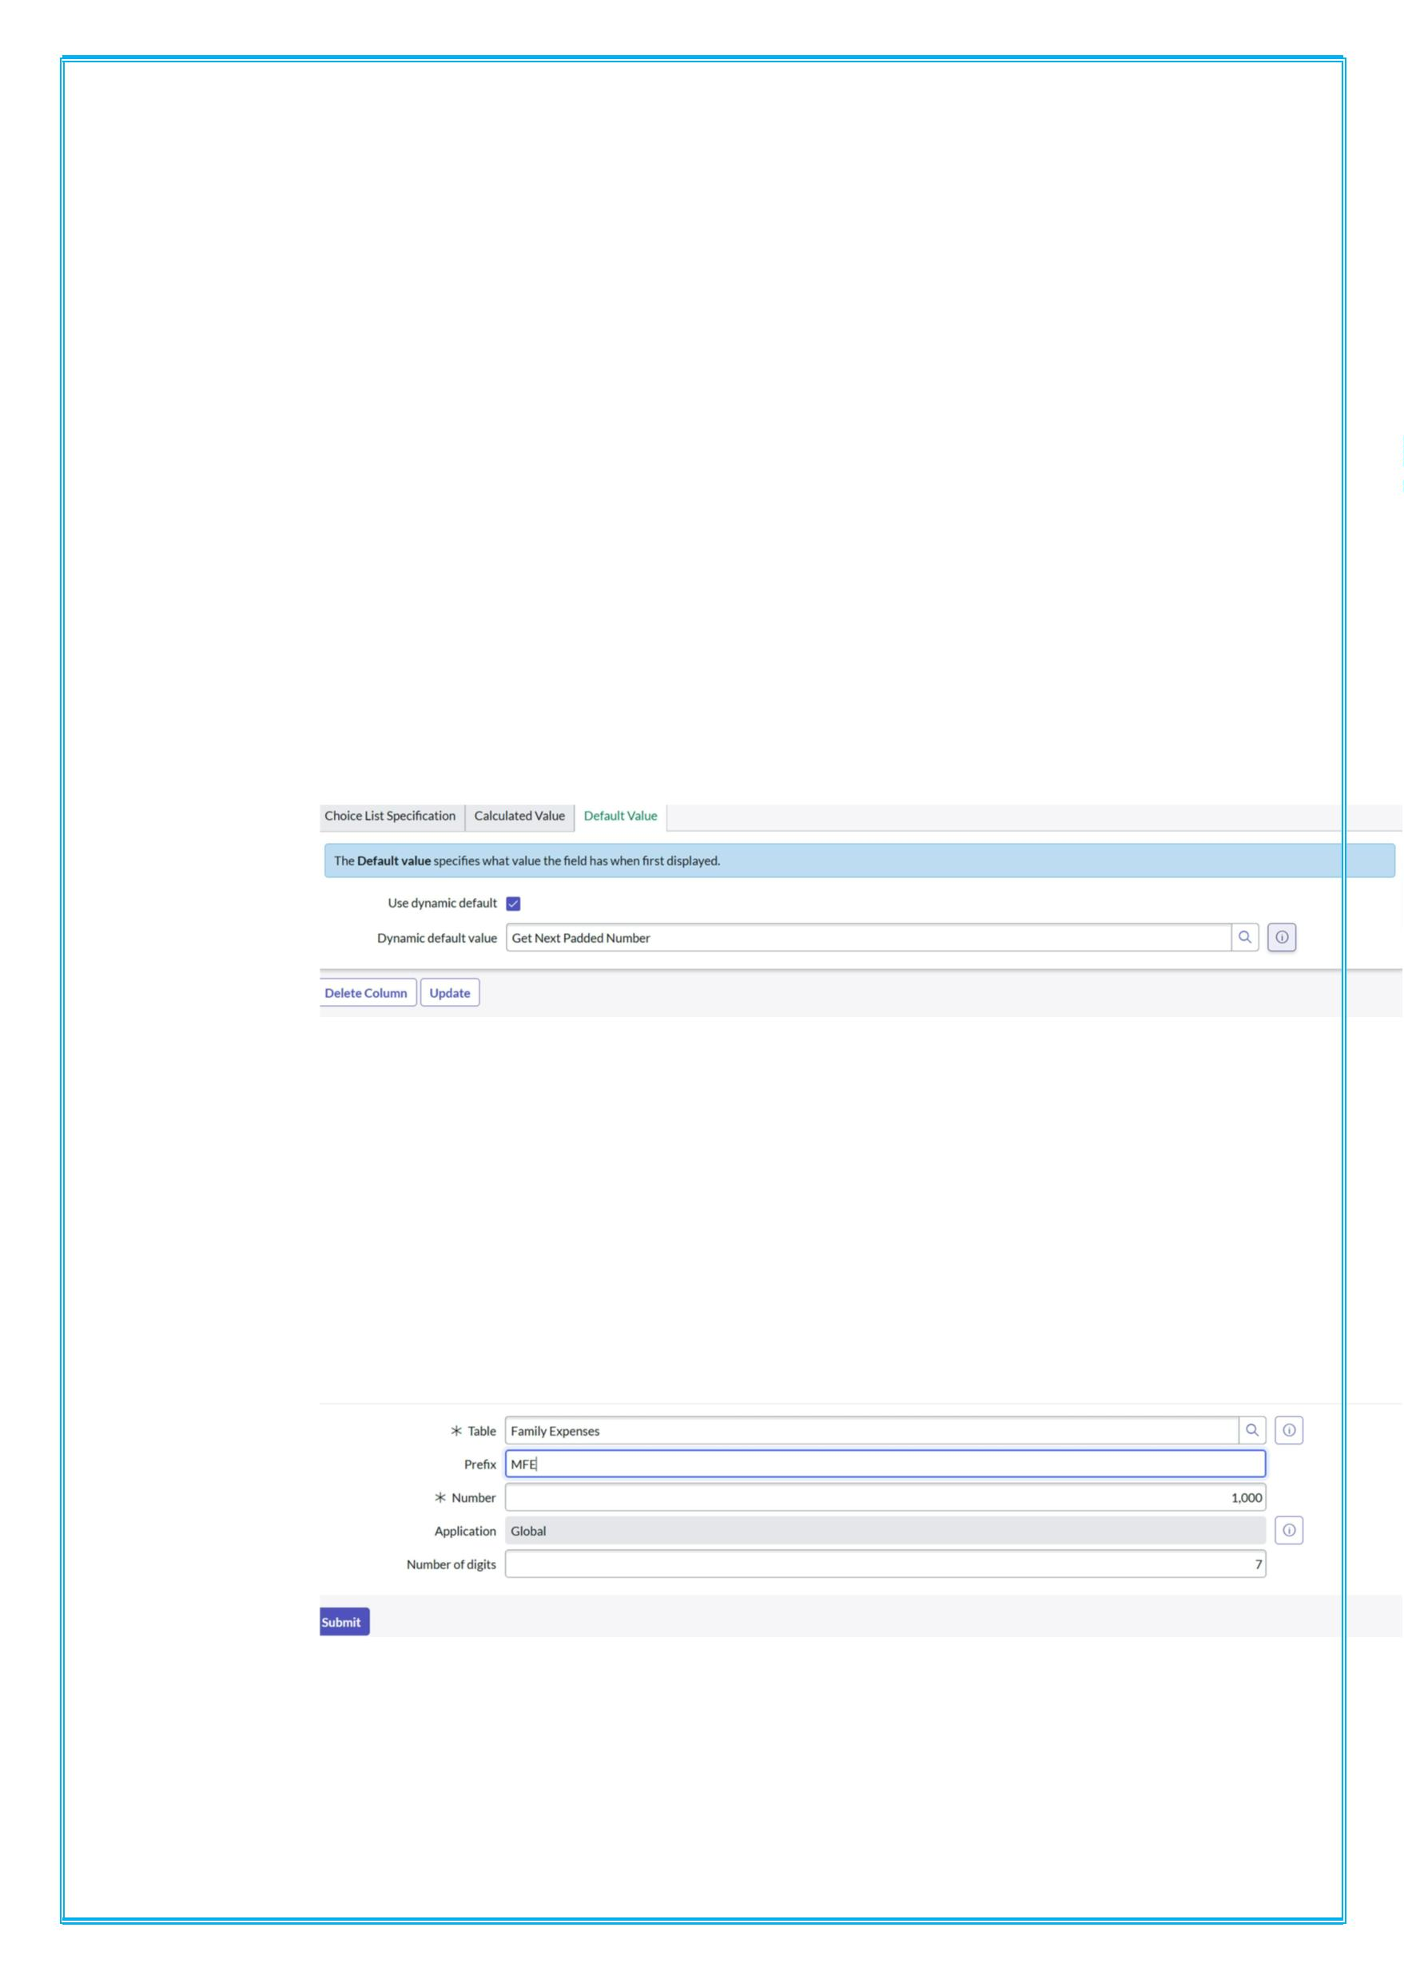
11.Go to the Header and right click there>> click on Save.
Making Number Field an Auto-Number
1. Double click on the Number Field/Column.
2. Go down and double click on Advanced view
3. In Default Value:
i Use dynamic default: check the box
ii Dynamic default value: Get Next Padded Number
4. Click on Update.
i
5. Go to All >> In the filter search for Number
Maintenance >> select Number Maintenance
6. Click on New.
7. Enter the below Details:
i Table: Family Expenses
ii Prefix: MFE
iii
8. Click on Submit.

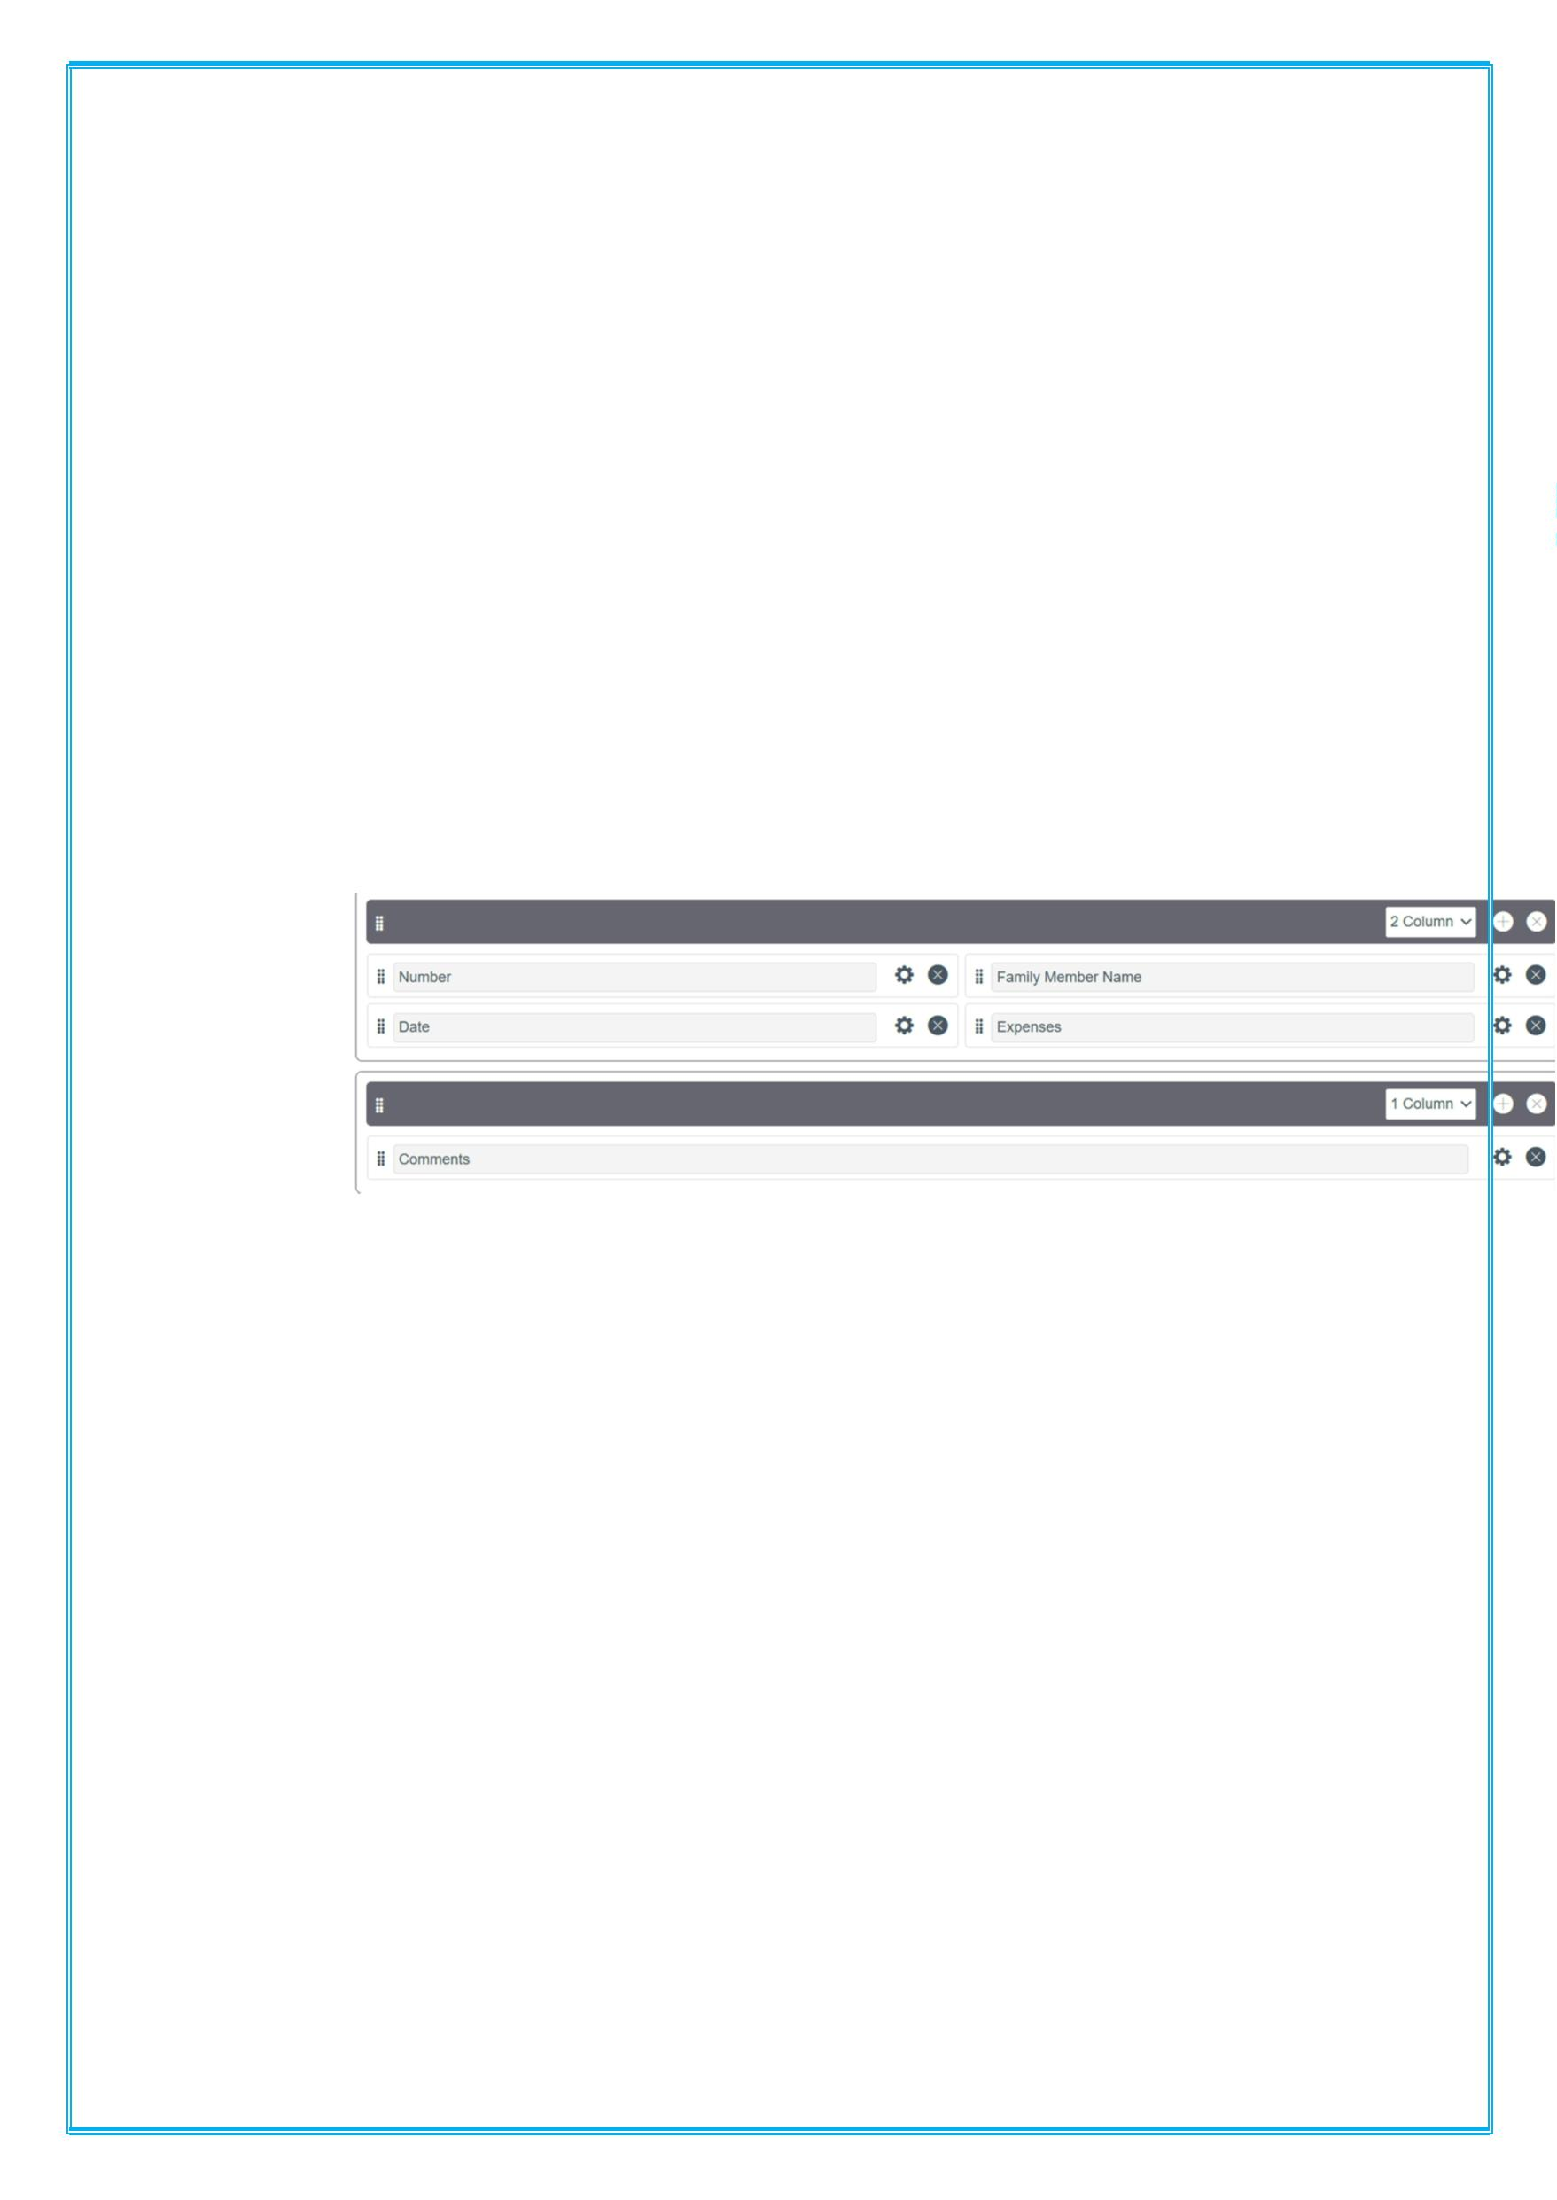
Configure the Form
1. Go to All >> In the filter search for Daily Expenses >>
Open Daily Expenses
2. Click on New
3. Go to the Header and right click there>> click on
Configure >> Select Form Design
4. Customize or Drag Drop the form as per your
requirement.
i
5. Make Number Read-Only Field by clicking on the gear
icon and checking Read-Only
6. Make Date, Family Member Name Mandatory Field by
clicking on the gear icon and checking Mandatory
7. Click on Save
Milestone 6: Creation of Relationship
Activity 1: Creation of Relationship between Family
Expenses and Daily Expenses tables
1. Go to All >> In the filter search for Relationships
>> Open Relationships

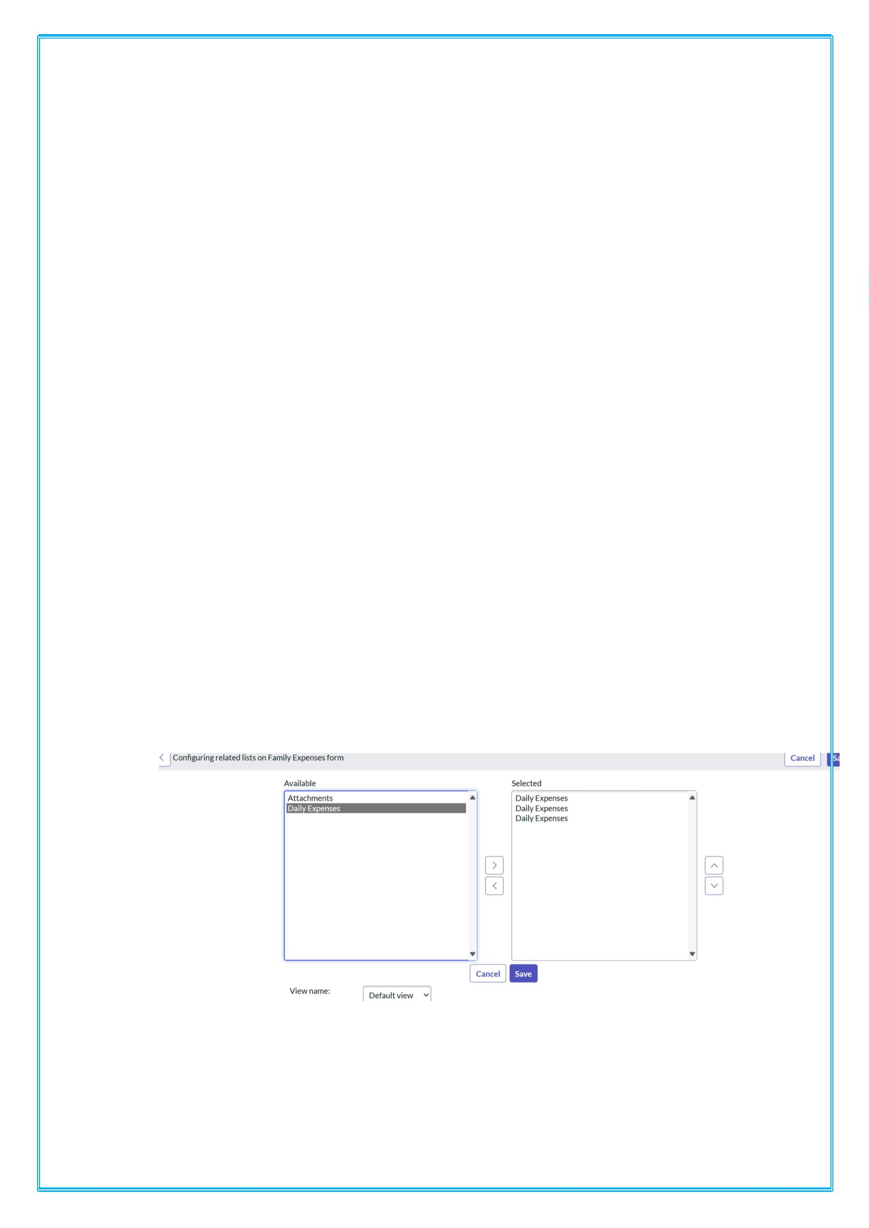
2. Click on New.
3. Enter the details:
i Name: Daily Expenses
ii Applies to table: Select Family Expenses
iii Daily Expenses: Select Daily Expenses
4. Click Save.
Milestone 7: Configuring Related List
Activity 1: Configuring Related List on Family Expenses
1. Go to All >> In the filter search for Family Expenses
>> Open Family Expenses
2. Click on New
3. Go to the Header and right click there>> click on
Configure >> Select Related Lists
4. Add Daily Expenses to the Selected Area.
5. Click on Save
Milestone 8: creation of Business
Activity 1: Creation of Business Rules

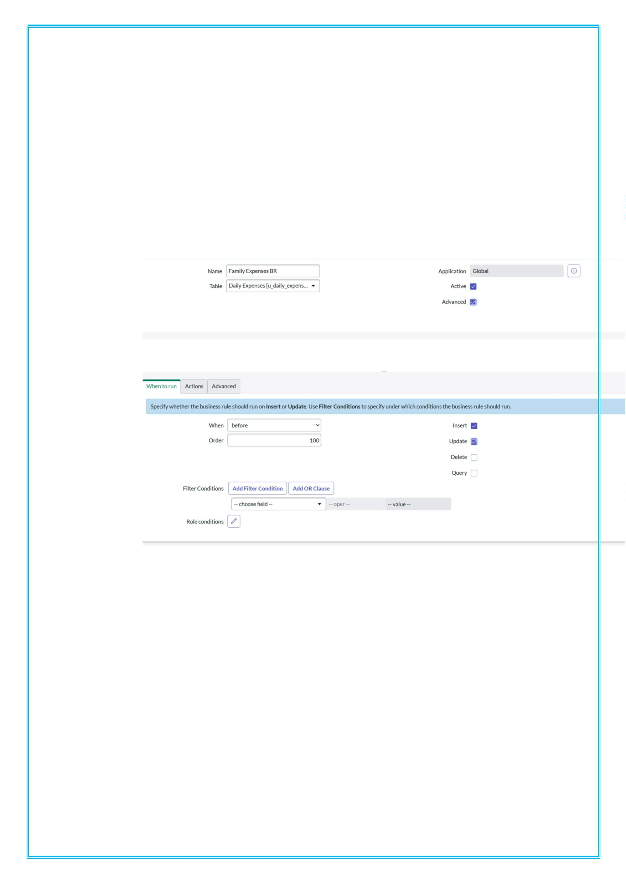
1. Go to All >> In the filter search for Business Rules.
2. Under System Definition Select Business Rules then
click on New.
3. Enter the Details:
i Name: Family Expenses BR
ii Table: Select Daily Expenses
iii Check Advanced
iv
4. In when to run Check Insert and Update
i
5. In Advance(we write the code): Write the below code
>>
6.
i (function executeRule(current, previous /*null
when async*/) {
7.
i var Family Expenses = new
GlideRecord('u_family_expenses');

ii FamilyExpenses.addQuery('u_date',current.u_dat
e);
iii FamilyExpenses.query();
iv if(FamilyExpenses.next())
v {
vi FamilyExpenses.u_amount += current.u_expense;
vii FamilyExpenses.u_expense_details +=
">"+current.u_comments+":"+"Rs."+current.u_
expense+"/-";
viii FamilyExpenses.update();
ix }
x else
xi {
xii var NewFamilyExpenses = new
GlideRecord('u_family_expenses');
xiii NewFamilyExpenses.u_date = current.u_date;
xiv NewFamilyExpenses.u_amount =
current.u_expense;
xv NewFamilyExpenses.u_expense_details +=
">"+current.u_comments+":"+"Rs."+current.u_
expense+"/-";
xvi NewFamilyExpenses.insert();
xvii }
8.
i })(current, previous);
9. Go to the Header and right click there>> click on Save

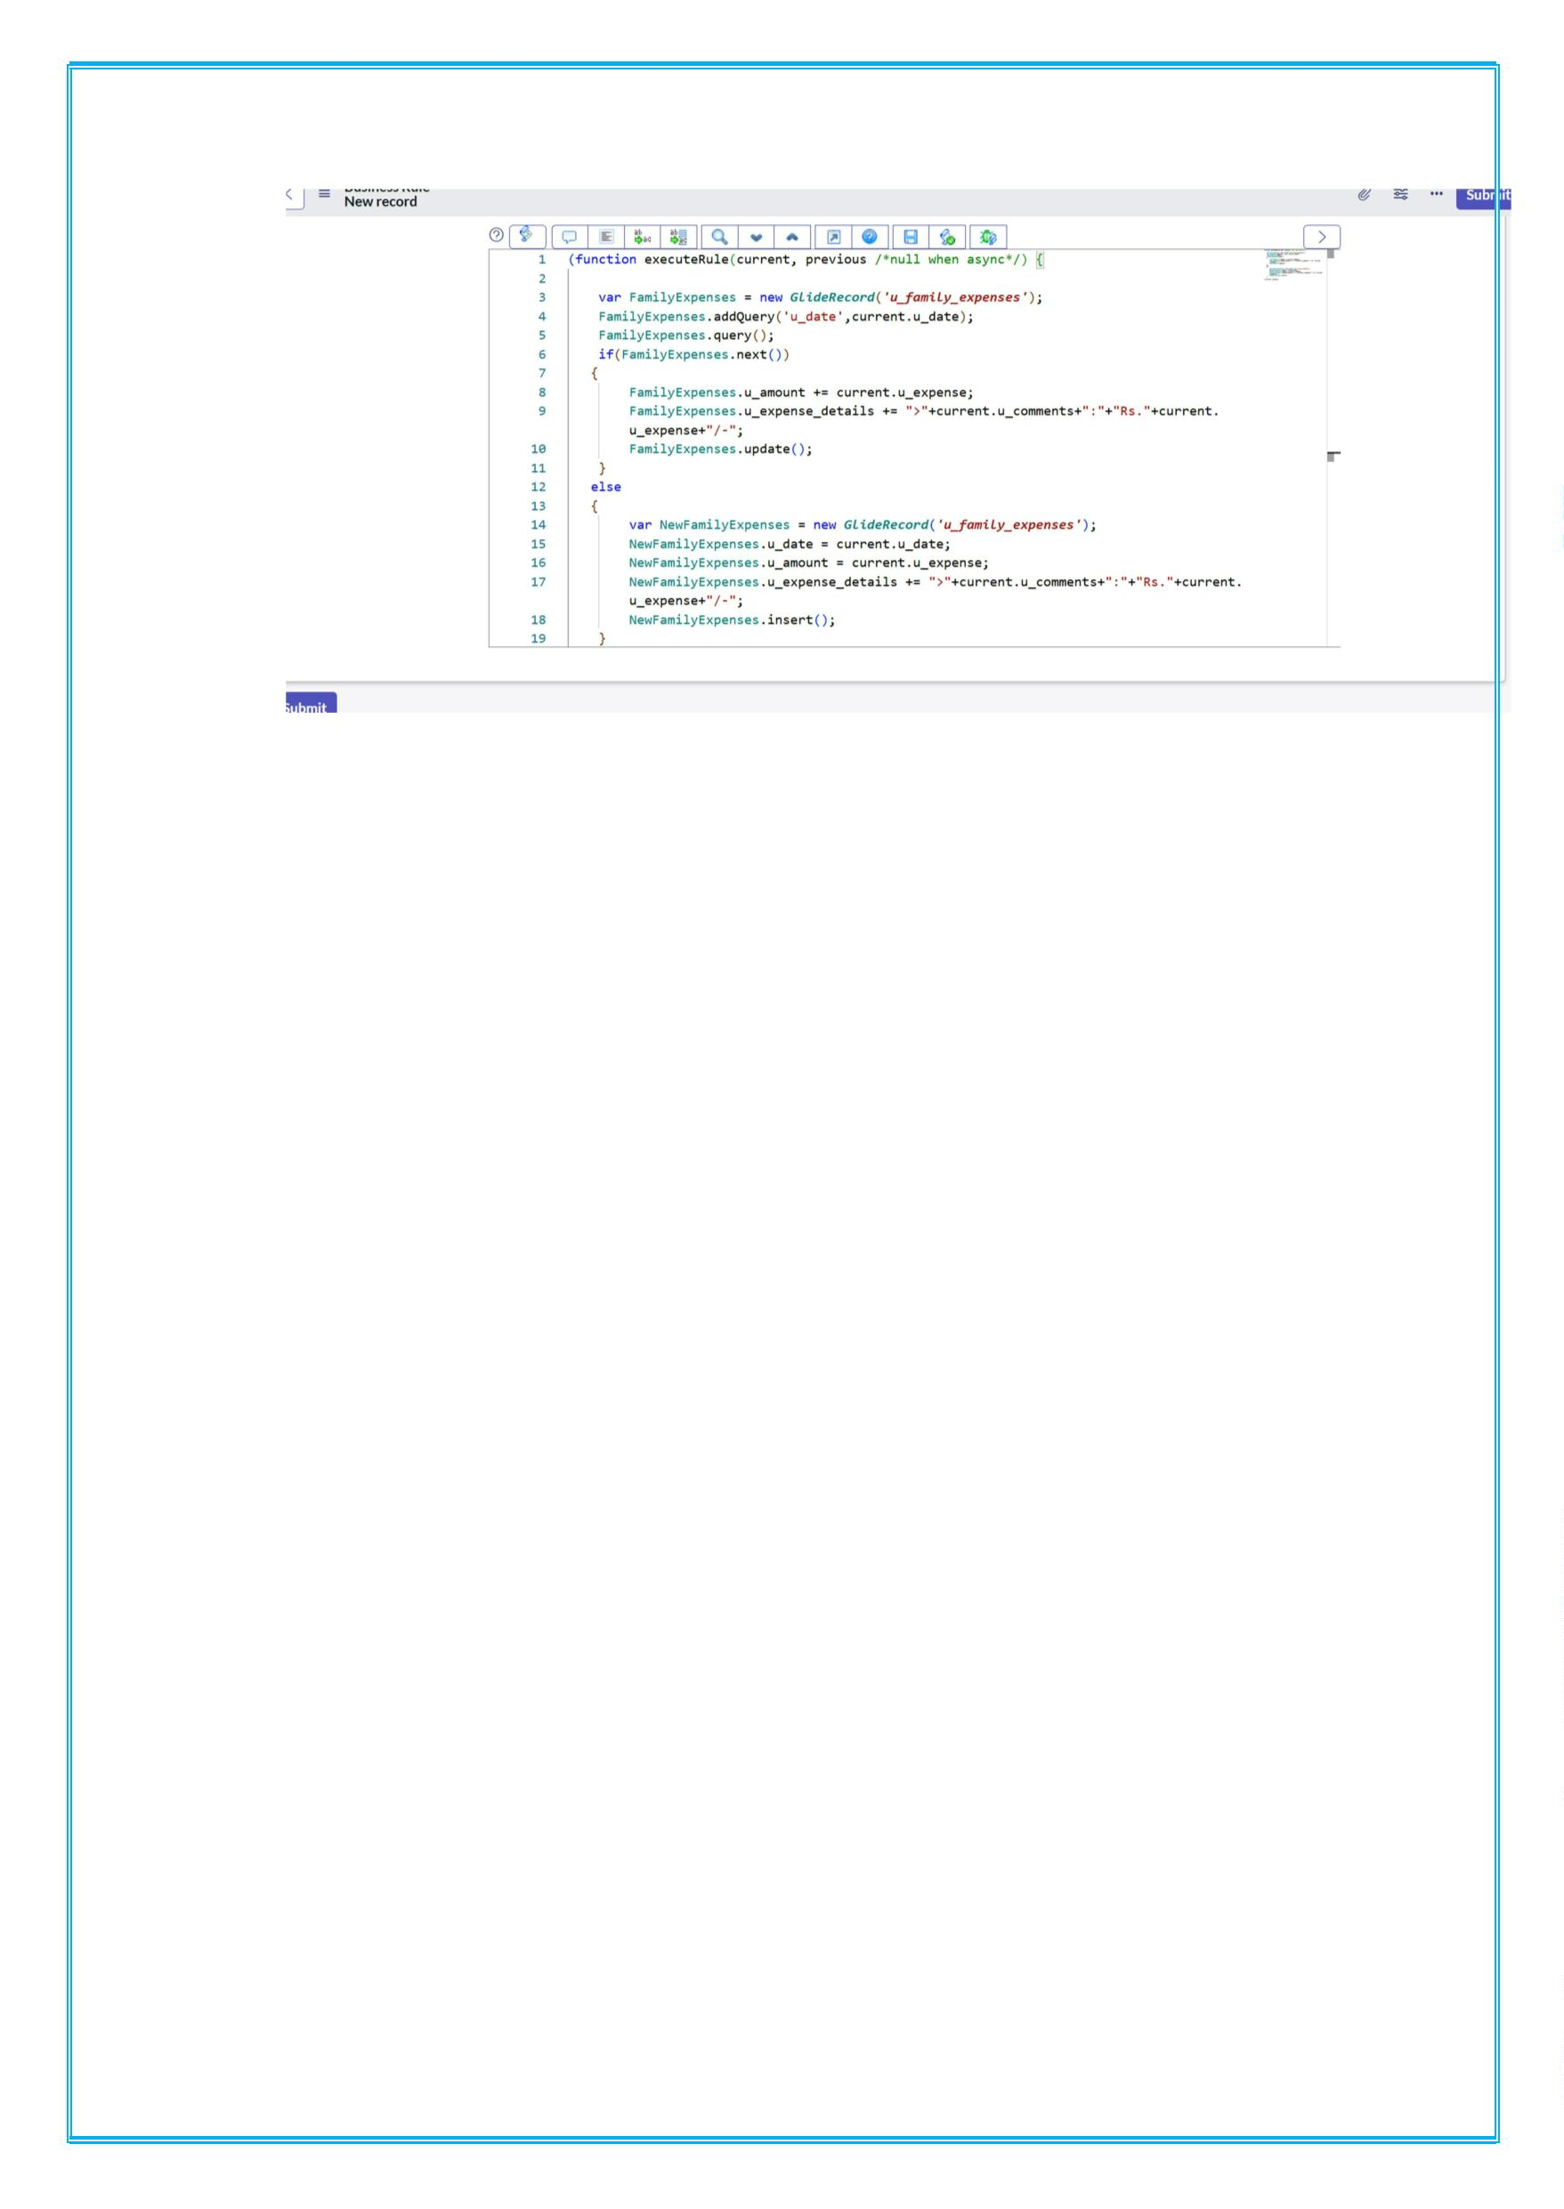
Milestone 9: Configure the Relationship
Activity 1: Configure the Relationship
1. Go to All >> In the filter search for Relationships >>
Open Relationships.
2. In that, open Daily Expenses Relationship.
3. For Applies to table: Select Family Expenses.
4. In Query with: write the below Query.
(function refineQuery(current, parent) {
// Add your code here, such as
current.addQuery(field, value);
current.addQuery('u_date',parent.u_date);
current.query();
})(current, parent);

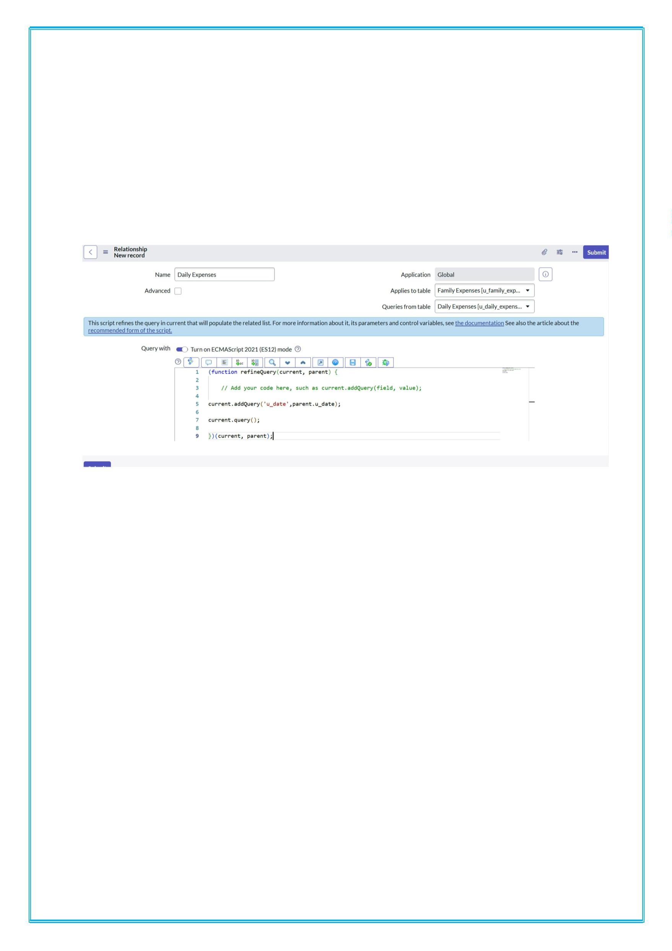
5.Click on Update.
6.Go to the Header and right click there>> click on Save.

