GENERIC JAVASCRIPT VALIDATION

ABOUT THIS APPLICATION:

The main base of the application is to validate a HTML5 FORM using a GENERIC JAVASCRIPT . Here we can check each field whether it is validating or not. This js file validating all any HTML form elements.The HTML5 page creating using CSS3 properties.

THE APPLICATION CONSISTS:

The application consists of two folders form1 and form2 , both the folders consists of the following files ,

index.html:- This consists of the form elements (Textbox , radio button, combobox ,Checkbox,etc ) we used in the form and what way we have taken.

style.css:- This had been existed in the css folder which is an external style sheet that has been linked in the html for applying styles to the elements in the html file.

validation.js :- This had been existed in the js folder of the application that is linked through the html file.This consists of the generic validation functions that have been applied to any of the form elements.

SCREENSHOT FOR FORM1 :-

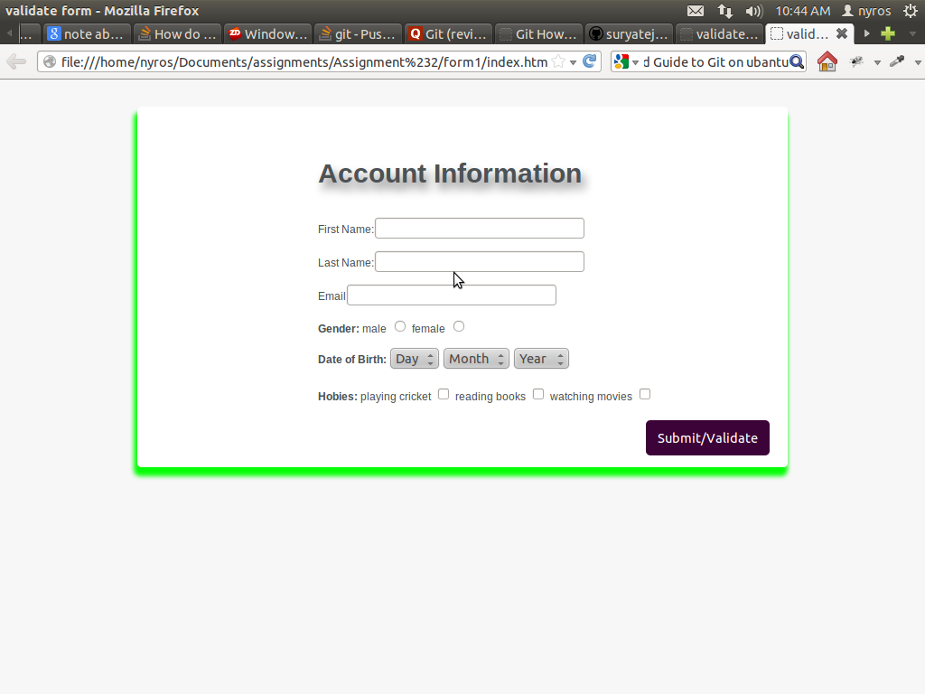
SCREENSHOT FOR FORM2 :-

