HEALTHCARE DATA VISUALISATION,
PAST RELATIONSHIP AND POLICY INSIGHTS

Name: | DHANALAKSHMI.C
Reg. No: | 26BSC080
Course: | BSC.CS(AI&DS)
Data Set: | Healthcare Dataset (sample data, 3,790 patient records, 2024–2025)
Tools Used: | Python, Pandas, NumPy, Matplotlib, Seaborn, Microsoft Word

1. Objective
The objective of this report is to explore a healthcare dataset through data visualisation and to turn the patterns found into practical insights for hospital management. The analysis aims to:
- Understand who the patients are by studying age, gender and medical condition.
- Analyse how hospital billing varies across medical conditions and admission types.
- Identify monthly trends in patient admissions to support capacity planning.
- Measure the relationship of billing amount with age and length of stay using correlation analysis.
- Provide evidence-based recommendations for resource planning, billing control and further study.

2. Data Set Overview
The dataset contains 3,790 patient admission records from January 2024 to December 2025. Each record describes one hospital admission. The main fields used in the analysis are listed below.
Field | Type | Description
Age | Numeric | Age of the patient in years
Gender | Categorical | Male or Female
Medical_Condition | Categorical | Diabetes, Hypertension, Asthma, Cancer, Arthritis, Obesity
Admission_Type | Categorical | Emergency, Urgent or Elective
Insurance | Categorical | Insurance provider of the patient
Date_of_Admission | Date | Date on which the patient was admitted
Length_of_Stay | Numeric | Number of days spent in hospital
Billing_Amount | Numeric | Total bill in USD

Summary Measure | Value
Total records | 3,790
Period covered | Jan 2024 – Dec 2025
Average age | 50.7 years
Average length of stay | 6.1 days
Average billing amount | USD 15,987
Total billing | USD 60.6 million

3. Patient Demographic Visualisation
This section shows the age profile, gender balance and the medical conditions of admitted patients.
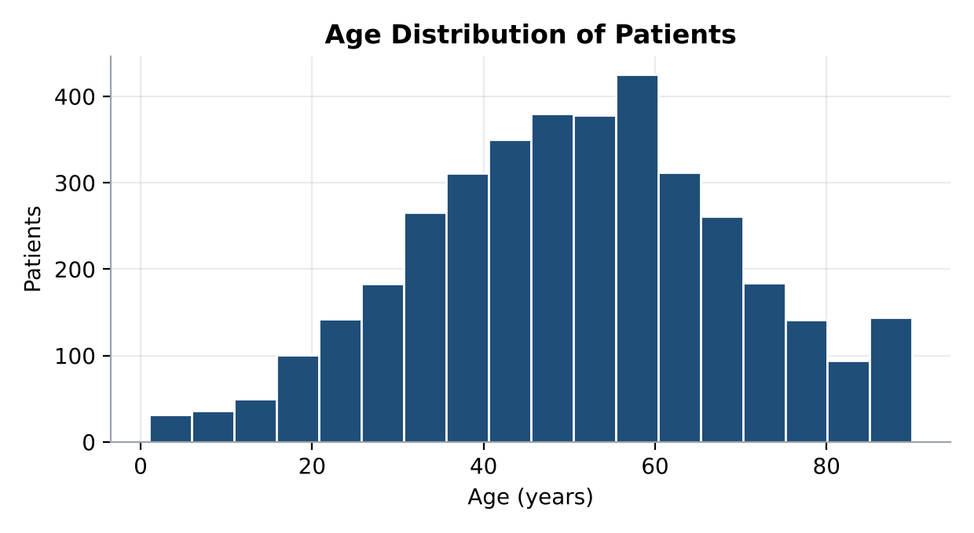  Figure 1: Age distribution of patients | 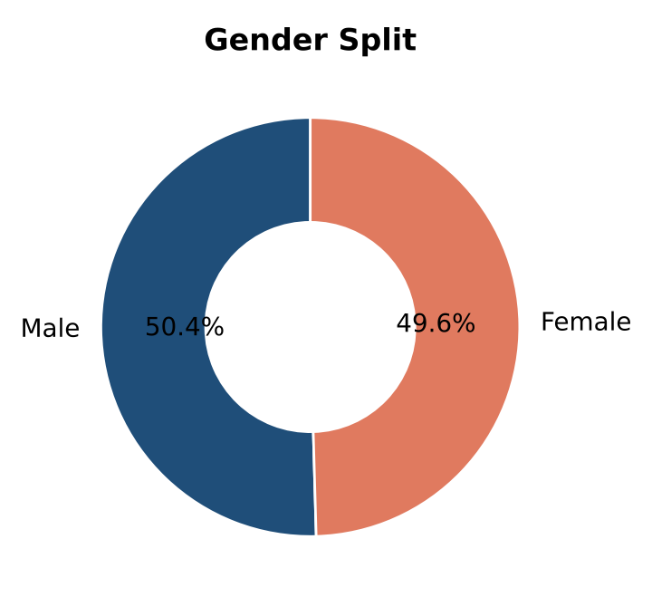  Figure 2: Gender split of patients
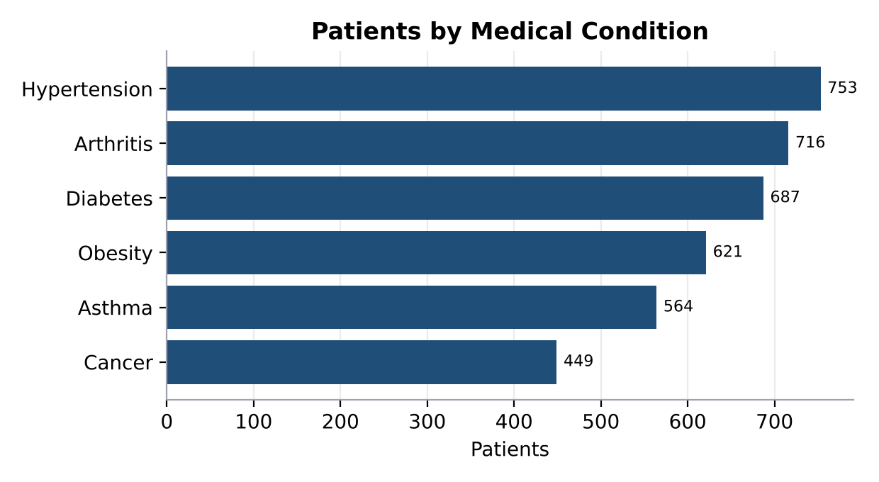
Figure 3: Number of patients by medical condition

Observations
- The average patient age is 50.7 years (median 51), and 31.9% of patients are aged 60 or above.
- Patients aged 40–59 form the largest group (1,525 patients), while children below 18 are the smallest group (151).
- Gender is evenly balanced: 50.4% male and 49.6% female.
- Hypertension is the most common condition (753 patients, 19.9%), and Cancer is the least common (449 patients, 11.8%).

4. Billing Analysis
Three charts examine how much patients are billed and what drives the differences between them.
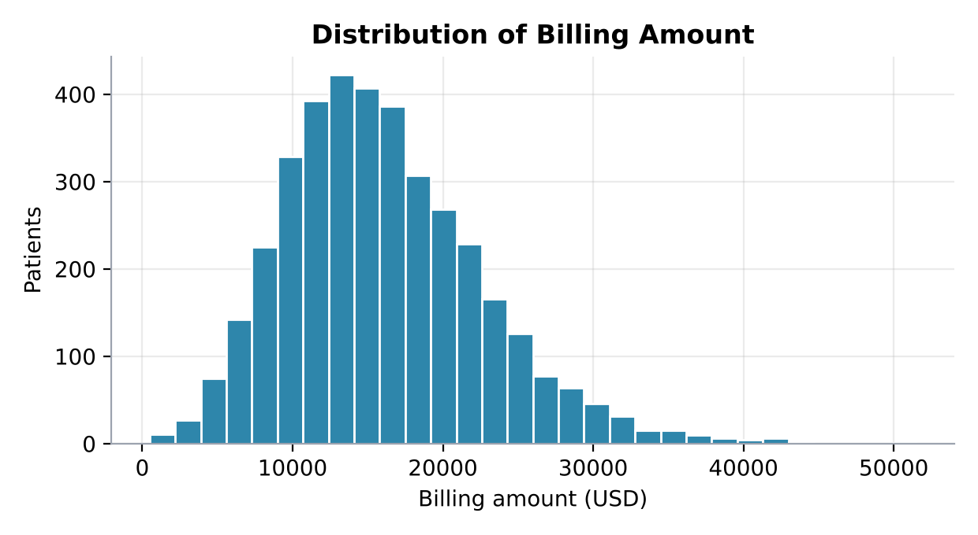
Figure 4: Distribution of billing amount
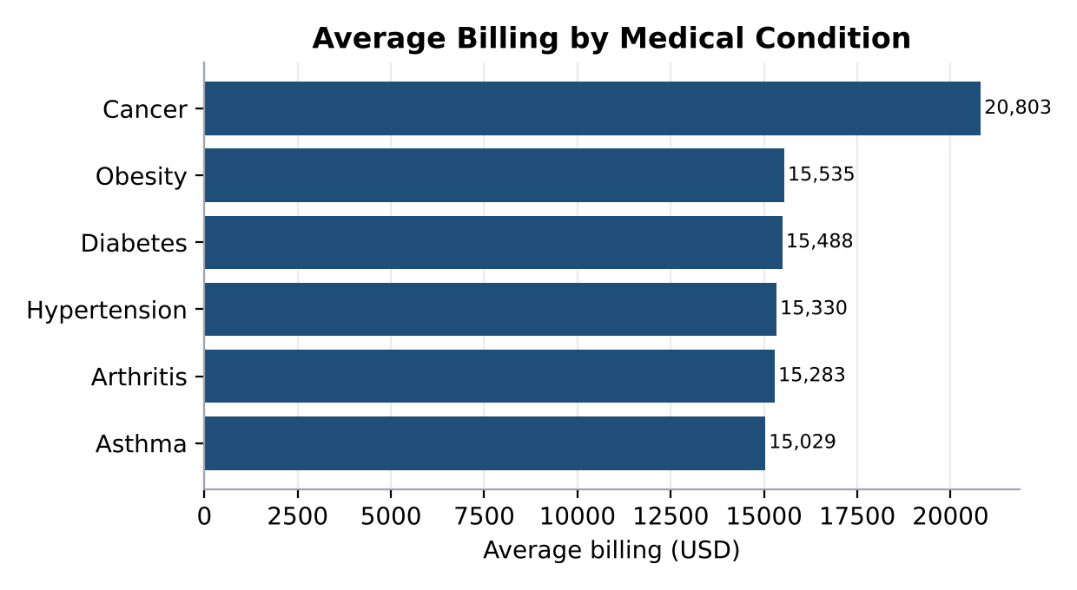
Figure 5: Average billing by medical condition
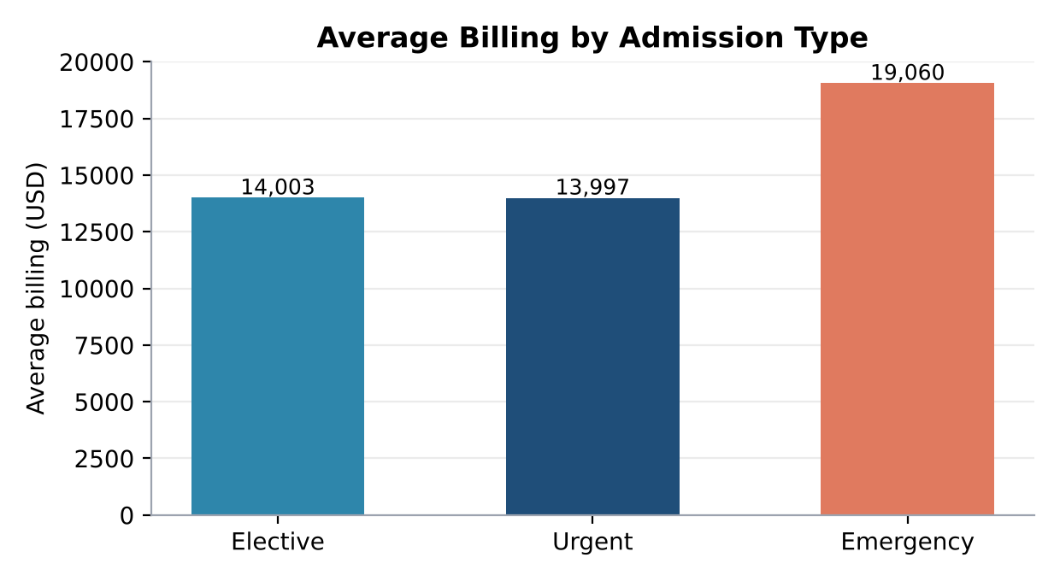
Figure 6: Average billing by admission type

Observations
- The average bill is USD 15,987 and the median is USD 15,278. Bills range from USD 500 to USD 51,483, with a slight right skew caused by a few very high bills.
- Cancer is the costliest condition at USD 20,803 per patient, about 35% above the other conditions, which all fall between USD 15,029 and USD 15,535.
- Emergency admissions average USD 19,060, which is 36% higher than elective admissions (USD 14,003). Urgent and elective admissions cost almost the same.
- The top 10% of bills account for 18.2% of the total billing, so costs are fairly spread out rather than concentrated in a few cases.

5. Temporal Admission Trend Analysis
The monthly admission count shows how hospital demand changes over the two years.
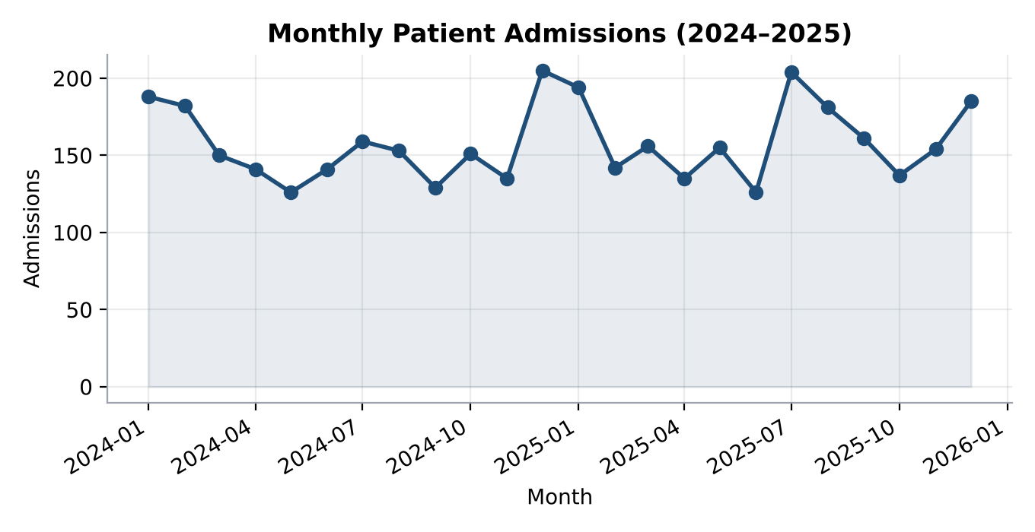
Figure 7: Monthly patient admissions, 2024–2025

Observations
- The hospital admitted about 158 patients per month on average.
- Admissions peaked in December 2024 (205) and July 2025 (204), and were lowest in May 2024 and June 2025 (126 each).
- The winter months (December to February) account for 28.9% of all admissions, above the 25% expected from an even spread.
- Total admissions grew from 1,860 in 2024 to 1,930 in 2025, an increase of 3.8%.

6. Past Relationship and Correlation Analysis
Scatter plots with trend lines and a correlation heatmap show how billing amount relates to age and to length of stay.

6.1 Age vs Billing Amount
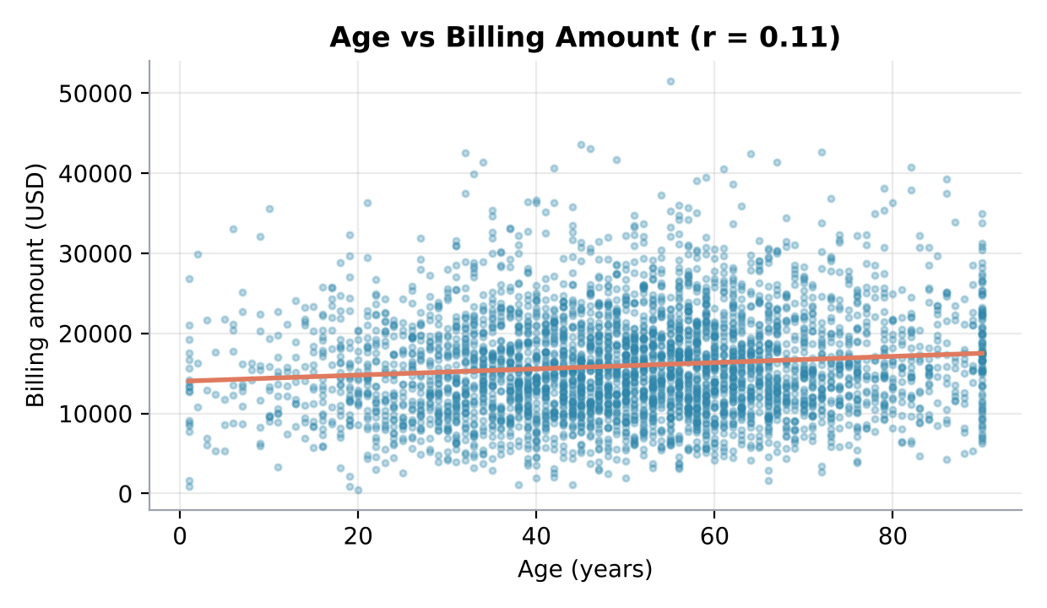
Figure 8: Age vs billing amount (r = 0.11)

6.2 Length of Stay vs Billing Amount
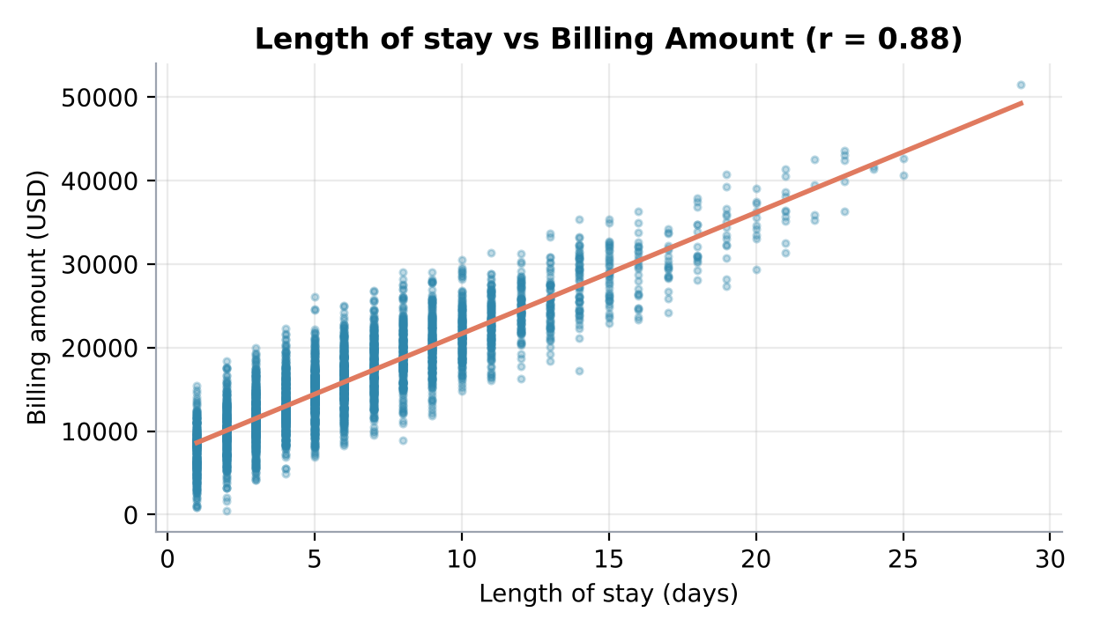
Figure 9: Length of stay vs billing amount (r = 0.88)

6.3 Correlation Heatmap
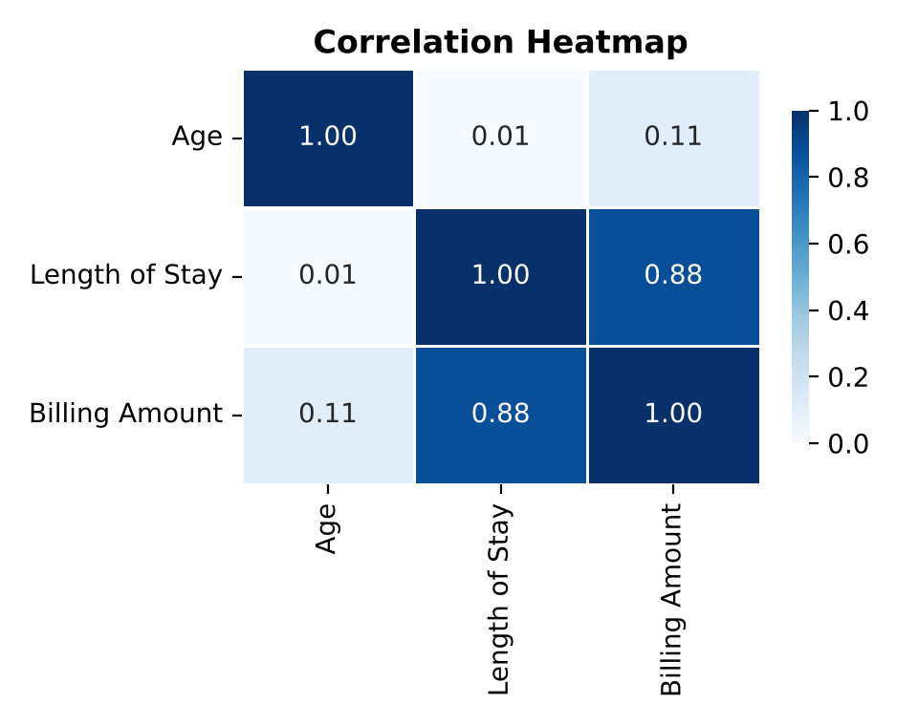
Figure 10: Correlation heatmap of age, length of stay and billing amount

Observations
- Age has only a weak positive correlation with billing (r = 0.11), so older patients are billed slightly more but age alone explains little.
- Length of stay has a strong positive correlation with billing (r = 0.88). Each additional day adds roughly USD 1,450 to the bill.
- Age and length of stay are almost unrelated (r = 0.01), meaning older patients do not necessarily stay longer.

7. Key Findings
- Length of stay is the main cost driver. It shows a strong correlation with billing (r = 0.88), at about USD 1,450 per extra day.
- Age is a weak predictor of cost. The age and billing correlation is only 0.11, so billing cannot be forecast from age alone.
- Cancer care is the most expensive. Cancer patients are billed USD 20,803 on average and stay 7.7 days, against 5.9 days for other conditions, although they are the smallest patient group.
- Emergency admissions cost more. They make up 39.3% of admissions and are billed 36% higher than elective admissions.
- Admissions are seasonal. Winter months carry 28.9% of admissions, with peaks in December 2024 and July 2025.

8. Healthcare Management Recommendations

8.1 Resource Planning
Plan staff rosters, beds and emergency capacity around the seasonal pattern. Add staff and keep spare beds ready for December to February and for the mid-year peak, and schedule elective procedures in low-demand months such as May and June. Because emergency cases are 39% of admissions, keep dedicated emergency capacity throughout the year.

8.2 Billing Analysis
Since length of stay drives cost, reducing avoidable hospital days through early discharge planning and faster diagnostics offers the biggest saving, at roughly USD 1,450 per day saved. Review pricing and package rates for cancer and emergency care, and monitor the highest-cost cases regularly to detect unusual billing.

8.3 Further Investigation
Extend the study with additional data such as diagnosis severity, procedures, insurance coverage, readmissions and patient outcomes. Build a multiple regression or predictive model to estimate billing and length of stay, and investigate the reasons behind the mid-year admission peak. Findings should be validated on the hospital's actual records before policy decisions are taken.

9. Conclusion
This study used visual analysis of 3,790 admissions to show how patient profile, billing and admission timing are connected. Length of stay emerged as the clearest driver of cost, while age had little effect. Cancer and emergency cases are the most expensive, and demand rises in winter and around mid-year. Using these insights, hospital management can plan resources ahead of peak periods, control costs by shortening unnecessary stays, and direct further research to areas where deeper data can improve both care quality and financial planning.

