STUDENT PERCENTAGE PERFORMANCE TRACKING SYSTEM

ABSTRACT

The Student Result Management System is a desktop-based application developed to simplify and automate the management of student academic records in an educational institution. The system uses a graphical user interface as the frontend to provide an easy and interactive platform for users, while a database management system is used as the backend to store and manage student information and academic results efficiently. The application allows the administrator to add and view student details and generate a Top 10 merit list based on student performance. Staff members can enter subject marks for students, and the system automatically calculates totals and percentages. It also provides graphical visualization of student performance and allows the export of result data for record keeping. By integrating a user-friendly interface with a structured database, the system reduces manual work, improves accuracy in result processing, and helps institutions manage student academic data more effectively.

INDEX
NO | CONTENTS | PAGE NO
1 | Introduction  1.1 Objectives | 2
2 | Problem Definition And Methodology  2.1 Problem Definition  2.2 Existing System  2.3 Proposed System  2.4 Methodology  2.5 Modules And Description  2.5.1 Module Description
3 | Development Process And Documentation  3.1 Requirement Analysis And Specification  3.1.1 Software Requirement  3.1.2 Hardware Requirement  3.1.3 Data Flow Diagram  3.1.4 Entity Relation Diagram  3.1.5 Data Dictionary  3.2 System Design  3.2.1 Input Design  3.2.2 Output Design  3.2.3 Database Design  3.2.3.1 Table structure  3.2.3.2 Normalization  3.3 Implementation  3.4 Testing  3.5 Maintenance
4 | Conclusion
5 | Bibliography  5.1 Book References  5.2 Web Reference
6 | Appendix  6.1 Software Profile  6.2 Source Code  6.3 Screen Layouts

1) INTRODUCTION

Objective

The Student Percentage Performance Tracking System is designed to automate the management of student academic performance. It provides functionalities for tracking marks, calculating percentages, generating top 10 merit lists, visualizing results graphically, and producing downloadable reports. The system reduces manual effort, ensures accuracy, and provides an intuitive interface for administrators, staff, and students.

2) Problem Definition and Methodology

2.1 Problem Definition
Manual record-keeping for student marks and performance reports is inefficient and error-prone. Generating merit lists and visualizing results manually consumes significant time for teachers and administrative staff.

2.2 Existing System
- Marks and records maintained in notebooks or spreadsheets.
- Calculations and reports are time-consuming.
- No centralized system for tracking performance.
- High risk of human error.

2.3 Proposed System
- Desktop application using Python with Tkinter for GUI and SQLite for database.
- Role-based access: Admin, Staff, and Student.
- Admin can add/view students, and view top 10 merit list.
- Staff can enter student marks, view department/year-wise results, visualize results in graphs, and download reports.
- Students can view their marks, see graphical representation, and download their personal results.

2.4 Methodology
- Requirement analysis
- System and database design
- Module development in Python
- Testing and debugging
- Deployment and maintenance

2.5 Modules and Descriptions

2.5.1 Admin Module
- Add Student: Add students with username, password, department, program (UG/PG), and year.
- View Students: Display all students in a table.
- Top 10 Merit List: Display top 10 students based on percentage.

2.5.2 Staff Module
- Add Student Marks: Enter internal and external marks for each subject based on department and semester. Internal total 25 marks, external total 75 marks, total 100.
- View Class Results: Display student marks by department and year.
- Graphical View: Visualize marks and class performance.
- Download Report: Export class-wise results as CSV or Excel.

2.5.3 Student Module
- Login: Students log in using their credentials.
- Table View: View personal marks, total, and percentage.
- Graphical View: Visual representation of performance.
- Download Report: Export marksheet for personal records.

3) Development Process and Documentation

3.1 Requirements Analysis and Specifications

3.1.1 Software Requirements
- Python 3.13
- Tkinter for GUI
- SQLite for database
- matplotlib for graphs

3.1.2 Hardware Requirements
- Minimum 4 GB RAM
- 500 MB free disk space
- Intel i3 or equivalent processor

3.1.3 Data Flow Diagrams
- Depicts data flow from user input through processing and output in GUI and database.

DFD
Symbol | Description
 | An entity A source of data or a destination for data.
A process or task that is performed
by the system.
 | A data flows.
 | A data store, a place where data is held between processes.

Data Flow Symbols

Level 0

Login
Data
base
Student Percentage Performance Tracking System

Admin

Manage student

Login
Staff

Manage Marks

Login
Student

View Marks

Level 1

Admin

Login

Add
Student
Database

View
Student

\
Top 10
Merit List

Level 2

Staff

Login

Add Marks

Database

View
Graph

Export
CSV

3.1.4 Entity Relationship Diagram

- Represents relationships among students, staff, subjects, and marks tables.
Login Page
Entity
Password
Username

View Student
Add Student
Admin
role

Top 10 Merit Lists

Graph
Staff

Student
Add Marks

Graph
View
Marks
Download

3.1.5 Data Dictionary
- Users Table: id, username, password, role, department, program, year.
- Marks Table: id, student_id, subject, semester, internal, external, total, percentage.

3.2 System Design
3.2.1 Input Design
- GUI forms for adding students and entering marks.
- Comboboxes for selecting program, year, semester, and department.

3.2.2 Output Design
- Tkinter Treeview tables for student lists.
- Graphs using matplotlib for performance visualization.
- Downloadable CSV or Excel reports.

3.2.3 Database Design
3.2.3.1 Table Structure
- Users Table: Stores staff and student credentials, roles, department, program, and year.
- Marks Table: Stores subject-wise marks, total, and percentage.

3.2.3.2 Normalization
- Tables normalized to prevent redundancy.
- Relationships via foreign keys linking students to marks.

3.3 Implementation
- Python modules: login.py, admin_dashboard.py, staff_dashboard.py, student_dashboard.py, database.py.
- Tkinter GUI with professional layout, background images, college logo, and college name.
- Data stored in SQLite database.

3.4 Testing
- Unit testing of each module.
- Integration testing for dashboards and workflows.
- Verification of percentage calculation and merit list accuracy.

3.5 Maintenance
- Modular code allows easy updates and feature addition.
- Database structure can accommodate new semesters, programs, and subjects.

4) Conclusion
The Student Percentage Tracking System offers a professional, automated platform for managing student academic performance, generating merit lists, visualizations, and downloadable reports, improving efficiency for administrators, staff, and students.

5) Bibliography
5.1 Book References
- Python Programming, John Zelle, 4th Edition
- Database System Concepts, Silberschatz, 7th Edition

5.2 Web References
- https://docs.python.org/3/tutorial/
- https://www.sqlite.org/docs.html
- https://matplotlib.org/stable/tutorials/index.html

6) Appendix

6.1 Software Profile
- Python 3.13
- Tkinter GUI framework
- SQLite database
- matplotlib for graph plotting

6.2 Source Code
- login.py, admin_dashboard.py, staff_dashboard.py, student_dashboard.py, database.py

Login.py

import tkinter as tk
from tkinter import ttk, messagebox
from PIL import Image, ImageTk
import sqlite3

class LoginPage:

def __init__(self, root):

self.root = root
self.root.title("College Performance System")
self.root.geometry("900x600")

# ===== BACKGROUND IMAGE =====
bg = Image.open("assets/background.jpg")
bg = bg.resize((900, 600))
self.bg_img = ImageTk.PhotoImage(bg)

bg_label = tk.Label(self.root, image=self.bg_img)
bg_label.place(x=0, y=0, relwidth=1, relheight=1)

# ===== LOGIN BOX =====
frame = tk.Frame(self.root, bg="white", bd=3)
frame.place(relx=0.5, rely=0.5, anchor="center", width=360, height=420)

# ===== COLLEGE LOGO =====
logo = Image.open("assets/logo.png")
logo = logo.resize((80, 80))
self.logo_img = ImageTk.PhotoImage(logo)

tk.Label(frame, image=self.logo_img, bg="white").pack(pady=10)

# ===== COLLEGE NAME =====
tk.Label(
frame,
text="NEHRU MEMORIAL COLLEGE",
font=("Arial", 16, "bold"),
bg="white",
fg="darkblue",
justify="center",
wraplength=260
).pack(pady=5)

# ===== PROJECT TITLE =====
tk.Label(
frame,
text="Student Percentage Performance Tracking System",
font=("Arial", 10),
bg="white",
fg="gray"
).pack(pady=2)

# ===== USERNAME =====
tk.Label(frame, text="Username", bg="white").pack(pady=5)
self.username_entry = tk.Entry(frame)
self.username_entry.pack()

# ===== PASSWORD =====
tk.Label(frame, text="Password", bg="white").pack(pady=5)
self.password_entry = tk.Entry(frame, show="*")
self.password_entry.pack()

# ===== ROLE =====
tk.Label(frame, text="Login As", bg="white").pack(pady=5)

self.role_combo = ttk.Combobox(
frame,
values=["Admin", "Staff", "Student"],
state="readonly"
)
self.role_combo.pack()

# ===== LOGIN BUTTON =====
tk.Button(
frame,
text="Login",
bg="royalblue",
fg="white",
width=15,
command=self.login
).pack(pady=20)

# ===== LOGIN FUNCTION =====
def login(self):

username = self.username_entry.get()
password = self.password_entry.get()
role = self.role_combo.get()

conn = sqlite3.connect("college.db")
cursor = conn.cursor()

cursor.execute(
"SELECT * FROM users WHERE username=? AND password=? AND role=?",
(username, password, role)
)

result = cursor.fetchone()

conn.close()

if result:

messagebox.showinfo("Success", "Login Successful")

if role == "Admin":
from admin_dashboard import AdminDashboard
new = tk.Toplevel(self.root)
AdminDashboard(new)

elif role == "Staff":
from staff_dashboard import StaffDashboard
new = tk.Toplevel(self.root)
StaffDashboard(new)

elif role == "Student":
from student_dashboard import StudentDashboard
new = tk.Toplevel(self.root)
StudentDashboard(new)

else:
messagebox.showerror("Error", "Invalid Login Details")

# ===== MAIN =====
if __name__ == "__main__":

root = tk.Tk()
app = LoginPage(root)
root.mainloop()

Admin_dashboard.py

import tkinter as tk
from tkinter import ttk, messagebox
import sqlite3

class AdminDashboard:

def __init__(self, root):

self.root = root
self.root.title("Admin Dashboard")
self.root.geometry("500x400")

title = tk.Label(root,
text="ADMIN DASHBOARD",
font=("Arial", 20, "bold"),
fg="darkblue")
title.pack(pady=20)

# Buttons

add_btn = tk.Button(root,
text="Add Student",
width=25,
height=2,
command=self.add_student_window)
add_btn.pack(pady=10)

view_btn = tk.Button(root,
text="View Students",
width=25,
height=2,
command=self.view_student_window)
view_btn.pack(pady=10)

merit_btn = tk.Button(root,
text="Top 10 Merit List",
width=25,
height=2,
command=self.merit_window)
merit_btn.pack(pady=10)

self.create_tables()

# ------------------------
# DATABASE
# ------------------------

def create_tables(self):

conn = sqlite3.connect("college.db")
cursor = conn.cursor()

cursor.execute("""
CREATE TABLE IF NOT EXISTS students(
student_id INTEGER PRIMARY KEY,
name TEXT
)
""")

cursor.execute("""
CREATE TABLE IF NOT EXISTS results(
student_id INTEGER,
percentage REAL
)
""")

conn.commit()
conn.close()

# ------------------------
# ADD STUDENT WINDOW
# ------------------------

def add_student_window(self):

win = tk.Toplevel(self.root)
win.title("Add Student")
win.geometry("350x250")

tk.Label(win, text="Student ID").pack(pady=5)
sid = tk.Entry(win)
sid.pack()

tk.Label(win, text="Student Name").pack(pady=5)
name = tk.Entry(win)
name.pack()

def save_student():

s = sid.get()
n = name.get()

if s == "" or n == "":
messagebox.showerror("Error", "Enter all fields")
return

s = int(s)

conn = sqlite3.connect("college.db")
cursor = conn.cursor()

try:
cursor.execute(
"INSERT INTO students (student_id, name) VALUES (?,?)",
(s, n)
)
conn.commit()
messagebox.showinfo("Success", "Student Added")

sid.delete(0, tk.END)
name.delete(0, tk.END)

except sqlite3.IntegrityError:
messagebox.showerror("Error", "Student ID already exists")

conn.close()

tk.Button(win,
text="Add Student",
command=save_student).pack(pady=15)

# ------------------------
# VIEW STUDENT WINDOW
# ------------------------

def view_student_window(self):

win = tk.Toplevel(self.root)
win.title("View Students")
win.geometry("500x350")

table = ttk.Treeview(win,
columns=("id", "name"),
show="headings")

table.heading("id", text="Student ID")
table.heading("name", text="Student Name")

table.pack(fill="both", expand=True)

conn = sqlite3.connect("college.db")
cursor = conn.cursor()

cursor.execute("SELECT * FROM students")

rows = cursor.fetchall()

for row in rows:
table.insert("", tk.END, values=row)

conn.close()

# ------------------------
# MERIT LIST WINDOW
# ------------------------

def merit_window(self):

win = tk.Toplevel(self.root)
win.title("Top 10 Merit List")
win.geometry("500x350")

table = ttk.Treeview(win,
columns=("id", "percentage"),
show="headings")

table.heading("id", text="Student ID")
table.heading("percentage", text="Average Marks")

table.pack(fill="both", expand=True)

conn = sqlite3.connect("college.db")
cursor = conn.cursor()

cursor.execute("""
SELECT student_id, AVG(total) as avg_marks
FROM marks
GROUP BY student_id
ORDER BY avg_marks DESC
LIMIT 10
""")

rows = cursor.fetchall()

for row in rows:
table.insert("", tk.END, values=row)

conn.close()

if __name__ == "__main__":

root = tk.Tk()
app = AdminDashboard(root)
root.mainloop()

Staff_dashboard.py

import tkinter as tk
from tkinter import messagebox, ttk, filedialog
import sqlite3
import matplotlib.pyplot as plt
import csv
from subjects import subjects

class StaffDashboard:

def __init__(self,root):

root.title("Staff Dashboard")
root.geometry("600x500")

tk.Label(root,text="ENTER MARKS",font=("Arial",18,"bold")).pack()

tk.Label(root,text="Student ID").pack()
self.sid=tk.Entry(root)
self.sid.pack()

tk.Label(root,text="Department").pack()
self.dept=ttk.Combobox(root,values=list(subjects.keys()))
self.dept.pack()

tk.Label(root,text="Semester").pack()
self.sem=tk.Entry(root)
self.sem.pack()

tk.Button(root,text="Load Subjects",command=self.load_subjects).pack()

self.sub=ttk.Combobox(root)
self.sub.pack()

tk.Label(root,text="Internal (25)").pack()
self.internal=tk.Entry(root)
self.internal.pack()

tk.Label(root,text="External (75)").pack()
self.external=tk.Entry(root)
self.external.pack()

tk.Button(root,text="Save Marks",command=self.save).pack(pady=5)
tk.Button(root,text="Graph",command=self.graph).pack()
tk.Button(root,text="Export CSV",command=self.export).pack()

def load_subjects(self):

d=self.dept.get()
s=int(self.sem.get())

if d in subjects and s in subjects[d]:
self.sub["values"]=subjects[d][s]

def save(self):

i=int(self.internal.get())
e=int(self.external.get())

total=i+e
percentage=total

conn=sqlite3.connect("college.db")
cur=conn.cursor()

cur.execute(
"INSERT INTO marks(student_id,subject,internal,external,total,percentage) VALUES(?,?,?,?,?,?)",
(self.sid.get(),self.sub.get(),i,e,total,percentage))

conn.commit()
conn.close()

messagebox.showinfo("Saved","Marks saved")

def graph(self):

conn=sqlite3.connect("college.db")
cur=conn.cursor()

cur.execute("SELECT subject,total FROM marks WHERE student_id=?",(self.sid.get(),))
rows=cur.fetchall()

subjects=[r[0] for r in rows]
marks=[r[1] for r in rows]

plt.bar(subjects,marks)
plt.title("Student Marks")
plt.show()

def export(self):

conn=sqlite3.connect("college.db")
cur=conn.cursor()

cur.execute("SELECT * FROM marks WHERE student_id=?",(self.sid.get(),))
rows=cur.fetchall()

path=filedialog.asksaveasfilename(defaultextension=".csv")

if path == "":
return

with open(path,"w",newline="") as f:
writer=csv.writer(f)
writer.writerow(["ID","Student","Subject","Internal","External","Total","Percentage"])
writer.writerows(rows)

conn.close()

Student_dashboard.py

import tkinter as tk
from tkinter import ttk
import sqlite3
import matplotlib.pyplot as plt

class StudentDashboard:

def __init__(self,root):

root.title("Student Result")
root.geometry("600x500")

tk.Label(root,text="Student Result",font=("Arial",20)).pack()

tk.Label(root,text="Student ID").pack()
self.sid=tk.Entry(root)
self.sid.pack()

tk.Button(root,text="Show Result",command=self.show).pack()

self.table = ttk.Treeview(root,columns=("subject","internal","external","total","percentage"),
show="headings")

self.table.heading("subject", text="Subject")
self.table.heading("internal", text="Internal")
self.table.heading("external", text="External")
self.table.heading("total", text="Total")
self.table.heading("percentage", text="Percentage")

self.table.pack(fill="both", expand=True)

tk.Button(root,text="Graph",command=self.graph).pack()

def show(self):

conn=sqlite3.connect("college.db")
cur=conn.cursor()

cur.execute(
"SELECT subject,internal,external,total,percentage FROM marks WHERE student_id=?",
(self.sid.get(),)
)

for r in cur.fetchall():
self.table.insert("",tk.END,values=r)

conn.close()

def graph(self):

conn=sqlite3.connect("college.db")
cur=conn.cursor()

cur.execute("SELECT subject,total FROM marks WHERE student_id=?",(self.sid.get(),))
rows=cur.fetchall()

subjects=[r[0] for r in rows]
marks=[r[1] for r in rows]

plt.bar(subjects,marks)
plt.title("Result Graph")
plt.show()

Subjects.py

subjects = {
"CSE": {
1:["Maths","Programming","Physics"],
2:["DSA","OOP","Digital Logic"],
3:["DBMS","Operating System","Networks"]
},
"IT": {
1:["Maths","Programming","Electronics"],
2:["Web Tech","Data Structures","Java"],
3:["Cloud","AI","Cyber Security"]
}
}

Database.py

import sqlite3

def create_database():
conn = sqlite3.connect("college.db")
cur = conn.cursor()

cur.execute("""
CREATE TABLE IF NOT EXISTS users(
id INTEGER PRIMARY KEY AUTOINCREMENT,
username TEXT UNIQUE,
password TEXT,
role TEXT
)
""")

cur.execute("""
CREATE TABLE IF NOT EXISTS students(
student_id TEXT PRIMARY KEY,
name TEXT,
program TEXT,
department TEXT,
semester INTEGER
)
""")

cur.execute("""
CREATE TABLE IF NOT EXISTS marks(
id INTEGER PRIMARY KEY AUTOINCREMENT,
student_id TEXT,
subject TEXT,
internal INTEGER,
external INTEGER,
total INTEGER,
percentage REAL
)
""")

cur.execute("INSERT OR IGNORE INTO users VALUES(1,'admin','admin123','Admin')")
cur.execute("INSERT OR IGNORE INTO users VALUES(2,'staff','staff123','Staff')")
cur.execute("INSERT OR IGNORE INTO users VALUES(3,'student','student123','Student')")

conn.commit()
conn.close()

Main.py

import tkinter as tk
from database import create_database
from login import LoginPage

create_database()

root = tk.Tk()
root.title("College Performance System")
root.geometry("800x500")

LoginPage(root)

root.mainloop()

6.3 Screen Layouts
- Login page with role selection, background image, college logo, and name (Nehru Memorial College).
- Admin dashboard with Add Student, View Student, Top 10 Merit List buttons.
- Staff dashboard with Add Marks, View Class, Graph, and Download Report.
- Student dashboard with Table and Graphical Result View, Downloadable Marksheet.

Login Page

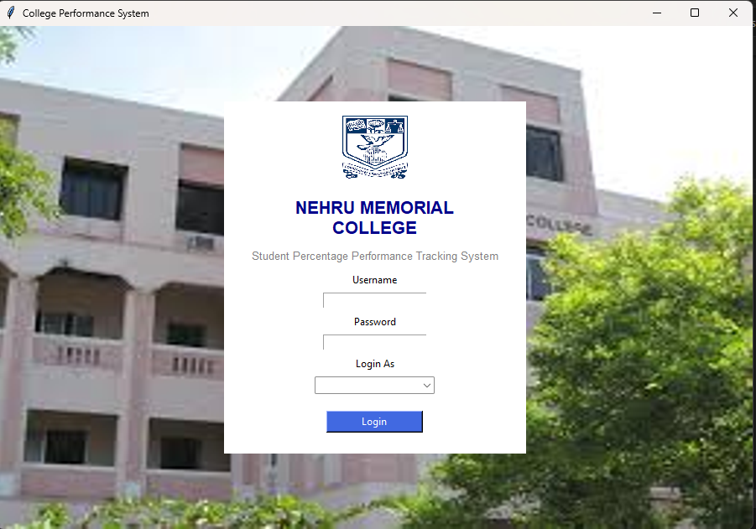

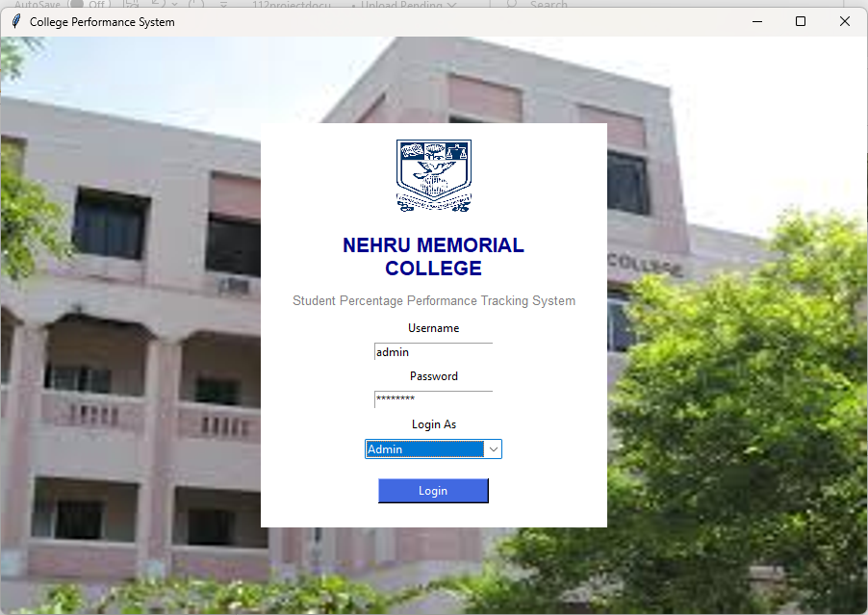

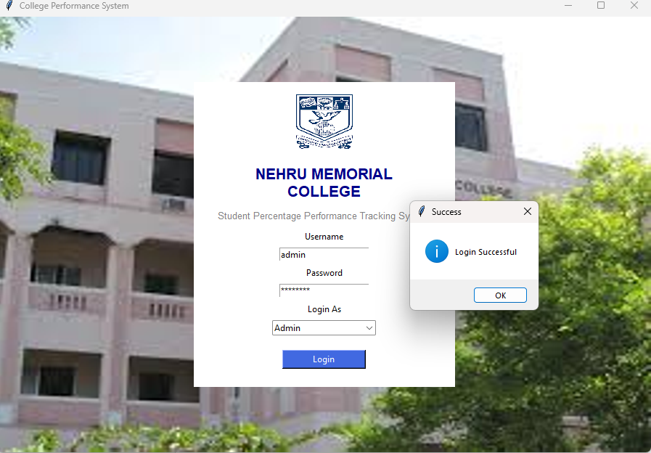

Admin Dashboard

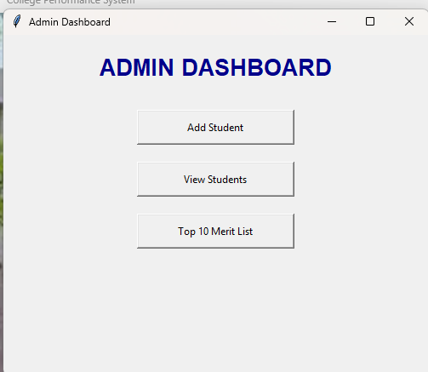

Add Student
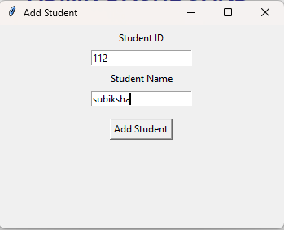
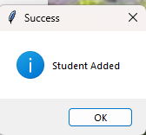
View Students
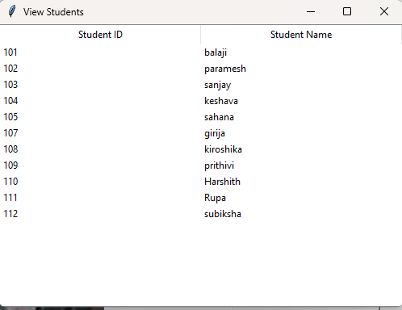

Top 10 Merit List
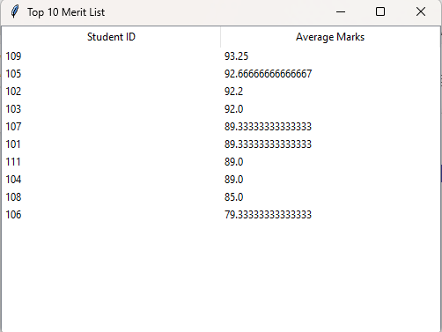
Staff Login
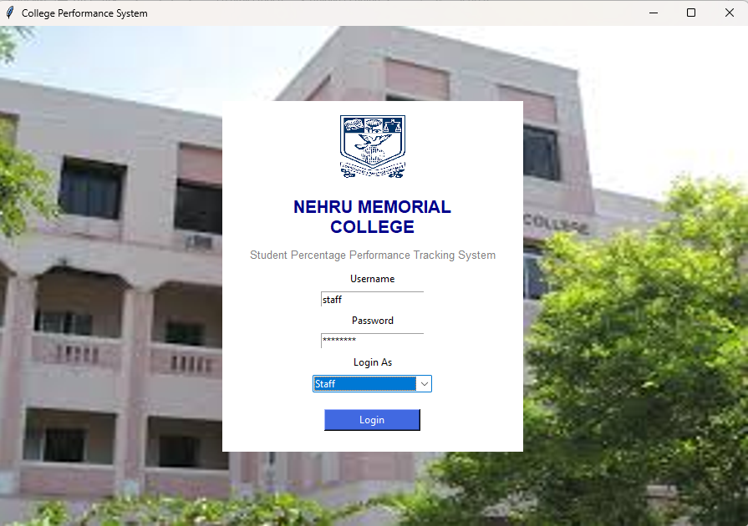

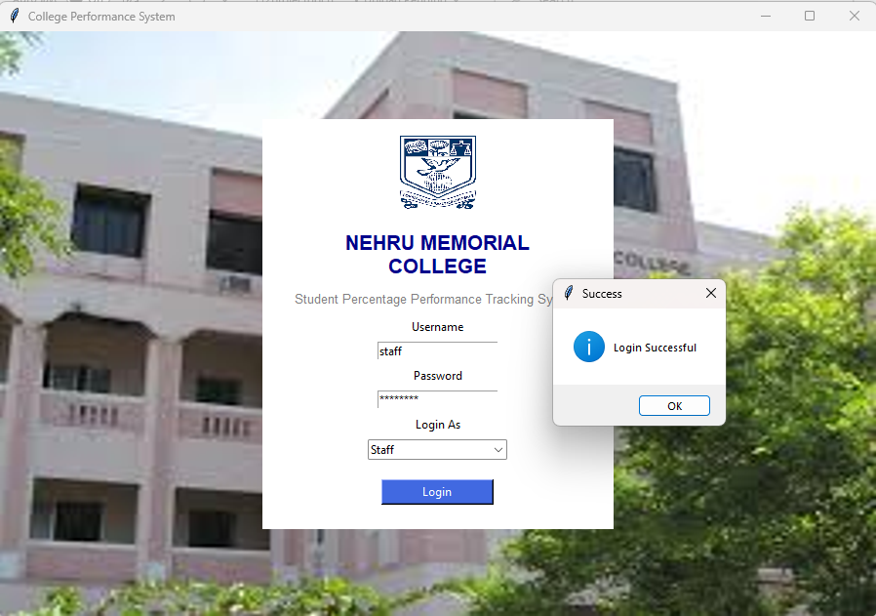

Staff Dashboard

Add Student Marks
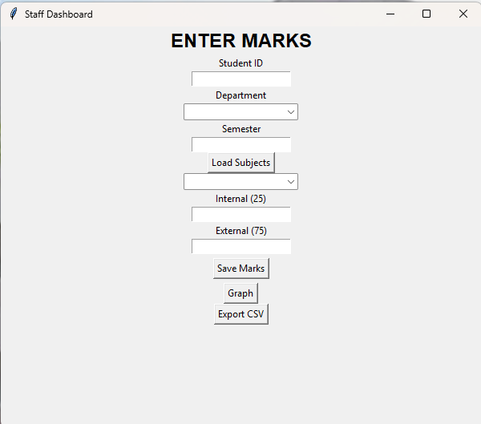

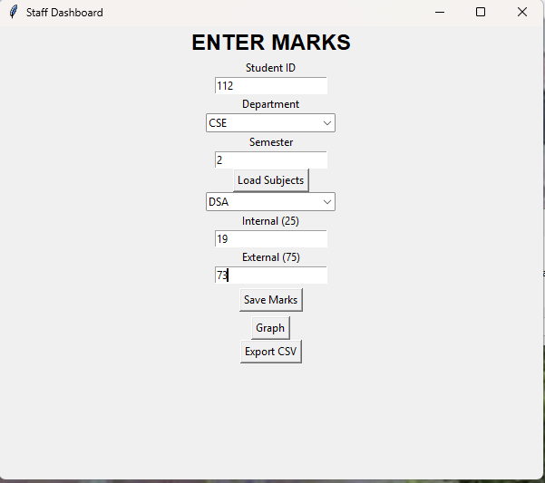

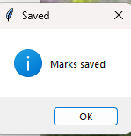

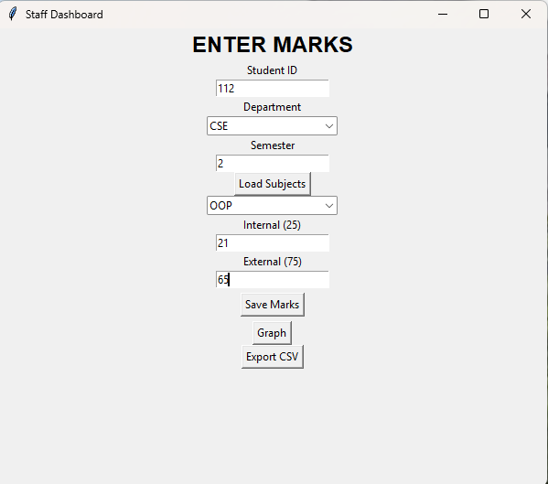



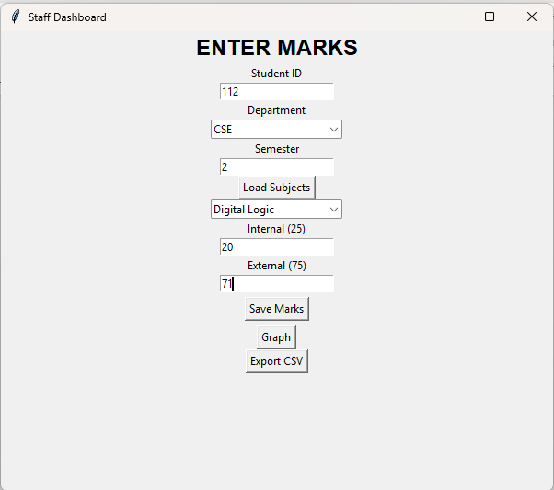



Graph View

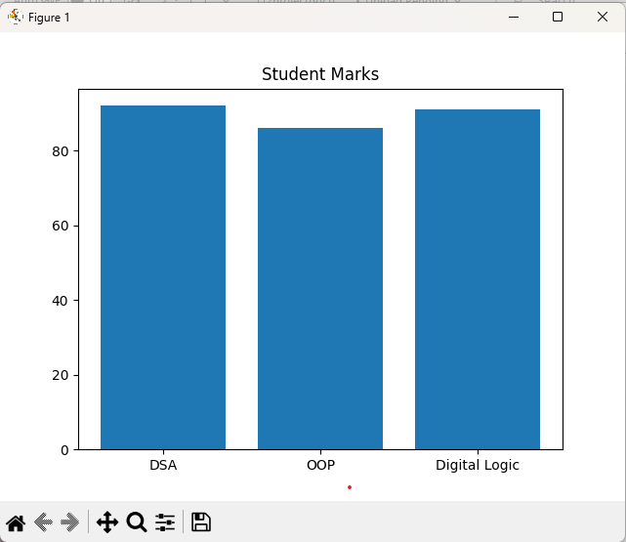

Download Report

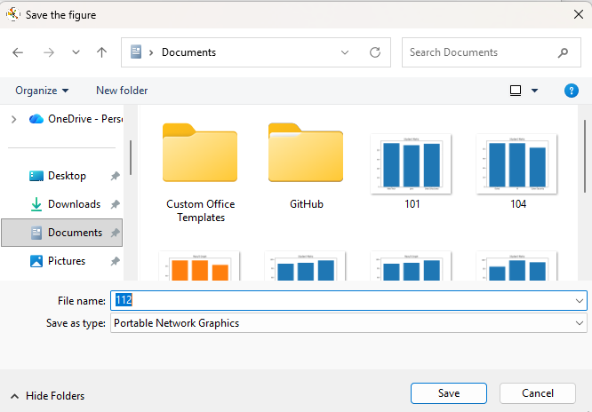

Export CSV
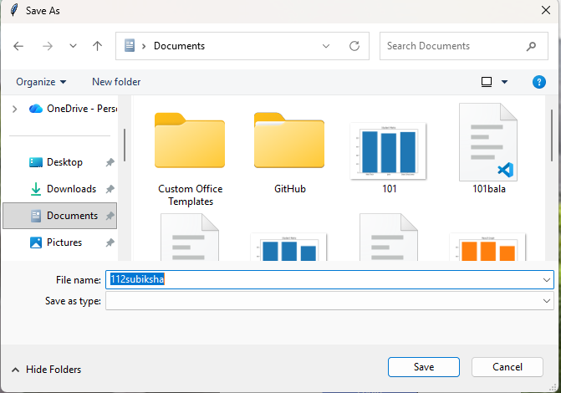

Student Login

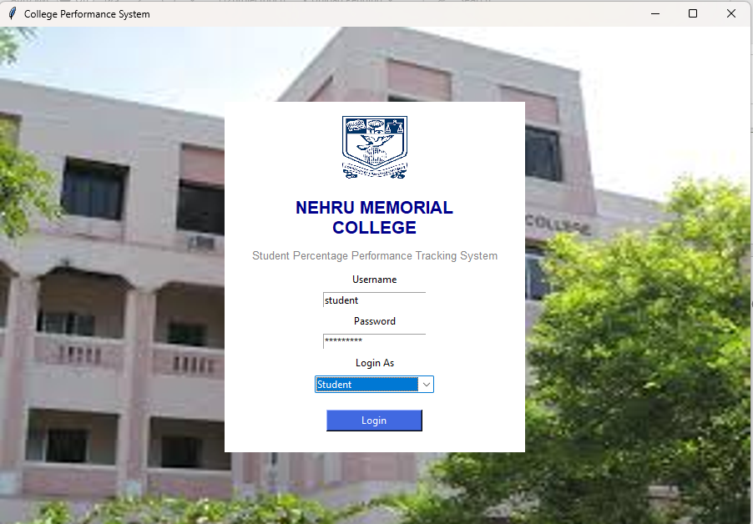

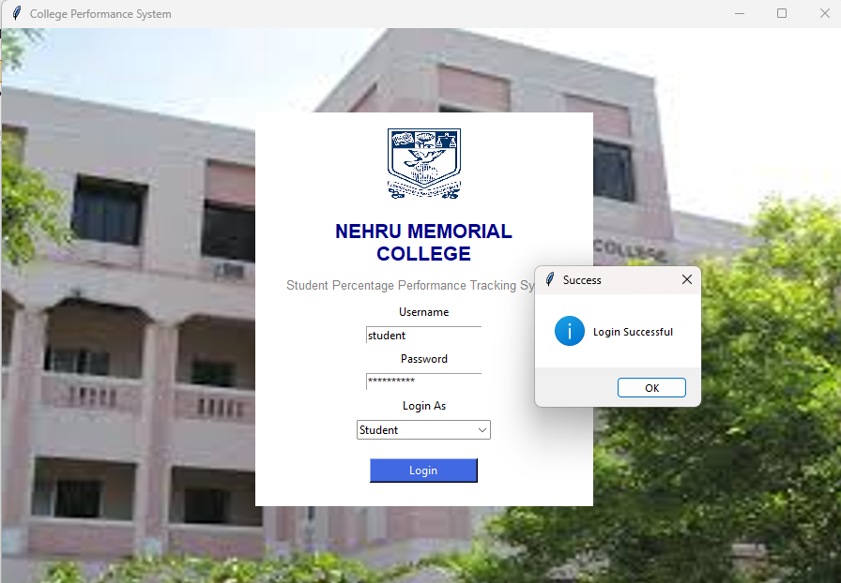
Student Dashboard

View Result
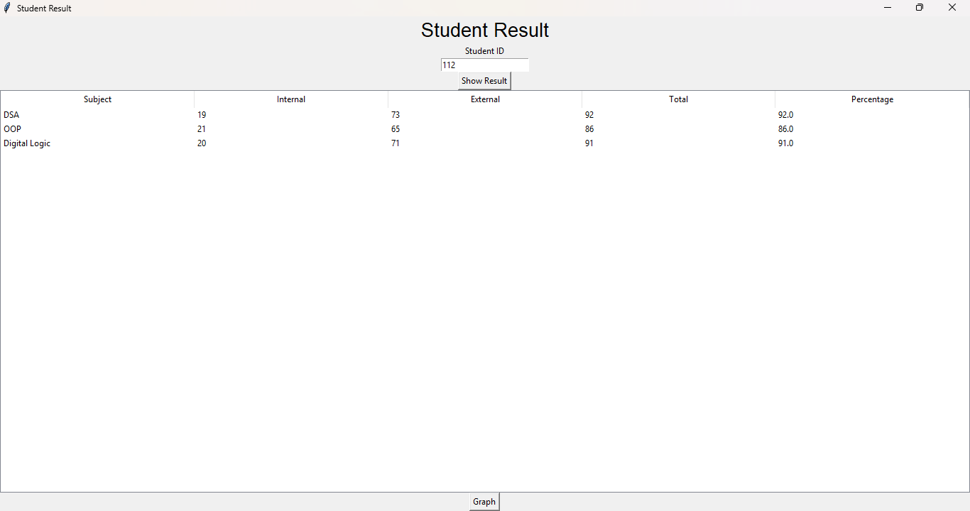

Graph View

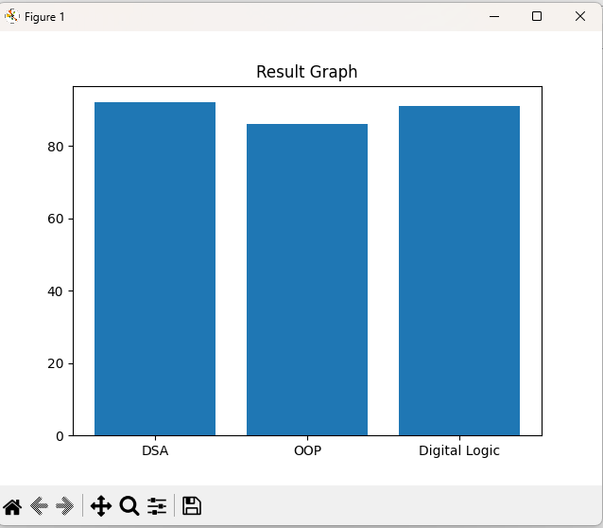

Download Marksheet

