[*finanalytica@gmail.com*](mailto:contact@example.com) *+999999999*

[**Fin Analytica.**](http://docs.google.com/index.html)

* Home
* About
* Dashboard
* Story
* Contact

Welcome to Fin Analytica

A widely used approach to analyzing a bank, CAMELS, considers a bank's Capital adequacy, Asset quality, Management capabilities, Earnings sufficiency, Liquidity position, and Sensitivity to market risk..

Get Started [Watch Video](https://www.youtube.com/watch?v=fTTGALaRZoc)



Statiscal analysis

Data Visualization

Machine Learning

Artificial Intelligence

About Us

We provide best Business intelligence solutions to the companies,which makes a strategy for elevating their business in the market

Insight generations through sophasticated tools



We provide business solutions in various domains.

* Insights generations using Business Intelligence.
* Building Data models using Statistics.
* Developing the predictive models.





**Students** has Succesfully trained

**Projects** has been developed

**Hours Of Support** has been delivered

Call To Action

Call To Action

Insights

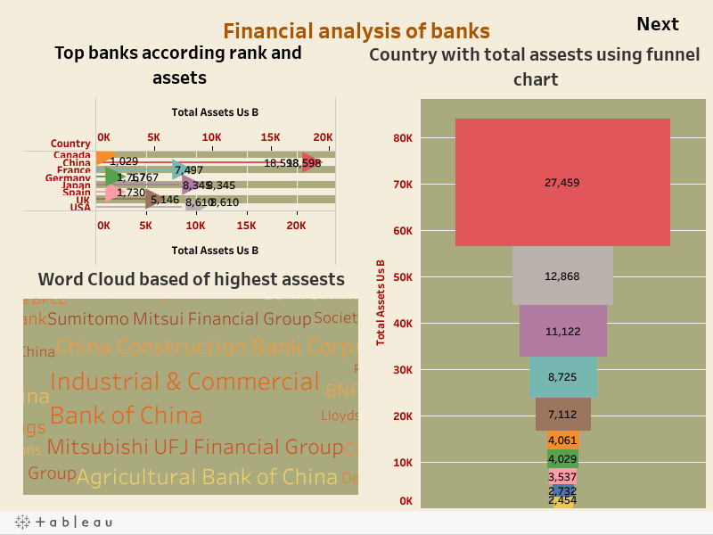

Story Board

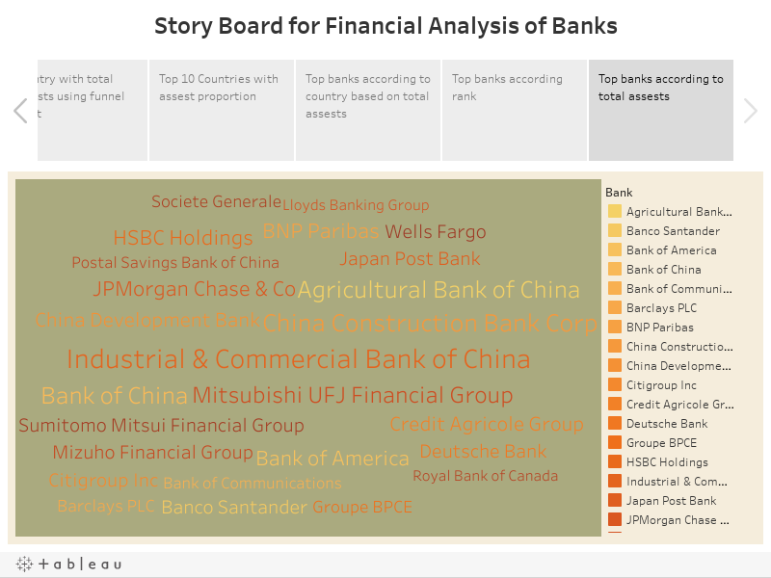

Contact

Location:

Telangana

Email:

finanalytica

Call:

+1 5589 55488 55

Open Hours:

Mon-Sat: 11AM - 23PM

Loading

Your message has been sent. Thank you!

Send Message

[Fin Analytica](http://docs.google.com/index.html)

We provide solutions to your business.

Useful Links

* Home
* About us
* Services
* Terms of service
* Privacy policy

Our Services

* Data Science
* Artificial Intelligence
* Business Intelligence
* Data Analytics
* Cloud Application Development

Contact Us

Gachibowli

Hyderabad,Telangana 500050

India

**Phone:** +1 5589 55488 55

**Email:** Finanalytica@example.com

© Copyright **Impact**. All Rights Reserved

Designed by [BootstrapMade](https://bootstrapmade.com/)