**Creating a Django model creates a corresponding table in database.**

**\*\*** Relationships between tables are created by foreign key links .

**customer**.Name_title_id = **nametitle**.Id

|  |  |
| --- | --- |
| Table **customer** | |
| **id** | 1 |
| **Name_title_id** | 2 |
| **fullname** | dhana |
| **Customer_id** | 6 |
| **mobile** | 88999345621 |

Model **Customer:**

**Title (Foreign key)**

**Full Name**

**Customer ID**

**Mobile Num**

|  |  |
| --- | --- |
| Table **nametitle** | |
| **Id** | **title** |
| 1 | Mr. |
| 2 | Mrs. |
| 3 | Miss. |
| 4 | Sir. |
| 5 | Ms. |

**Customer Registration Form**

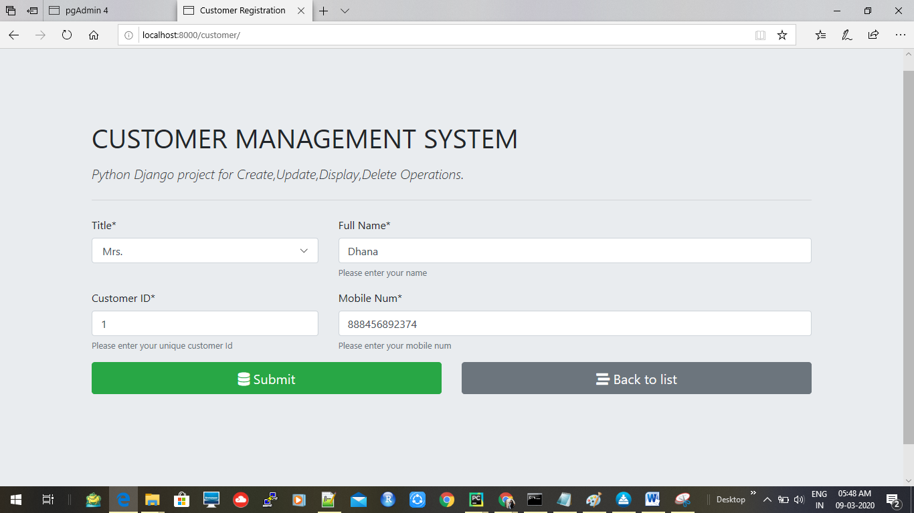

**Operations**

