Stock Portfolio Tracker
Task 2 — Project Report
Submitted on: July 8, 2026

1. Objective
Build a simple, console-based stock portfolio tracker in Python that calculates a user's total investment value using manually defined (hardcoded) stock prices.

2. Scope
- Accept stock names and quantities entered by the user.
- Use a hardcoded dictionary to define available stock prices.
- Calculate and display the total investment value.
- Display the value of each individual stock holding.
- Save the final result to a CSV file for record-keeping.
- Handle invalid stock names gracefully, without crashing the program.

3. Key Concepts Used
Concept | Where it's applied
Dictionary | STOCK_PRICES stores each ticker symbol mapped to its price
Input / Output | input() collects stock names and quantities; print() displays results
Basic Arithmetic | price × quantity per stock, summed for the total investment
File Handling | csv.writer saves the summary to portfolio_summary.csv
Error Handling | try/except and membership checks catch invalid tickers and quantities

4. Program Design
The program is organized into small, single-purpose functions:
- get_portfolio_input() — repeatedly prompts for a stock name and quantity until the user types 'done'; rejects unknown tickers and non-numeric or negative quantities.
- calculate_investment() — multiplies price by quantity for each holding and accumulates the total.
- display_results() — prints a formatted table of each stock's value and the grand total.
- save_to_csv() — writes the same data, plus a timestamp, to a CSV file.
- main() — orchestrates the above in sequence.

5. Hardcoded Stock Prices
STOCK_PRICES = {
"AAPL": 180,
"TSLA": 250,
"GOOGL": 170,
"MSFT": 420,
"AMZN": 190
}

6. Sample Run
Example session: the user buys 10 shares of AAPL, 5 shares of TSLA, 3 shares of MSFT, and mistakenly enters an invalid ticker (XYZ), which is caught and rejected.
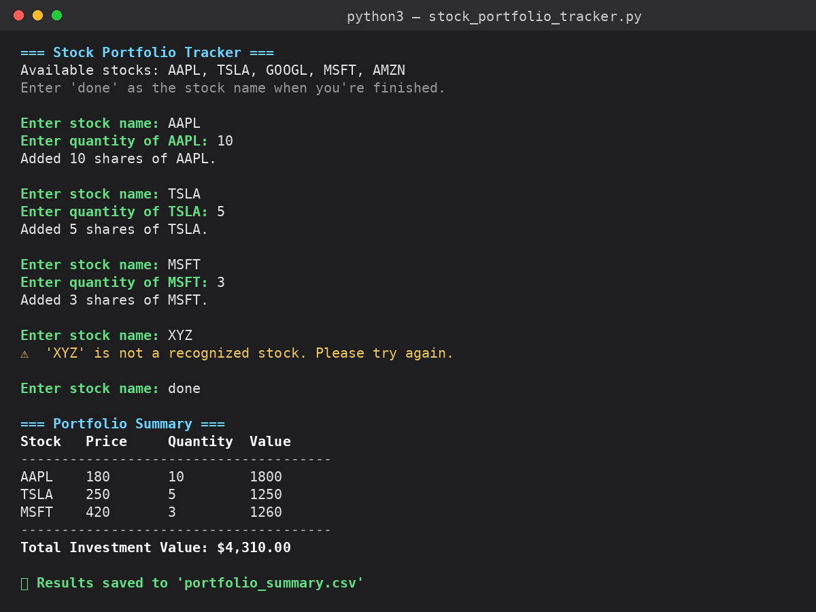

7. CSV Output
The results are written to portfolio_summary.csv, including a generation timestamp:
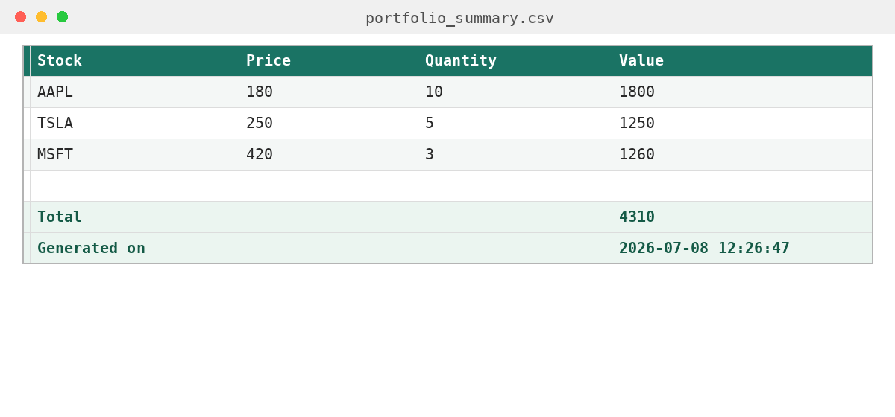

8. Result Summary
Stock | Price | Quantity | Value
AAPL | $180 | 10 | $1,800
TSLA | $250 | 5 | $1,250
MSFT | $420 | 3 | $1,260
Total |  |  | $4,310

9. Error Handling Notes
- Unknown ticker symbols (e.g., 'XYZ') are detected and rejected with a warning, without stopping the program.
- Non-numeric quantity entries are caught using a try/except block around int() conversion.
- Zero or negative quantities are rejected with a prompt to re-enter.
- If the user enters no valid stocks at all, the program exits cleanly with a message instead of crashing.

10. How to Run
python3 stock_portfolio_tracker.py
Follow the on-screen prompts to enter stock names and quantities, then type 'done' to see the summary and generate portfolio_summary.csv.

11. Conclusion
This task demonstrates practical use of dictionaries for lookup data, user I/O, arithmetic calculations, and basic file handling — all wrapped in a small, defensively-coded Python script suitable for further extension (e.g., live price APIs, a GUI, or persistent portfolio storage across sessions).

