Task 1: Hangman Game
Python Console-Based Project Report

1. Goal
Create a simple text-based Hangman game where the player guesses a word one letter at a time.

2. Scope
- Use a small list of 5 predefined words (no file or API required).
- Limit incorrect guesses to 6.
- Basic console input/output only — no graphics or audio.

3. Key Concepts Used
- random — to randomly select a word from the word list.
- while loop — to keep the game running until it is won or lost.
- if-else — to check guesses, validate input, and decide win/lose conditions.
- strings — to build and display the masked word and guessed letters.
- lists — to store the word bank and track guessed letters.

4. Requirements Checklist
- Predefined list of 5 words — Implemented (WORDS list).
- Random word selection — Implemented using random.choice().
- Guess one letter at a time — Implemented via input() inside the game loop.
- Maximum 6 wrong guesses — Implemented (MAX_WRONG_GUESSES = 6).
- Word displayed with underscores — Implemented via display_word().
- Guessed letters shown — Implemented, printed every turn.
- Win/lose message — Implemented at end of play_game().
- Play again option — Implemented in main() using a while loop.
- Only allowed concepts used (random, while, if-else, strings, lists) — Confirmed, no extra modules imported.

5. Program Design
The program is organized into four functions:
- choose_word() — picks a random word from the WORDS list.
- display_word(word, guessed_letters) — builds the underscore/letter display string.
- play_game() — runs a single round: handles guesses, tracks wrong attempts, checks win/lose.
- main() — the entry point; loops play_game() based on the player's “play again” response.

6. Source Code (hangman.py)
import random

WORDS = ["python", "hangman", "computer", "keyboard", "science"]
MAX_WRONG_GUESSES = 6

def choose_word():
return random.choice(WORDS)

def display_word(word, guessed_letters):
display = ""
for letter in word:
if letter in guessed_letters:
display += letter + " "
else:
display += "_ "
return display.strip()

def play_game():
word = choose_word()
guessed_letters = []
wrong_guesses = 0

print("\nWelcome to Hangman!")
print("Guess the word, one letter at a time.")
print("You have", MAX_WRONG_GUESSES, "wrong guesses allowed.\n")

while wrong_guesses < MAX_WRONG_GUESSES:
print("Word: " + display_word(word, guessed_letters))
print("Guessed letters: " + ", ".join(guessed_letters))
print("Wrong guesses: " + str(wrong_guesses) + "/" + str(MAX_WRONG_GUESSES))

guess = input("Guess a letter: ").lower().strip()

if len(guess) != 1 or not guess.isalpha():
print("Please enter a single letter.\n")
continue

if guess in guessed_letters:
print("You already guessed that letter.\n")
continue

guessed_letters.append(guess)

if guess in word:
print("Good guess!\n")
else:
wrong_guesses += 1
print("Wrong guess!\n")

won = True
for letter in word:
if letter not in guessed_letters:
won = False

if won:
print("Congratulations! You guessed the word: " + word)
return

print("You lost! The word was: " + word)

def main():
play_again = "yes"

while play_again == "yes":
play_game()
answer = input("\nDo you want to play again? (yes/no): ").lower().strip()

if answer == "yes":
play_again = "yes"
else:
play_again = "no"

print("Thanks for playing Hangman!")

if __name__ == "__main__":
main()

7. Sample Output — Winning Run
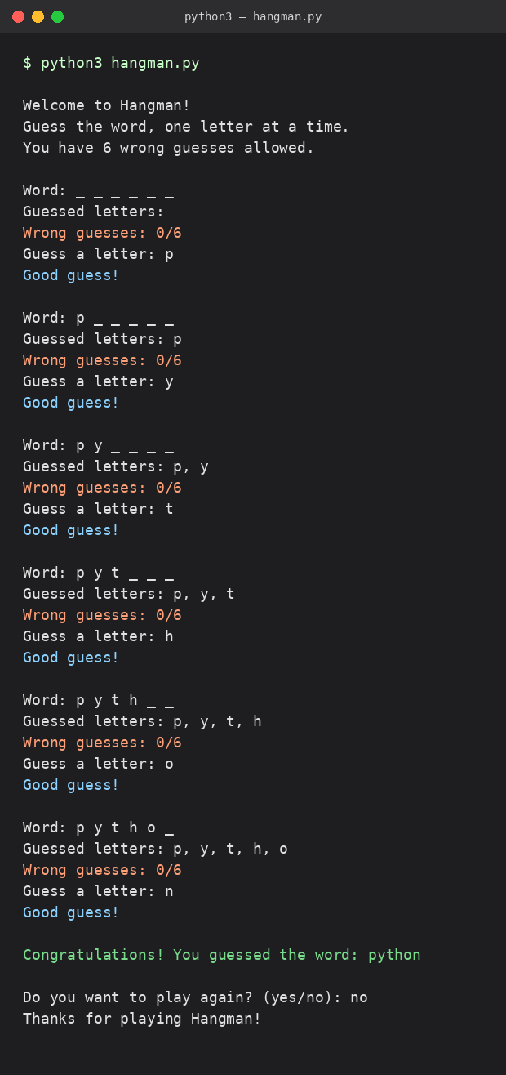

8. Sample Output — Losing Run
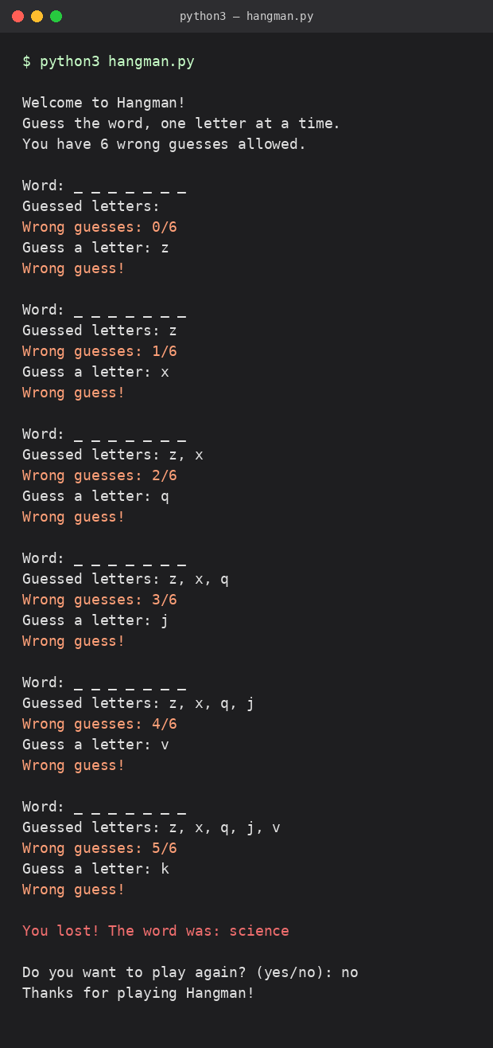

9. Conclusion
The Hangman game meets all specified requirements using only basic Python constructs — random, while loops, if-else statements, strings, and lists. The game correctly handles valid and invalid input, tracks guessed letters, enforces the 6-wrong-guess limit, and allows repeated play sessions.

