TASK 3: Task Automation with Python Scripts
Automating a Real-Life Repetitive Task Using Python
Task | Automate a small, real-life repetitive task
Idea Chosen | Move all .jpg files from a source folder to a destination folder
Key Concepts Used | os, shutil, file handling, exception handling
Language | Python 3
Script File | move_jpg_files.py

1. Objective
The goal of this task is to automate a small, real-life repetitive task using a Python script. The chosen idea is to build a script that moves all .jpg image files from a source folder into a destination folder automatically, instead of doing it manually through file explorer. This kind of automation is useful for organizing photo backups, sorting downloaded images, or cleaning up a folder that mixes many file types together.

2. Requirements Covered
- Uses the os and shutil modules to interact with the file system.
- Asks the user to input the source and destination folder paths at runtime.
- Automatically creates the destination folder using os.makedirs() if it does not already exist.
- Filters and moves only files ending in .jpg (case-insensitive, so .JPG is also matched).
- Displays a running log of every file moved, plus a final count of total files moved.
- Handles errors gracefully: missing source folder, folder-creation failures, permission errors, missing files, naming collisions at the destination, and any other unexpected exceptions.

3. How the Script Works

3.1 Step-by-step logic
- Check whether the source folder exists; if not, print an error and stop.
- Check whether the destination folder exists; if not, create it with os.makedirs().
- List all entries in the source folder using os.listdir().
- For each entry, check if the filename ends with '.jpg' (case-insensitive) and is an actual file.
- Skip the file (with a message) if a file with the same name already exists at the destination, to avoid silently overwriting data.
- Move the file using shutil.move() inside a try/except block that catches PermissionError, FileNotFoundError, shutil.Error, and any other unexpected exception.
- Keep a running counter of successfully moved files and print the total at the end.

3.2 Full Source Code
"""
Task 3: Task Automation with Python Scripts
--------------------------------------------
Move all .jpg files from a source folder to a destination folder.

Key concepts used: os, shutil, file handling, error handling
"""

import os
import shutil

def move_jpg_files(source_folder, destination_folder):
"""
Move all .jpg files from source_folder to destination_folder.
Creates the destination folder if it doesn't exist.
Returns the number of files moved.
"""
moved_count = 0

# Check if source folder exists
if not os.path.isdir(source_folder):
print(f"Error: Source folder '{source_folder}' does not exist.")
return moved_count

# Create destination folder if it doesn't exist
if not os.path.exists(destination_folder):
try:
os.makedirs(destination_folder)
print(f"Destination folder '{destination_folder}' created.")
except OSError as e:
print(f"Error: Could not create destination folder. {e}")
return moved_count

# Loop through files in source folder
try:
files = os.listdir(source_folder)
except OSError as e:
print(f"Error: Could not read source folder. {e}")
return moved_count

for file_name in files:
# Check for .jpg extension (case-insensitive)
if file_name.lower().endswith(".jpg"):
source_path = os.path.join(source_folder, file_name)
destination_path = os.path.join(destination_folder, file_name)

# Skip if it's not actually a file (e.g., a folder named something.jpg)
if not os.path.isfile(source_path):
continue

try:
# Avoid overwriting an existing file at destination
if os.path.exists(destination_path):
print(f"Skipped (already exists at destination): {file_name}")
continue

shutil.move(source_path, destination_path)
print(f"Moved: {file_name}")
moved_count += 1

except PermissionError:
print(f"Error: Permission denied while moving '{file_name}'.")
except FileNotFoundError:
print(f"Error: '{file_name}' not found (may have been removed).")
except shutil.Error as e:
print(f"Error: Could not move '{file_name}'. {e}")
except Exception as e:
print(f"Unexpected error moving '{file_name}': {e}")

return moved_count

def main():
print("=== Move .jpg Files From One Folder To Another ===\n")

source_folder = input("Enter the source folder path: ").strip()
destination_folder = input("Enter the destination folder path: ").strip()

try:
moved_count = move_jpg_files(source_folder, destination_folder)
print(f"\nDone. Total .jpg files moved: {moved_count}")
except Exception as e:
print(f"An unexpected error occurred: {e}")

if __name__ == "__main__":
main()

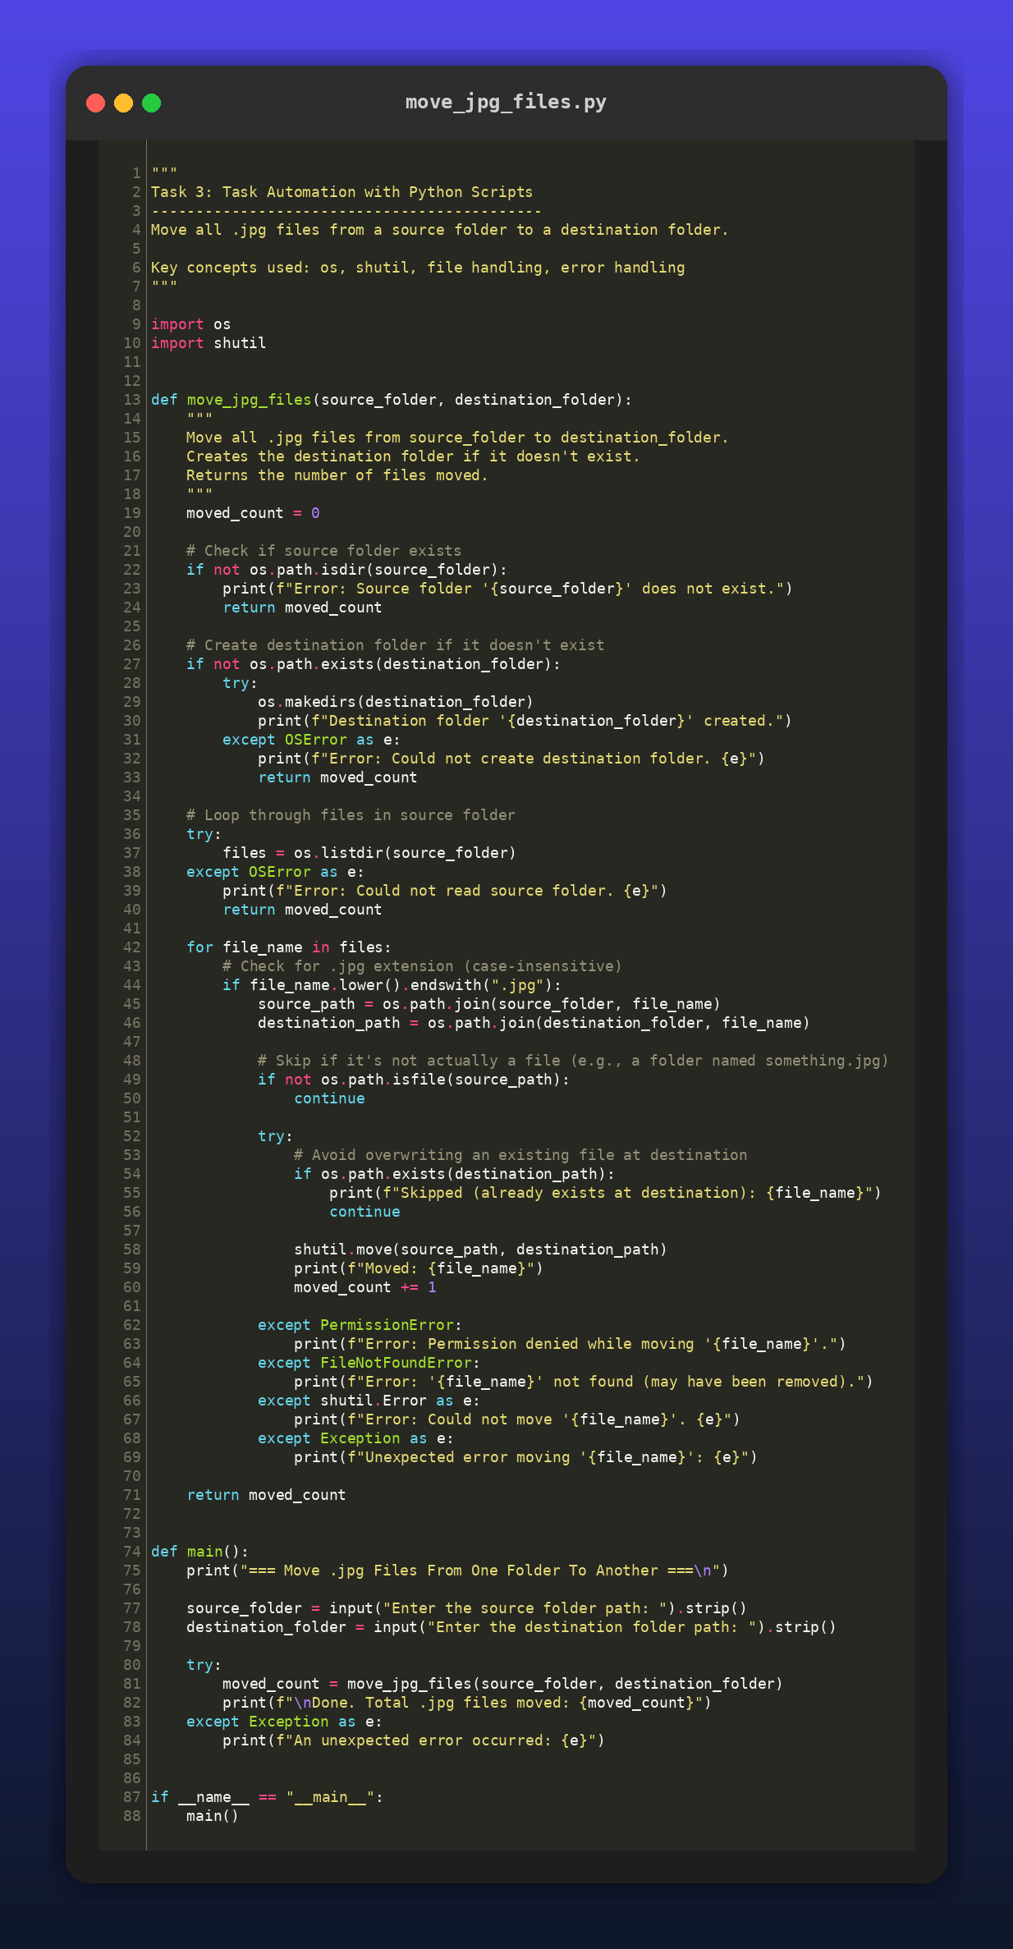
Figure 1: Syntax-highlighted view of move_jpg_files.py

4. Sample Run / Output
The script was tested with a sample source folder containing three .jpg files, one .JPG file (uppercase extension), one .txt file, and one .png file. Only the four .jpg/.JPG files were moved; the .txt and .png files were correctly left untouched, and the destination folder was created automatically since it did not already exist.
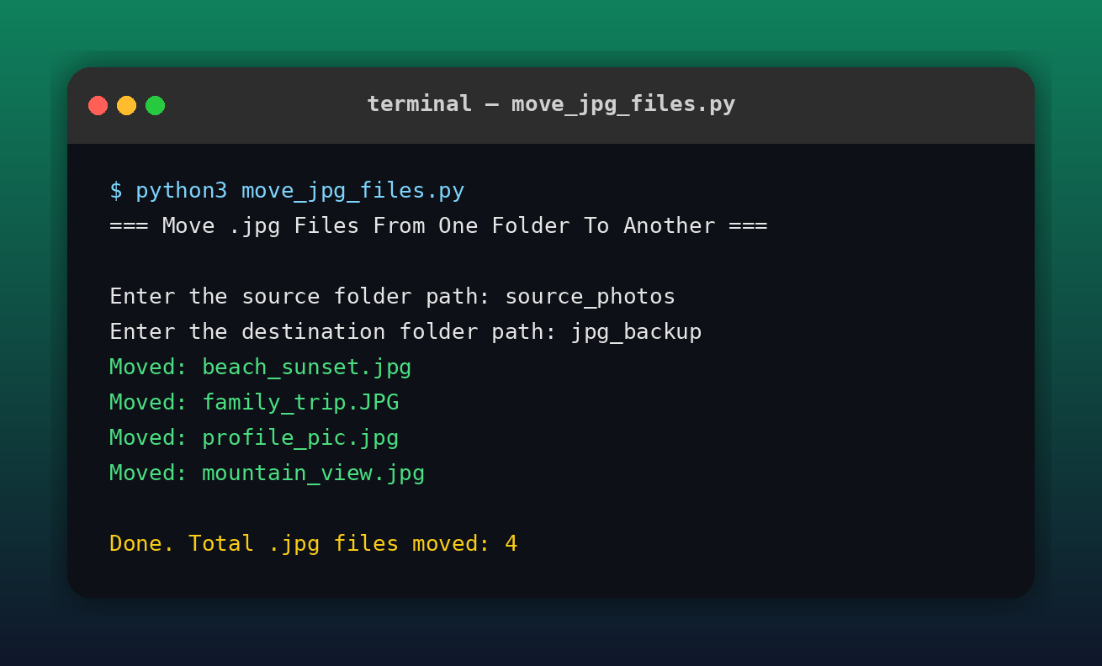
Figure 2: Terminal output from a real run of the script

5. Error Handling Summary
Scenario | Handling
Source folder missing | Prints an error message and exits without crashing.
Destination folder missing | Automatically created with os.makedirs(); creation failures are caught.
Unreadable source folder | os.listdir() failure is caught and reported.
Permission denied | Caught with PermissionError; script continues with remaining files.
File disappears mid-move | Caught with FileNotFoundError.
Name already exists at destination | File is skipped with a message; nothing is overwritten.
Any other unexpected error | Caught by a generic Exception handler so the script never crashes.

6. Conclusion
This task demonstrates practical use of Python's os and shutil modules to automate a common file management chore. The script is robust against missing folders, permission issues, and naming conflicts, and gives clear feedback to the user at every step, making it suitable for real-world use such as organizing photo libraries or cleaning up download folders.

