NetBeans IDE

Installation:
- Go to Yum Extender.
- Select radio button All.
- Add keyword as "Netbeans"
- Get all the packages that are marked as green in below screenshot installed on your machine.
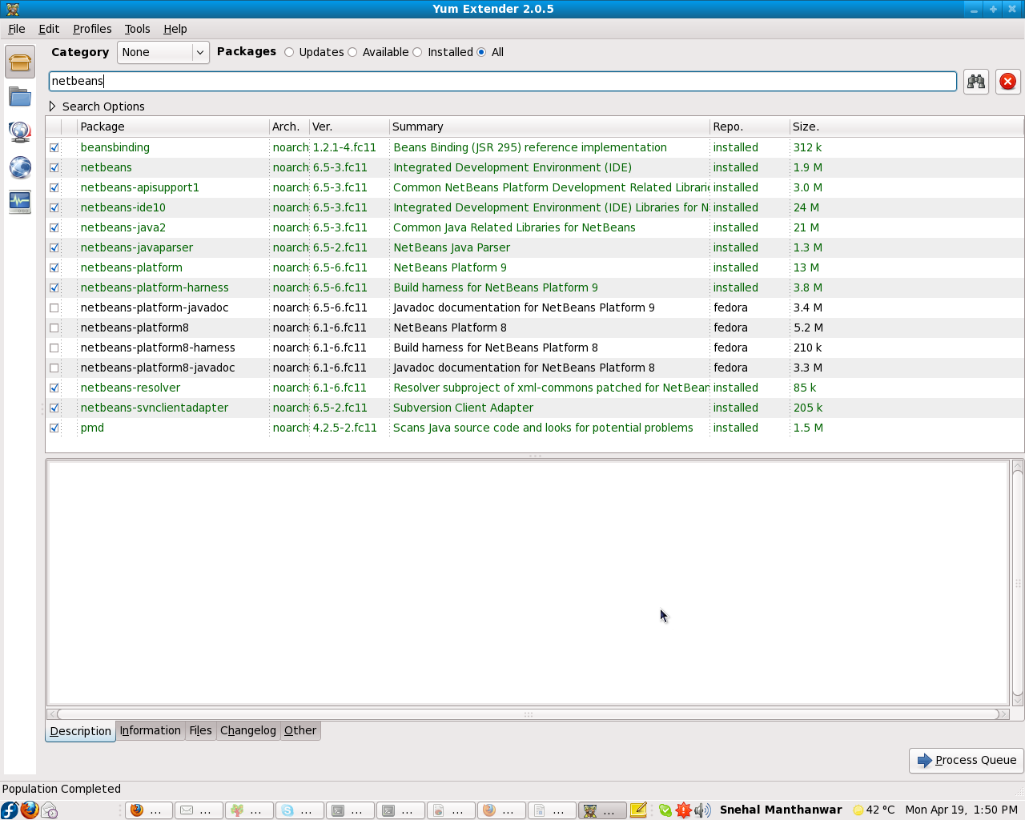

CVS Integration with Netbens IDE:

The steps for cvs integration are given as follows:
- Please check your netbeans ide version. If it is less than 6.7.1 then update it.
- Go to :- Team-> cvs-> checkout .
- After it, you will get a pop-up window. Select “.ext:xyz@”.
- Enter the following format into the cvs root:- .ext:xyz@hostname:/repository path where,
xyz -> User name
hostname -> cvs main server ip address (192.168.1.6)
repository path -> /home/cvsroot
- Choose “Use Internal SSH ” and enter the password . Now click on next button.
- In second window, choose the Module name by clicking on “Browse” and choose the local server path.
- Click on “Finish”.

Netbeans IDE Updation if required:

- Copy the netbeans sh file from the following location:-
Comp10->Shared Docs->netbeans-6.7.1-ml-ruby-linux.sh
- Execute cd “local path of netbeans-6.7.1-ml-ruby-linux.sh”.
- Execute / from the terminal.
- Follow the instructions.
- Click on “Finish”.

CVS Checkout through NetBeans IDE:
CVS Checkout:
- Go to: From menu select -> Versioning >> cvs >> checkout
- You will get following pop-up window
- make suitable entries in following fields as
  - cvs root = :ext:username@192.168.1.6:/home/cvsroot
  - select user internal SSH and enter password here
- click on next (cont...)
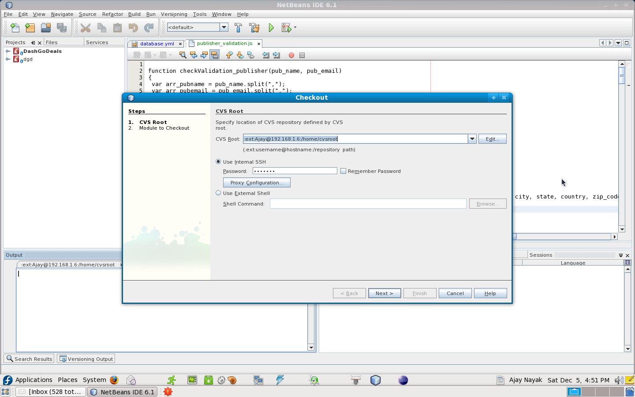

- This will navigate you to following window:
- just mention the module name which you want to check out. You can also hit browse button if you doesnt know exact name of module. (eg. DashGoDeals)
- select branch – HEAD
- local folder where you want to checkout your code (eg: /home/Ajay/code)
- Hit Finish (cont..)

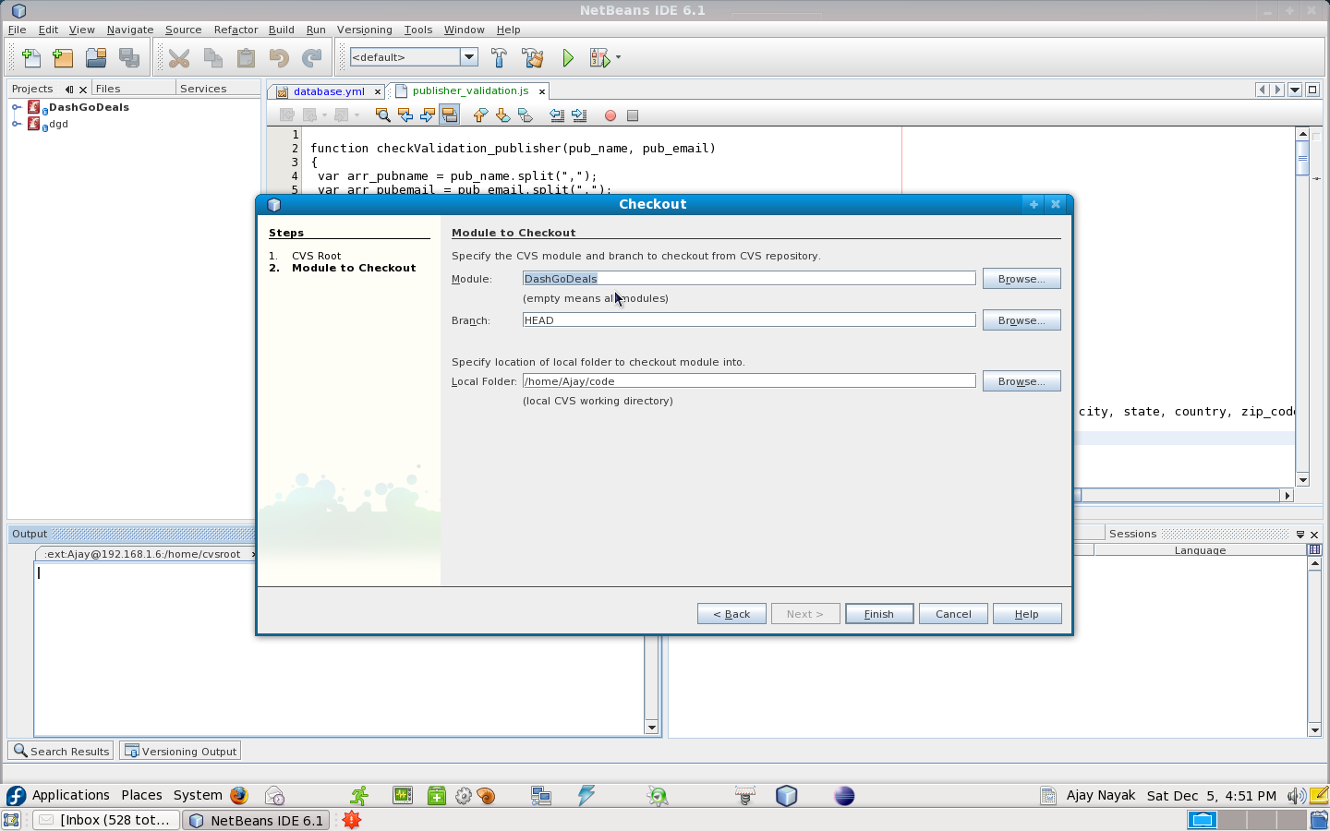
- This will start checking-out of desired module.
- You can see check-out files in netbeans console.
- Once this done you will see the following window:

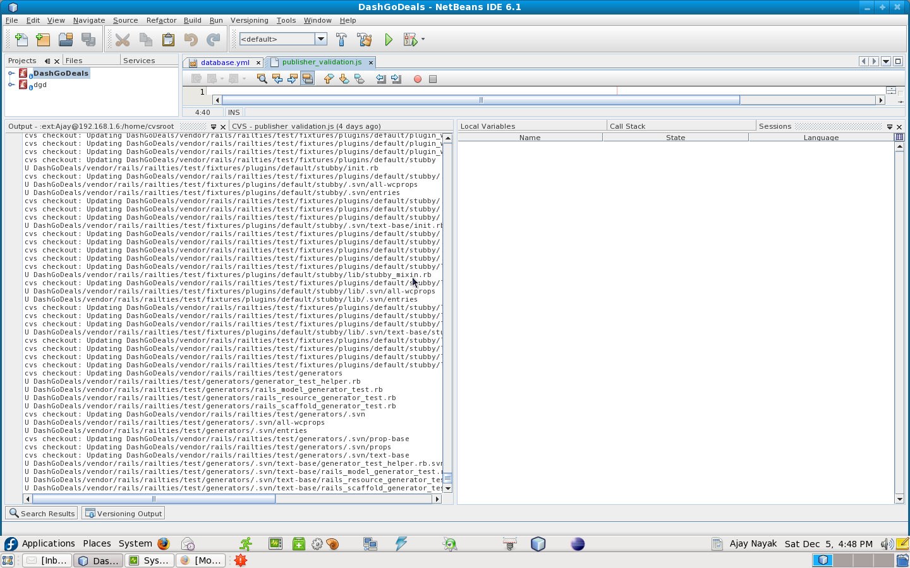
Minimum Hardware Requirements
Your hardware platform is not important, however, please familiarize yourself with the requirements of NetBeans 5.5.1 IDE. In addition, note that IDE's minimum screen resolution is 1024x768 pixels.
Minimum Hardware Configuration
Operating system | Processor | Memory | Disk space
Solaris | 450 MHz (SPARC II) or 1.8 GHz (AMD Opteron 100) | 512 MB | 450 MB
Windows | 500 MHz Pentium III | 512 MB | 850 MB
Linux | 500 MHz Pentium III | 512 MB | 450 MB
Mac OS X | Power PC G4 | 512 MB | 450 MB
Recommended Hardware Configuration
Operating system | Processor | Memory | Disk space
Solaris | 1 GHz (SPARC III) or 1.8 GHz (AMD Opteron 100) | 1 GB | 850 MB
Windows | 1.4 GHz Pentium III | 1 GB | 1 GB
Linux | 1.4 GHz Pentium III | 1 GB | 850 MB
Mac OS X | Power PC G5 | 1 GB | 850 MB
(Source: http://qa.netbeans.org/processes/cat/551/entpack/faqs.html)

Improving Performance of NetBeans IDE on system: Slow and Hangup issues

As along with the netbeans IDE there are so many other proccess (services) are running in system.
So netbeans is unable to get memory requirement what its actaully required.
So we can manually kill and make sure that unnecessary services are not running in system.
Along with this we can increase system cache size so it will help Netbeans to allocate memory for its running processes.
(Note : Use JRE 1.6)
Adjust disk cache parameters.
Background
This adjustment tells Linux to prefer inode/dentry cache to other caches. The parameter that is adjusted is /proc/sys/vm/vfs_cache_pressure.
View current vfs_cache_pressure setting
1. To view the current vfs_cache_pressure factor run this as root.

cat /proc/sys/vm/vfs_cache_pressure
2. Change vfs_cache_pressure setting
echo 50 > /proc/sys/vm/vfs_cache_pressure
Change the 50 above to whatever you want between 1 and 100 (100 is the default).
3. Making the change permanent
This is made permanent by adding "vm.vfs_cache_pressure=50" to "/etc/sysctl.conf"
(source: http://www.excusemeplease.org/computers/linux/adjust_caching.shtml)

Steps to set catch pressure in sysctl.conf.
- Open terminal and login as root user
- Type command nano /etc/sysctl.conf
- Copy below two lines in terminal (append in sysctl.conf fiel)
# To increase cache
vm.vfs_cache_pressure = 60
- press ctrl+o (override command).
- Press enter
- Press ctrl+x (to exit)
- Reboot system .

View code differences( or changes done):
It is very good practice that before checking any code to cvs one will make sure that only his changes are going.
This will eliminate chances of over ridding others code (which is just by mistake) and also point out on our debugging statements which we need to remove while checking-in code.
- Simple select that file from Project window(shown in left hand side).
- Right click over it.
- Select "Subversion"
- Select "Diff"
(Here you can also find so many features as "Show local history/ update/ commit/ merge change etc)
- You will see a window containing difference of files which is in between locally modified file and cvs server latest file.

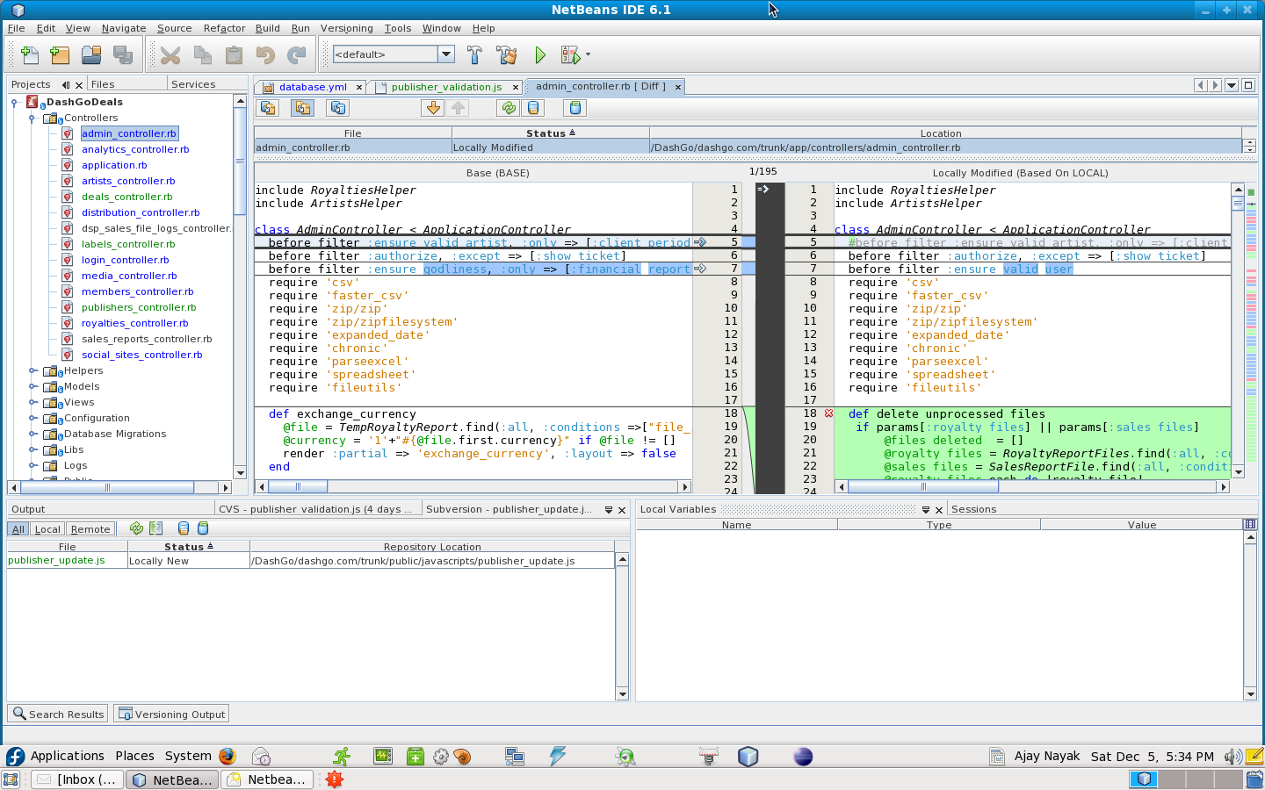
Following things we have observed for NetBeans IDE:
- IDE is dependent on JVM, so must have latest JVM installed.
- First time load obviously will take time as it scans our project, check for dependencies, run time compilation, running its services.
- Step debugging is allowed here in latest IDE, so there is no panic for manual breakpoints.
- Inspect/ watch for variable values are also quite impressive.

