Assignment - 2

By Dhananjay Arora

pingall

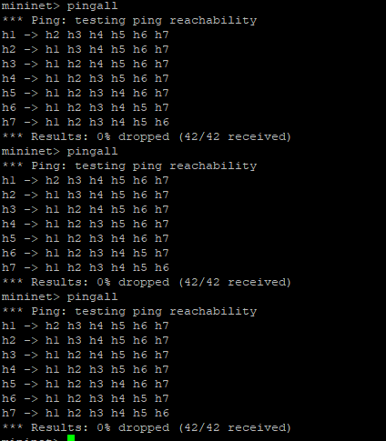

iperf

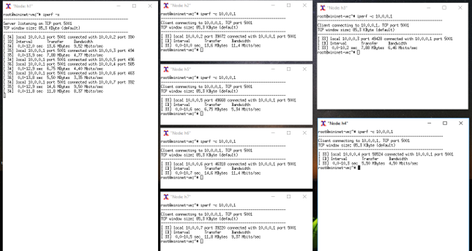

Node h1: iperf -s

Node h2: iperf -c 10.0.0.1

Node h3: iperf -c 10.0.0.1

Node h4: iperf -c 10.0.0.1

Node h5: iperf -c 10.0.0.1

Node h6: iperf -c 10.0.0.1

Node h7: iperf -c 10.0.0.1