**11_RestFulAPI_Assignment2_594665_Dhananjay**

**Project Code** 🡪



**Menu Options** 🡪

1. **New Book Added** 🡪

Output screen shots 🡪

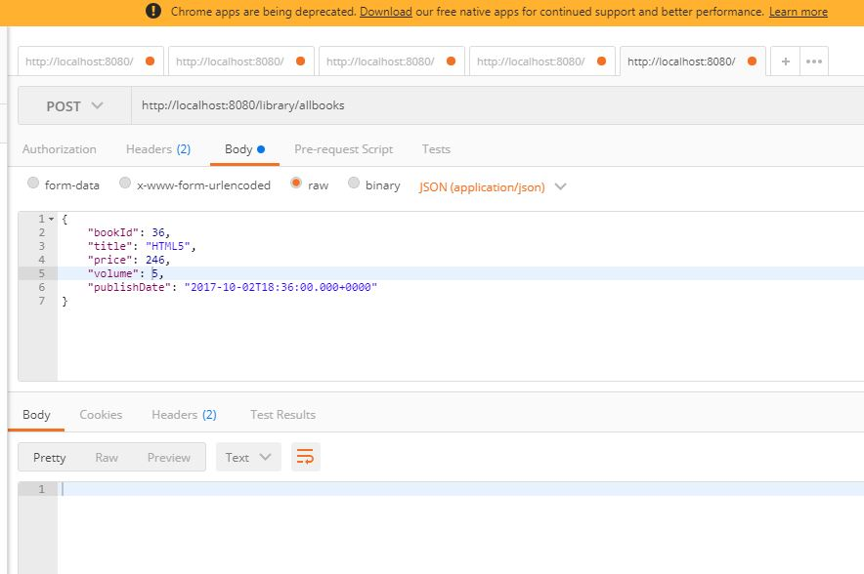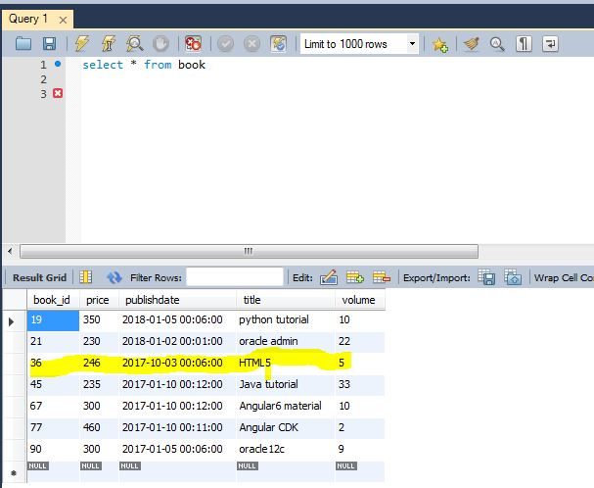

1. **Delete Book** 🡪

**Output** **screen** **shots** 🡪

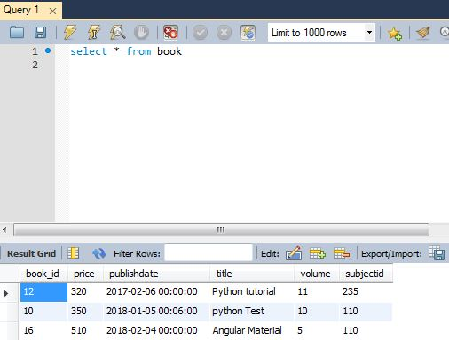

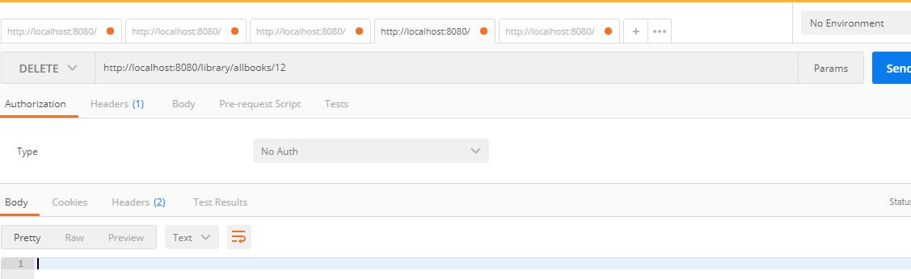

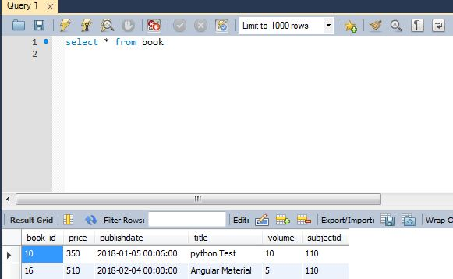

1. Delete book operation with non-existing bookId 🡪

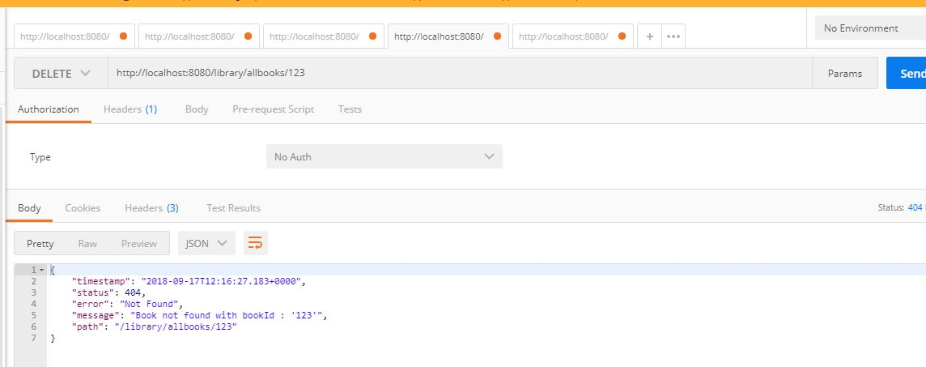

1. Update book with existing ID 🡪

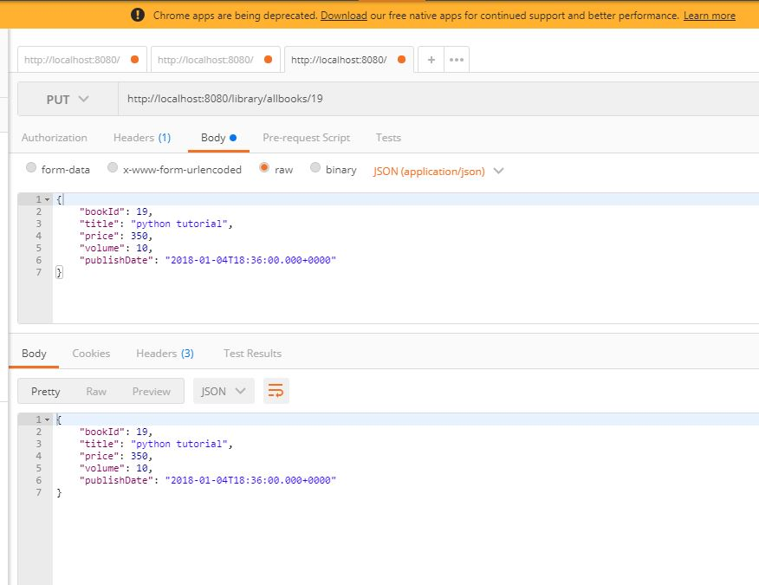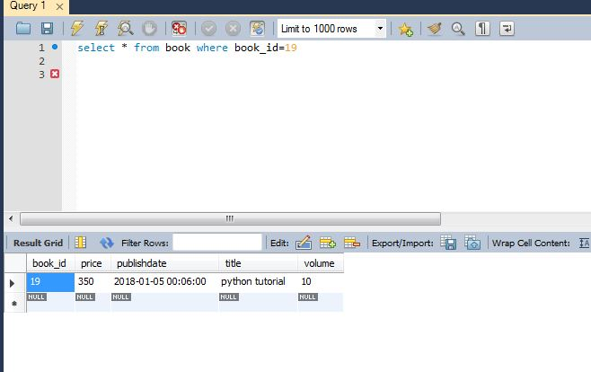

1. Update book operation with non-existing id 🡪

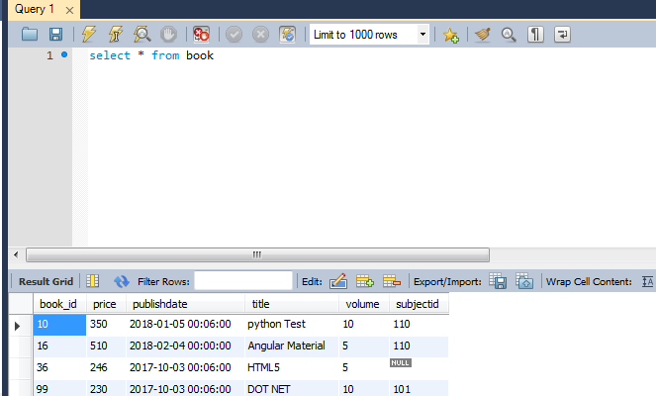

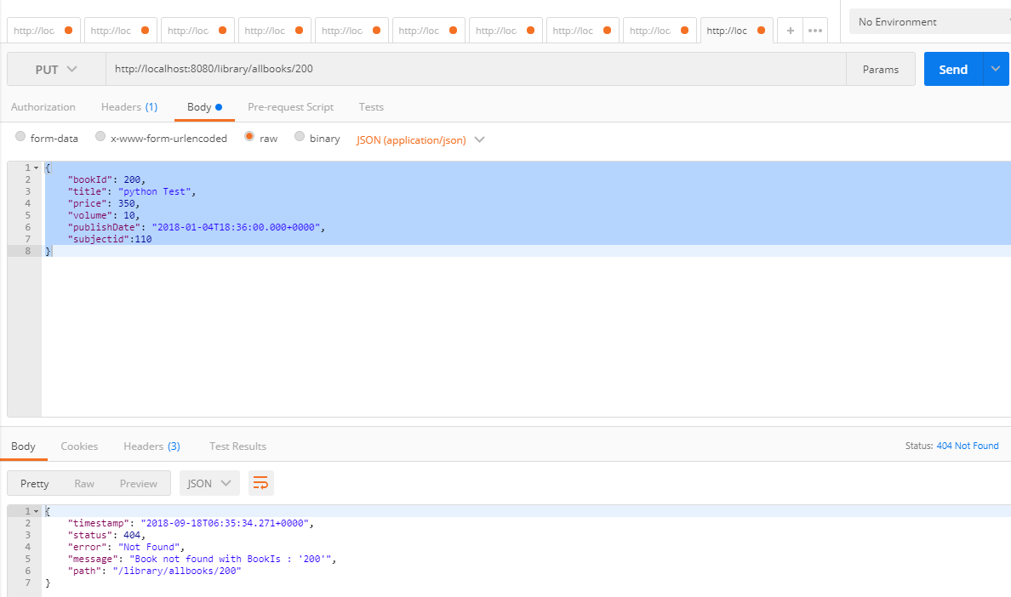

1. Get Book with existing Id 🡪

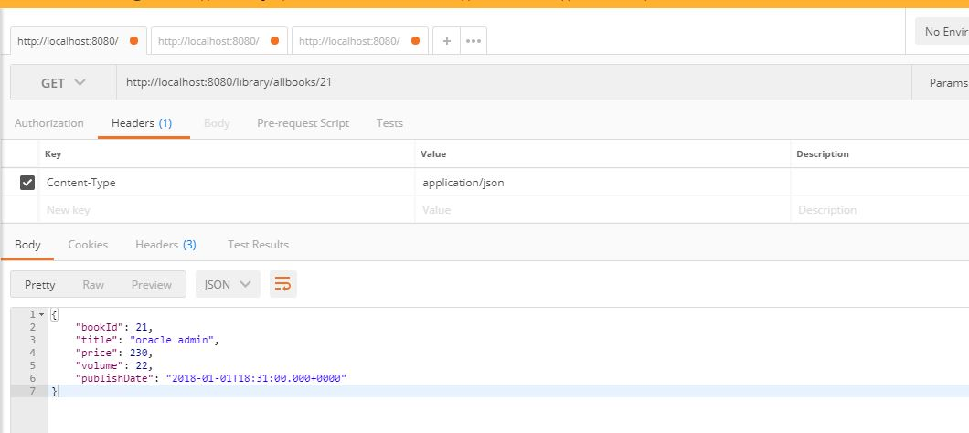

1. Get book with non-existing Id 🡪

