**11_RestFulAPI_Assignment3_594665_Dhananjay**

Project Code 🡪



**Menu Options** 🡪

1. **New Book Added** 🡪

Output screen shots 🡪

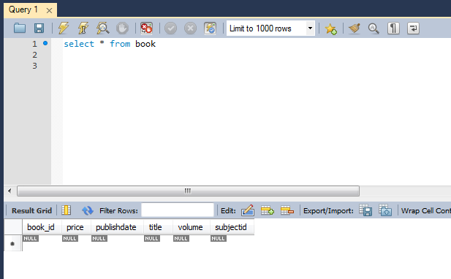

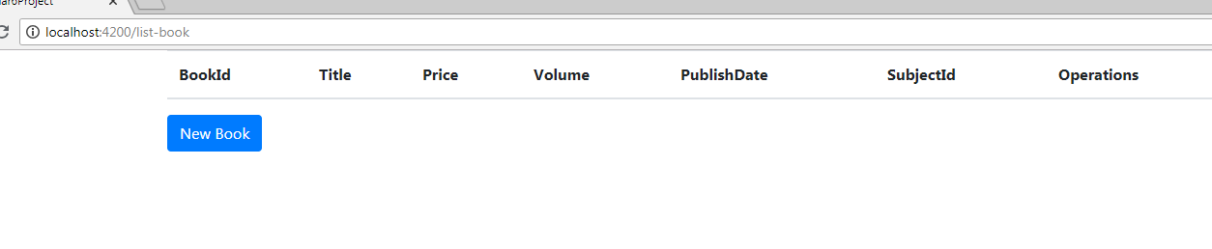

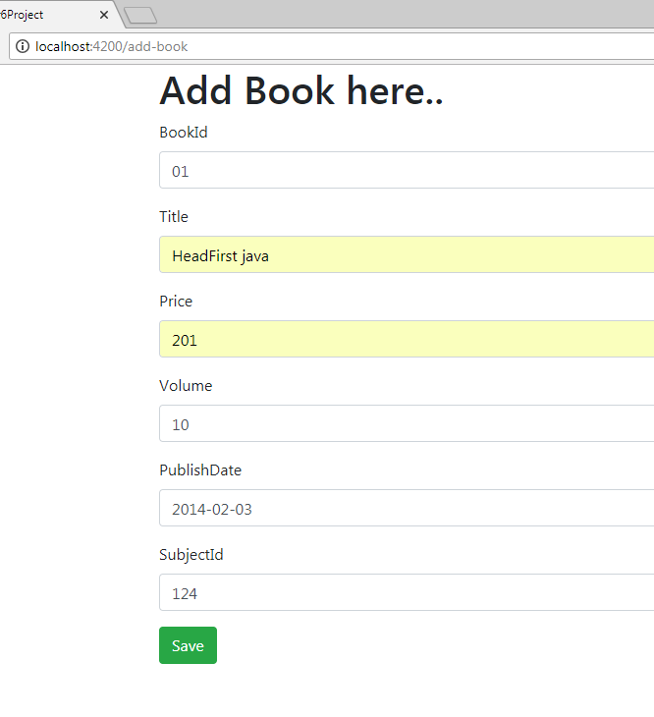

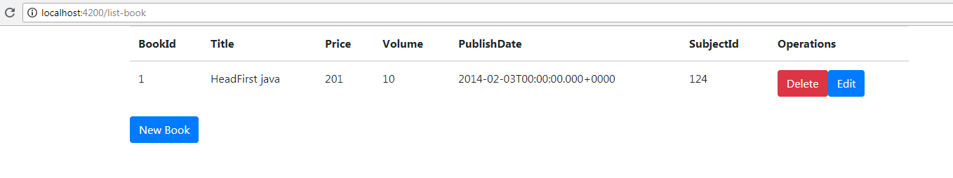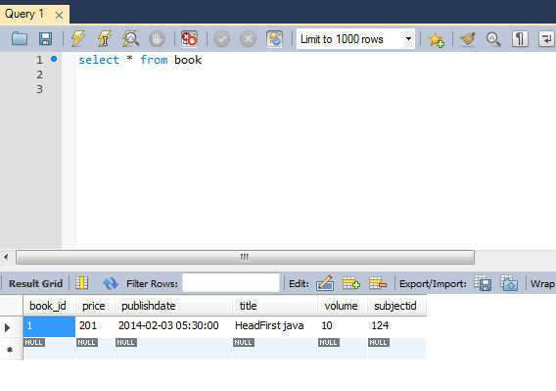

1. **Delete Book** 🡪

**Output** **screen** **shots** 🡪

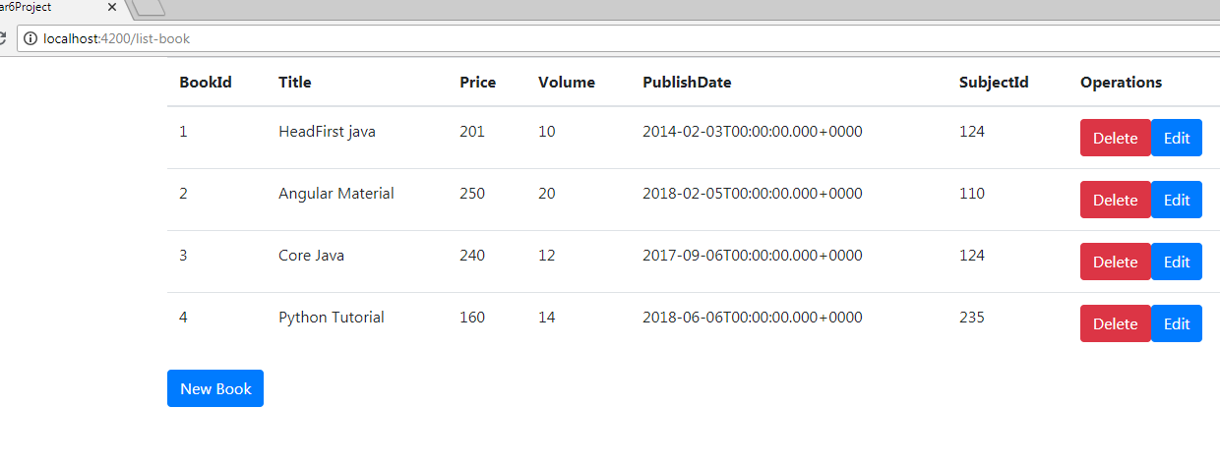

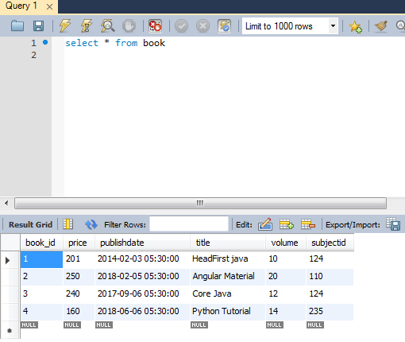

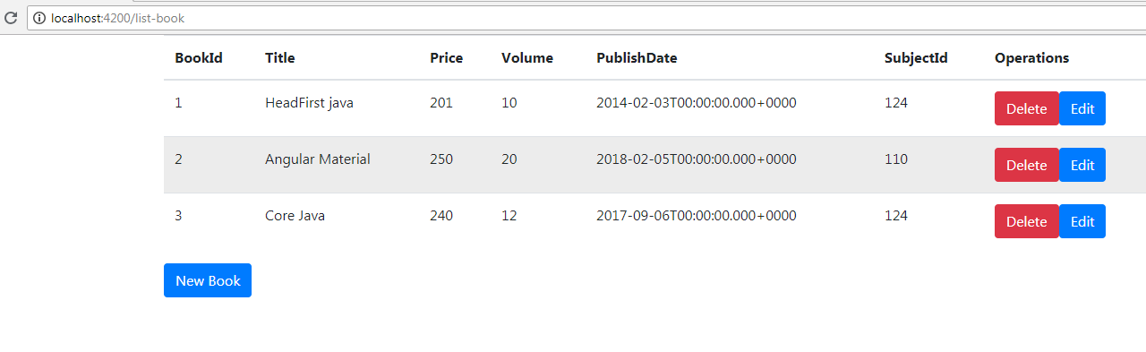

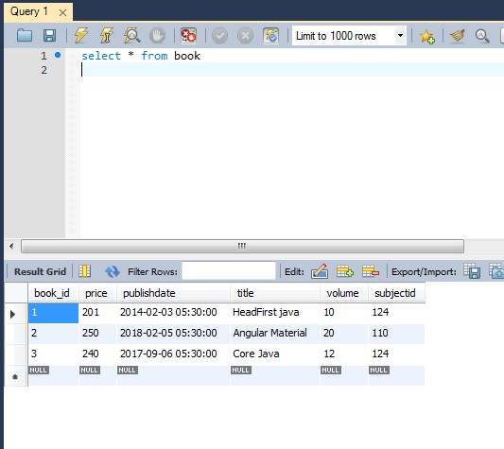

1. Edit book Details 🡪

