**17_Jenkins_Assignment1_594665_Dhananjay**

Project Code 🡪



Output screen shots 🡪

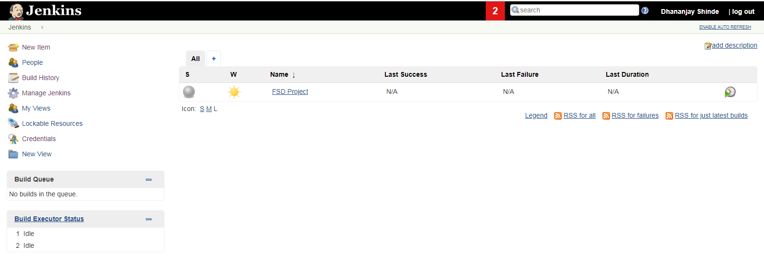

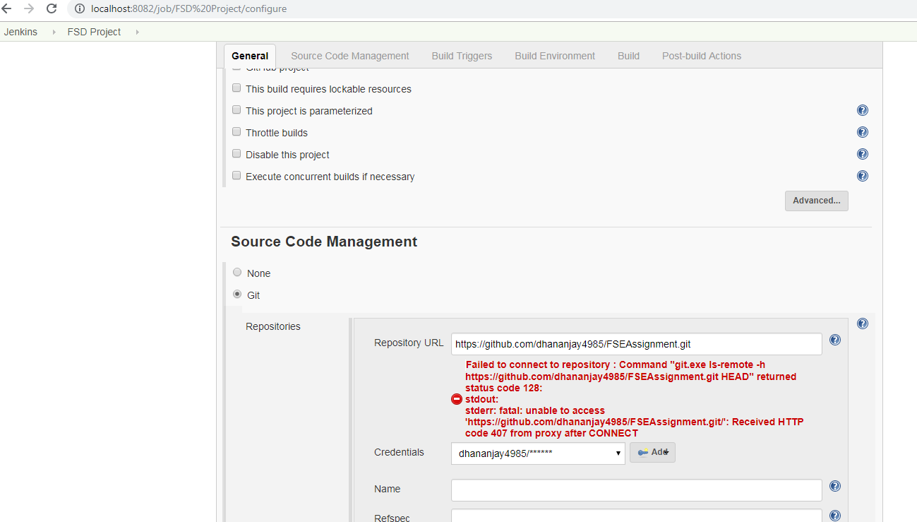

**Book Test Cases**🡪

GetBookById Test Case Result 🡪

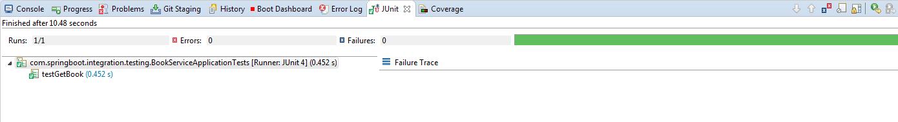

2) GetAllBooks Test Case Result 🡪

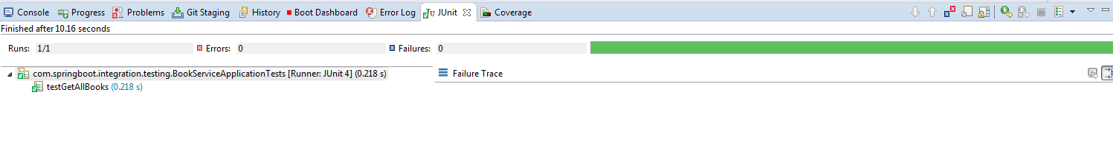

3) AddBook Test Case Result 🡪

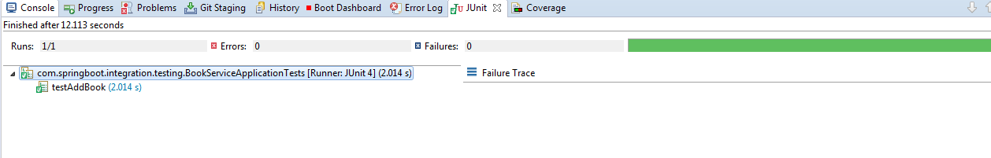

4) UpdateBookById test Case Result 🡪

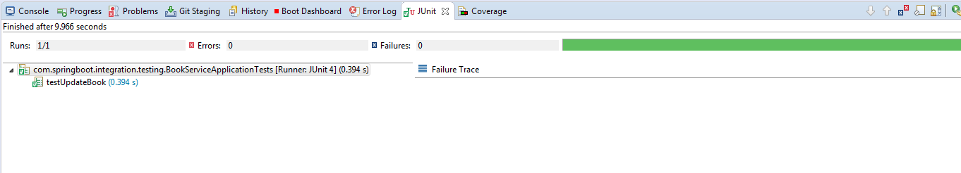

5) DeleteBookById Test Case Result 🡪

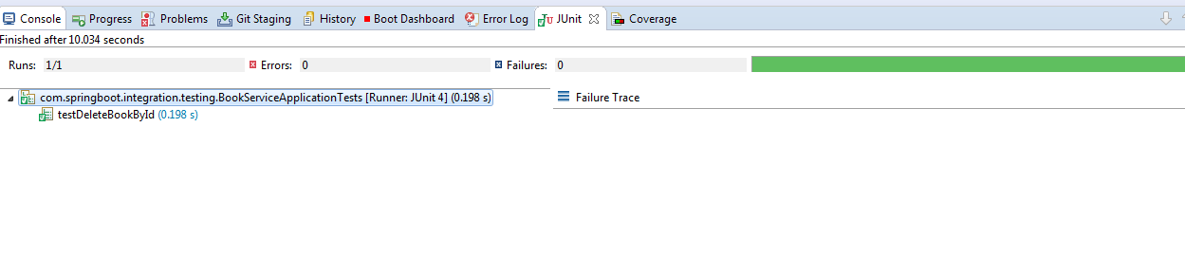

**Subject test Cases** 🡪

1. GetAllSubjects Test Case Result 🡪

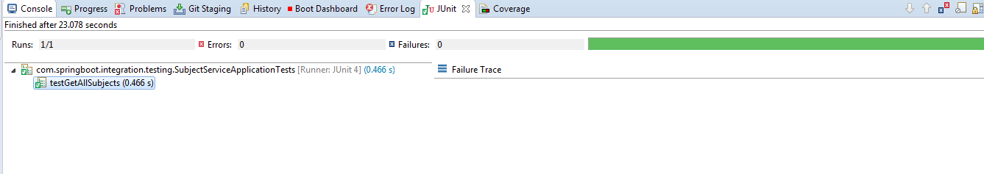

1. FindSubjectById test Case Result 🡪

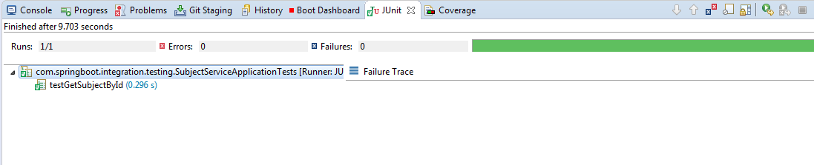

1. AddSubject Test Case Result 🡪

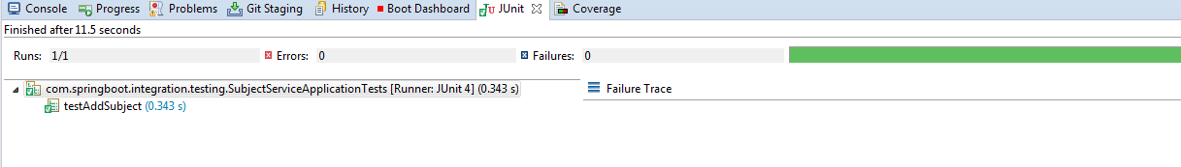

1. UpdateSubjectById Test Case Result 🡪

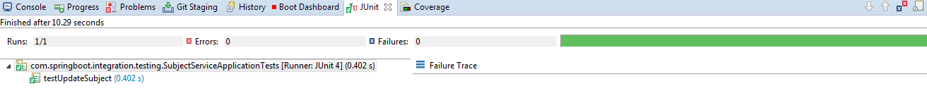

1. DeleteSubjectById test case Result 🡪

