**10_Spring_Assignment1_594665_Dhananjay**

Java File 🡪



Configuration Files 🡪



**Menu Options** 🡪

1. **Add** **Subject** 🡪

Output screen shots 🡪

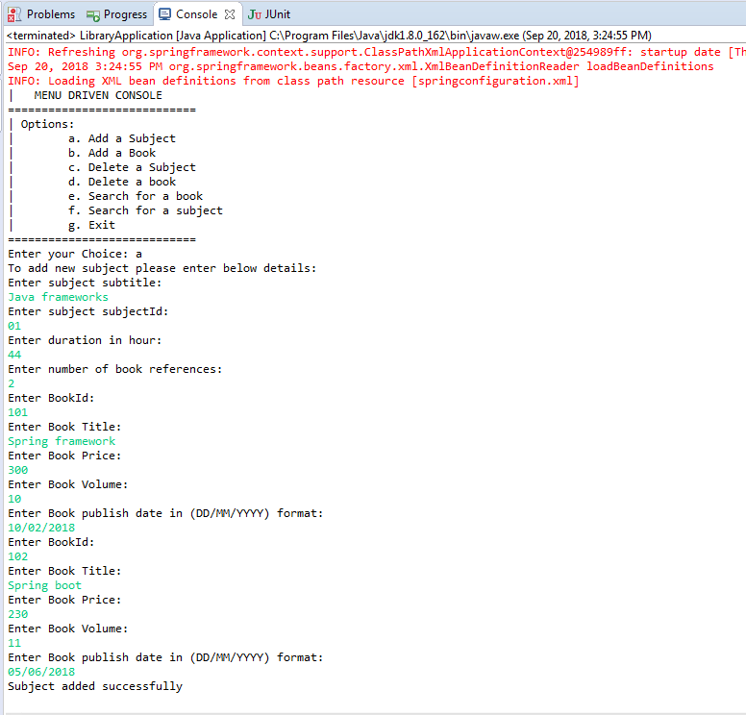

1. **Add** **Book** 🡪

**Output** **screen** **shots** 🡪

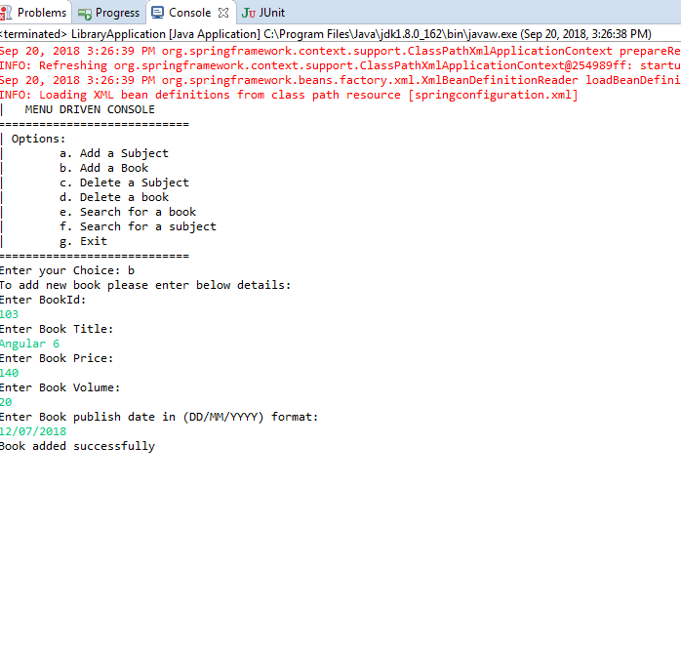

1. **Delete Subject** 🡪

**Output** **screen** **shots** 🡪

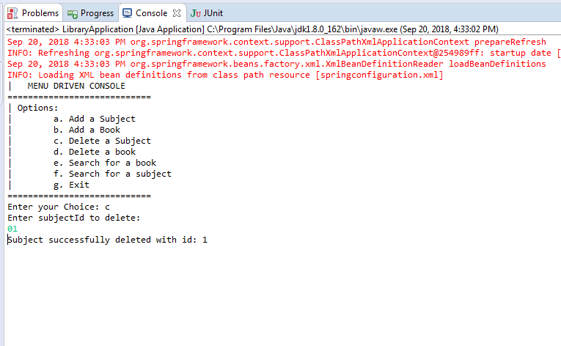

1. **Delete Book** 🡪

**Output** **screen** **shots** 🡪

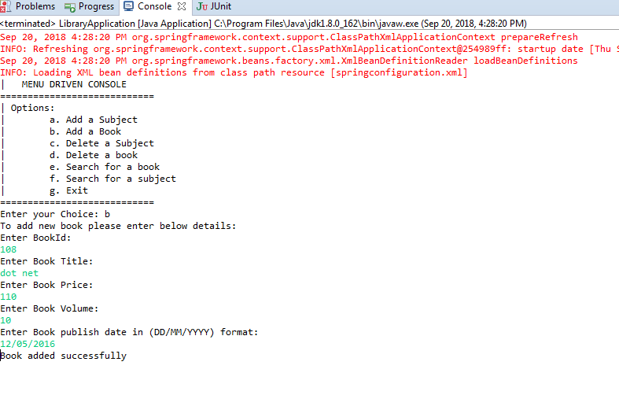

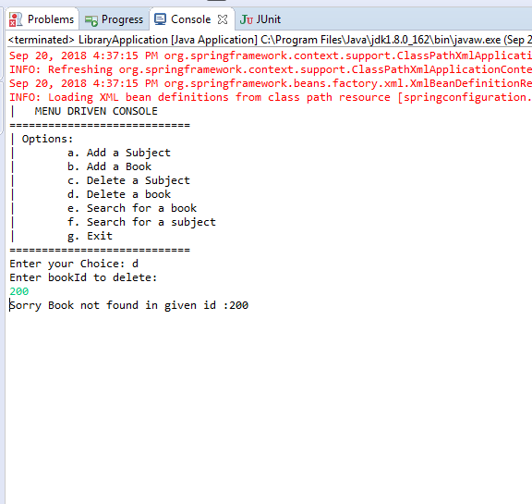

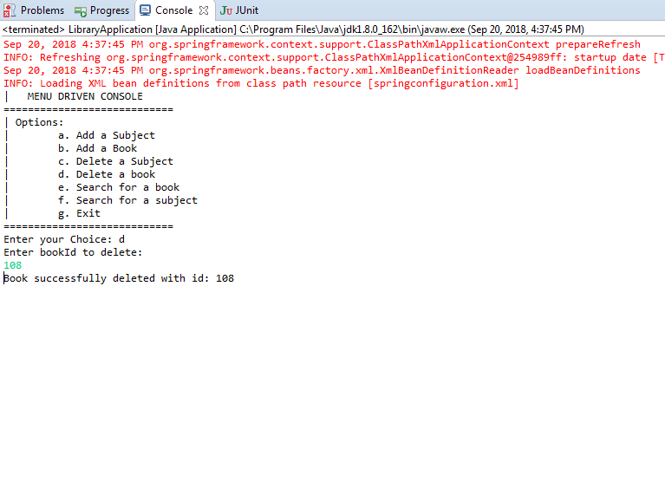

1. **Search** **Subject** 🡪

**Output** **screen** **shots** 🡪

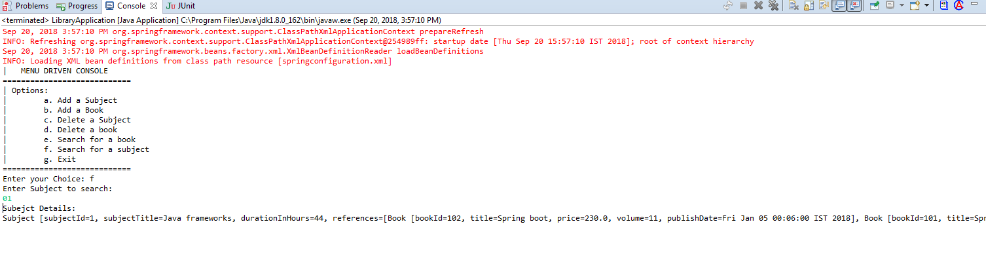

1. Search Book 🡪

**Output** **screen** **shots** 🡪

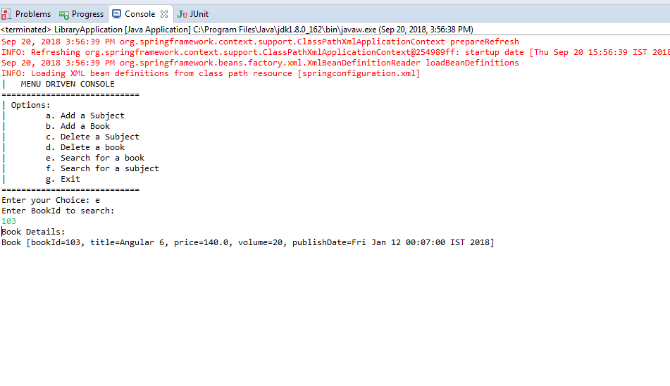

1. Exit 🡪

