 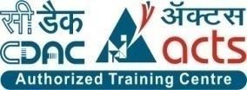

INSTITUTE FOR ADVANCED COMPUTING AND SOFTWARE DEVELOPMENT AKURDI, PUNE

Documentation On

**“Knowledge Explorer”**

PG-DAC SEPT 2021

*Submitted By:*

**Group No: 38**

**Vedant Palwankar**

**Dhananjay Deshmukh**

**Prashant Karhale Mr.Kashinath Patil**

**Centre Coordinator Project Guide**

**CERTIFICATE**

This is to certify that the project work under the title ‘Knowledge Explorer’ is done by

**1. Vedant Palwankar**

**2. Dhananjay Deshmukh**

in partial fulfillment of the requirement for award of Diploma in Advanced Computing Course.

**Mr. Kashinath Patil Mr. Prashant Karhale**

**Project Guide Course Co-Coordinator**

Date:

# 

**ACKNOWLEDGEMENT**

A project usually falls short of its expectation unless aided and guided by the right persons at the right time. We avail this opportunity to express our deep sense of gratitude towards Mr. Keshav Kumar (Center Coordinator, IACSD, Pune) and Mr. Prashant Karhale (Course Coordinator, IACSD ,Pune) .

We are deeply indebted and grateful to them for their guidance, encouragement and deep concern for our project. Without their critical evaluation and suggestions at every stage of the project, this project could never have reached its present form.

Last but not the least we thank the entire faculty and the staff members of Institute for Advance Computing And Software Development, Pune for their support.

**Vedant Palwankar**

**Dhananjay Deshmukh**

PG-DAC SEPT 2021 Batch,

IACSD Pune

# Table of Contents

1. Introduction 6

Document Purpose 7

Problem Statement 7

Product Scope 7

Aim & Objectives 7

Module…………………………………………………………………………………………….7

1. Requirements Specification 8

External Interface Requirements 9

Table Structure………………………………………………………………………………….12

Non-Functional Requirements 14

1. System Diagram 15

Activity Diagram 15

Use Case Diagram 18

ER Diagram 19

1. Conclusion 20
2. **Future Scope……………………………………………………………………….........................21**

**List of Figures**

Figure 1 Admin Activity Diagram 15

Figure 2 Faculty Activity Diagram 16

Figure 3 Student Activity Diagram 17

Figure 4 ER Diagram 18

Figure 5 Use case Diagram 19

# 

# 1.Introduction

Now a days many things has been affected because of pandemic. One of them is education system. As per government guidelines schools and colleges are not opened yet or partial opened. Many schools and colleges have managed to conduct online class programs. But those programs have some limitations too and every student not much familier to this system. Each and every student is not able to attend schools or colleges because of network issues, lack of computer knowledge, lack of equipments and severfal problems like this. It caused a communication gap between students and teachers as well. To eleminate that gap, we are making a software **KNOWLEDGE EXPLORER** that will help to increase communication between students and teachers. It will also helps students or teachers to communicate each other from there remote places. Students can ask any doubts, questions to teachers any time and teachers cans resolves their doubts.KNOWLEDGE EXPLORER is an online platform for learning and exchanging knowledge between student and faculty who properly logged into the “Knowledge Explorer”.The all control rights are given to admin person,who manages app properly.

## Document Purpose

Purpose of this document is to give an idea about **Knowledge Explorer** app. This app is used to enhance the communication between students and teachers in this pandemic time. All functional and non functional requirements of this project is mentioned here.

## Problem Statement

## Current pandemic situation cannot be neglected by any one of us. It has effected and useful communication between students and teachers. Online classes have many advantages and disadvantages. If a students wants to connect a teacher after class time to discuss some problem, he/she will not able to discuss with teachers. And this causes uncertainity between students about study topics.So there should a app that will help students to ask doubts, questions and get answered by any faculty at any time. Questions and answers should be stored so that any student can refer those answers.And also students will search for a particular question at any time and also like/dislike contents.

## Product/app Scope

* All students as well as the college’s staff will be able to use the system effectively.
* Web-platform means that the system will be available for access 24*7 except when there is a temporary server issue which is expected to be minimal.

## 

## Aims & Objectives

Specific goals are: -

To produce a web-based system that allow students and teachers to register and then participate in discussion of students problem.

To ease the communication between students and teachers.

To search and like/dislike for particular question.

To allow admin to monitor all activities.

**Modules:**

* Registration Module
* Login Module
* Questions Module
* Answers Module
* Logout Module

**Requirement Specifications**:

## Users and Characteristics

Admin:

.

* Admin can login to the system.
* He can add Student .
* Delete Student.
* Add Faculty .
* Delete Faculty .
* Activate/Inactivate student.
* Manage page

Faculty:

* Faculty first register to the system.
* Then He/She can Login
* Add Answer
* Delete Answer
* Likes questions.
* Logout.

Student:

* Student first register to the system.
* Then He/She can Login
* Add Questions
* Search question.
* Likes answers.
* Logout.

## Functional Requirements:

**A)Student Account**

Login

Register

Home

Answers

First page will be login page. Student has to login with credentials to move to questions page. Credentials are provided after completing registration. If student don’t have credentials ,he/she can register using register page where all fields are compulsory. After submitting registration form a email is sent to respective email id provided in form. Email contains credentials required for login into application. After entering credentials user will be moved to next page.

Next page is questions page. All questions added till that time will be shown with date and person name who asked question. If student want to ask a doubt or question he/she can post question using question block. In question block he/she can type question and click button to add new question. If student want to see answers of particular question then he/she has to click on that question. Then he/she will be redirected to answers page where all answers provided or added for that question will be available with answered date and name of person who answered. Student can add his/her answer as well. To achieve this a block is provided to write answer. Student can write their answer and click button to add answer.

Students also search for particular question,so that he/she will not consume his/her time for scrolling questions list.If student like some question/answer,there is one like button for them.Students also change their profile information at any time during login except email id. Student is not allowed to delete any of the questions and answers. An attribute is added where student can see his name, by clicking it logout button will appear and student can logout from there.

**B)Faculty Account**

Login

Register

Home

Answers

Faculty and students have same kind of user interface. First page will be login page. Faculty has to login with credentials to move to questions page. Credentials are provided after completing registration. If faculty don’t have credentials ,he/she can register using register page where all fields are compulsory. After submitting registration form an email is sent to respective email id provided in form. Email contains credentials required for login into application. After entering credentials user will be moved to next page.

Next page is questions page. All questions added till that time will be shown with date and person name who asked question. If faculty want to give response for a doubt or question he/she can click on question. Then he/she will be redirected to answers page where all answers provided or added for that question will be available with answered date and name of person who answered. Here faculty can add his/her answer as well. To achieve this a block is provided to write answer.

One more facility is provided only for faculty that they can search questions. In case a question is inappropriate or answer is wrong faculty can control these activities. An attribute is added where faculty can see his name, by clicking it logout button will appear and faculty can logout from there.

## C)Admin Account

Login

Manage all activities

Admin will be added from backend for security concerns. But admin also has to login with his/her credentials, once credentials are validated admin will be moved to a different page where he/she can see all registered user.Admin can manages all necessary stuff of this application.Admin will see all active/inactive users.Admin can see all questions and answers and also will delete this contents at any time. Authority is given to admin that he/she will also delete particular user. An attribute is added where admin can see his name, by clicking it logout button will appear and admin can logout from there.

## Table Structure:

**Faculty Table:**

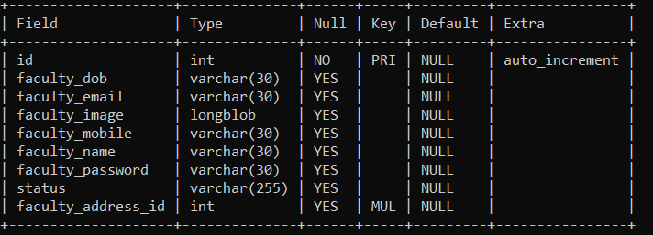

Question Table:

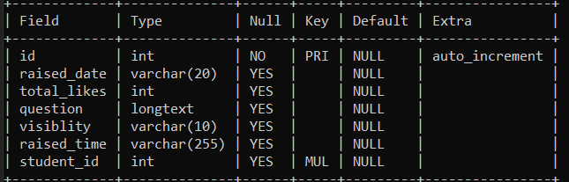

## Answer Table:

## 

## Student Table:

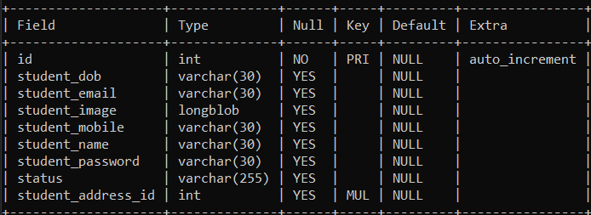

## Admin Table:

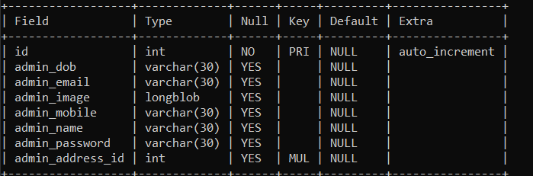

## address_table;

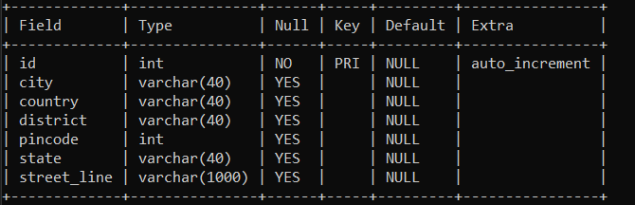

## Faculty_question_like;

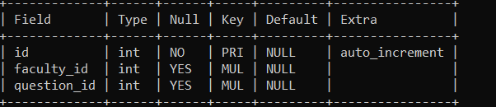

## Student_question_like;

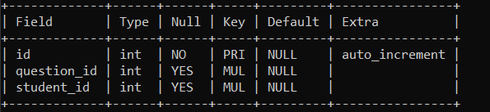

## Operating Environment:

Server Side:

**Processor:** Intel® Xeon® processor 3500 series

**HDD:** Minimum 500GB Disk Space

**RAM:** Minimum 2GB **OS:** Windows 8.1, Linux 6 **Database:** Oracle 11g

Client Side (minimum requirement):

**Processor:** Intel Dual Core

**HDD:** Minimum 80GB Disk Space

**RAM:** Minimum 1GB

**OS:** Windows 7, Linux

# System Design

## Activity Diagram:

## 

**Figure 1: Admin Activity Diagram**

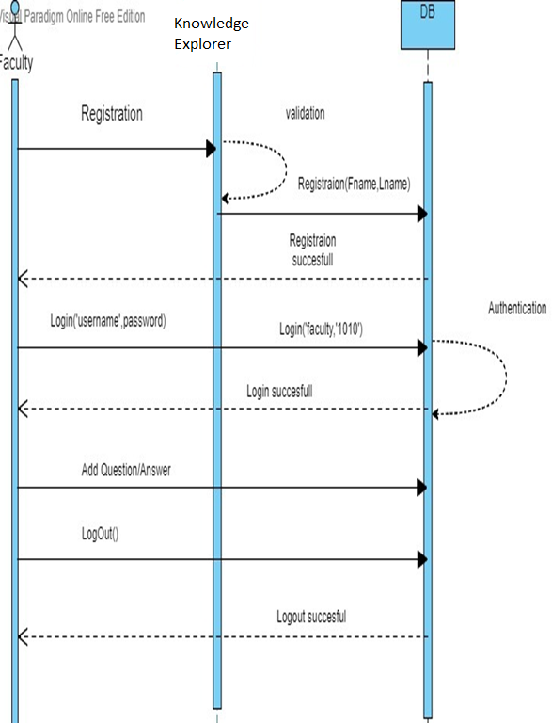

**Figure 2: Faculty Activity Diagram**

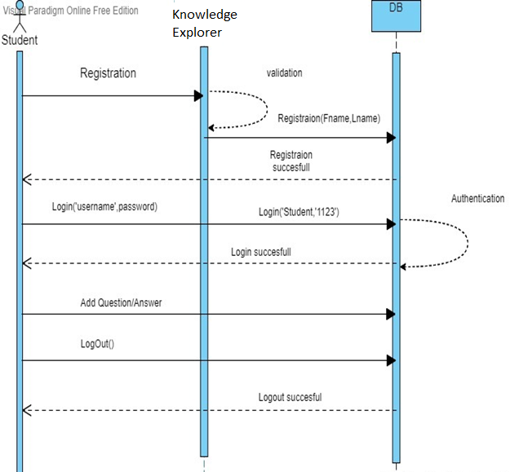

**Figure 3: Student Activity Diagram**

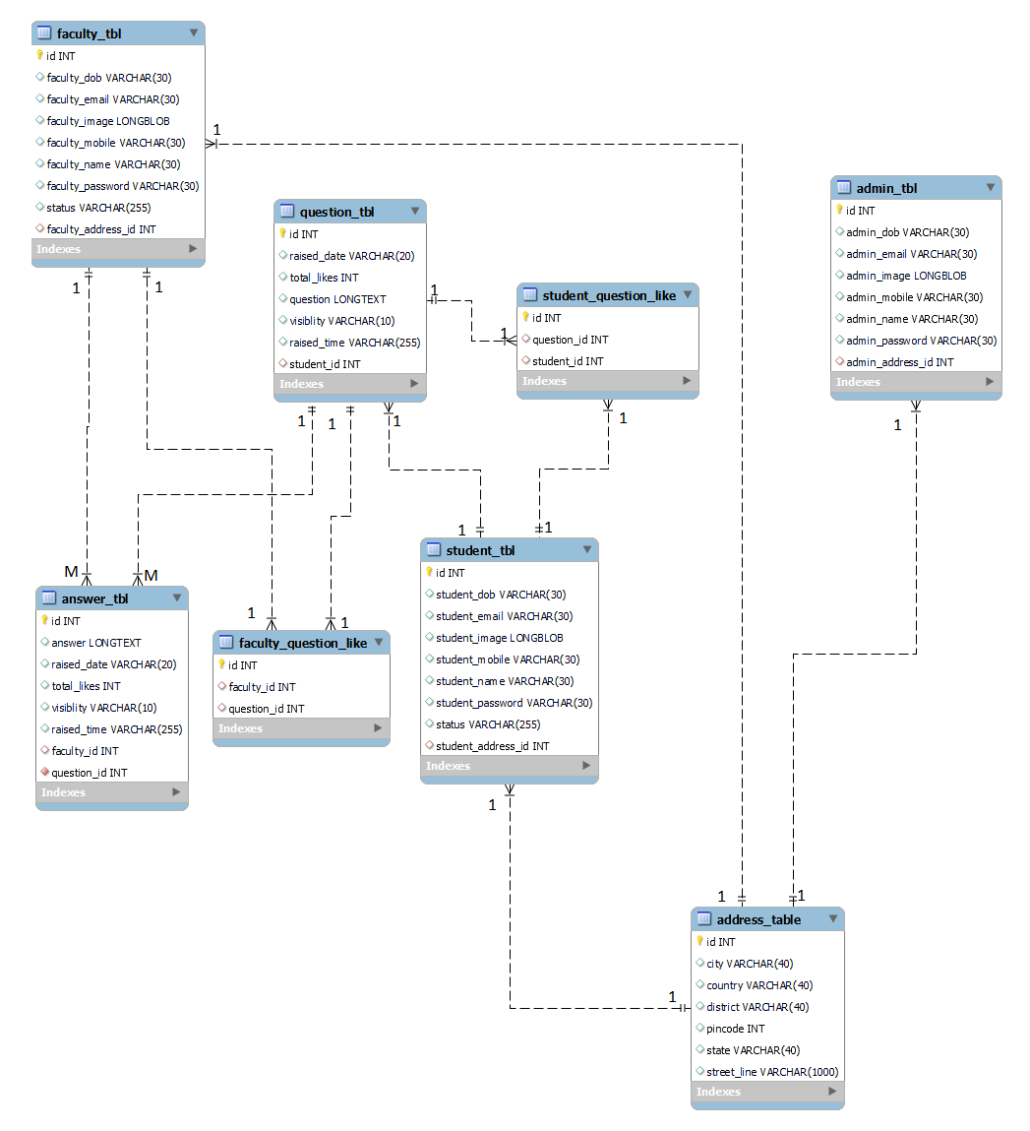

## Fig 4.ER Diagram

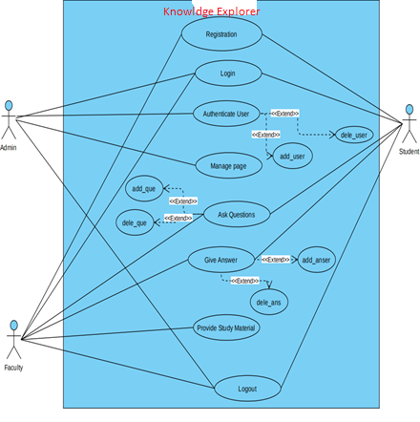

## Fig 5.Use CaseDiagram

**Conclusion**

This application is mainly created to enhance the relation between students and teachers. Students and teachers of a particular college as well as of different institute can communicate here and share their knowledge with each other. Interface is very easily so no one will face any issue while using this software. And have user friendly UI will help users to use this software easily.

# 

# Future Scope

This project can be enhanced further by adding features that can be easily add images, videos, kind of data. So that everyone can understand answers easily. If a candidate looking for a particular answer and the answer is not yet given by any faculties,so we will add one feature that candidate will redirect to google or any other browser for more answers. The software is flexible enough to be modified and implemented as per future requirements.