RAJARATA UNIVERSITY OF SRI LANKA
Department of Computing

ICT2403 – Graphics and Image Processing

Submission 03 – Frame Enhancement Method

Course Code: ICT2403
Course Title: Graphics and Image Processing
Assignment Title: Frame Enhancement Method for Road Damage Detection

Submitted By
Member Name | Registration Number | Index Number
Mr.H.M.T.D.M.Amarasingha | ICT/2023/058 | 6046
Mr.H.M.N.R.B.Herath | ICT/2023/059 | 6047
Mr.D.M.R.V.Dissanayaka | ICT/2023/060 | 6048
Mr.D.S.M.D.B.Subasingha | ICT/2023/083 | 6065

Submitted To:
Mr.K.A.S.H.Kularathna
Department of Computing
Rajarata University of Sri Lanka

- Introduction to Frame Enhancement

Image enhancement is and is a essential preprocessing step in a road damage detection system. Raw video frames may contain various types of noises that reduce image clarity and can affect crack detection.
One common type of noise is sensor noise. These noises can cause by Low-light conditions, camera sensor limitations and electronic interference. It causes small random intensity variations and grainy texture.
Video frames also can capture salt and pepper noise caused by transmission errors, sudden bit corruption or hardware malfunctions. It appears as random white and black pixels.
Another possible noise is Gaussian noise can have caused by electronic circuit fluctuation or sensor thermal noise. It appears as grainy effect.
Frame enhancement techniques such as contrast stretching, histogram equalization and noise filtering help to prevent these issues. Noise reduction smooths unwanted intensity variants. Enhancement provides clear structural information and improve the accuracy.

- Identification of Frame Degradations
The extracted frames from the road video were analyzed to identify quality degradations that may affect crack detection accuracy. Visual inspection , histogram analysis, and standard deviation measurements were used to detect and evaluate these degradations.
Noise Analysis
Sensor Noise (Mobile Camera Noise)
Sensor Noise is visible in the extracted frames as small random intensity variations . This noise is primarily caused by mobile camera sensor limitations, low light conditions.
Low-Light Noise Effect
Low-light were detected by observing darker regions in the frames and analyzing histogram distributions

Illumination Variations
Uneven illumination affects crack detection because segmentation algorithms rely on intensity differences. When lighting is inconsistent, cracks may either merge with shadows or become less visible

Motion Blur and Camera Instability
This degradation was identified by visually examining the sharpness of crack edges and comparing frame clarity across the video sequence.

- Pre-processing of Video Frames
A video is a sequence of pixel frames displayed over time. To enable image processing and analysis The video needs to convert into frames. It enables further image processing and analysis.

Frame Extraction Method
Frame extraction was performed using the OpenCV library.
Videos were loaded using cv2.VideoCapture()
Frames were read sequentially in a loop
Each frames were using read() function

Frame Format
Extracted frames were saved in JPG format. The JPG format provides efficient storage with image quality suitable for processing multiple frames.

Frame Selection Strategy
Every 30th frame was extracted and saved for analyzing. This approach reduces computational load while helping to capture sufficient structural information for crack analysis.

- Proposed Image Enhancement Pipeline
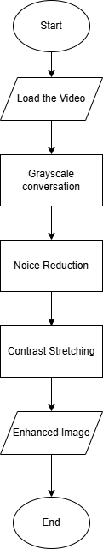
Purpose: Expand intensity range 0 - 255

Purpose: Remove Gaussian Noise
Kernel Size: 5 * 5
Purpose: Reduce Complexity
Formula: 0.299 * R + 0.587 * G + 0.114 * B

Frame extraction and noise analysis - https://github.com/dhananjaya-subasingha/-Frame-Enhancement-Method
Contrast enhancement and illumination correction - https://github.com/virajDissanayaka/ICT2403-Graphics-and-Image-Processing.git
Sharpening and edge preservation - https://github.com/NirmalHerath-cmd/ICT2403---Graphics-and-image-processing.git
Pipeline integration and testing - https://github.com/thrusha506/ICT2403-Graphics-and-Image-Processing.git
Videos https://drive.google.com/drive/folders/1ZVdq1rUqeI_5qkQjhwKIiS1-YygAGnsm?usp=drive_link

Grayscale Conversation
The purpose of grayscale conversation is to reduce computational complexity while processing the frames. Since road cracks are mainly depending on intensity variations grayscale is more sufficient than color frames.
Formula
Grayscale = 0.299 * R + 0.587 * G + 0.114 * B
Code statement
gray_image = cv2.cvtColor(frame,cv2.COLOR_BGR2RGB)

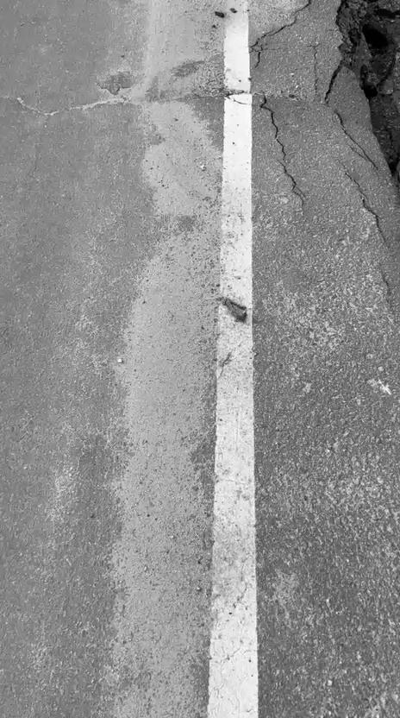
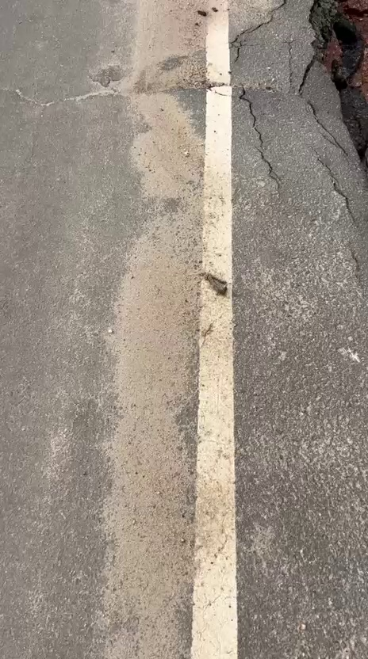

Noise Reduction
Noise is a visual distortion in digital images that causes degradation. Gaussian noise arises due t electronic circuited noises and sensor noisiness.
Formula
G(x,y) = f(x,y) + n(x,y)
Code Statement
gaussian = cv2.GaussianBlur(image , (5,5) , 0)
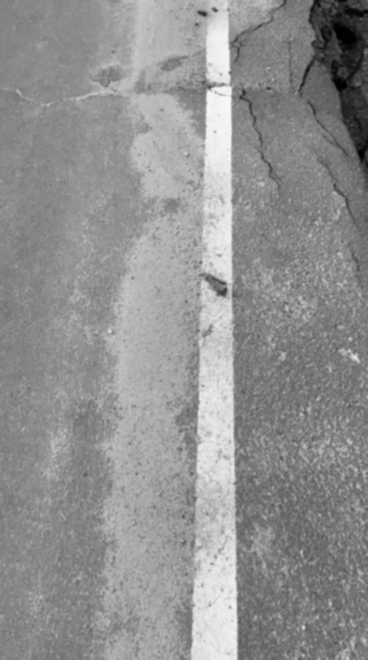


Contrast Enhancement
Road cracks has low-intensity regions that blends with road surface. Contrast stretching can expand hee intensity range and improve visibility.
Formula
S = { a + ( r – r _{min} ) ( b – a ) } / ( r _{max} – r _{min} )
r = Original pixel value
a and b = Desired minimum and maximum values
Code Statement
def contrast_stretch(image):
min_val = np.min(image)
max_val = np.max(image)

if max_val == min_val:
return image.copy()

stretched = (image - min_val) * (255 / (max_val - min_val))
return stretched.astype(np.uint8)
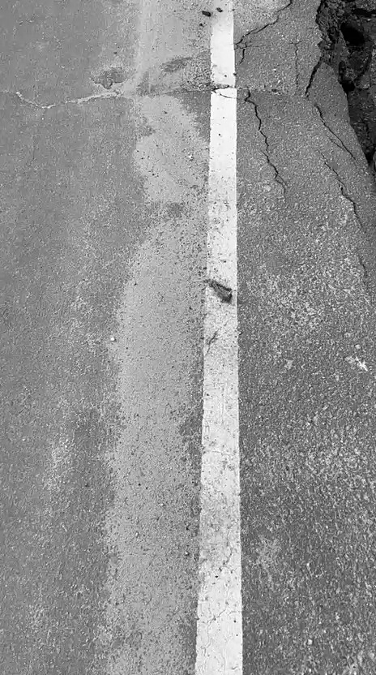

Graysale Sharpened

Before edged after edged
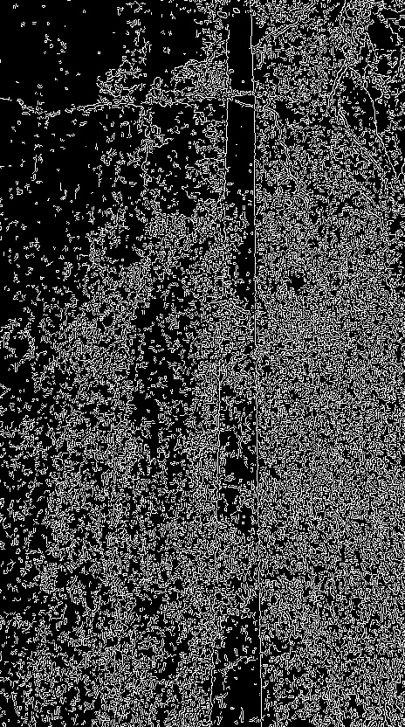
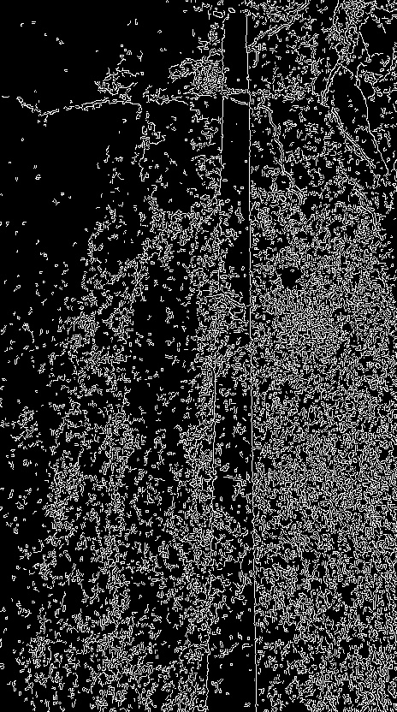

- Experimental Setup and Results
Test Data Preparation
The test dataset was prepared from recorded road inspection videos. This video was processed using OpenCV and frames were extracted using a frame sampling strategy.
Frame Selection Criteria
Every 30th frame was saved in JPG format to reduce redundancy while preserving structural variation in road surface conditions.
Image Format and Resolution
Format: JPG
Resolution : Original video resolution
Color Mode: Converted to grayscale

Evaluation Metrics Selected
Laplacian Variance
This operator used to measure image sharpness. Laplacian can detect regions of intensity changes.
def measure_blur(image):
laplacian = cv2.Laplacian(image, cv2.CV_64F)
return laplacian.var()
Canny Edge detection analysis
Canny edge detection was applied before and after sharpening to visually compare enhancement.
edges_before = cv2.Canny(image, 100, 200)
edges_after = cv2.Canny(sharpened, 100, 200)

Testing the enhanced pipeline
The pipeline was tested using extracted videoframes from the dataset. Each frames was sequentially processed through following stages
Contrast enhancement
Sharpening
Edge visualization
Histogram

Parameter Settings
Gaussian Blur
Kernel size 5 * 5
Reduce high-quality frequency and prevent excessive edge amplifications
Sharpening
Original Image weight: 1.5
Blurred image weight: -0.5
Gamma: 0
Enhance edge boundaries
Histogram
Range 0-255
Intensity 256
Spreads pixel intensity values
Canny Edge Detection
Lower threshold: 100
Upper threshold: 200

Results
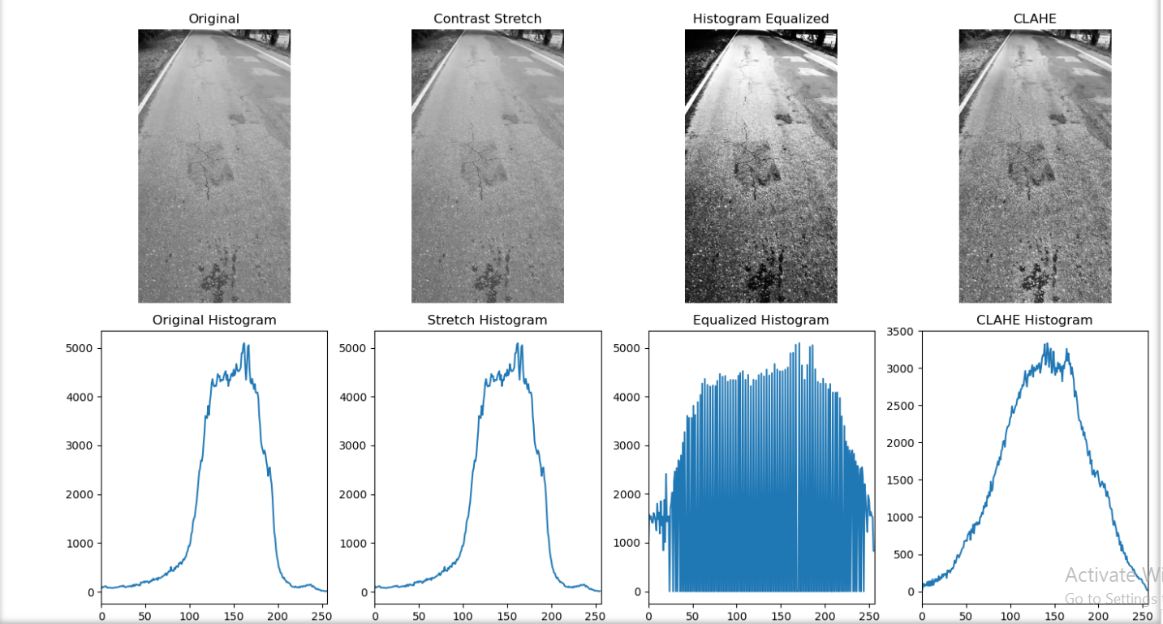

- Recommendation
Final Recommendation based on result
Based on results, the image enhancement pipeline successfully improved the quality of video frames. The results obtained from the standard deviation measurements indicate that noise levels were reduced after applying Gaussian and Median filtering. Sharpening improved the visibility of structural edges within frames. The histogram comparisons and visual inspection of the enhanced frames also showed improved intensity distribution.
Critical Analysis of Enhancement Techniques
Gaussian filter – Reduce random noise present in the extracted frames
Median Filter – Reduce impulse noise such as salt and pepper noises.
Sharpening – Enhance the structural details of the frames.
Limitations of the Proposed Enhancement Method
Strong shadows sometimes affected the visibility of road cracks.
Extreme lightning reduces the effectiveness of enhanced techniques.
Motion blur caused by camera movements.
Impact on Future Segmentation Accuracy
The enhanced frames provide better input data for the segmentation stage of the road damage detection system
Noise reduction helps prevent segmentation algorithms from detecting false edges
Cracks and potholes more distinguishable from the surrounding road surface.
Edge sharpening improves the visibility of crack boundaries.

