RAJARATA UNIVERSITY OF SRI LANKA
Department of Computing

ICT2403 – Graphics and Image Processing

Submission 03 – Frame Segmentation Method

Course Code: ICT2403
Course Title: Graphics and Image Processing
Assignment Title: Frame Enhancement Method for Road Damage Detection

Submitted By
Member Name | Registration Number | Index Number
Mr.H.M.T.D.M.Amarasingha | ICT/2023/058 | 6046
Mr.H.M.N.R.B.Herath | ICT/2023/059 | 6047
Mr.D.M.R.V.Dissanayaka | ICT/2023/060 | 6048
Mr.D.S.M.D.B.Subasingha | ICT/2023/083 | 6065

Submitted To:
Mr.K.A.S.H.Kularathna
Department of Computing
Rajarata University of Sri Lanka

- Introduction
Purpose of Segmentation
Image Segmentation is dividing images into meaningful regions so that important objects can be isolated from the background. Segmentations can use to separate damaged regions such as cracks and potholes from the surrounding road surface.

Why segmentation is required after frame enhancement
Frame enhancement use to reduce noise, improve contrast, and highlight important texture. Performing segmentation after enhancement improves accuracy of detecting damaged regions.

Importance of identifying and isolating road degrading regions accurately
It allows the system to focus only on the damage areas of the road while ignoring normal road surfaces.
Easy to calculate important properties such as length, area and shape of cracks and potholes.
Accurate isolation helps to minimize false detected caused by such as shadows.
Identifying and isolating road degradations helps in achieving reliable and meaningful results in the road damaged framework.

Relationship between segmentation quality and damage severity assessment
Accurate segmentation allows the system to correctly capture the boundaries. Low quality segmentation
Occurs non-damaged areas such as road markings, shadows or surface textures are incorrectly.
Therefore, maintaining high segmentation quality is essential for ensuring that the extracted road degradation regions closely represent the actual damage present on the road surface.

Connection between segmentation, evaluation, and final integrated deployment
Segmentation separates damaged road areas from normal road surface.
The evaluation process uses different metrics and visual inspection to measure the performance of the segmentation method. This helps to determine regions correctly,
In final integrated deployment the enhancement stage, segmentation stage and result making together to process input videos and frames and produce the final road damage detection results

- Proposed Frame Segmentation Pipeline (Core Section)
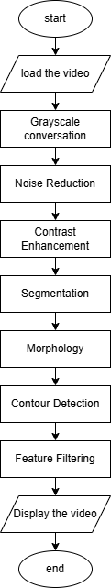

Load Video
Purpose – Loading the videos into memory to process

Grayscale Conversion
Purpose – Simplifies the image by removing 3 layers into 1.
Theoretical Background – Image has 3 layers. In grayscale it turns into 1 .
Gray = 0.299R + 0.587G + 0.114B
Input – Video frames
Output – Grayscale frame

Noise Reduction
Purpose – Removes small unwanted variations in the image like pepper and salt noise
Algorithm used – Gaussian Blur filtering
Input – Grayscale image
Output – Smoothed image

Contrast stretching
Purpose – Improves the visibility of road surface details by expanding intensity range
Theoretical Background – Use to improve the contrast of the grayscale image by expanding the
range of pixel intensity values.
Input – Smoothed grayscale image
Output – Contrasted image

Enhanced Image
Purpose – More clear images with improved contrast and reduced noise
Output – Enhanced Image

Segmentation
Purpose – Identify damaged regions from the image
Theoretical Background – Segmentation divide the image into regions based pixel intensity values.
Input – Enhanced image
Output – Binary masks damage regions

Morphology
Purpose – improve segmentation by removing noise and connecting broken regions.
Theoretical Background – Morphological operations process images using a structuring element to
refie shapes.
Input – Segmented Binary masks
Output – Cleaned and connected regions

Contour Detection
Purpose – Detect boundaries of segmented regions to identify individual objects.
Theoretical Background – Contours represent the outline of connected components in a binary image.
Algorithm used - cv2.findConour
Input – Binary Image
Output – List of contours representing detected regions

Feature Filtering
Purpose – Remove unwanted detections and keep only meaningful damage regions.
Theoretical Background – Small regions are often noise, while larger regions represent actual
damage.
Algorithm used – cv2.contourArea()
Input – Detected contour
Output – Filtered contours

Display the Video
Purpose – Display detected damages on the frames

Original vs enhanced vs segmented frame comparison
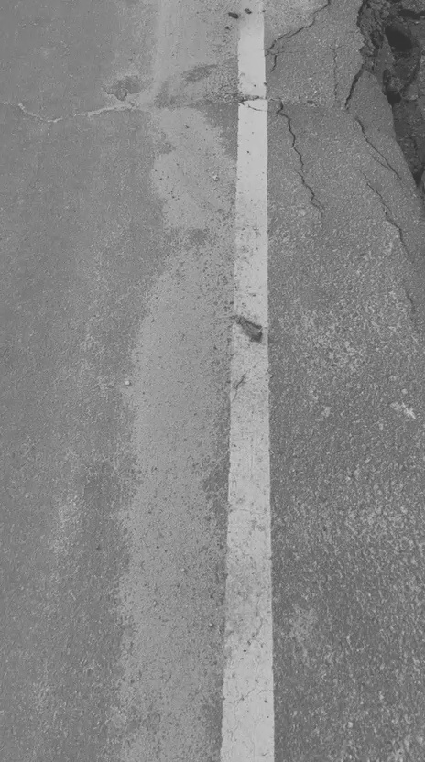
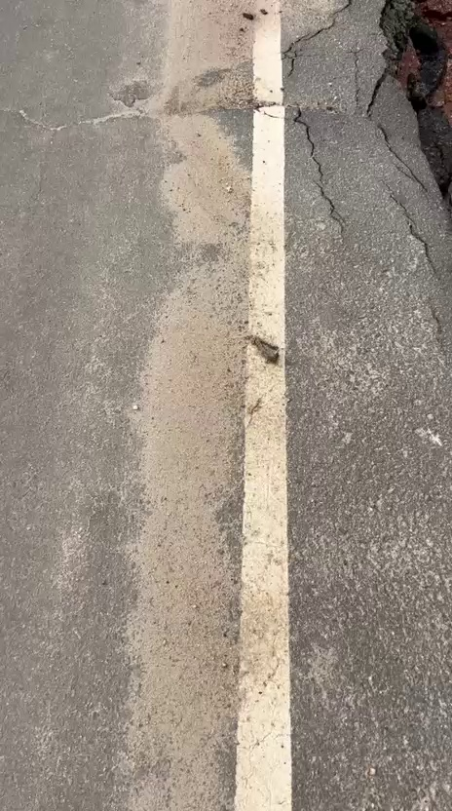

- Experimental Setup and Results
3.1 Test Data Preparation
Video ID | Frame Extracted | Frame Tested | Road Degradation Type | Lightning Condition | Remarks
Edge_Cracking_1 | 423 | 15 | Cracks | Normal daylight | Clear cracks
Edge_Cracking_2 | 379 | 13 | Cracks | Normal daylight | Clear cracks
Edge_Cracking_3 | 292 | 10 | Cracks | Normal daylight | Clear cracks
Raveling_1 | 623 | 21 | Raveling | Normal daylight | Clear raveling
Raveling_2 | 552 | 19 | Raveling | Normal daylight | Clear raveling
Transvers_cracks_1 | 350 | 12 | Transvers cracks | Normal daylight | Clear cracks
Transvers_cracks_2 | 529 | 18 | Transvers cracks | Normal daylight | Clear cracks

3.2 Evaluation Metrics
To evaluate the performance of the proposed segmentation model, both quantitative and qualitative evaluation methods were used. Quantitative metrics provide numerical measurments of performances, while qualitative evaluation involves visual inspection of the segmentation results.
Accuracy = (TP + TN) / (TP + TN + FP + FN)
Precision = TP / (TP + FP)
Recall = TP / (TP + FN)
F1 Score = (2. Precision. Recall) / (Precision +Recall)
IoU = Intersection / Union
Dice = (2|A and B|) / (|A| + |B|)

3.3 Quantitative Testing on Test Data

3.4 Qualitative Testing and Visual Results


Visual Comparison

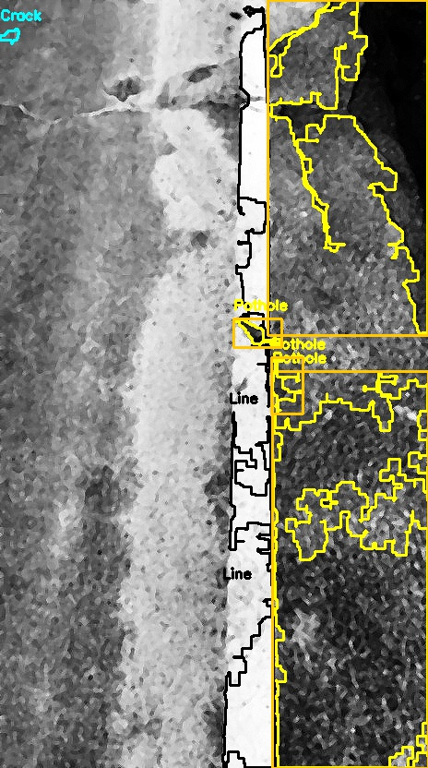


3.5 Interpretation of Results
Segmentation Performed by Degradation Type
Potholes - appears as dark, high-contrast regions compared to the road surface.
Road Markings – appears in bright, high brightness intensity.
Cracks – appears as thin as low contrast. Difficult to detect. Used canny edge detection.

Difficult Cases in Segmentation
Shadows – Strong shadows detected as potholes
Motion blur – Blur frames caused weak edges
Low contrast – Similar intensity of cracks and the surface

Impact of Environmental Conditions
Shadows - Strong shadows detected as potholes
Environment – Things are not the parts of road detect as objects

Suitability of the Segmentation Method
Suitable for simple and controlled road frames with clear contrast between damage regions
Not Suitable for strong shadows, uneven lightning and heavy noise

Effect of Enhancement on Segmentation Performance
Histogram equalization and Gaussian Blur makes potholes visible.
Gaussian Blur reduce noise

- Recommendation

4.1 Final Recommendation Based on Result
The developed segmentation model is partially suitable for detecting road damages.
It is not 100% reliable for a real world use but works in a controlled environment.
Most effectively detect potholes and road markings. Cracks are detected with lower accuracy.

4.2 Critical Analysis of the Segmentation Method
Strengths of selected segmentation method
- Works well with clear intensity differences.
- Effective for large visible damages

Why it worked well in some cases
- High contrast between surface and damages
- Morphological operation improved noise removal

Limitation in real environment
- Threshold is not adaptive
- Sensitive to lightning changes

4.3 Limitations observed
Strong shadows as potholes
Uneven lightning as reduce accuracy
Faded road marks
Similar texture between damaged and undamaged road
Motion blur
Under segmentation

4.4 Suggestions for Improvements
Use adaptive thresholdings
Apply deep learning model
Improve contrast enhancement techniques
- Team Contribution Planning and Individual Responsibilities
Member1 – Implement segmentation and evaluate for crack type 1
Member2 – Handled crack type 2
Member3 – Assigned the detection and segmentation of potholes include threshold
Member4 – Develop overall integration of the system including enhancement, segmentation, contour feature filtering and final output generation

- Contradiction Table
Member | Segmentation Responsibility | Coding contribution | Experimental Task | Evidence attach
ICT/2023/058 | Crack Type 1 | Part of segmentation | Tests on crack frames
ICT/2023/059 | Crack Type 2 | Part of Segmentation | Tests on crack frames
ICT/2023/060 | Potholes | Segmentation | Tested o pothole frame
ICT/2023/083 | System Integration | Full Pipeline | Overall testing & result generation

