# D.Y. PATIL COLLEGE OF ENGINEERING & TECHNOLOGY,

## KASABA BAWADA, KOLHAPUR

**DEPARTMENT OF COMPUTER SCIENCE AND ENGINEERING**

**(DATA SCIENCE)**

## (2022-23)

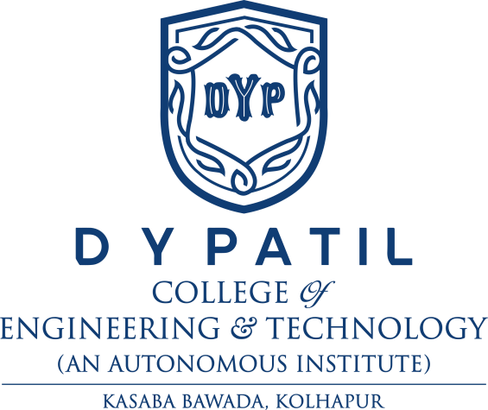

**A**

**Report on Project - I**

“**ADMISSION CELL CHATBOT**”

## Submitted by

**Roll No. Name**

1. Mr. Aryan Shahaji Tapase.
2. Mr. Dhananjay Ramrao Ambatawar.
3. Mr. Afif Sharif Sayyad.

## Under the guidance of

Proff. Dr. V. I. Pujari

**Class: SY( DS) Div: A Batch: A1**

**DEPARTMENT OF COMPUTER SCIENCE AND ENGINEERING**

**(DATA SCIENCE)**

**KOLHAPUR**

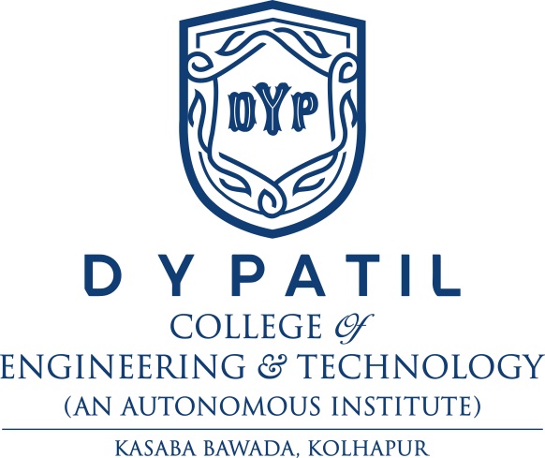

## CERTIFICATE

This is to certify that the following members have excellently completed the Project - I work entitled **“Admission cell ChatBot”** at SY (DS) semester-IV as prescribed in the syllabus of DYPCET Autonomy for the academic year 2022-23.

**Name Exam seat no.**

1. Mr. Aryan Shahaji Tapase.
2. Mr. Dhananjay Ramrao Ambatawar.
3. Mr. Afif Sharif Sayyad.

**Date: Place:** Kolhapur

**Proff. Dr. V. I. Pujari Prof. Dr. J. N. Jadhav**

(Project Guide) **(**HOD)

**Proff. Dr. V. I. Pujari Prof. Dr. S. D. Chede**

(Project Coordinator) (Principal)

**External Examiner**

## ACKNOWLEDGEMENT

It is a great relief and satisfaction whenever we accomplish a college project. Whenever a project was completed then there will definitely be the support and guidance of our teachers, principal, friends, and family members. So it is always a good practice to acknowledge all the members who supported in completing your project.

**Date: Place:** Kolhapur

**Name of Student Sign**

1. Mr. Aryan Shahaji Tapase.
2. Mr. Dhananjay Ramrao Ambatawar.
3. Mr. Afif Sharif Sayyad.

# INDEX

|  |  |  |
| --- | --- | --- |
| **Sr.no** | **Title** | **Page No.** |
| **1** | **Abstract** | **1** |
| **2** | **Introduction** | **2** |
| **3** | **Literature Review** | **3** |
| **4** | **Problem Statement** | **4** |
| **5** | **Objectives** | **5** |
| **6** | **Implementation** | **6** |
| **7** | **Experimental Results & conclusion** | **8** |
| **8** | **Reference** | **12** |

**Abstract**

* Chatbots have become a go-to arena in the recent years. We propose a Chatbot that uses a wholesome blending of some technologies like Internet of Things, Natural Language Processing
* In this project, we developed a ‘ADMISSION CELL CHATBOT’ (using python programming language) chatbot with voice assistance to provide users with an interactive and engaging experience.
* The chatbot was designed to perform a variety of tasks, including answering questions and executing commands. Overall, the chatbot demonstrated the potential to improve productivity and streamline communication between users and various systems.

# Introduction

* The chatbot is designed to handle a range of queries related admission in an educational institute as general inquiries and services .
* It uses natural language processing algorithms to understand the user and provide appropriate responses.

* The project involved gathering and analyzing user queries and feedback to identified the most common issues.
* The expected outcome of this project is a chatbot that can understand the users' queries and provide immediate and accurate responses.

* The chatbot will improve the user service experience by reducing response time and providing appropriate solutions.
* Language used to design the chatbot is python as this language is reliable and provide facilities like libraries ,etc.

# Literature Review

There are several existing systems that offer similar functionalities to the Chatbot voice assistance project. Some of the notable examples include:

* **Siri:** Apple's voice assistant that is integrated with its devices, such as iPhones, iPads, and Mac computers.
* **Google Assistant:** A voice assistant developed by Google that is available on a variety of devices, including smartphones, smart speakers, and smart displays.
* **Amazon Alexa:** A virtual assistant developed by Amazon that is available on the company's Echo smart speakers and other compatible devices.

# Microsoft Cortana : A voice assistant developed by Microsoft that is available on Windows devices and can also be integrated with other applications.

# Problem Statement

When any student willing to take admission into an institution and want to enquire about several things about institution he might be going through the manual process of enquiry. As the man power or staff allocated for the same have to face all types of students sometimes student might not get proper information and process may become time consuming, boring, exhaustive. The existing user service systems often face challenges in providing timely and efficient solutions to users' queries.

# Objectives

1. **Streamlining communication :** Chatbots can be used to provide a quick and easy way for users to get information or perform tasks without having to navigate complex websites or manual way.
2. **Increasing engagement :** Chatbots can be designed to engage users in a conversational manner, which can help to increase user satisfaction and retention and resolving the queries.
3. **Automating task :** Chatbots can be used to automate tasks such as gathering detailed information about the Institute and its departments, knowing details about the methodology of educations, or details about departments and schedule .
4. **Improve accessibility :** The chatbot will improve accessibility for users with disabilities or mobility impairments, allowing them to get the information about the Institution and its education easily and independently.
5. **Providing reliable services :** Chatbot provide an reliable services to user as it uses NLP and developed using python.

Overall, the objective of a Admission cell chatbot project is to provide a valuable and efficient tool for users, while also helping institute to streamline operations and improve customer satisfaction and services.

# Implementation

The proposed work for the Chatbot Voice assistance system project involved several phases, including:

**Enquiry & Requirements Gathering:** This phase involved understanding user needs and requirements for an intelligent assistant. The team identified the features and functionalities that are most important to users and gathered feedback through surveys, interviews, and focus groups.

**System Design:** Based on the Enquiry and requirements gathered, the team designed the system architecture and develop a roadmap for implementation.

**Development:** The development phase involved building the core functionality of the system, including natural language processing, voice recognition, and task automation.

**Testing and Deployment:** In this phase, the team tested the system to ensure it meets the requirements and functions as intended. The system deployed to a limited group of users for initial testing, and feedback is gathered to identify any bugs or usability issues.

**Iteration and Improvement:** Based on user feedback and testing results, the team iterated on the system and make improvements to enhance its functionality and usability.

## System Requirements:

* 1. Operating system: - Linux/Windows
  2. Processor: - Intel i3 and Above
  3. RAM: - 4GB
  4. Web Browser

## System Architecture:

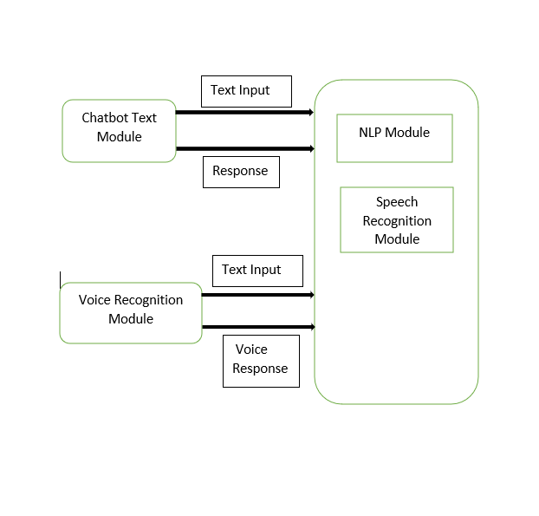

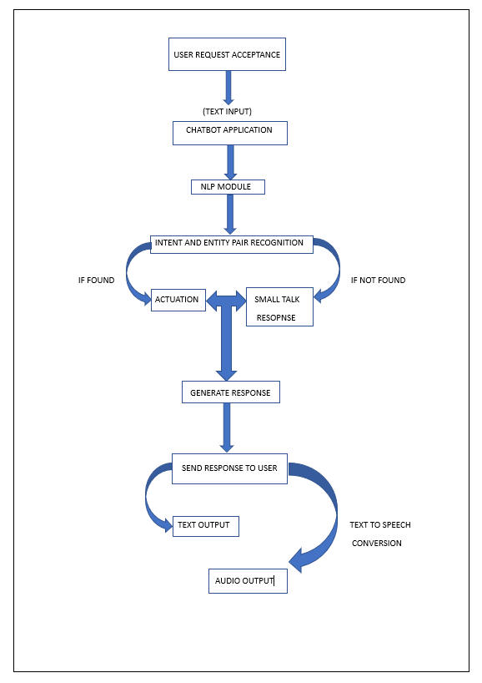

# Experimental Results & conclusion

**Code**

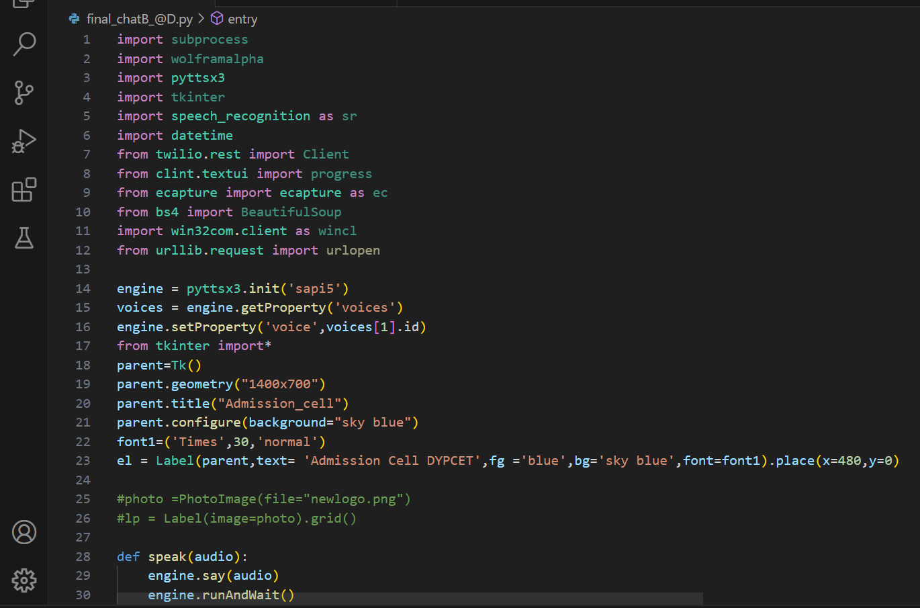

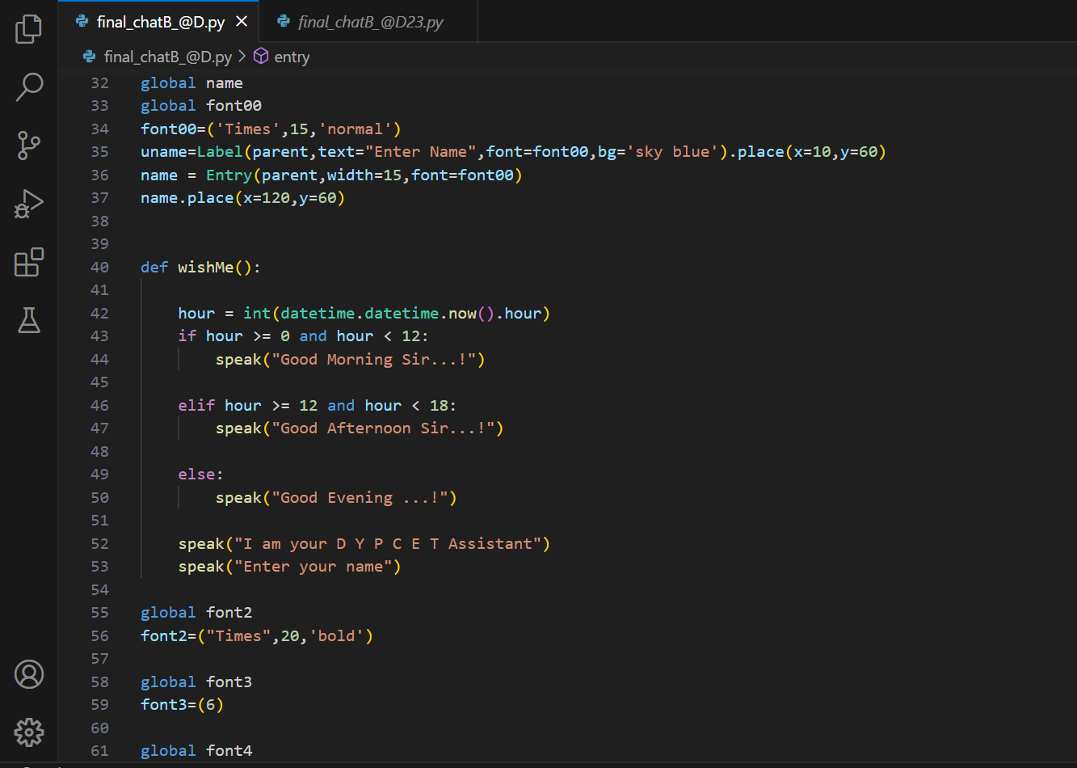

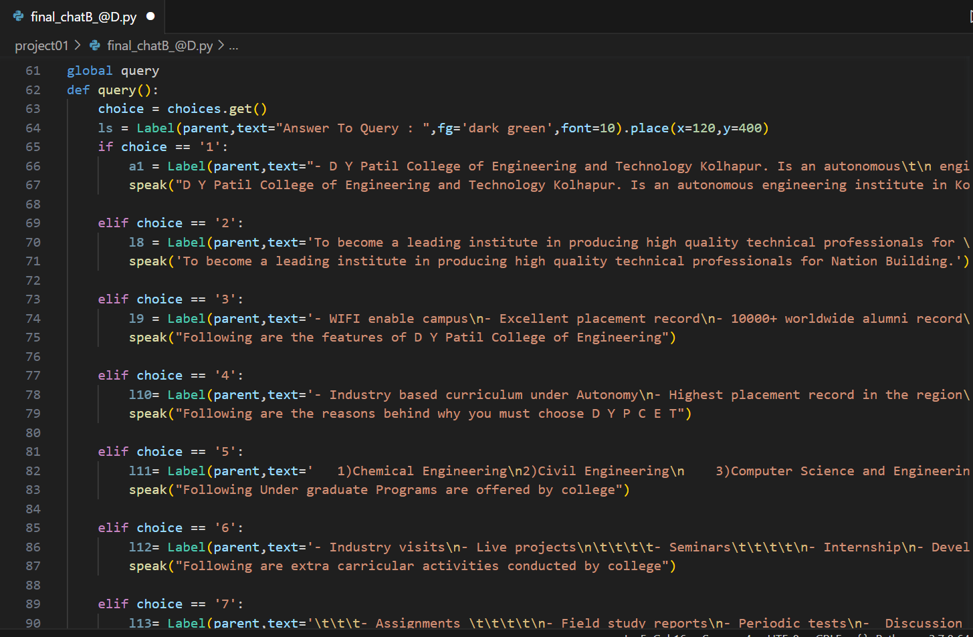

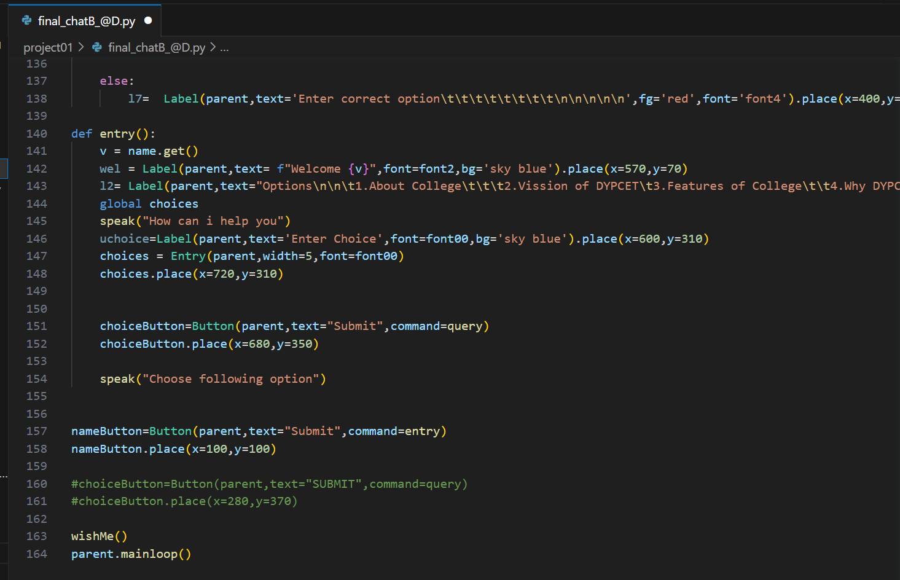

**Output**

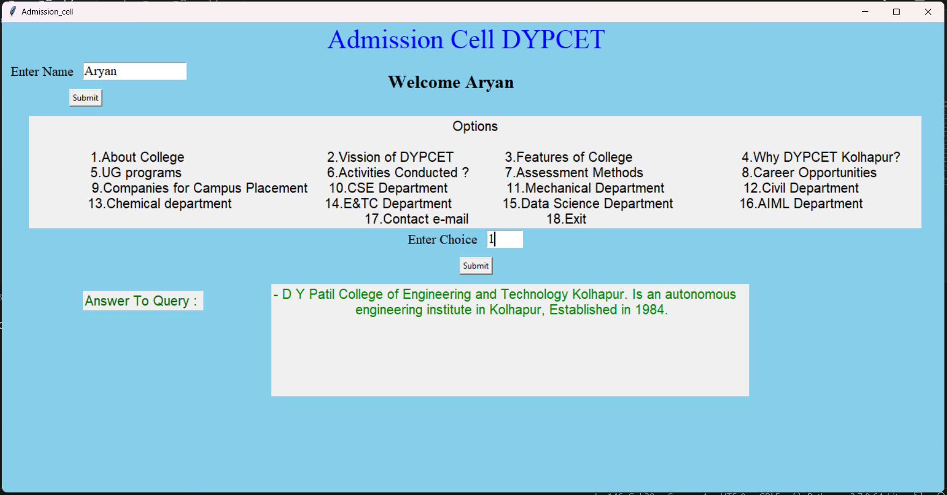

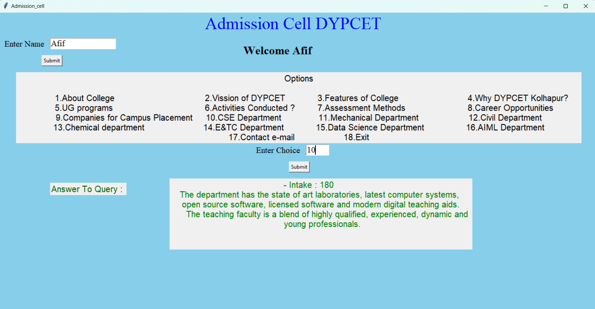

## Conclusion :

In conclusion, the admission cell chatbot project is an innovative and useful tool for educational institutions as well as students that can streamline the admission process and provide quick and efficient assistance to prospective students. By integrating natural language processing and machine learning algorithms, the chatbot can understand and respond to student queries and provide personalized guidance to applicants, resulting in higher student satisfaction and increased admissions. However, it is important to continually update and improve the chatbot to ensure accuracy and effectiveness, and to provide a human backup for more complex queries. Overall, the admission cell chatbot is a valuable addition to any educational institution's admissions process.

Overall, the chatbot project has the potential to revolutionize the way of organizations interact with their users. With continued development and improvements, chatbots will become an increasingly important tool in the digital landscape.

# Reference

<https://www.researchgate.net/Chatbot_and_Voice_Assistant>

<https://www.academia.edu/38409853/CHATBOT_IN_PYTHON>

https://www.coursehero.com/file/