Assessment:

Git Link : <https://github.com/dhananjayarathnayake/Techadamy.git>

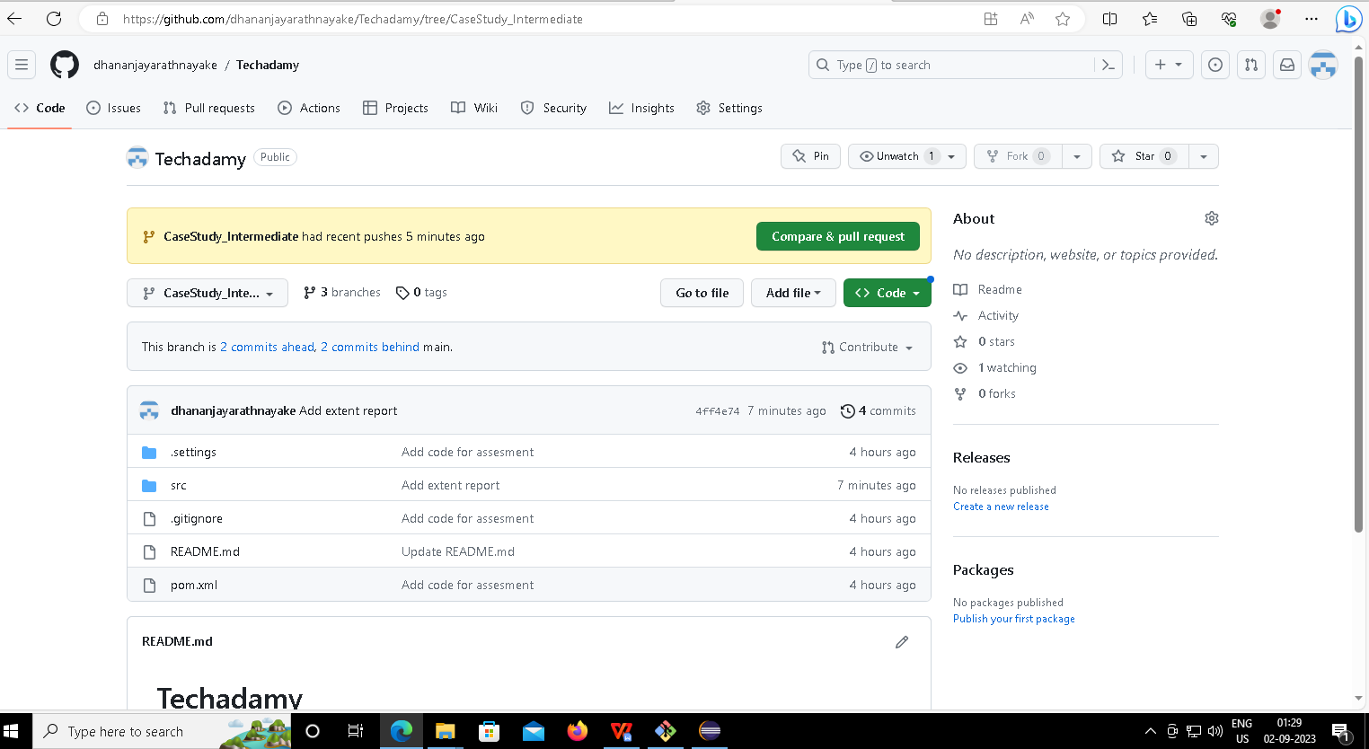

1. Positive

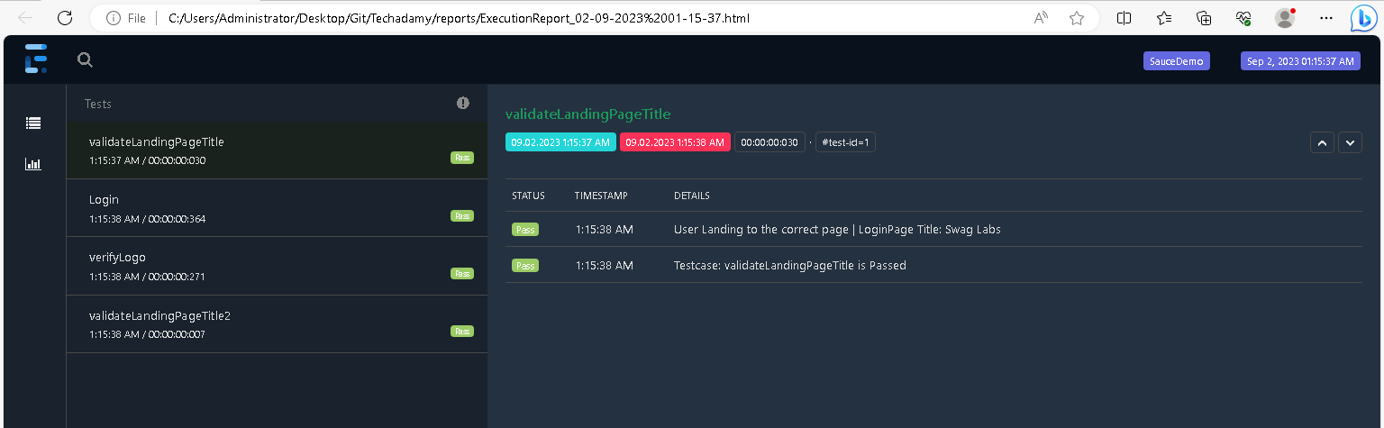

1. Negative

