Name: Dhananjay madhukar bhirud
Roll: 152
Practical No:1 Write a Python script to perform basic operations on images
a)Read and display an image
import cv2
img = cv2.imread("E:\\Msc\\flower.jpg",1)
cv2.imshow("image",img)

output

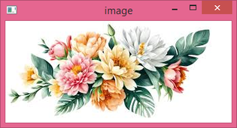

b)Print Image pixel
pixel = img[100,100]
print(pixel)

Output
[175 175 239]

c)Printheight,widthand size of an image
height = img.shape[0]
width = img.shape[1]
channels = img.shape[2]
size1=img.size
print('Image Height :',height)
print('Image Width :',width)
print('Image Size :',size1)

Output
Image Height : 151
Image Width : 334
Image Size : 151302

d)Convert RGB image into Gray image
import cv2
img = cv2.imread("E:\\Msc\\flower.jpg",1)
cv2.imshow("image",img)

img1=cv2.imread("E:\\Msc\\flower.jpg",0)
cv2.imshow("Gray Image",img1)

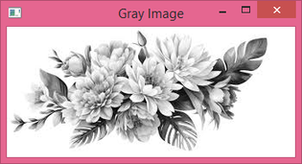

e)Color conversion of an image
import cv2
img = cv2.imread("E:\\Msc\\flower.jpg",1)
cv2.imshow("image",img)

img1=cv2.cvtColor(img,cv2.COLOR_BGR2GRAY)
cv2.imshow("image",img1)

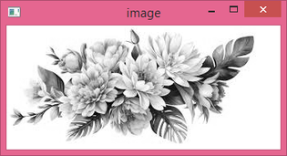

f)Convert RGB image into Binary image
ret,kh=cv2.threshold(img,127,255,cv2.THRESH_BINARY)
cv2.imshow("Binary Image",kh)

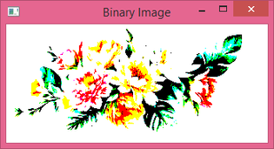

g)Resize Image
imageresize=cv2.resize(img,(150,160))
cv2.imshow("resize Image",imageresize)
cv2.waitKey(0)

