Name: Dhananjay madhukar bhirud
Roll No:152
Practical No 10. Write a Python script to extract texture and color features of an image.

import cv2
importnumpy as np

defextract_color_features(image):
# Convert the image from BGR to RGB (OpenCV uses BGR by default)
image_rgb = cv2.cvtColor(image, cv2.COLOR_BGR2RGB)
# Compute color histogram for each channel
hist_r = cv2.calcHist([image_rgb], [0], None, [256], [0, 256])
hist_g = cv2.calcHist([image_rgb], [1], None, [256], [0, 256])
hist_b = cv2.calcHist([image_rgb], [2], None, [256], [0, 256])

# Normalize histograms
hist_r = cv2.normalize(hist_r, hist_r).flatten()
hist_g = cv2.normalize(hist_g, hist_g).flatten()
hist_b = cv2.normalize(hist_b, hist_b).flatten()
# Return color features as a concatenated array
returnnp.concatenate([hist_r, hist_g, hist_b])

defextract_texture_features(image):
# Convert the image to grayscale
gray_image = cv2.cvtColor(image, cv2.COLOR_BGR2GRAY)
# Calculate Local Binary Pattern (LBP) for texture features
# Note: You need to implement or use a library that provides LBP functionality
# For demonstration purposes, we'll use a placeholder for LBP features
# Placeholder function for LBP computation

defcompute_lbp(image):
# LBP computation should be implemented or use an existing library
# This example assumes a placeholder method
# Install 'scikit-image' for an actual implementation
fromskimage.feature import local_binary_pattern
lbp = local_binary_pattern(image, P=8, R=1, method='uniform')

# Compute histogram for LBP values
lbp_hist, _ = np.histogram(lbp.ravel(), bins=np.arange(0, 11), range=(0, 10))
returnlbp_hist
lbp_hist = compute_lbp(gray_image)

# Normalize the LBP histogram
lbp_hist = lbp_hist.astype('float')
lbp_hist /= (lbp_hist.sum() + 1e-7) # Avoid division by zero

returnlbp_hist
def main(image_path):
# Load the image
image = cv2.imread(image_path)
if image is None:
print("Error: Image not found.")
return
# Extract color features
color_features = extract_color_features(image)
print("Color Features:")
print(color_features)

# Extract texture features
texture_features = extract_texture_features(image)
print("Texture Features:")
print(texture_features)

if __name__ == "__main__":
image_path = 'E:\\Msc\\rose.jpg' # Replace with your image path
main(image_path)

output

Color Features:

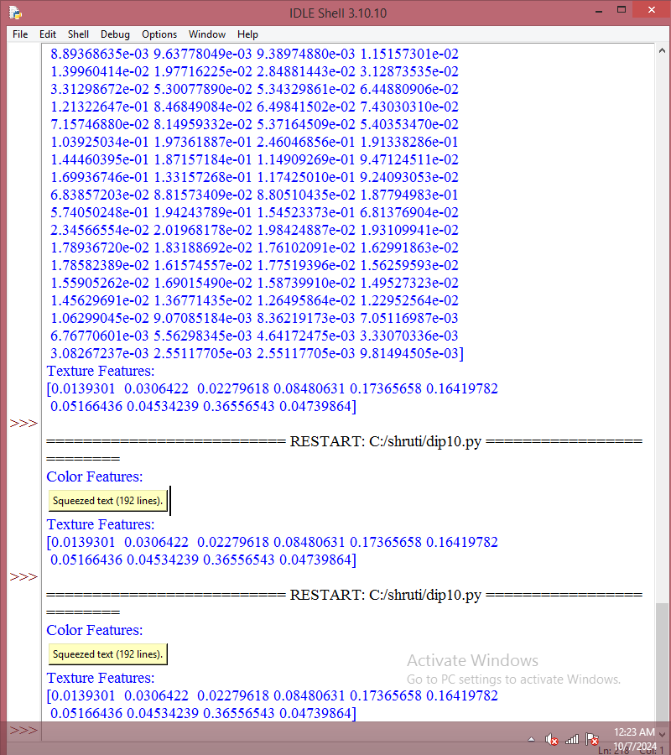

Texture Features:
[0.0139301 0.0306422 0.02279618 0.08480631 0.17365658 0.16419782
0.05166436 0.04534239 0.36556543 0.04739864]

