Name: Dhananjay madhukar bhirud
Roll No: 152
Practical No: 11 Write a python script to character recognition
import cv2
importpytesseract
img = cv2.imread('E:\\Msc\\leaf.jpg')
cv2.imshow('Image',img)

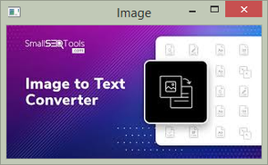

grayimg = cv2.cvtColor(img,cv2.COLOR_BGR2GRAY)
text = pytesseract.image_to_string(grayimg)

print("Recognized Text")
Recognized Text

print(text)
SmalS=iToos
Image to Text
Converter

