Name: Dhananjay madhukar bhirud
Roll No: 152
Practical no: 2 Write a Python script to perform conversion between color spaces.

import cv2
img = cv2.imread("E:\\Msc\\rose.jpg",1)
cv2.imshow("Original Image",img)

Output



img1 = cv2.cvtColor(img,cv2.COLOR_BGR2GRAY)
cv2.imshow("Gray Image",img1)

OUTPUT

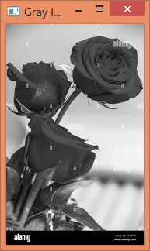

img2 = cv2.cvtColor(img,cv2.COLOR_BGR2RGB)
cv2.imshow("RGB Image",img2)

OUTPUT

