Name:Dhananjay madhukar bhirud
Roll No: 152

Practical No.3 Write a python script to perform Histogram Equilization

import cv2
importnumpy as np
a = cv2.imread("E:\\Msc\\image.jpg",1)
cv2.imshow("Original Image",a)

Output

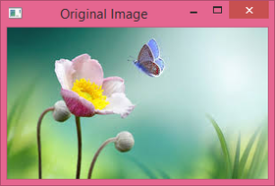

img =cv2.cvtColor(a,cv2.COLOR_BGR2GRAY)
cv2.imshow("Gray Image",img)

Output

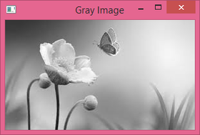

equ=cv2.equalizeHist(img)
cv2.imshow("Histogram Equalize Image",equ)

Output

