Name: Dhananjay madhukar bhirud
Roll No: 152
Practical No.4 Write a Python script to perform image filtering in special domains.

import cv2
importnumpy as np
img = cv2.imread("E:\\Msc\\orange.jpg",1)
cv2.imshow("Original Image",img)

Output

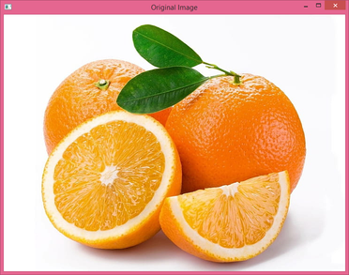

gray_img =cv2.cvtColor(img,cv2.COLOR_BGR2GRAY)
gaussian_blur = cv2.GaussianBlur(gray_img,(5,5),0)
median_blur = cv2.medianBlur(gray_img,5)
kernal = np.array([[0,-1,0],[-1,5,-1],[0,-1,0]])
sharpened_img = cv2.filter2D(gray_img,-1,kernal)
cv2.imshow("Gray Image",gray_img)

Output

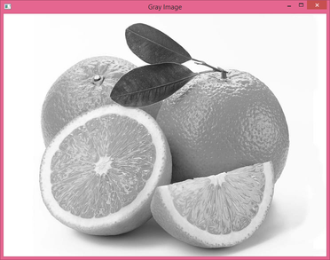

cv2.imshow("Gaussian Blur Image",gaussian_blur)

Output

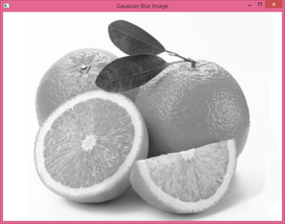

cv2.imshow("Sharp Image",sharpened_img)

Output

