Name:Dhananjay madhukar bhirud
Roll No: 152
Practical 6: Write a Python script to perform Image Restoration.

import cv2
importnumpy as np
a= cv2.imread("E:\\ Msc\\flower.jpg",1)
cv2.imshow("Original Image",a)

Output

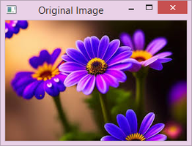

b=cv2.cvtColor(a,cv2.COLOR_BGR2GRAY)
denoised_img=cv2.fastNlMeansDenoisingColored(a,None,10,10,7,21)

cv2.imshow("Denoised Image",denoised_img)

Output

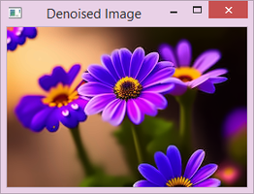

cv2.imwrite("restored_image.jpg",denoised_img)
True

