Name: Dhananjay madhukar bhirud
Roll No: 152
Practical No.7: Write a python script to perform edge detection using various operations

import cv2
importnumpy as np
a = cv2.imread("E:\\Msc\\bike.jpeg",1)
cv2.imshow('image',a)
sobelx=cv2.Sobel(a,cv2.CV_64F,1,0,ksize=5)
sobely=cv2.Sobel(a,cv2.CV_64F,1,0,ksize=5)
sobel=cv2.magnitude(sobelx,sobely)
sobel=np.uint8(sobel)
laplacian=cv2.Laplacian(a,cv2.CV_64F)
laplacian=np.uint8(np.absolute(laplacian))
canny=cv2.Canny(a,100,200)

Output

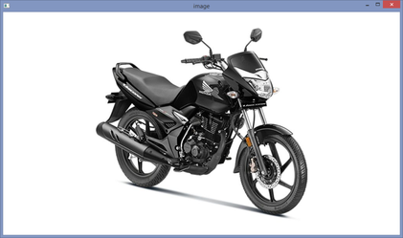

cv2.imshow('Sobel Edge Detection',sobel)

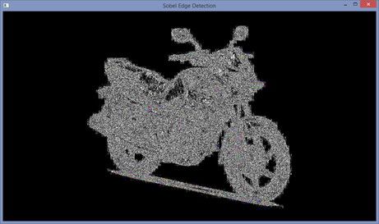

cv2.imshow('laplacian Edge Detection',laplacian)

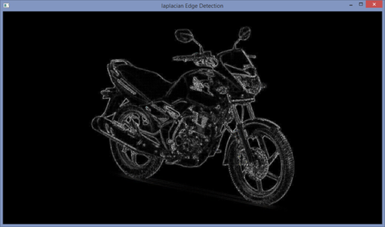

cv2.imshow('canny Edge Detection',canny)

