Name: Dhananjay madhukar bhirud
Roll No:152

Practical No.8: Write a python script to perform global adaptive otsu’sthresholding

import cv2
img = cv2.imread("E:\\Msc\\flower.jpg",0)
ret1,global_thresh=cv2.threshold(img,127,255,cv2.THRESH_BINARY)
adaptive_mean_thresh=cv2.adaptiveThreshold(img,255,cv2.ADAPTIVE_THRESH_MEAN_C,cv2.THRESH_BINARY,11,2)
adaptive_gaussian_thresh =cv2.adaptiveThreshold(img,255,cv2.ADAPTIVE_THRESH_GAUSSIAN_C,cv2.THRESH_BINARY,11,2)
ret2,otsu_thresh=cv2.threshold(img,0,255,cv2.THRESH_BINARY+cv2.THRESH_OTSU)
cv2.imshow("Original image",img)

Output

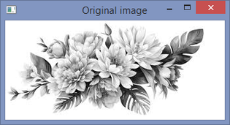

cv2.imshow("Global Threshold(v=127)",global_thresh)

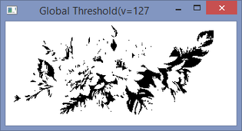

cv2.imshow('Adaptive Mean Thresholding',adaptive_mean_thresh)

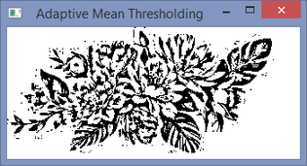

cv2.imshow('Adaptive Gaussian Thresholding',adaptive_gaussian_thresh)

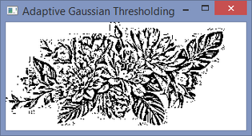

cv2.imshow('Otsu Thresholding',otsu_thresh)

