Name: Dhananjay madhukar bhirud
Roll No: 152
Practical No.9: Write a python script to apply morphological operation on an image
import cv2
import numpy as np
img=cv2.imread("E:\\Msc\\image.jpg",1)
cv2.imshow("Original Image",img)

output

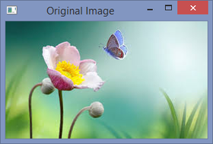

img1=cv2.imread("E:\\Msc\\image.jpg",0)
cv2.imshow("Gray Image",img1)

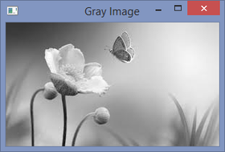

kernal=np.ones((5,5),np.uint8)
erosion=cv2.erode(img1,kernal,iterations=1)
dilation=cv2.dilate(img1,kernal,iterations=1)
opening=cv2.morphologyEx(img1,cv2.MORPH_OPEN,kernal)
closing=cv2.morphologyEx(img1,cv2.MORPH_CLOSE,kernal)
cv2.imshow('Erosion',erosion)

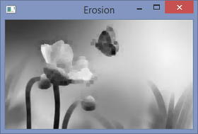

cv2.imshow('Dilation',dilation)

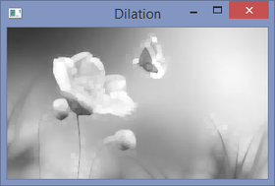

cv2.imshow('opening',opening)

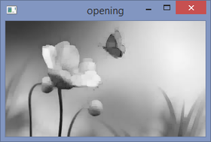

cv2.imshow('closing',closing)

