**Data Wrangling Part - II**

**Problem Statement :**

**Create an “Academic performance” dataset of students and perform the following operations using Python.  
1. Scan all variables for missing values and inconsistencies. If there are missing values and/or inconsistencies, use any of the suitable techniques to deal with them.  
2. Scan all numeric variables for outliers. If there are outliers, use any of the suitable techniques to deal with them.  
3. Apply data transformations on at least one of the variables. The purpose of this transformation should be one of the following reasons: to change the scale for better understanding of the variable, to convert a non-linear relation into a linear one, or to decrease the skewness and convert the distribution into a normal distribution. Reason and document your approach properly.**

In [48]:

*#imports*

**import** numpy **as** np

**import** pandas **as** pd

**import** seaborn **as** sns

**from** sklearn.preprocessing **import** StandardScaler

In [35]:

*#Create dataset for student performance*

*# Create a dictionary with the data*

data **=** {

'name': pd**.**Series(['Alice', 'Bob', 'Charlie', 'David', 'Emma', 'Frank', 'Grace', 'Henry', 'Ivy', 'Jack',

'Katie', 'Liam', 'Mia', 'Nate', 'Olivia', 'Peter', 'Quinn', 'Rachel', 'Sam', 'Tyler']),

'division': pd**.**Series(['A', 'B', 'A', 'C', 'B', 'A', 'B', 'C', 'B', 'A', 'C', 'B', 'A', 'C', 'B', 'A', 'C',

'B', 'A', 'C']),

'marks1': pd**.**Series([70, 80, 85, 90, 95, 65, 75, 60, 50, 85, np**.**nan, 55, 80, 70, 75, 40, 90, 80, 85, 65]),

'marks2': pd**.**Series([60, 70, 75, 80, 85, 55, 65, 50, 40, 75, 80, 45, 70, 60, np**.**nan, 30, 80, 70, 75, 55]),

'marks3': pd**.**Series([5, 60, 65, 70, 75, 45, 55, 40, 30, 65, 70, 35, 60, 50, 55, 20, 70, 60, np**.**nan, 45])

}

*# Create the dataframe*

df **=** pd**.**DataFrame(data)

In [36]:

df**.**sample(7)

Out[36]:

|  | **name** | **division** | **marks1** | **marks2** | **marks3** |
| --- | --- | --- | --- | --- | --- |
| **4** | Emma | B | 95.0 | 85.0 | 75.0 |
| **11** | Liam | B | 55.0 | 45.0 | 35.0 |
| **19** | Tyler | C | 65.0 | 55.0 | 45.0 |
| **2** | Charlie | A | 85.0 | 75.0 | 65.0 |
| **12** | Mia | A | 80.0 | 70.0 | 60.0 |
| **1** | Bob | B | 80.0 | 70.0 | 60.0 |
| **14** | Olivia | B | 75.0 | NaN | 55.0 |

In [37]:

df**.**info()

<class 'pandas.core.frame.DataFrame'>

RangeIndex: 20 entries, 0 to 19

Data columns (total 5 columns):

# Column Non-Null Count Dtype

--- ------ -------------- -----

0 name 20 non-null object

1 division 20 non-null object

2 marks1 19 non-null float64

3 marks2 19 non-null float64

4 marks3 19 non-null float64

dtypes: float64(3), object(2)

memory usage: 928.0+ bytes

In [38]:

df**.**isna()**.**sum()

Out[38]:

name 0

division 0

marks1 1

marks2 1

marks3 1

dtype: int64

In [39]:

*# Fill NaN values in marks1 with the mean of marks2 and marks3 for that row*

df['marks1']**.**fillna(df[['marks2', 'marks3']]**.**mean(axis**=**1), inplace**=True**)

*# Fill NaN values in marks2 with the mean of marks1 and marks3 for that row*

df['marks2']**.**fillna(df[['marks1', 'marks3']]**.**mean(axis**=**1), inplace**=True**)

*# Fill NaN values in marks3 with the mean of marks1 and marks2 for that row*

df['marks3']**.**fillna(df[['marks1', 'marks2']]**.**mean(axis**=**1), inplace**=True**)

In [40]:

df**.**isna()**.**sum()

Out[40]:

name 0

division 0

marks1 0

marks2 0

marks3 0

dtype: int64

In [46]:

*#Outlier present in 'marks3' can be visualized below*

sns**.**boxplot(data**=** data, x**=** 'marks3', color**=** 'red');

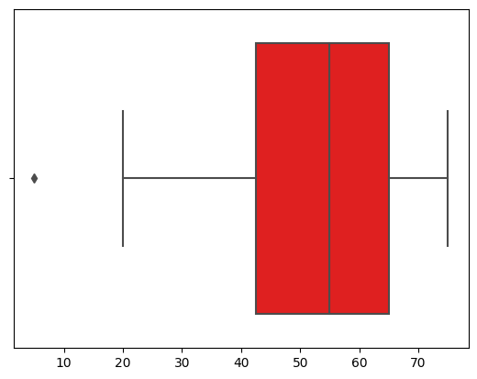

In [42]:

**def** detect_outliers_iqr(data):

Q1 **=** data**.**quantile(0.25)

Q3 **=** data**.**quantile(0.75)

IQR **=** Q3 **-** Q1

*# print(Q1,Q3,IQR)*

lower_bound **=** Q1 **-** 1.5 **\*** IQR

upper_bound **=** Q3 **+** 1.5 **\*** IQR

outliers **=** data[(data **<** lower_bound) **|** (data **>** upper_bound)]

**return** outliers

In [43]:

outliers **=** detect_outliers_iqr(data['marks3'])

outliers

Out[43]:

0 5.0

dtype: float64

In [44]:

data_wo_outliers **=** df[**~**df['marks3']**.**isin(outliers)]

In [45]:

data_wo_outliers

Out[45]:

|  | **name** | **division** | **marks1** | **marks2** | **marks3** |
| --- | --- | --- | --- | --- | --- |
| **1** | Bob | B | 80.0 | 70.0 | 60.0 |
| **2** | Charlie | A | 85.0 | 75.0 | 65.0 |
| **3** | David | C | 90.0 | 80.0 | 70.0 |
| **4** | Emma | B | 95.0 | 85.0 | 75.0 |
| **5** | Frank | A | 65.0 | 55.0 | 45.0 |
| **6** | Grace | B | 75.0 | 65.0 | 55.0 |
| **7** | Henry | C | 60.0 | 50.0 | 40.0 |
| **8** | Ivy | B | 50.0 | 40.0 | 30.0 |
| **9** | Jack | A | 85.0 | 75.0 | 65.0 |
| **10** | Katie | C | 75.0 | 80.0 | 70.0 |
| **11** | Liam | B | 55.0 | 45.0 | 35.0 |
| **12** | Mia | A | 80.0 | 70.0 | 60.0 |
| **13** | Nate | C | 70.0 | 60.0 | 50.0 |
| **14** | Olivia | B | 75.0 | 65.0 | 55.0 |
| **15** | Peter | A | 40.0 | 30.0 | 20.0 |
| **16** | Quinn | C | 90.0 | 80.0 | 70.0 |
| **17** | Rachel | B | 80.0 | 70.0 | 60.0 |
| **18** | Sam | A | 85.0 | 75.0 | 80.0 |
| **19** | Tyler | C | 65.0 | 55.0 | 45.0 |

In [47]:

*# The outlier has been removed and this can be visualized by the plot below*

sns**.**boxplot(data**=** data_wo_outliers, x**=** 'marks3', color**=** 'green');

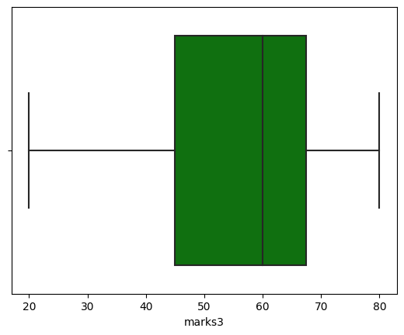

In [49]:

*# Create a StandardScaler object*

scaler **=** StandardScaler()

*# Fit the scaler to the data and transform the data*

df[['marks1', 'marks2', 'marks3']] **=** scaler**.**fit_transform(df[['marks1', 'marks2', 'marks3']])

In [52]:

sns**.**histplot(df, kde**=True**);

