**Data Visualization**

**Problem Statement**

**Use the inbuilt dataset 'titanic' as used in the above problem.  
1. Plot a box plot for distribution of age with respect to each gender along with the information about whether they survived or not. (Column names : 'sex' and 'age')  
2. Write observations on the inference from the above statistics.**

In [1]:

*#imports*

**import** pandas **as** pd

**import** numpy **as** np

**import** seaborn **as** sns

**import** matplotlib.pyplot **as** plt

In [3]:

data **=** pd**.**read_csv('train.csv')

data**.**sample(5)

Out[3]:

|  | **PassengerId** | **Survived** | **Pclass** | **Name** | **Sex** | **Age** | **SibSp** | **Parch** | **Ticket** | **Fare** | **Cabin** | **Embarked** |
| --- | --- | --- | --- | --- | --- | --- | --- | --- | --- | --- | --- | --- |
| **194** | 195 | 1 | 1 | Brown, Mrs. James Joseph (Margaret Tobin) | female | 44.0 | 0 | 0 | PC 17610 | 27.7208 | B4 | C |
| **299** | 300 | 1 | 1 | Baxter, Mrs. James (Helene DeLaudeniere Chaput) | female | 50.0 | 0 | 1 | PC 17558 | 247.5208 | B58 B60 | C |
| **96** | 97 | 0 | 1 | Goldschmidt, Mr. George B | male | 71.0 | 0 | 0 | PC 17754 | 34.6542 | A5 | C |
| **554** | 555 | 1 | 3 | Ohman, Miss. Velin | female | 22.0 | 0 | 0 | 347085 | 7.7750 | NaN | S |
| **864** | 865 | 0 | 2 | Gill, Mr. John William | male | 24.0 | 0 | 0 | 233866 | 13.0000 | NaN | S |

In [4]:

data**.**isna()**.**sum()

Out[4]:

PassengerId 0

Survived 0

Pclass 0

Name 0

Sex 0

Age 177

SibSp 0

Parch 0

Ticket 0

Fare 0

Cabin 687

Embarked 2

dtype: int64

In [6]:

*#Age has a lot of null values and is one of the attributes we need to use.*

sns**.**heatmap(data**.**corr(), annot **=** **True**);

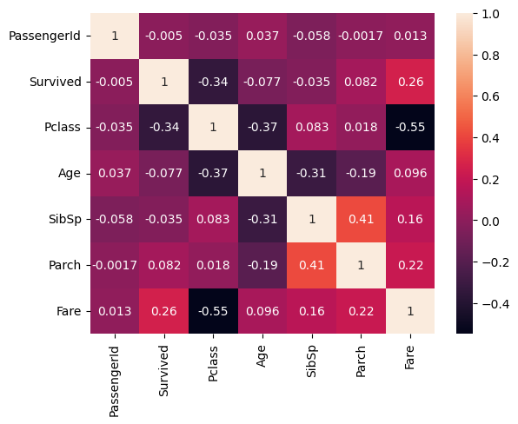

From the above corealtion matrix we can see that the attribute 'Age' is not highly dependant on any other attribute  
This means we can randomly fill in the missing data for 'Age' within the valid distribution.

In [7]:

age_null_mask **=** data['Age']**.**isnull()

age_mean **=** data['Age']**.**mean()

age_std **=** data['Age']**.**std()

*# generate random ages based on the age distribution of the dataset*

age_random **=** np**.**random**.**normal(loc**=**age_mean, scale**=**age_std, size**=**age_null_mask**.**sum())

*# fill in missing age values with random ages*

data**.**loc[age_null_mask, 'Age'] **=** age_random

In [17]:

*# 177 normal random values generated for 177 missing data points*

age_random**.**size

Out[17]:

177

In [8]:

data**.**isna()**.**sum()

Out[8]:

PassengerId 0

Survived 0

Pclass 0

Name 0

Sex 0

Age 0

SibSp 0

Parch 0

Ticket 0

Fare 0

Cabin 687

Embarked 2

dtype: int64

In [15]:

data**.**sample(7)

Out[15]:

|  | **PassengerId** | **Survived** | **Pclass** | **Name** | **Sex** | **Age** | **SibSp** | **Parch** | **Ticket** | **Fare** | **Cabin** | **Embarked** |
| --- | --- | --- | --- | --- | --- | --- | --- | --- | --- | --- | --- | --- |
| **205** | 206 | 0 | 3 | Strom, Miss. Telma Matilda | female | 2.000000 | 0 | 1 | 347054 | 10.4625 | G6 | S |
| **794** | 795 | 0 | 3 | Dantcheff, Mr. Ristiu | male | 25.000000 | 0 | 0 | 349203 | 7.8958 | NaN | S |
| **598** | 599 | 0 | 3 | Boulos, Mr. Hanna | male | 4.419244 | 0 | 0 | 2664 | 7.2250 | NaN | C |
| **743** | 744 | 0 | 3 | McNamee, Mr. Neal | male | 24.000000 | 1 | 0 | 376566 | 16.1000 | NaN | S |
| **810** | 811 | 0 | 3 | Alexander, Mr. William | male | 26.000000 | 0 | 0 | 3474 | 7.8875 | NaN | S |
| **47** | 48 | 1 | 3 | O'Driscoll, Miss. Bridget | female | 35.287735 | 0 | 0 | 14311 | 7.7500 | NaN | Q |
| **604** | 605 | 1 | 1 | Homer, Mr. Harry ("Mr E Haven") | male | 35.000000 | 0 | 0 | 111426 | 26.5500 | NaN | C |

In [14]:

sns**.**boxplot(x**=**'Sex', y**=**'Age', hue**=**'Survived', data**=**data);

