1. Docker Image : - patildhananjay/my-image:1.0

In Minikube the below commands to run:-

1. kubectl.exe create deploy nginx-depl --image=patildhananjay/my-image:1.0
2. kubectl.exe expose deployment nginx-depl --type=NodePort --name=ex-nginx-svc --port=80
3. minikube service --url ex-nginx-svc

You will get below screen containing the URL with port:-

Once you hit this URL on browser, you will get the output with current date time stamp and visitor public IP address.

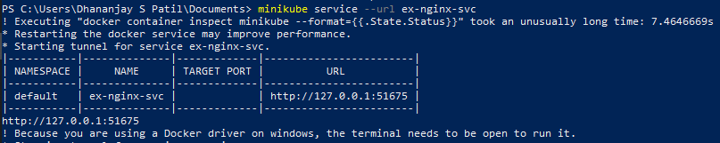

############# As I was facing issues using the Minikube on Windows system, it was not allowing me to carry out deployment with deployment and services yaml file.

PFB code for both :- (If it can run on working system)

deploy-nginx.yml

***apiVersion: apps/v1***

***kind: Deployment***

***metadata:***

***name: mynginx***

***labels:***

***app: nginx***

***spec:***

***replicas: 1***

***selector:***

***matchLabels:***

***app: nginx***

***template:***

***metadata:***

***labels:***

***app: nginx***

***spec:***

***containers:***

***- name: mynginx***

***image: patildhananjay/my-image:1.0***

***ports:***

***- containerPort: 80***

Nginx-svc.yml

***apiVersion: v1***

***kind: Service***

***metadata:***

***name: nginx-svc***

***spce:***

***type: NodePort***

***ports:***

***- port: 80***

***targetPort: 8081***

***protocol: TCP***

***selector:***

***app: nginx***