***CT Fastrack- App (Team- Scrum Masters)***

1. **Intended use of the System**

CT Fastrack Application will plan a transit trip, find best stops, and see next departures using GPS no matter where you are in the Hartford, Connecticut, and surrounding areas. This system will be used by all the people who will commute using CT Fastrack buses and by the CT Fastrack bus management system. This Application will be compatible with all the Smartphone operating systems and the App will also be installed at the KIOSK located CT Fastrack bus stops for the non-smartphone users. The application will be available for free on Play store and Apple Store and other OS for General public: Office workers, students, handicapped people and others to install on their smartphones. CT Fastrack App does it all and more. It works with all modes of public transportation — transit bus and regional trains(Amtrak) to get further connections. It not only includes Trip Planning but its unique blending of regional trip planning with real-time arrivals lets you navigate the whole region while you’re on the go. Plus, it has all the information and details about trips — complete route schedules, helpful maps, new ways to customize your trips, service alerts, fares, walking distances with Online Ticketing System and much, much more. Whether getting around Hartford or commuting around Connecticut area the CT Fastrack App makes the best use of time and energy. No smartphone, That’s fine as this application will be available on the KIOSK at every CT Fastrack bus stops to guide passengers.

1. **Functionality**

**Trip Planning**

* Allows regional trip planning.
* Fully customizable trip plan preferences, including transportation schedule and helps passengers how to go to nearest bus stops, like walking distance and more.
* Plan trips using popular landmarks and addresses.
* Full trip itineraries with fare information, actual walking distance, and map view.

**Route Schedules**

* Access to scheduled times for transit agencies in the region.
* Create point-to-point schedules within a route.
* Map based route traces.
* Search by route

**Next Departures**

* Estimated (Est) real-time departure times available for all CT FastTrack buses and Provides scheduled (Sch) departure times for CT Transit and Amtrak at a customer selected stop.
* Map and List view of Nearby Stops.
* List of recent stops.
* Park and Ride details.

**Online Bus Ticketing and Pass System**

* Buy online tickets and have an electronic copy of the ticket.
* No worry to print physical tickets and support Go Green initiative.

**Goals**

* With CT Fastrack App, it will be extremely valuable for passengers to be able to access the accurate and real-time bus location, arriving time, and delay information (if any) anytime and anywhere
* It is especially beneficial to the passengers waiting at outdoor bus stations during summer and winter time when weather conditions are not ideal. Specifically, the CTfastrak project has bus stations at shopping centers, universities, and other entertainment locations, and with the real-time bus location and accurate arriving time information, passengers could plan their activities better with less hassle.
* This application develops a bus tracking and trip planning system that provides easy, reliable and mobile access to the real-time bus location and arrival/delay information for both passengers and the transportation management.

1. **Main Components of the system (Architecture)**

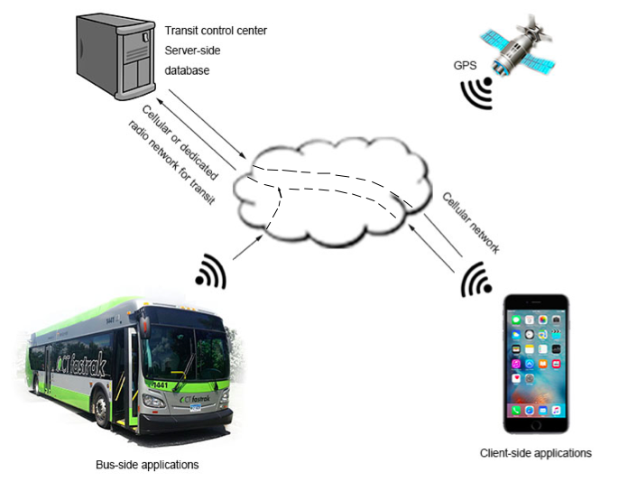

The entire system consists of three modules: bus-side application, server-side database and client-side (passenger-side) application, as shown in Figure The current bus-side application is developed on a mobile phone with GPS receiver capability to acquire location information, calculate delay, and report to the transit center (server-side).