Apache Camel is an open-source enterprises integration pattern.

Camel runs on Standalone, Springboot, Wildfly, Tomcat, Kubernetes etc…

Camel 3.x is very fast and low memory footprint.

* Supports different protocols HTTP, FTP, FILES, JMS etc…
* Supports different language Java, Python, Hadoop, PHP etc…
* We can transfer data like XML, JSON, TEXT, AVRO etc…
* Support cross connectivity like messaging to FILE or File to DB etc…  
    
  **Camel Supports three types of operations.**

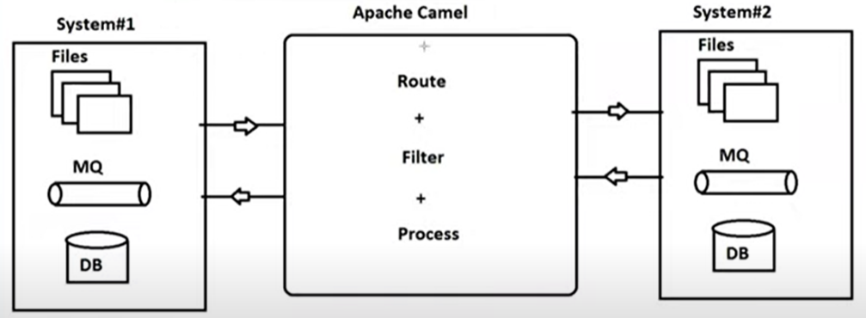🡪Routing: Transfer data from source to destination.  
🡪Filtering: Check condition before transfer  
🡪Processing: Modify/Conversion/Calculation etc… (XML->JSON)

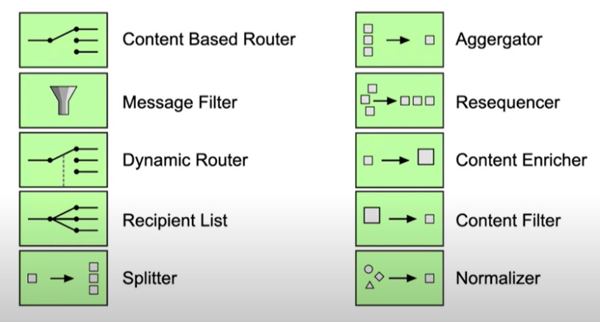  
**Supporting patterns**

Spring supports Autoconfiguration with camel using below starter dependency.

<dependency>  
 <groupId>org.apache.camel.springboot</groupId>  
 <artifactId>camel-spring-boot-starter</artifactId>  
 <version>3.19.0</version>  
</dependency>

Default Configuration Class

org.apache.camel.component.kafka.KafkaConfiguration