**Container runtime** – it will help us to create a containers

* Docker
* Roket
* CRI-O
* Container-d

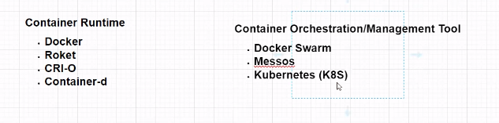

**Containers Orchestration/management Tool –** It will monitor the container that’s up and running fine. It will have more containers.

* Docker Swarm
* Messos
* Kubernetes(K8S)

Virtual container system

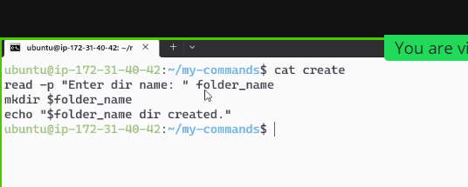

$path variable

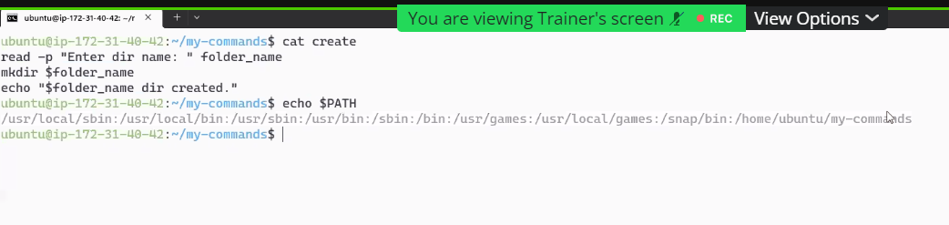

Echo will print only

Expr $A + $B

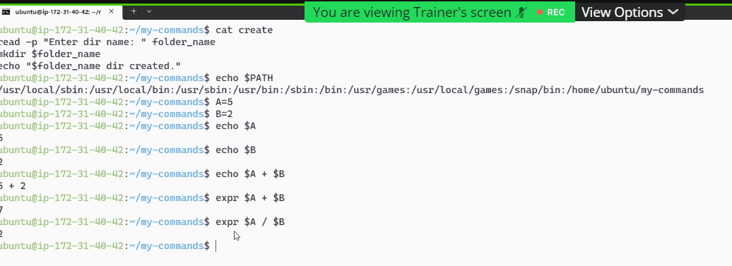

VCS- version control system.

Git- it will help you to track working directory, Putting and getting the latest code’s.It is maintaining by own.

GitHub- Centralized system to maintain Git, Everyone can put and get the code’s.

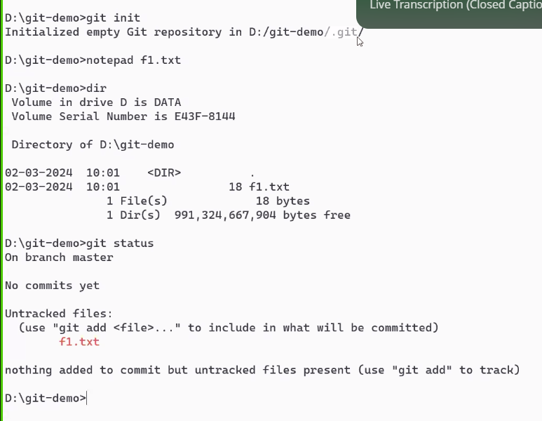

Git init – it is created new directory

.git folder create – local directory.

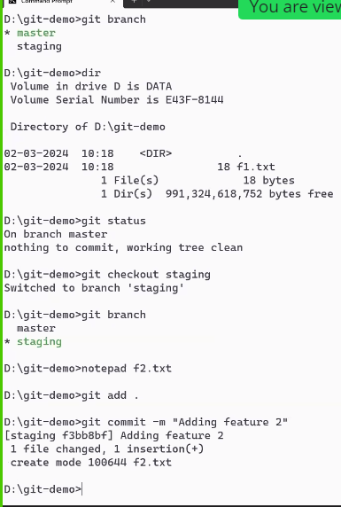

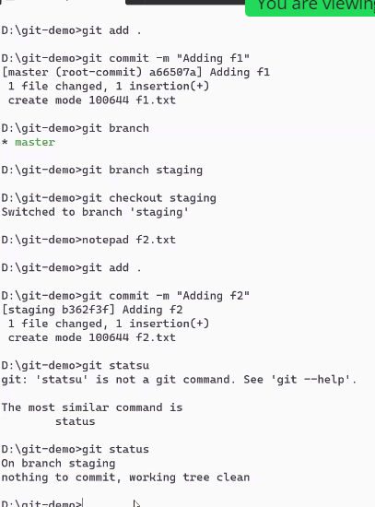

Git.log

Git ignore

Git Stash- will store the value

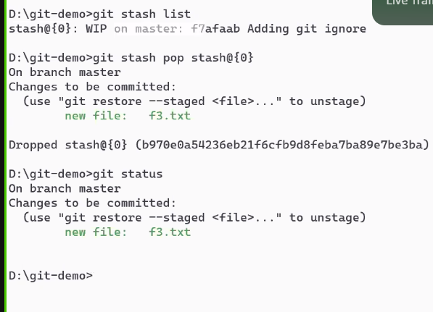

Github login need to create

Github.com

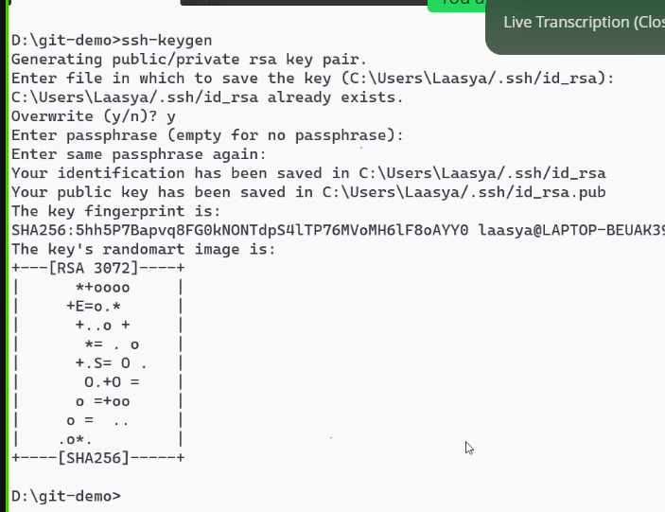

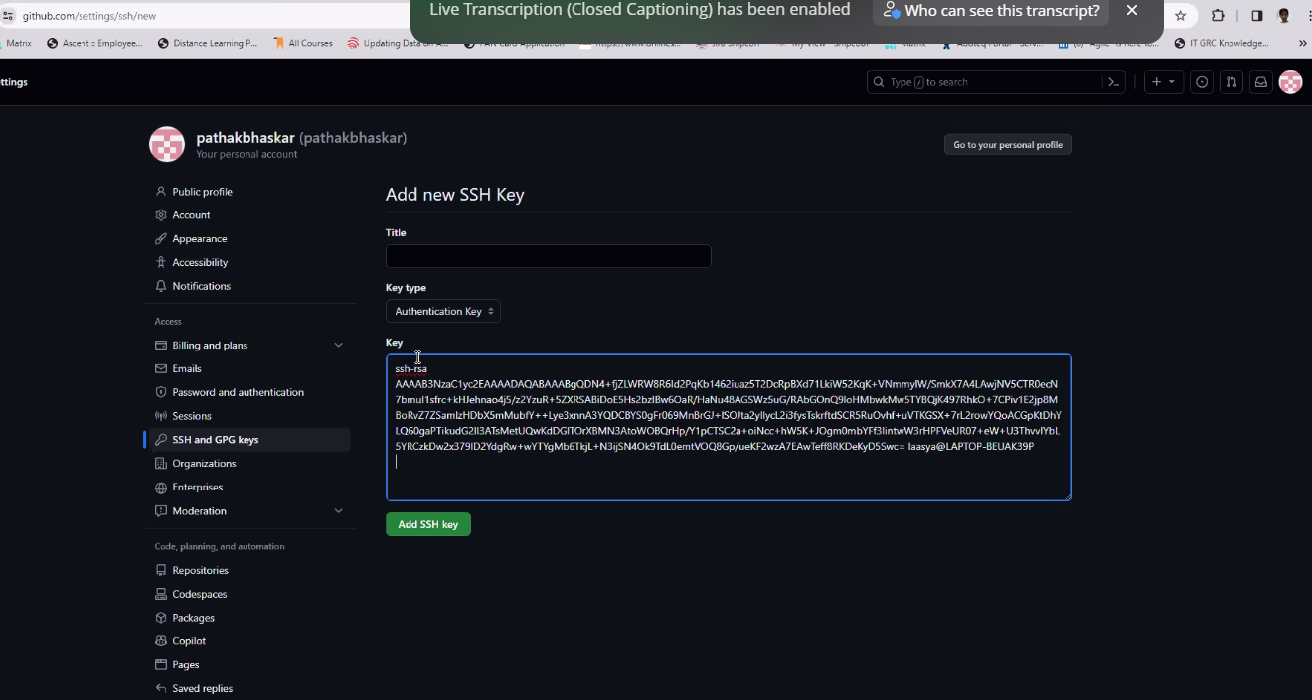

YAML